DRAFT
2020-2024 New Mexico Consolidated Plan & 2020 Annual Action Plan
New Mexico Mortgage Finance Authority
&
New Mexico Department of Finance and Administration

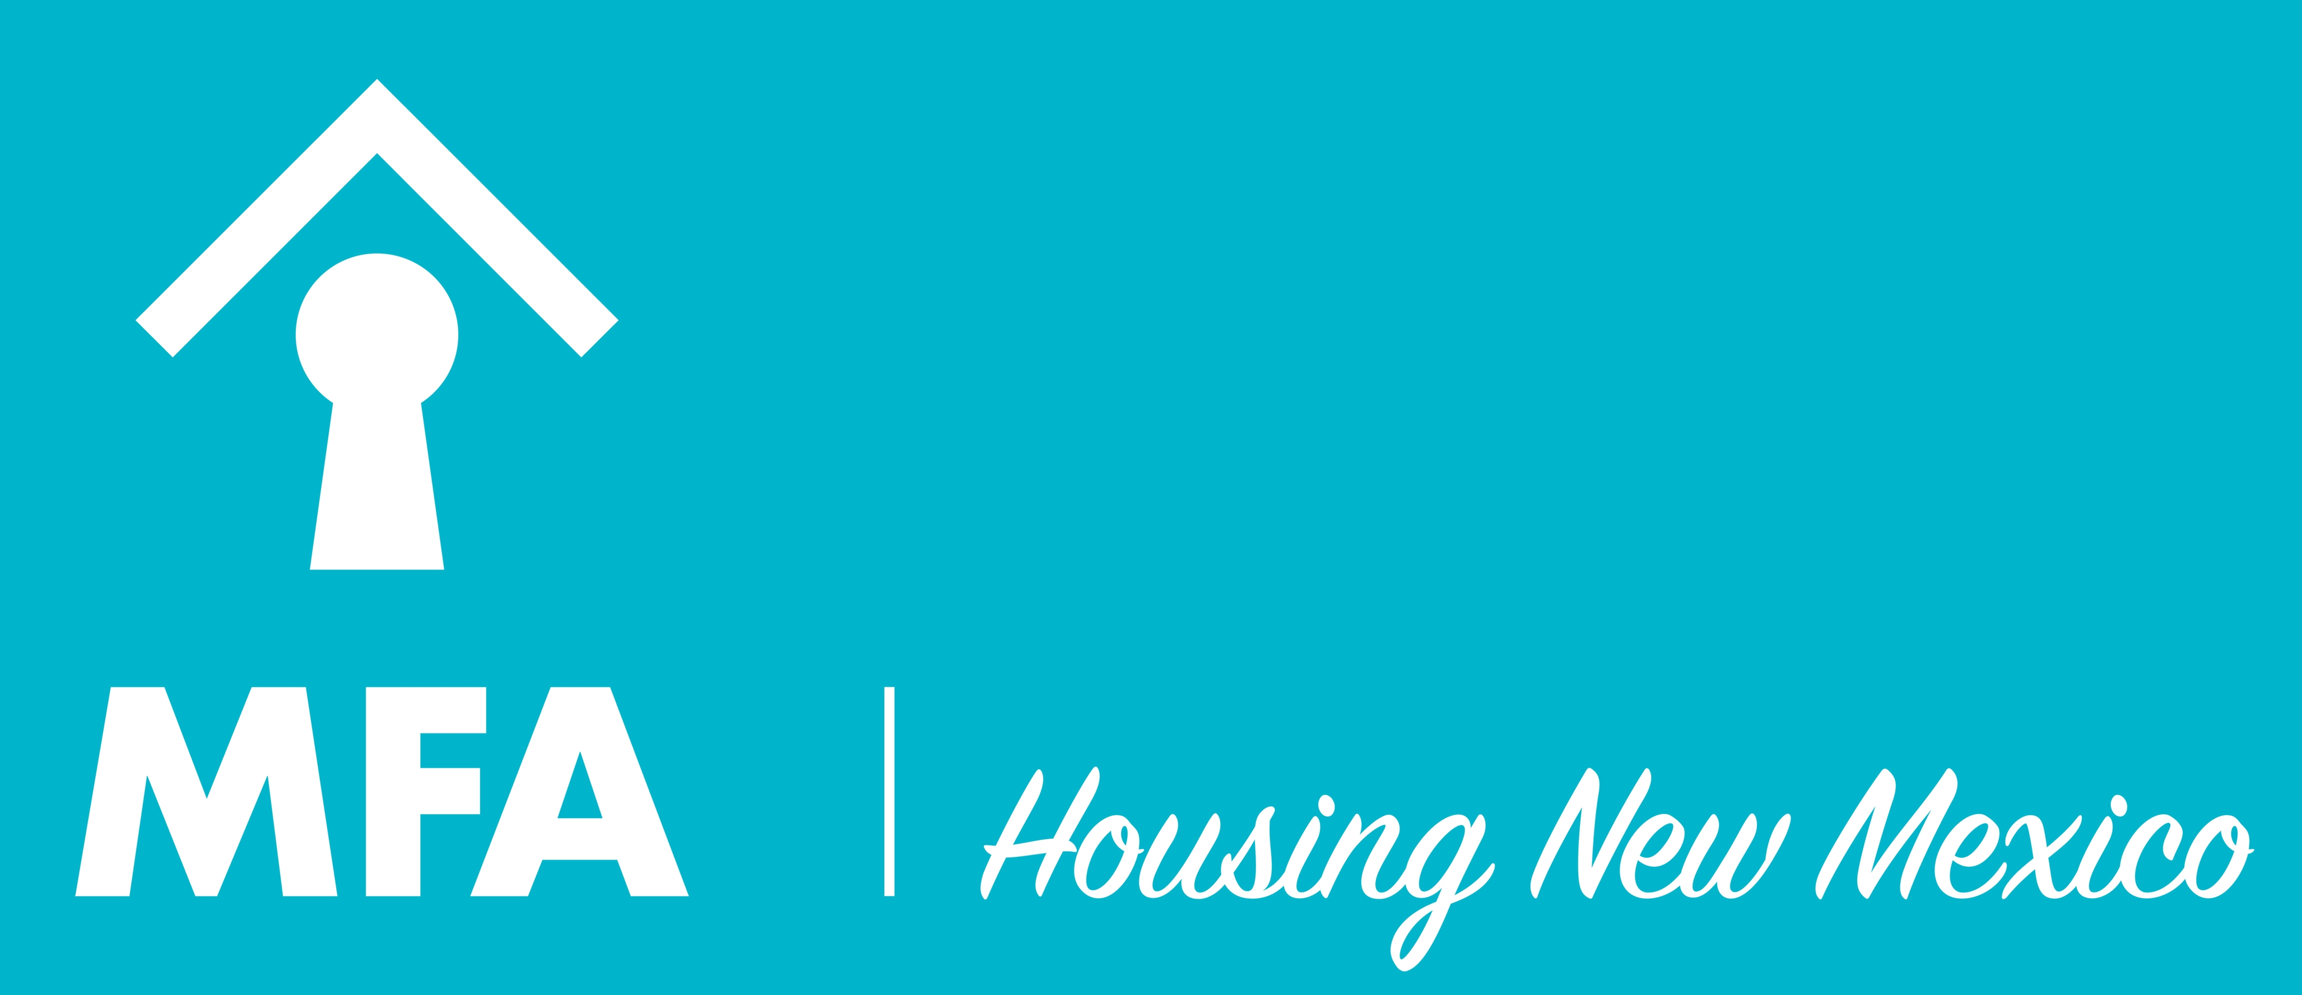

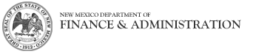

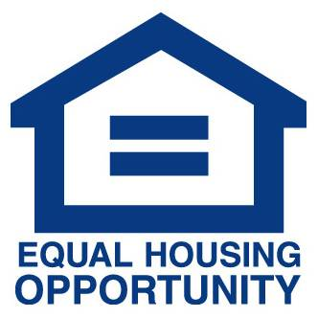

Alternative accessible formats of this document will be provided upon request. If you need this document in an alternative format such as large print, Braille or audiotape, please contact Sabrina Su at the New Mexico Mortgage Finance Authority at:

Phone: 505-843-6880
Instate Toll Free: 1-800-444-6880
Fax: 505-243-3289

Dial 7-1-1 to use Hamilton Relay in New Mexico or call one of the toll-free numbers below:

TTY: 800-659-8331
Voice: 800-659-1779
VCO (Voice Carry Over): 877-659-4174
Mobile Caption Service: 800-855-8111
Speech-to-Speech: 888-659-3952
Spanish: 800-327-1857

(Includes Spanish-to-Spanish and translation from English to Spanish)

Table of Contents

Executive Summary 1
ES-05 Executive Summary - 91.300(c), 91.320(b) 1
The Process 6
PR-05 Lead & Responsible Agencies 24 CFR 91.300(b) 6
PR-10 Consultation - 91.110, 91.300(b); 91.315(l) 7
PR-15 Citizen Participation - 91.115, 91.300(c) 21
Needs Assessment 28
NA-05 Overview 28
NA-10 Housing Needs Assessment - 24 CFR 91.305 (a, b, c) 29
NA-15 Disproportionately Greater Need: Housing Problems - 91.305 (b)(2) 48
NA-20 Disproportionately Greater Need: Severe Housing Problems – 91.305(b)(2) 52
NA-25 Disproportionately Greater Need: Housing Cost Burdens – 91.305 (b)(2) 56
NA-30 Disproportionately Greater Need: Discussion – 91.305 (b)(2) 57
NA-35 Public Housing – (Optional) 60
NA-40 Homeless Needs Assessment – 91.305(c) 62
NA-45 Non-Homeless Special Needs Assessment – 91.305 (b, d) 68
NA-50 Non-Housing Community Development Needs - 91.315 (f) 74
Market Analysis 76
MA-05 Overview 76
MA-10 Number of Housing Units – 91.310(a) 77
MA-15 Cost of Housing – 91.310(a) 82
MA-20 Condition of Housing – 91.310(a) 88
MA-25 Public and Assisted Housing 96
MA-30 Homeless Facilities – 91.310(b) 97
MA-35 Special Needs Facilities and Services – 91.310(c) 102
MA-40 Barriers to Affordable Housing – 91.310(d) 105
MA-45 Non-Housing Community Development Assets -91.315(f) 106
MA-50 Needs and Market Analysis Discussion 115
Strategic Plan 119
SP-05 Overview 119
SP-10 Geographic Priorities – 91.315(a)(1) 120
SP-25 Priority Needs – 91.315(a)(2) 123
SP-30 Influence of Market Conditions – 91.315(b) 128
SP-35 Anticipated Resources - 91.315(a)(4), 91.320(c)(1,2) 131
SP-40 Institutional Delivery Structure – 91.315(k) 139
SP-45 Goals Summary – 91.315(a)(4) 144
SP-50 Public Housing Accessibility and Involvement – 91.315(c) 150
SP-55 Barriers to Affordable Housing – 91.315(h) 151
SP-60 Homelessness Strategy – 91.315(d) 152
SP-65 Lead based paint Hazards – 91.315(i) 155
SP-70 Anti-Poverty Strategy – 91.315(j) 157
SP-75 Colonias Strategy – 91.315 159
SP-80 Monitoring – 91.330 161
Action Plan 162
AP-15 Expected Resources – 91.320(c)(1,2) 162
AP-25 Allocation Priorities – 91.320(d) 172
AP-30 Methods of Distribution – 91.320(d)&(k) 175
AP-35 Projects – (Optional) 185
AP-38 Project Summary 186
AP-40 Section 108 Loan Guarantee – 91.320(k)(1)(ii) 187
AP-45 Community Revitalization Strategies – 91.320(k)(1)(ii) 188
AP-48 Method of Distribution for Colonias Set-aside – 91.320(d)&(k) 189
AP-50 Geographic Distribution – 91.320(f) 191
AP-55 Affordable Housing – 24 CFR 91.320(g) 191
AP-60 Public Housing - 24 CFR 91.320(j) 193
AP-65 Homeless and Other Special Needs Activities – 91.320(h) 195
AP-70 HOPWA Goals – 91.320(k)(4) 198
AP-75 Barriers to Affordable Housing – 91.320(i) 199
AP-80 Colonias Actions – 91.320(j) 200
AP-85 Other Actions – 91.320(j) 202
AP-90 Program Specific Requirements – 91.320(k)(1,2,3) 204

Grantee Unique Appendices
Part A: Notices of Public Hearings and Public Comment Period
Part B: Publication Certifications
Part C: Summary of Public Comments
Part D: Survey Questions
Part E: Survey Responses
Part F: SF424s and State Certifications
Part G: HOME Recapture/Affordability Guidelines
Part H: 2020 Housing Trust Fund Allocation Plan and Design Standards
Part I: HOME Purchase Price Limits
Part J: Monitoring Plans
Part K: ESG Written Standards
Part L: Citizen Participation Plan
Part M: Interview Comments
Part N: Focus Group Comments

Executive Summary

ES-05 Executive Summary - 91.300(c), 91.320(b)
1. Introduction
All sections are marked with the eCon Planning Suite screen number and name, and the report is laid out in the way that it occurs, in order, with regulatory references
In 1994, the U.S. Department of Housing and Urban Development (HUD) issued new rules consolidating the planning, application, reporting and citizen participation processes for four formula grant programs: Community Development Block Grants (CDBG), HOME Investment Partnerships (HOME), Emergency Solutions Grants (ESG) and Housing Opportunities for Persons with AIDS (HOPWA). The new single-planning process was intended to more comprehensively fulfill three basic goals: to provide decent housing, to provide a suitable living environment and to expand economic opportunities. It was termed the Consolidated Plan for Housing and Community Development.
According to HUD, the Consolidated Plan is designed to be a collaborative process whereby a community establishes a unified vision for housing and community development actions. It offers communities the opportunity to shape these housing and community development programs into effective and coordinated neighborhood and community development strategies. It also allows for strategic planning and citizen participation to occur in a comprehensive context, thereby reducing duplication of effort. The term "entitlement area" refers to cities and counties that, because of their size, are able to receive federal funding directly. These areas must complete a Consolidated Plan separately from the State's to receive funding. For purposes of this report, non-entitlement refers to cities and towns that do not file Consolidated Plans individually and are not able to receive funding from the HUD programs directly. Entitlement areas receiving funding not covered by the New Mexico Consolidated Plan are City of Albuquerque, City of Las Cruces, City of Santa Fe, City of Farmington and the City of Rio Rancho. Individuals wishing to contribute to the consolidated planning process in these areas should contact housing and community development specialists in these cities.
As the lead agency for the Consolidated Plan, the New Mexico Mortgage Finance Authority (MFA) hereby follows HUD's guidelines for citizen and community involvement. Furthermore, it is responsible for overseeing these citizen participation requirements, including those that accompany the Consolidated Plan and the CDBG, HOME, HOPWA, ESG and Housing Trust Fund (HTF) programs, as well as those that complement the MFA planning processes already at work in the State. MFA administers the HOME, ESG, HOPWA and HTF programs. The New Mexico Department of Finance and Administration (DFA), Local Government Division, administers the CDBG program and is responsible for overseeing that the communities meet all CDBG citizen participation requirements.
2. Summary of the objectives and outcomes identified in the plan needs assessment overview
The following list presents the overriding strategies and goals of the New Mexico Five-Year Consolidated Plan for Housing and Community Development, including selected performance criteria associated with each strategy and goal. Furthermore, there may be a need to direct such housing resources by use of project selection criteria, which may be updated annually, based upon year-to-year need and local circumstances.
The strategies the State will pursue over the next five years are as follows:
- Expand the supply of quality affordable housing, including financing multifamily rental new construction;
- Increase opportunities for homeownership, including financing new construction of single-family homes and providing financial assistance to prospective buyers of those homes;
- Preserve the State’s existing affordable housing stock, including providing resources for owner-occupied homeowner housing rehabilitation and financing multifamily rental acquisition and rehabilitation;
- Provide housing for special needs populations, including encouraging the development of special needs housing with services, expanding housing opportunities and access for special needs populations and funding non-profit entities providing housing and related services for persons living with HIV/AIDS;
- Address immediate needs of persons experiencing homelessness through housing assistance and assistance to shelters and reduce the incidence of homelessness by increasing the level and range of services provided to persons experiencing homelessness and persons at risk of homelessness and increasing the number of available living environments, especially permanent housing situations, for persons who have been homeless or are at risk of homelessness;
- Enhance the quality of life for New Mexicans by providing funding for public infrastructure improvements such as projects relating to water, wastewater, sewer systems, roadways, storm drainage, public facilities and housing in non-entitlement communities, with a set-aside for Colonias;
- Provide assistance to non-entitlement communities to plan and prepare for infrastructure projects by funding planning grants that include comprehensive, asset management and related plans; and
- Enhance economic development activities in non-entitlement communities to create new, permanent jobs for New Mexicans.
3. Evaluation of past performance
MFA’s and DFA’s evaluations of their past performance on CDBG, HOME, ESG, HOPWA and HTF have been completed in annual Consolidated Annual Performance and Evaluation Reports (CAPERs); the most recent of which was approved by HUD in May 2019. Each CAPER states the objectives and outcomes identified in each Annual Action Plan and includes an evaluation of past performance through measurable goals and objectives compared to actual performance. The 2015-2019 CAPERs can be found on MFA’s website at http://www.housingnm.org/consolidated-annual-performance-and-evaluation-report-caper
4. Summary of citizen participation process and consultation process
A. CONSULTATION ACTIVITIES
Citizen participation and consultation for this plan began with a review of New Mexico’s past Citizen Participation Plan which sought to broaden citizen participation. The State identified methods of additional participation and clarified existing consultation processes. Those methods and activities were a key part of the Consolidated Plan’s preparation. The current Citizen Participation Plan is attached in the Grantee Unique Appendices.
MFA and DFA must consult with a wide variety of organizations in order to gain understanding of the housing and community development process. This Consolidated Plan represents a collective effort from a broad array of entities in New Mexico, ranging from governmental officials, advocacy groups, social service providers and economic development organizations. Private, non-profit and public organization representatives, including councils of government, government administrators, persons interested in the CDBG program, persons interested in the HOME program and persons associated with Continuum of Care organizations were contacted through several means, such as e-mail correspondence, online surveys and face-to-face interactions. These persons were solicited to discuss housing and community development needs in New Mexico, including the ranking of those needs and activities that MFA and DFA might consider in better addressing needs throughout the State. Further, individuals were asked to provide additional insight into prospective barriers and constraints to addressing housing and community development needs in New Mexico.
B. EFFORTS TO ENHANCE CITIZEN INVOLVEMENT
The citizen participation process for this plan began in February 2019 with the creation of comprehensive fair housing, housing and community development surveys that were offered in both English and in Spanish. MFA created a multi-disciplinary planning team made up of twenty organizations from across the State. The planning team helped disseminate the surveys throughout their communities, participated in stakeholder interviews and participated in and provided outreach and/or space for the focus groups to convene.
Out of the twenty members of the planning team, fourteen sat for in-depth interviews covering a range of issues related to housing and community development. They represented a geographic diversity from across the State and played different roles in community development, housing and advocacy, which provided a diverse set of perspectives on the issues.
Three focus groups were conducted throughout the State, in Santa Fe, Albuquerque and Las Cruces. Participants included community residents, social service agencies, advocacy groups, housing developers, City agencies and public housing authorities to name a few. They covered topics including but not limited to transportation, education, access to jobs, social services and housing and community development.
A thirty-day public comment period was held from October 1, 2019 to October 31, 2019 during which citizens were invited to comment on a draft of the Consolidated Plan.
C. ESTIMATED ALLOCATION AMOUNTS DURING PLANNING PROCESS:
Because the citizen participation process was conducted prior to receiving the 2020 allocations of funding amounts from HUD, the draft Consolidated Plan published for comment was based on estimated funding amounts and included contingency provisions stating that all proposed budgets would be proportionally increased or decreased from the estimated funding levels to match actual allocation amounts. Once the final allocations were made, the State adjusted its funding amounts accordingly before submission of the Consolidated Plan to HUD.

D. AMENDMENT CRITERIA:
The Consolidated Plan and Annual Action Plan will be amended whenever there is a change in one (1) of the priorities presented on the HUD‐required Priority Table; a change in the use of money to an activity not mentioned in the final Annual Action Plan; or a change in the purpose, location, scope or beneficiaries of an activity. The public will be notified whenever there is a “substantial” amendment as defined below:

- Changing the priorities contained in the Five (5) Year Strategic Plan of the Consolidated Plan.

- Funding of a goal not described in the Annual Action Plan.

- Any change in the described method of distributing funds in the Annual Action Plan to local governments or nonprofit organizations to carry out activities. Elements of a method of distribution are:
  - Application process;
  - Resource allocation method;
  - Threshold factors
  - Grant size limits; and
  - Criteria selection.

Any changes in federal funding level after the Consolidated Plan's draft comment period has expired and the resulting effect on the distribution of funds will not be considered an amendment or a substantial amendment.

There must be reasonable notice of a proposed substantial amendment so that residents of the affected areas of the state will have an opportunity to review it and comment on it. Notice will be made according to the procedures described herein with the addition of the following procedures specifically for substantial amendments:

- Issue a public notice upon release of the proposed substantial amendment announcing a thirty (30) day review and comment period and a public hearing regarding the proposed substantial amendment after the review and comment period. Published notices will be in the Albuquerque Journal, the Santa Fe New Mexican, Las Cruces Sun News and other local newspapers, and on MFA’s website (http://www.housingnm.org/) and DFA’s website (http://nmdfa.state.nm.us/Local_Government.aspx) at least seven (7) days in advance of the hearings.

- Include a section in the final substantial amendment that presents all comments, plus explanations why any comments were not accepted.

It may be necessary to amend the Consolidated Plan or Annual Action Plan in the event of an emergency such as a natural disaster. These amendments may include funding activities outside of the method of distribution process described in the Annual Action Plan and/or reprogramming funds to meet community development needs that have a particular urgency. Therefore, the state of New Mexico, acting through MFA, may utilize its HOME, HTF, ESG and HOPWA funds to meet an urgent need without the normal public comment period, which is otherwise required for substantial amendments. DFA, through its Community Development Bureau, may administer the CDBG funds for urgent needs in a similar fashion.

To comply with the national objective of meeting community development needs having a particular urgency, an activity will alleviate existing conditions that the state of New Mexico certifies:

- Pose a serious and immediate threat to the health and welfare of the community;
- Are of recent origin or recently became urgent;
- The state and MFA or DFA are unable to finance the activity on its own; or
- Other resources of funding are not available to carry out the activity.

A condition will generally be considered to be of recent origin if it is developed or became critical within 18 months preceding MFA's or DFA's certification.

5. Summary of public comments
Public comments are attached to this Plan in the Grantee Unique Appendices Part C – Summary of Public Comments.
6. Summary of comments or views not accepted and the reasons for not accepting them
Public comments and responses are attached to this Plan in the Grantee Unique Appendices. All comments were considered in preparation of the final plan.
7. Summary
The Consolidated Plan provides residents of New Mexico with a comprehensive review of housing and community development needs within New Mexico, an opportunity to provide perspectives on those needs and an understanding of the State’s five-year plan for addressing those needs. Through a citizen participation process that included many stakeholders and multiple community outreach efforts, MFA used community feedback to shape strategies that focus on affordable and special needs housing, assistance for those experiencing homelessness and infrastructure improvements. All comments received through this process are summarized in the Citizen Participation Section.

The Process

PR-05 Lead & Responsible Agencies 24 CFR 91.300(b)
1. Describe agency/entity responsible for preparing the Consolidated Plan and those responsible for administration of each grant program and funding source
The following are the agencies/entities responsible for preparing the Consolidated Plan and those responsible for administration of each grant program and funding source.
Agency Role | Name | Department/Agency
Lead Agency | NEW MEXICO | MFA Policy and Planning Department

CDBG Administrator | NEW MEXICO | DFA Community Development Bureau
HOPWA Administrator | NEW MEXICO | MFA Community Development Department
HOME Administrator | NEW MEXICO | MFA Housing Development Dept./MFA Community Development Dept.
ESG Administrator | NEW MEXICO | MFA Community Development Department
HOPWA-C Administrator | NEW MEXICO | N/A
HTF Administrator | NEW MEXICO | MFA Housing Development Department
Table 1 – Responsible Agencies

Narrative
New Mexico will meet its responsibility to provide decent and affordable housing and aid in the development of viable communities with suitable living environments and expanded economic and community development opportunities. This will be done with the help and support of a network of public institutions, nonprofit organizations and private industries. For example, MFA partners with DFA, and DFA provides CDBG funding on projects involving housing. The State is fortunate to have such a strong working relationship with and between its service agencies.
MFA also works to instill capacity for strong housing and community development across the State through funding initiatives, outreach and training and other capacity building endeavors.
Consolidated Plan Public Contact Information
Dimitri Florez, Program Manager
New Mexico Mortgage Finance Authority
505-767-2249

PR-10 Consultation - 91.110, 91.300(b); 91.315(l)
1. Introduction
As part of the consolidated planning process, MFA and DFA must consult with a wide variety of organizations in order to gain understanding of the housing and community development process. This Consolidated Plan represents a collective effort from a broad array of entities in New Mexico, ranging from governmental officials, advocacy groups, social service providers and economic development organizations. Private, non-profit and public organization representatives, including agencies that provide assisted and public housing; agencies with expertise regarding lead-based paint hazards; local governments; Continuum of Care organizations; public and private agencies that address low-income, homeless or special needs populations; publicly funded institutions that may discharge persons into homelessness; and business and civic leaders were contacted through several means, such as e-mail correspondence, online surveys and face-to-face interactions. These persons were solicited to discuss housing and community development needs in New Mexico, including the ranking of those needs and activities that MFA and DFA might consider in better addressing needs throughout the State. Further, individuals were asked to provide additional insight into prospective barriers and constraints to addressing housing and community development needs in New Mexico.
Provide a concise summary of the State’s activities to enhance coordination between public and assisted housing providers and private and governmental health, mental health and service agencies (91.215(l))
As part of the planning process, MFA and DFA consulted with social service organizations that provide assistance to individuals facing health and mental health challenges, including the New Mexico Coalition to End Homelessness. Three focus groups were held where affordable housing topics were highlighted, and feedback gathered from affordable housing industry participants. These discussions included considerations for coordinating both health and housing needs for vulnerable populations. Additionally, the New Mexico Department of Corrections and Probation held a remote session that invited participation from individuals in State custody to identify housing needs upon release. Finally, through the surveys and stakeholder interviews, a wide range of housing and health providers were consulted.
Describe coordination with the Continuum of Care and efforts to address the needs of homeless persons (particularly chronically homeless individuals and families, families with children, veterans and unaccompanied youth) and persons at risk of homelessness
New Mexico is served by two Continuums of Care (CoCs): the Albuquerque CoC, which serves the City of Albuquerque, and the Balance of State CoC, which serves the rest of the State. The New Mexico Coalition to End Homelessness (NMCEH) coordinates both CoCs. MFA is a member of each CoC’s governing board and works with the CoCs in planning, policies and procedures related to CoC activities.
MFA also works closely with NMCEH in the coordination of other efforts to address the needs of individuals and families who are experiencing homelessness or are at risk of homelessness. In addition to administering both CoCs in New Mexico, NMCEH offers training and technical assistance to nonprofit agencies and other groups in New Mexico, partners with other organizations to create supportive housing, manages the New Mexico Homeless Management Information System (HMIS) and the statewide coordinated entry system, and is engaged in campaigns at the state and local levels to end homelessness. MFA provides support for activities undertaken by NMCEH through financial commitments, such as resources from its General Fund and in-kind contributions, such as meeting facilities and technical assistance to its members. Further, as part of the consolidated planning process, MFA worked with the New Mexico Department of Corrections and Probation to gather input from individuals in state custody regarding housing needs upon release.
Describe consultation with the Continuum(s) of Care that serve(s) the State in determining how to allocate ESG funds, develop performance standards and evaluate outcomes and develop funding, policies and procedures for the administration of HMIS
MFA is a member of the governing boards of both CoCs in New Mexico and receives input from CoC staff and member agencies regarding allocation priorities, performance standards and outcome measures for ESG funds.
MFA is a member of the HMIS Governing Committee, which includes representation from NMCEH and several HMIS user agencies. This committee meets quarterly to address all issues related to HMIS administration in the State and works with the CoCs to: (1) review, revise and approve a privacy plan, security plan and data quality plan for the HMIS; (2) ensure consistent participation of recipients and sub-recipients in the HMIS; and (3) ensure the HMIS is administered in compliance with HUD requirements.
Provide a concise summary of the State’s activities to enhance coordination with local jurisdictions serving Colonias and organizations working within Colonias communities.
Both MFA and DFA serve on the Colonias Infrastructure Board, which was created by the Colonias Infrastructure Act. The Act’s purpose is to ensure adequate financial resources for infrastructure development for Colonia recognized communities, provide for the planning and development of infrastructure in an efficient and cost-effective manner and develop infrastructure projects to improve quality of life and encourage economic development. As part of this effort, the Colonias Infrastructure Board may make loans and grants from the Colonias Infrastructure Project Fund to qualified entities for projects prioritized by the Board.
As part of the planning process, input from agencies serving Colonias was included through the online surveys, community focus groups and the invitation to comment on the Consolidated Plan throughout the participation process. The New Mexico Planning Team included representation from the Eastern Plains Council of Governments, the Southwest New Mexico Council of Governments, Eastern Regional Housing Authority and El Camino Real Housing Authority, all of which serve Colonias. Additionally, the Las Cruces focus group included the City of Las Cruces and Mesilla Valley Housing Authority, which serve Colonias.
2. Describe agencies, groups, organizations and others who participated in the process and describe the jurisdictions consultations with housing, social service agencies and other entities
Table 2 – Agencies, groups, organizations who participated
1 | Agency/Group/Organization | NEW MEXICO COALITION TO END HOMELESSNESS
 | Agency/Group/Organization Type | Services-homeless  Child Welfare  Fair Housing
 | What section of the Plan was addressed by Consultation? | Homelessness Strategy  Veterans  Unaccompanied Youth
 | How was the Agency/Group/Organization consulted and what are the anticipated outcomes of the consultation or areas for improved coordination? | Survey and interview conducted, which helped to shape priority needs and strategies.
2 | Agency/Group/Organization | CITY OF ALBUQUERQUE
 | Agency/Group/Organization Type | Other government – Local  Business and Civic Leaders  Fair Housing  Persons, especially low-income, living in areas where CDBG funds are proposed
 | What section of the Plan was addressed by Consultation? | Housing Need Assessment  Economic Development
 | How was the Agency/Group/Organization consulted and what are the anticipated outcomes of the consultation or areas for improved coordination? | Survey and interview conducted, which helped to shape priority needs and strategies.
3 | Agency/Group/Organization | CITY OF RIO RANCHO
 | Agency/Group/Organization Type | Other government – Local  Business and Civic Leaders  Persons, especially low-income, living in areas where CDBG funds are proposed
 | What section of the Plan was addressed by Consultation? | Housing Need Assessment  Homeless Needs - Chronically homeless  Non-Homeless Special Needs  Economic Development
 | How was the Agency/Group/Organization consulted and what are the anticipated outcomes of the consultation or areas for improved coordination? | Survey and interview conducted, which helped to shape priority needs and strategies.
4 | Agency/Group/Organization | SANDOVAL COUNTY
 | Agency/Group/Organization Type | Other government - regional  Local Governments in non-entitlement areas of the State  Business and Civic Leaders  Persons, especially low-income, living in areas where CDBG funds are proposed
 | What section of the Plan was addressed by Consultation? | Housing Need Assessment  Homelessness Strategy  Non-Homeless Special Needs  Economic Development
 | How was the Agency/Group/Organization consulted and what are the anticipated outcomes of the consultation or areas for improved coordination? | Participated in focus group, interview and survey, which helped to shape priority needs and strategies.
5 | Agency/Group/Organization | NEW MEXICO LEGAL AID
 | Agency/Group/Organization Type | Statewide organization  Fair Housing
 | What section of the Plan was addressed by Consultation? | Foreclosure  Housing Advocacy
 | How was the Agency/Group/Organization consulted and what are the anticipated outcomes of the consultation or areas for improved coordination? | Interview conducted, which helped to shape priority needs and strategies.
6 | Agency/Group/Organization | HOPEWORKS
 | Agency/Group/Organization Type | Supportive Service  Education  Fair Housing  Persons, especially low-income, living in areas where CDBG funds are proposed
 | What section of the Plan was addressed by Consultation? | Supportive Housing
 | How was the Agency/Group/Organization consulted and what are the anticipated outcomes of the consultation or areas for improved coordination? | Participated in focus group, which helped to shape priority needs and strategies.
7 | Agency/Group/Organization | GREATER ALBUQUERQUE HOUSING PARTNERSHIP
 | Agency/Group/Organization Type | Housing
 | What section of the Plan was addressed by Consultation? | Rental housing  First-time homeowner
 | How was the Agency/Group/Organization consulted and what are the anticipated outcomes of the consultation or areas for improved coordination? | Survey and interview conducted, which helped to shape priority needs and strategies.
8 | Agency/Group/Organization | SOUTHWEST NEW MEXICO COUNCIL OF GOVERNMENTS
 | Agency/Group/Organization Type | Regional organization  Local Governments in non-entitlement areas of the State  Business and Civic Leaders  Persons, especially low-income, living in areas where CDBG funds are proposed
 | What section of the Plan was addressed by Consultation? | Housing Need Assessment  Homelessness Strategy  Economic Development  Colonias Set-Aside Strategy  Other – Non-Housing Community Development Needs
 | How was the Agency/Group/Organization consulted and what are the anticipated outcomes of the consultation or areas for improved coordination? | Interviews conducted, which helped to shape priority needs and strategies.
9 | Agency/Group/Organization | EASTERN PLAINS COUNCIL OF GOVERNMENTS
 | Agency/Group/Organization Type | Regional organization  Local Governments in non-entitlement areas of the State  Business and Civic Leaders  Persons, especially low-income, living in areas where CDBG funds are proposed
 | What section of the Plan was addressed by Consultation? | Homelessness
 | How was the Agency/Group/Organization consulted and what are the anticipated outcomes of the consultation or areas for improved coordination? | Interview conducted, which helped to shape priority needs and strategies.
10 | Agency/Group/Organization | CITY OF SANTA FE
 | Agency/Group/Organization Type | Other government – Local  Business and Civic Leaders  Persons, especially low-income, living in areas where CDBG funds are proposed
 | What section of the Plan was addressed by Consultation? | Housing Need Assessment
 | How was the Agency/Group/Organization consulted and what are the anticipated outcomes of the consultation or areas for improved coordination? | Survey and interview conducted, which helped to shape priority needs and strategies.
11 | Agency/Group/Organization | WHITE SANDS HABITAT FOR HUMANITY
 | Agency/Group/Organization Type | Housing  Fair Housing
 | What section of the Plan was addressed by Consultation? | Housing Need Assessment  Homelessness Strategy
 | How was the Agency/Group/Organization consulted and what are the anticipated outcomes of the consultation or areas for improved coordination? | Survey and interview conducted, which helped to shape priority needs and strategies.
12 | Agency/Group/Organization | New Mexico Department of Finance and Administration
 | Agency/Group/Organization Type | Other government – State  Business and Civic Leaders
 | What section of the Plan was addressed by Consultation? | Economic Development
 | How was the Agency/Group/Organization consulted and what are the anticipated outcomes of the consultation or areas for improved coordination? | Survey and interview conducted, which helped to shape priority needs and strategies.
13 | Agency/Group/Organization | LOS ALAMOS HOUSING PARTNERSHIP
 | Agency/Group/Organization Type | Housing
 | What section of the Plan was addressed by Consultation? | Homeownership training  Down payment assistance
 | How was the Agency/Group/Organization consulted and what are the anticipated outcomes of the consultation or areas for improved coordination? | Survey and interview conducted, which helped to shape priority needs and strategies.
14 | Agency/Group/Organization | UNIVERSITY OF NEW MEXICO BUREAU OF BUSINESS AND ECONOMIC RESEARCH
 | Agency/Group/Organization Type | Other government – State
 | What section of the Plan was addressed by Consultation? | Housing Needs Assessment  Economic Development
 | How was the Agency/Group/Organization consulted and what are the anticipated outcomes of the consultation or areas for improved coordination? | Survey and interview conducted, which helped to shape priority needs and strategies.
15 | Agency/Group/Organization | INDEPENDENT LIVING RESOURCE CENTER
 | Agency/Group/Organization Type | Social Services
 | What section of the Plan was addressed by Consultation? | Housing Needs Assessment  Housing  Social Services
 | How was the Agency/Group/Organization consulted and what are the anticipated outcomes of the consultation or areas for improved coordination? | Member of planning team; requested to distribute surveys, which helped to shape priority needs and strategies.
16 | Agency/Group/Organization | NEW MEXICO COUNCIL AGAINST DOMESTIC VIOLENCE
 | Agency/Group/Organization Type | Statewide Organization  Victim Services  Victims of Domestic Violence  Child Welfare  Education  Persons, especially low-income, living in areas where CDBG funds are proposed
 | What section of the Plan was addressed by Consultation? | Supportive Services  Housing
 | How was the Agency/Group/Organization consulted and what are the anticipated outcomes of the consultation or areas for improved coordination? | Member of planning team; requested to distribute surveys, which helped to shape priority needs and strategies.
17 | Agency/Group/Organization | CATHOLIC CHARITIES
 | Agency/Group/Organization Type | Statewide Organization  Child Welfare
 | What section of the Plan was addressed by Consultation? | Housing Needs Assessment  Supportive Services  Housing
 | How was the Agency/Group/Organization consulted and what are the anticipated outcomes of the consultation or areas for improved coordination? | Member of planning team; requested to distribute surveys, which helped to shape priority needs and strategies.
18 | Agency/Group/Organization | MESILLA VALLEY COMMUNITY OF HOPE
 | Agency/Group/Organization Type | Regional Organization
 | What section of the Plan was addressed by Consultation? | Supportive Services
 | How was the Agency/Group/Organization consulted and what are the anticipated outcomes of the consultation or areas for improved coordination? | Member of planning team; requested to distribute surveys, which helped to shape priority needs and strategies.
19 | Agency/Group/Organization | APARTMENT ASSOCIATION OF NEW MEXICO
 | Agency/Group/Organization Type | Statewide Organization
 | What section of the Plan was addressed by Consultation? | Needs Assessment  Market Analysis  Housing
 | How was the Agency/Group/Organization consulted and what are the anticipated outcomes of the consultation or areas for improved coordination? | Member of planning team; requested to distribute surveys, which helped to shape priority needs and strategies.
20 | Agency/Group/Organization | EASTERN REGIONAL HOUSING AUTHORITY
 | Agency/Group/Organization Type | Regional Organization  Public Housing Agency  Persons, especially low-income persons, living in areas where CDBG funds are proposed to be used
 | What section of the Plan was addressed by Consultation? | Needs Assessment  Market Analysis  Housing  Social Services
 | How was the Agency/Group/Organization consulted and what are the anticipated outcomes of the consultation or areas for improved coordination? | Member of planning team; requested to distribute surveys, which helped to shape priority needs and strategies.
21 | Agency/Group/Organization | EL CAMINO REAL HOUSING AUTHORITY
 | Agency/Group/Organization Type | Housing  Public Housing Agency  Persons, especially low-income, living in areas where CDBG funds are proposed
 | What section of the Plan was addressed by Consultation? | Needs Assessment  Market Analysis  Housing  Social Services
 | How was the Agency/Group/Organization consulted and what are the anticipated outcomes of the consultation or areas for improved coordination? | Member of planning team; requested to distribute surveys, which helped to shape priority needs and strategies.
22 | Agency/Group/Organization | PUEBLO OF ACOMA HOUSING AUTHORITY
 | Agency/Group/Organization Type | Housing  Public Housing Agency  Persons, especially low-income persons, living in areas where CDBG funds are proposed to be used
 | What section of the Plan was addressed by Consultation? | Needs Assessment  Market Analysis  Housing  Social Services
 | How was the Agency/Group/Organization consulted and what are the anticipated outcomes of the consultation or areas for improved coordination? | Member of planning team; requested to distribute surveys, which helped to shape priority needs and strategies.
23 | Agency/Group/Organization | NATIVE PARTNERSHIP FOR HOUSING
 | Agency/Group/Organization Type | Housing
 | What section of the Plan was addressed by Consultation? | Needs Assessment  Market Analysis  Housing  Social Services
 | How was the Agency/Group/Organization consulted and what are the anticipated outcomes of the consultation or areas for improved coordination? | Member of planning team; requested to distribute surveys, which helped to shape priority needs and strategies.
24 | Agency/Group/Organization | NEW MEXICO CORRECTIONS DEPARTMENT – PROBATION & PAROLE
 | Agency/Group/Organization Type | Other government- State  Education  Persons, especially low-income, living in areas where CDBG funds are proposed
 | What section of the Plan was addressed by Consultation? | Needs Assessment  Market Analysis  Housing  Social Services
 | How was the Agency/Group/Organization consulted and what are the anticipated outcomes of the consultation or areas for improved coordination? | Conducted targeted focus group, which helped to shape priority needs and strategies; member of planning team; requested to distribute surveys.
25 | Agency/Group/Organization | NEW MEXICO ENVIRONMENT DEPARTMENT – WATER PROTECTION DIVISION
 | Agency/Group/Organization Type | Agency - Management of Public Land or Water Resources
 | What section of the Plan was addressed by Consultation? | Market Analysis  Other – Non-Housing Community Development Needs
 | How was the Agency/Group/Organization consulted and what are the anticipated outcomes of the consultation or areas for improved coordination? | Conducted telephone interview, which helped confirm priority needs and strategies.
26 | Agency/Group/Organization | NEW MEXICO DEPARTMENT OF HOMELAND SECURITY & EMERGENCY MANAGEMENT
 | Agency/Group/Organization Type | Agency – Managing Flood Prone Areas  Agency – Emergency Management
 | What section of the Plan was addressed by Consultation? | Market Analysis  Other – Non-Housing Community Development Needs
 | How was the Agency/Group/Organization consulted and what are the anticipated outcomes of the consultation or areas for improved coordination? | Conducted telephone interview, which helped confirm priority needs and strategies.
27 | Agency/Group/Organization | TIERRA DEL SOL HOUSING CORPORATION
 | Agency/Group/Organization Type | Housing
 | What section of the Plan was addressed by Consultation? | Needs Assessment  Market Analysis  Colonias Set-Aside Strategy
 | How was the Agency/Group/Organization consulted and what are the anticipated outcomes of the consultation or areas for improved coordination? | Conducted telephone interview, which helped confirm priority needs and strategies.
28 | Agency/Group/Organization | NEW MEXICO DEPARTMENT OF HEALTH – CHILDHOOD LEAD POISONING PREVENTION PROGRAM
 | Agency/Group/Organization Type | Health Agency  Health Services  Child Welfare
 | What section of the Plan was addressed by Consultation? | Lead-Based Paint Strategy
 | How was the Agency/Group/Organization consulted and what are the anticipated outcomes of the consultation or areas for improved coordination? | Conducted telephone interview, which helped confirm priority needs and strategies.
29 | Agency/Group/Organization | ConnectNM
 | Agency/Group/Organization Type | Services – Narrowing the Digital Divide
 | What section of the Plan was addressed by Consultation? | Needs Assessment
 | How was the Agency/Group/Organization consulted and what are the anticipated outcomes of the consultation or areas for improved coordination? | Conducted telephone interview, which helped confirm priority needs and strategies.

Identify any agency types not consulted and provide rationale for not consulting
The State made every attempt to be inclusive in its consultation process and consult all agency types during the preparation of the Consolidated Plan and supporting documents.
- Employment – Reached out to the New Mexico Association of Commerce and Industry on 10/9/2019 and 2/21/2020 and did not hear back.

Other local/regional/state/federal planning efforts considered when preparing the Plan
Name of Plan | Lead Organization | How do the goals of your Strategic Plan overlap with the goals of each plan?
Continuum of Care | New Mexico Coalition to End Homelessness | This plan incorporates the CoCs’ goals and strategies to reduce and end homelessness.
Analysis of Impediments (AI) to Fair Housing Choice | State of New Mexico | The AI identified housing impediments that can be addressed using the activities and priorities identified in the Consolidated Plan.
FY2020-2024 Infrastructure Capital Improvements Plan (ICIP) Summary Category Report | NM Department of Finance and Administration | The ICIP is a plan that establishes planning priorities for anticipated capital projects. The State-coordinated ICIP process encourages entities to plan for the development of capital improvements so that they do not find themselves in emergency situations, but can plan for, fund and develop infrastructure at a pace that sustains their activities.
Table 3 – Other local / regional / federal planning efforts

Describe cooperation and coordination among the State and any units of general local government, in the implementation of the Consolidated Plan (91.315(l))
During the planning process for the Consolidated Plan and in its implementation, New Mexico cooperates and coordinates fully with units of general local government.

This especially occurs in regard to the CDBG Program. Public participation within local communities is conducted by units of local governments to develop proposals for consideration by the State; and through the involvement of the statewide Community Development Council to review such proposals. The State’s DFA is responsible for overseeing those communities whose proposals are then funded with CDBG.

The State’s MFA leads quarterly participating jurisdiction (PJ) meetings that provide training, compare resources and plan expenditures and offer technical assistance and support to local governments. During these meetings, MFA presented information about the consolidated planning process to further engage the PJs. MFA also regularly partners with local governments and Tribally Designated Housing Entities (TDHEs) to provide information on the HOME, HTF, ESG and HOPWA programs at community meetings and housing fairs.
The New Mexico Planning Team also included members from various local governments across the State. This Team provided oversight to the Consolidated Plan’s preparation, during which local governments were included in the planning process through surveys, stakeholder interviews and focus groups.

PR-15 Citizen Participation - 91.115, 91.300(c)
1. Summary of citizen participation process/Efforts made to broaden citizen participation
Summarize citizen participation process and how it impacted goal-setting
The citizen participation process for this plan began with a review of New Mexico’s past Citizen Participation Plan, which sought to broaden citizen participation. The State identified methods of additional participation and clarified existing consultation processes. Those methods and activities were a key part of the Consolidated Plan’s preparation.
As part of its effort to enhance citizen involvement, New Mexico launched the citizen participation process in February 2019 with the creation of comprehensive fair housing, housing and community development surveys that were offered in both English and in Spanish. MFA created a multi-disciplinary planning team made of up twenty organizations from across the State. The planning team helped disseminate the surveys throughout their communities, participated in stakeholder interviews and participated and provided outreach and/or space for the focus groups to convene.
Out of the twenty members of the planning team, fourteen sat for in-depth interviews covering a range of issues related to housing and community development. They represented a geographic diversity from across the State and played different roles in community development, housing and advocacy; offering a diverse set of perspectives on the issues.
Three focus groups were conducted throughout the State, in Santa Fe, Albuquerque and Las Cruces. Focus group announcements were in English and Spanish and offered reasonable accommodations for those with disabilities. Participants included local governments, social service agencies, advocacy groups, housing developers, public housing authorities, public housing residents and supporting housing clients, to name a few. They covered topics including but not limited to housing, community development, transportation, education, employment and social services.
Further, targeted outreach was made to populations that may be less likely to participate in outreach efforts, including administration of surveys at a meeting of the New Mexico Tribal Homeownership Coalition; a remote session held by the Department of Corrections and Probation that invited participation from individuals in state custody to identify housing needs upon release; distribution of surveys to public housing authority residents and clients in southern New Mexico; and distribution of surveys to a nonprofit organization serving domestic violence survivors in Latino immigrant communities in central New Mexico.
As part of the Planning Process, input from agencies serving Colonias was included through the online surveys, community focus groups and the invitation to comment on the Consolidated Plan throughout the participation process. The New Mexico Planning Team included representation from the Eastern Plains Council of Governments, the Southwest New Mexico Council of Governments, Eastern Regional Housing Authority and El Camino Real Housing Authority, all of which serve Colonias. Additionally, the Las Cruces focus group included the City of Las Cruces and Mesilla Valley Housing Authority, which serve Colonias.
Two public hearings were held at MFA’s offices and via webcast. The first, on September 23, 2019, focused on the Needs Assessment and Market Analysis portions of the draft Consolidated Plan. The second, on October 23, 2019, invited comment on the draft Consolidated Plan and 2020 Action Plan.
A thirty-day public comment period was held from October 1, 2019 to October 31, 2019 during which citizens were invited to comment on a draft of the Consolidated Plan and 2020 Action Plan.
Notice of the dates, times, and locations of the public hearings, the availability of the draft Consolidated Plan and 2020 Action Plan and the public comment period were published statewide in both English and Spanish in the Albuquerque, Clovis, Farmington, Las Cruces, Las Vegas, Roswell, and Santa Fe newspapers (see Grantee Unique Appendices). E-mail blasts requesting public comment were sent to MFA contact lists, which included affordable housing developers; public housing agencies; HOME, ESG, HOPWA, CDBG and HTF recipients; Councils of Governments; disability advocates and service providers; providers of housing and services to the homeless; and nonprofit partners who provide services and programs in Colonias.

Notes and comments from public comments, focus groups and interviews are listed in Grantee Unique Appendices Part C – Summary of Public Comments, Part M – Interview Comments and Part N – Focus Group Comments.

The Consolidated Plan and Annual Action Plan will be amended whenever there is a change in one (1) of the priorities presented on the HUD‐required Priority Table; a change in the use of money to an activity not mentioned in the final Annual Action Plan; or a change in the purpose, location, scope or beneficiaries of an activity. The public will be notified whenever there is a “substantial” amendment as defined below:

- Changing the priorities contained in the Five (5) Year Strategic Plan of the Consolidated Plan.

- Funding of a goal not described in the Annual Action Plan.

- Any change in the described method of distributing funds in the Annual Action Plan to local governments or nonprofit organizations to carry out activities. Elements of a method of distribution are:
  - Application process;
  - Resource allocation method;
  - Threshold factors
  - Grant size limits; and
  - Criteria selection.

Any changes in federal funding level after the Consolidated Plan's draft comment period has expired and the resulting effect on the distribution of funds will not be considered an amendment or a substantial amendment.

Citizen Participation Outreach
Sort  Order | Mode of  Outreach | Target of  Outreach | Summary of  response/attendance | Summary  of  comments received | Additional Resources
1 | Focus group | Non-targeted/broad community | Three community focus groups were held throughout the State of New Mexico. The first one was offered in Santa Fe on May 6, 2019 at the offices of the Santa Fe United Way. The second focus group was held on May 7, 2019 in Albuquerque and at a local senior center. The third focus group was held in Las Cruces on May 8, 2019 at the community space at the Mesilla Valley Public Housing Authority. | Several common themes emerged across the focus groups. Key among them was the rising cost of housing, the lag in wages to keep up with those housing costs, and that there are disparities in access to affordable housing, services, and notably transportation options across the State. The group also generated much discussion about how important affordable housing and the services that providers helped them access was to their ability to lead a quality life. Additional points made during the second focus group were related to the economy, jobs and transportation options. While the statistics show relatively low unemployment, the rate in New Mexico is still higher than in the rest of the country, and poverty is high. Housing quality was also discussed as a need. Overcrowding – where family, grandparents raising grandchildren and unrelated people living together – is a common occurrence. Participants highlighted the geographical challenges of connecting people to opportunities. Rural communities and pueblos may have local transportation systems, but those often do not connect to larger regional or metropolitan systems.
2 | Online survey | Non-targeted/broad community | There were 635 responses to the English version and 10 responses to the Spanish survey. | In terms of housing, the majority of respondents felt that a top priority was providing people with safe, decent, affordable housing. Another top priority was providing housing and services for veterans. For more general community development priorities, the answers were more evenly split in terms of priorities, but the top priorities went to neighborhood improvements, environmental hazards and services for children and youth. The appendices contain the full responses to the surveys.
3 | Interviews | Community advocacy, housing, city agencies, housing developers and community development organizations | There were 14 interviews lasting at the minimum 30 minutes and most going to 45 minutes. | Through the interview process, fourteen stakeholders from across the State got an opportunity to provide input on their views around fair housing and community development. Their backgrounds were diverse and included affordable housing developers, service providers, state and local government representatives and advocacy organizations – to name a few. Their input gave insight into how housing issues have been addressed in the past and where to focus efforts going forward. Many said that they were grateful to be given the opportunity to provide their thoughts and opinions to the State through this process. The topics covered were far-ranging – from construction costs to transportation issues to housing discrimination, to name a few. | Full interview notes a can be found in the Grantee Unique Appendices Part M – Interview Comments.
4 | Newspaper Ad | Minorities  Non-English Speaking - Specify other language: Spanish  Persons with disabilities  Non-targeted/broad community | Notices were published in the newspapers detailed above in both Spanish and English. Offers to make accommodations for people with disabilities were included in the notices.  Two public hearings were held at MFA’s offices and via webcast. The first, on September 23, 2019, focused on the Needs Assessment and Market Analysis portions of the draft Consolidated Plan. Only MFA staff attended.  The second, on October 23, 2019, invited comment on the draft Consolidated Plan and 2020 Action Plan. Three members of the public attended.  A thirty-day public comment period was held from October 1, 2019 to October 31, 2019. | The State received a comment from the New Mexico Center on Law and Poverty (NMCLP), and no other comments were received in response to the newspaper ad. The NMCLP comment is addressed in Grantee Unique Appendices Part C – Summary of Public Comments.
5 | Internet Outreach | Non-targeted/broad community | The public notices and a draft of the Consolidated Plan and 2020 Action Plan were posted on MFA and DFA websites. E-mail blasts requesting public comment were sent to MFA contact lists. | One comment from the New Mexico Center on Law and Poverty was received, which stated that MFA was remiss in not releasing the draft Analysis of Impediments to Fair Housing (AI) with the Consolidated Plan for public comment, and urged MFA to not implement the Consolidated Plan until the AI had been released for public comment. Full text of the comment is provided in Grantee Unique Appendices Part C – Summary of Public Comments.
6 | Public Hearing | Non-targeted/broad community | Two public hearings were held at MFA’s offices and via webcast. The first, on September 23, 2019, focused on the Needs Assessment and Market Analysis portions of the draft Consolidated Plan. Only MFA staff attended.  The second, on October 23, 2019, invited comment on the draft Consolidated Plan and 2020 Action Plan. Three members of the public attended. | No comments were received.
Table 4 – Citizen Participation Outreach

Needs Assessment

NA-05 Overview
Needs Assessment Overview
This section assesses the housing needs in the State by analyzing various demographic and economic indicators. Developing a picture of the current needs in the region begins by looking at broad trends in population, area median income, number of households, etc. The next step is to examine those data points with a more nuanced analysis of variables such as family and household dynamics, race and housing problems.
A key goal of the Needs Assessment is to identify the nature and prevalence of housing problems experienced by the State’s citizens. The main housing problems assessed are: (a) cost-burdened households; (b) substandard housing; and (c) overcrowding. The area’s public housing, homeless and non-homeless special housing needs are also discussed. Finally, non-housing community development needs, such as public services, are considered. Furthermore, these housing problems are juxtaposed with economic and demographic indicators to discern if certain groups carry a disproportionate burden. Are Native Americans more cost-burdened than other racial groups? Do low-income households experience higher levels of overcrowding? Do large families have more housing problems than small families? These sorts of questions are empirically answered through data analysis.
Understanding the magnitude and prevalence of these issues in the State is crucial for setting evidence-based priorities for entitlement programs.

NA-10 Housing Needs Assessment - 24 CFR 91.305 (a, b, c)
Summary of Housing Needs
On the surface, determining the housing needs of a community is simply a matter of supply and demand, but determining the impact of different factors that influence supply and demand is more difficult. One main factor is change in population. As populations grow there is greater demand for homes, which drives up costs if new construction does not keep pace. The State experienced a population growth of approximately 14% between 2000 and 2016 with the population climbing from 1,819,046 to 2,082,669. The State saw a similar growth in the number of households which grew from 677,971 to 762,551, an increase of 12% during the same time period.
Between 2000 and 2016, the median household income (MHI) increased 34% from $34,133 to $45,674. This growth was adequate to improve the rate of cost-burdened homeowners since 2010. In 2010, the percentage of homeowners with a mortgage who were cost-burdened was 34.3%, but that fell to 31.7% by 2016. For homeowners without a mortgage, between 2010 and 2016 the rate of cost burden decreased slightly from 11.7% to 11.3%. Renters, on the other hand, have become more cost-burdened. In 2010, 47.9% of renters were cost-burdened but that increased to 50% by 2016.
The data indicate that the State is experiencing growth. However, this growth may exacerbate the housing barriers experienced by low-income families throughout the area. While an increase in the average wage is a positive indicator of economic growth, purchasing power as it relates to housing affordability may still be limited. The increases in the average housing value and contract rent are outpacing the increase in average household income, an indication that the State could be headed towards increasing housing cost burdens for its residents, particularly low- to moderate-income residents.
The table below highlights demographic changes in population, number of households and income between 2000 and 2016.
Demographics | Base Year: 2000 | Most Recent Year: 2016 | % Change
Population | 1,819,046 | 2,082,669 | 14%
Households | 677,971 | 762,551 | 12%
Median Income | $34,133.00 | $45,674.00 | 34%
Table 5 - Housing Needs Assessment Demographics

Alternate Data Source Name:
2000 Census, 2012-2016 American Community Survey (ACS)

The following maps display the geographic distribution of demographic trends in the State across a few key indicators including population change, median household income and poverty.
Change in Population
The map below displays the population change throughout the State since 2000. The average population growth in the State was 14%, but that growth is not evenly distributed throughout the area. Red colored census tracts had a reduction in population and green colored census tracts had an increase in population. Some areas saw growth or reductions of over 15%, which are represented by darker colors.
Source: 2012-2016 American Community Survey 5-Year Estimates
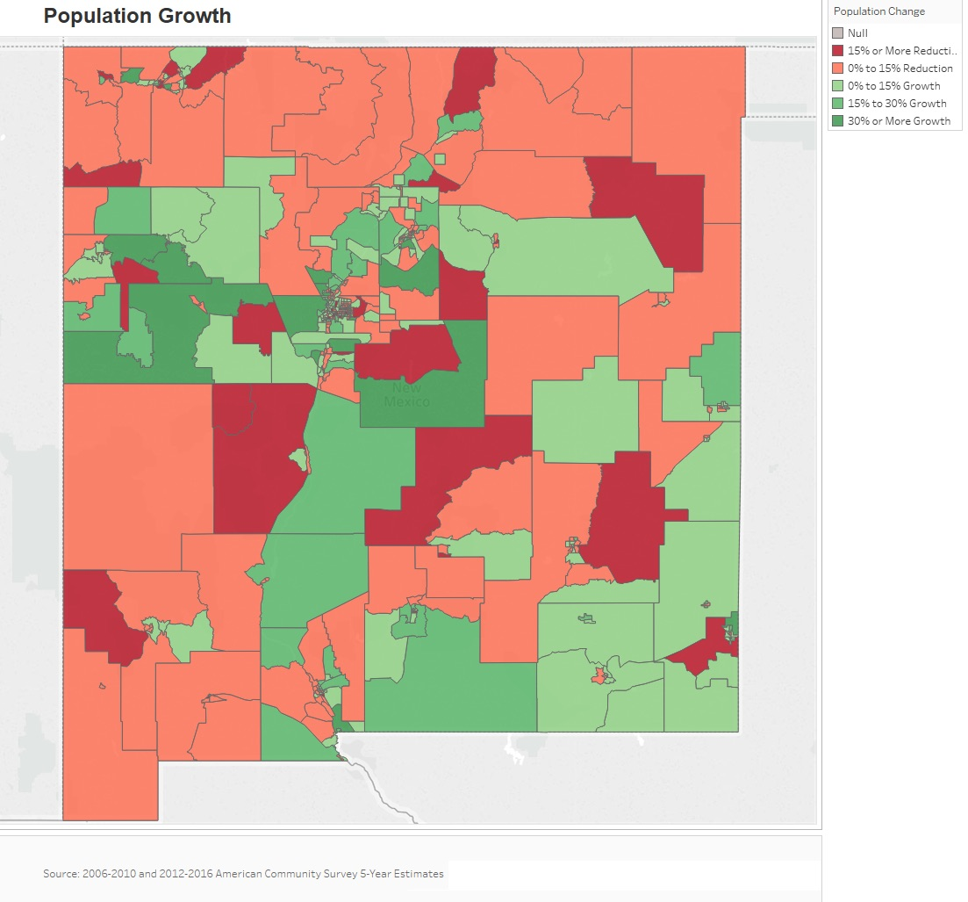
Median Household Income
The map below displays the median household income by census tract throughout the State. In 2016, the median household income was $45,674 but the income varied considerably throughout the State. In general, census tracts near urban centers and in the southeast have higher incomes than more rural areas.
Source: 2012-2016 American Community Survey 5-Year Estimates
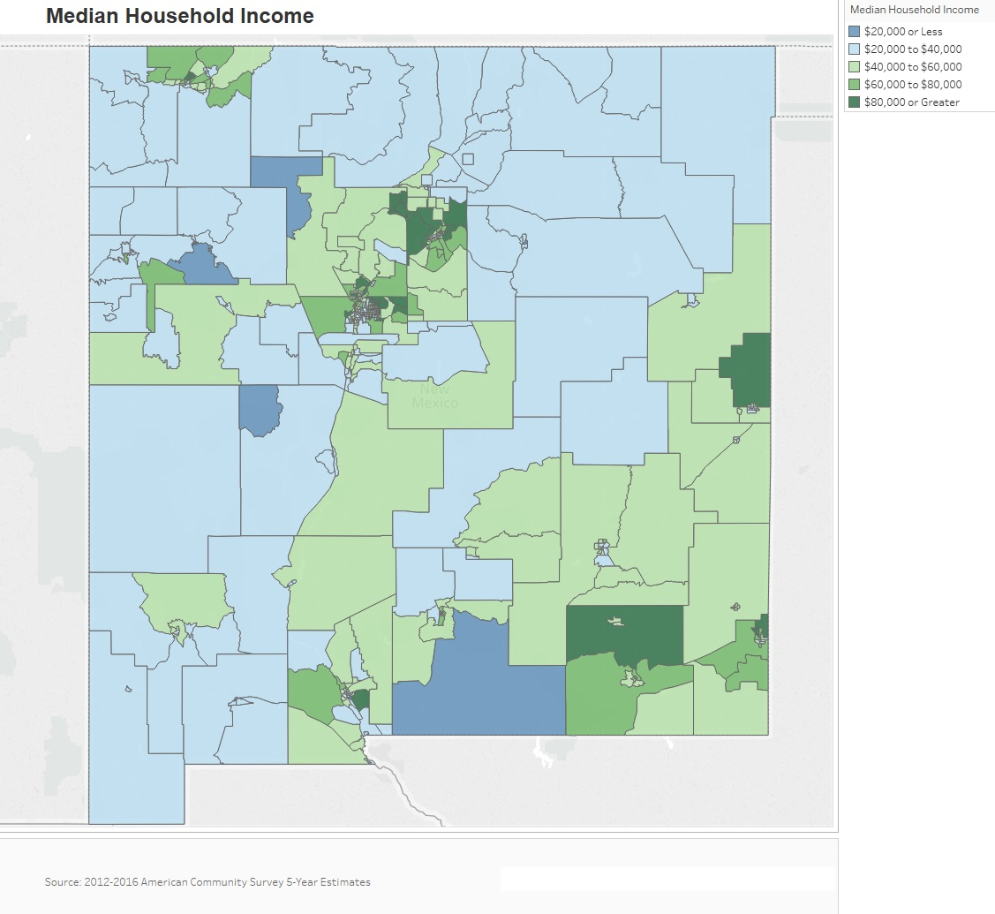

Poverty
The map below displays the percentage of the population who live below the poverty level by census tract. Unsurprisingly, areas that have higher median income tend to have lower levels of poverty. Many urban area census tracts have poverty rates below 10%, while many rural census tracts have 40% or more of their residents who live below the poverty line.
Source: 2012-2016 American Community Survey 5-Year Estimates
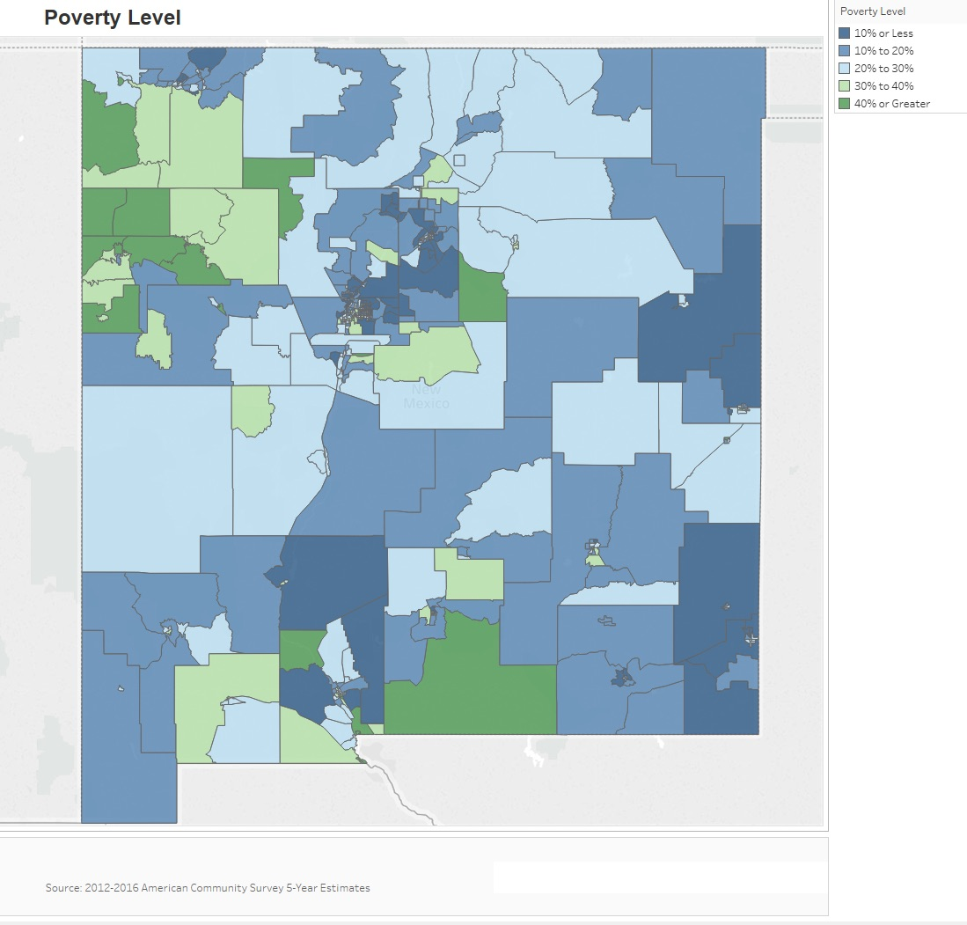
Number of Households Table

Type | 0-30% AMI |  | >30-50% AMI |  | >50-80% AMI |  | >80-100% AMI |  | >100% AMI |  | TOTAL
 | Number | Percent | Number | Percent | Number | Percent | Number | Percent | Number | Percent | Number | Percent
Total Households | 106,205 | 13.9% | 94,935 | 12.4% | 124,295 | 16.3% | 69,995 | 9.2% | 368,180 | 48.2% | 763,610 | 100.0%
Small Family Households | 33,845 | 10.8% | 31,715 | 10.1% | 45,535 | 14.5% | 27,325 | 8.7% | 175,300 | 55.9% | 313,720 | 100.0%
Large Family Households | 8,195 | 12.2% | 8,780 | 13.1% | 11,785 | 17.6% | 7,550 | 11.2% | 30,845 | 45.9% | 67,155 | 100.0%
Household contains at least one person 62-74 years of age | 19,505 | 11.1% | 21,580 | 12.3% | 27,200 | 15.5% | 16,635 | 9.5% | 90,435 | 51.6% | 175,355 | 100.0%
Household contains at least one person age 75 or older | 11,535 | 13.2% | 16,535 | 18.9% | 19,105 | 21.9% | 7,965 | 9.1% | 32,240 | 36.9% | 87,380 | 100.0%
Households with one or more children 6 years old or younger | 19,490 | 16.1% | 17,635 | 14.5% | 22,940 | 18.9% | 12,145 | 10.0% | 49,050 | 40.5% | 121,260 | 100.0%

Table 6 - Total Households Table

Alternate Data Source Name:
2011-2015 CHAS (Comprehensive Housing Affordability Strategy)
Data Source Comments: AMI refers to Area Median Income. In IDIS, this table uses the term HAMFI, or HUD Area Median Family Income, which is equivalent to AMI. Small Family Households are those with 2 to 4 persons. Large Family Households are those with 5 or more persons.

The table above breaks down family dynamics and income in the State using 2011-2015 CHAS data. Small families are much more prevalent, which follows the trend of smaller average household size throughout the nation. There is also a substantial number of households with at least one person over the age of 62.

Housing Needs Summary Tables
1. Housing Problems Table 1 (Households with one of the listed needs)
NUMBER OF HOUSEHOLDS | Renter
 | 0-30% AMI |  | >30-50% AMI |  | >50-80% AMI |  | >80-100% AMI |  | Total
 | Number | Percent | Number | Percent | Number | Percent | Number | Percent | Number | Percent
Substandard Housing - Lacking complete plumbing or kitchen facilities | 1,810 | 44.9% | 750 | 18.6% | 970 | 24.1% | 500 | 12.4% | 4,030 | 100.0%
Severely Overcrowded - With >1.51 people per room (and complete kitchen and plumbing) | 1,445 | 42.5% | 685 | 20.2% | 925 | 27.2% | 345 | 10.1% | 3,400 | 100.0%
Overcrowded - With 1.01-1.5 people per room (and none of the above problems) | 2,450 | 33.4% | 1,735 | 23.7% | 2,115 | 28.9% | 1,025 | 14.0% | 7,325 | 100.0%
Housing cost burden greater than 50% of income (and none of the above problems) | 33,135 | 64.3% | 14,425 | 27.9% | 3,635 | 7.1% | 355 | 0.7% | 51,550 | 100.0%
Housing cost burden greater than 30% of income (and none of the above problems) | 5,305 | 11.9% | 16,190 | 36.4% | 18,500 | 41.6% | 4,515 | 10.1% | 44,510 | 100.0%
Zero/negative Income (and none of the above problems) | 7,590 | 100.0% | 0 | 0.0% | 0 | 0.0% | 0 | 0.0% | 7,590 | 100.0%

NUMBER OF HOUSEHOLDS | Owner
 | 0-30% AMI |  | >30-50% AMI |  | >50-80% AMI |  | >80-100% AMI |  | Total
 | Number | Percent | Number | Percent | Number | Percent | Number | Percent | Number | Percent
Substandard Housing - Lacking complete plumbing or kitchen facilities | 2,775 | 44.3% | 1,470 | 23.4% | 1,480 | 23.6% | 545 | 8.7% | 6,270 | 100.0%
Severely Overcrowded - With >1.51 people per room (and complete kitchen and plumbing) | 365 | 21.2% | 430 | 25.0% | 655 | 38.1% | 270 | 15.7% | 1,720 | 100.0%
Overcrowded - With 1.01-1.5 people per room (and none of the above problems) | 1,535 | 23.6% | 1,755 | 27.0% | 2,260 | 34.8% | 945 | 14.6% | 6,495 | 100.0%
Housing cost burden greater than 50% of income (and none of the above problems) | 20,890 | 45.9% | 13,495 | 29.6% | 8,740 | 19.2% | 2,430 | 5.3% | 45,555 | 100.0%
Housing cost burden greater than 30% of income (and none of the above problems) | 6,320 | 14.5% | 10,740 | 24.6% | 17,195 | 39.4% | 9,400 | 21.5% | 43,655 | 100.0%
Zero/negative Income (and none of the above problems) | 6,930 | 100.0% | 0 | 0.0% | 0 | 0.0% | 0 | 0.0% | 6,930 | 100.0%
Table 7 – Housing Problems Table

Alternate Data Source Name:
2011-2015 CHAS

Data Source Comments: AMI refers to area median income. The Percent columns were added for public readability and will not be submitted to HUD through the IDIS system.

Housing Needs Summary
The table above gives an overview of housing problems in the State. Using 2011-2015 CHAS data, it provides the numbers of households experiencing each category of housing problem broken down by income ranges up to 100% of area median income (AMI) and owner/renter status. For example, looking at the first data cell (top left) we see that 1,810 renter households in the State made 30% AMI or below and lacked complete plumbing or kitchen facilities.
Cost burden is clearly the biggest housing problem in the State in terms of sheer numbers – a common trend in many communities across the nation today. According to the 2015 CHAS data there were 96,060 renters and 89,210 homeowners in the 0% to 100% AMI range spending more than 30% of their income on housing costs. The bigger picture is actually worse, however, because these figures do not include households that earn more than 100% of AMI – a distinction that will be further discussed in the cost burden section below.

2. Housing Problems Table 2 (Households with one or more Severe Housing Problems: Lacks kitchen or complete plumbing, severe overcrowding, severe cost burden)
NUMBER OF HOUSEHOLDS | Renter
 | 0-30% AMI |  | >30-50% AMI |  | >50-80% AMI |  | >80-100% AMI |  | Total
 | Number | Percent | Number | Percent | Number | Percent | Number | Percent | Number | Percent
Having 1 or more of four housing problems | 44,145 | 39.8% | 33,780 | 30.5% | 26,145 | 23.6% | 6,745 | 6.1% | 110,815 | 100.0%
Having none of four housing problems | 7,590 | 13.8% | 9,050 | 16.5% | 21,805 | 39.7% | 16,515 | 30.0% | 54,960 | 100.0%
Household has negative income, but none of the other housing problems | 7,590 | 100.0% | 0 | 0.0% | 0 | 0.0% | 0 | 0.0% | 7,590 | 100.0%

NUMBER OF HOUSEHOLDS | Owner
 | 0-30% AMI |  | >30-50% AMI |  | >50-80% AMI |  | >80-100% AMI |  | Total
 | Number | Percent | Number | Percent | Number | Percent | Number | Percent | Number | Percent
Having 1 or more of four housing problems | 31,890 | 30.8% | 27,890 | 26.9% | 30,330 | 29.2% | 13,595 | 13.1% | 103,705 | 100.0%
Having none of four housing problems | 8,060 | 7.2% | 24,215 | 21.7% | 46,010 | 41.3% | 33,140 | 29.8% | 111,425 | 100.0%
Household has negative income, but none of the other housing problems | 6,930 | 100.0% | 0 | 0.0% | 0 | 0.0% | 0 | 0.0% | 6,930 | 100.0%
Table 8 – Housing Problems 2
Alternate Data Source Name:
2011-2015 CHAS

Data Source Comments: The Percent columns were added for public readability and will not be submitted to HUD through the IDIS system.

Severe Housing Problems
The table above shows households with at least one severe housing problem broken out by income and occupancy. The trend in the data is simply the lower the income in a household, the greater presence of severe housing problems.
3. Cost Burden > 30%
NUMBER OF HOUSEHOLDS | Renter
 | 0-30% AMI |  | >30-50% AMI |  | >50-80% AMI |  | Total
 | Number | Percent | Number | Percent | Number | Percent | Number | Number
Small Related | 18,565 | 45.8% | 12,900 | 31.8% | 9,060 | 22.4% | 40,525 | 100.0%
Large Related | 4,335 | 49.9% | 2,940 | 33.8% | 1,415 | 16.3% | 8,690 | 100.0%
Elderly | 6,105 | 42.6% | 5,375 | 37.5% | 2,855 | 19.9% | 14,335 | 100.0%
Other | 20,940 | 51.8% | 10,810 | 26.7% | 8,690 | 21.5% | 40,440 | 100.0%
Total need by income | 49,945 | 48.0% | 32,025 | 30.8% | 22,020 | 21.2% | 103,990 | 100.0%

NUMBER OF HOUSEHOLDS | Owner
 | 0-30% AMI |  | >30-50% AMI |  | >50-80% AMI |  | >Total
 | Number | Percent | Number | Percent | Number | Percent | Number | Percent
Small Related | 10,335 | 34.3% | 8,860 | 29.4% | 10,970 | 36.3% | 30,165 | 100.0%
Large Related | 2,620 | 36.5% | 2,285 | 31.8% | 2,280 | 31.7% | 7,185 | 100.0%
Elderly | 10,185 | 47.9% | 6,580 | 30.9% | 4,515 | 21.2% | 21,280 | 100.0%
Other | 9,985 | 51.8% | 4,085 | 21.2% | 5,205 | 27.0% | 19,275 | 100.0%
Total need by income | 33,125 | 42.5% | 21,810 | 28.0% | 22,970 | 29.5% | 77,905 | 100.0%
Table 9 – Cost Burden > 30%

Alternate Data Source Name:
2011-2015 CHAS

Data Source Comments: Small Related refers to a household of 2 to 4 persons that includes at least one person related to the householder. Large Related refers to a household of 5 or more persons that includes at least one person related to the householder. Other refers to a household of one or more persons that does not meet the definition of a Small Related household, Large Related household or Elderly household. The Percent columns were added for public readability and will not be submitted to HUD through the IDIS system

Cost Burden
The table above displays 2015 CHAS data on cost-burdened households in the State for the 0% to 80% AMI cohorts. HUD defines cost-burden as paying more than 30% monthly income on housing costs.

Housing Cost-Burdened
The map below displays the percentage of the population who is cost-burdened by census tract using data from the 2012-2016 American Community Survey 5-Year Estimates. Despite higher median household incomes in the State, there are still high rates of cost burden, sometimes over 25%. There is greater cost burden in urban area census tracts, despite the higher incomes and lower poverty rates.
Source: 2012-2016 American Community Survey 5-Year Estimates
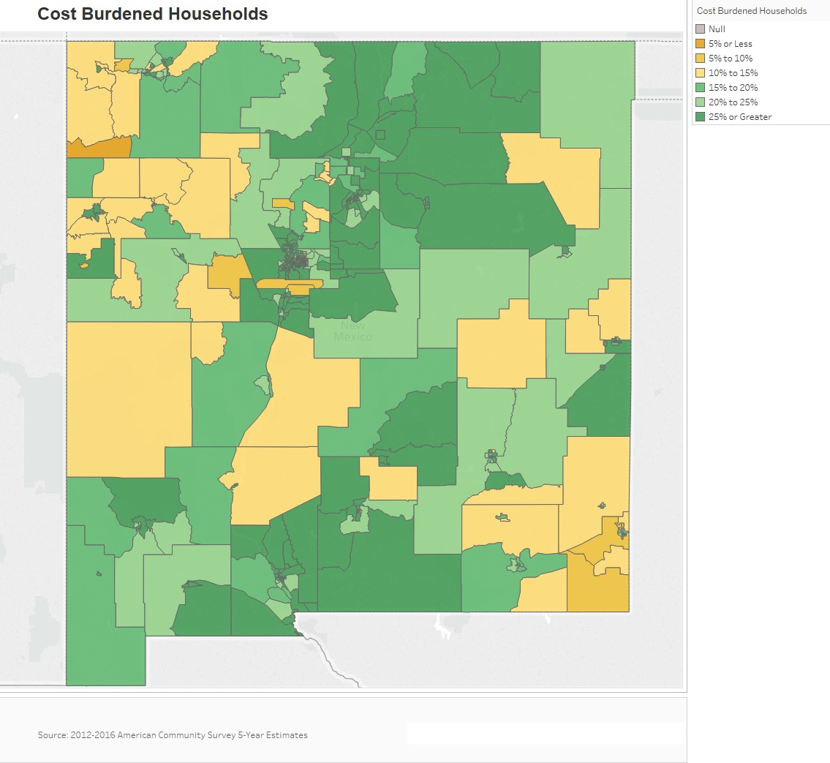
4. Cost Burden > 50%
NUMBER OF HOUSEHOLDS | Renter
 | 0-30% AMI |  | >30-50% AMI |  | >50-80% AMI |  | Total
 | Number | Percent | Number | Percent | Number | Percent | Number | Percent
Small Related | 14,135 | 68.5% | 5,495 | 26.6% | 1,000 | 0.4% | 20,630 | 100.0%
Large Related | 2,875 | 70.0% | 1,170 | 28.5% | 60 | 1.5% | 4,105 | 100.0%
Elderly | 4,535 | 51.1% | 3,330 | 37.5% | 1,015 | 11.4% | 8,880 | 100.0%
Other | 14,870 | 68.4% | 5,080 | 23.4% | 1,785 | 8.2% | 21,735 | 100.0%
Total need by income | 36,415 | 65.8% | 15,075 | 27.2% | 3,860 | 7.0% | 55,350 | 100.0%

NUMBER OF HOUSEHOLDS | Owner
 | 0-30% AMI |  | >30-50% AMI |  | >50-80% AMI |  | Total
 | Number | Percent | Number | Percent | Number | Percent |  | Number | Percent
Small Related | 6,715 | 43.4% | 5,380 | 34.8% | 3,370 | 21.8% |  | 15,465 | 100.0%
Large Related | 1,825 | 52.1% | 1,275 | 36.4% | 405 | 11.5% |  | 3,505 | 100.0%
Elderly | 8,400 | 52.5% | 4,620 | 28.9% | 2,990 | 18.6% |  | 16,010 | 100.0%
Other | 5,445 | 53.4% | 2,625 | 25.7% | 2,130 | 20.9% |  | 10,200 | 100.0%
Total need by income | 22,385 | 49.5% | 13,900 | 30.8% | 8,895 | 19.7% |  | 45,180 | 100.0%
Table 10 – Cost Burden > 50%

Alternate Data Source Name:
2011-2015 CHAS

Data Source Comments: Small Related refers to a household of 2 to 4 persons that includes at least one person related to the householder. Large Related refers to a household of 5 or more persons that includes at least one person related to the householder. Other refers to a household of one or more persons that does not meet the definition of a Small Related household, Large Related household or Elderly household. The Percent columns were added for public readability and will not be submitted to HUD through the IDIS system
Severe Cost Burden
The data presented above show the severe cost burden in the State, which is defined as paying more than 50% of household income on housing cost.

5. Crowding (More than one person per room)
NUMBER OF HOUSEHOLDS | Renter
 | 0-30% AMI |  | >30-50% AMI |  | >50-80% AMI |  | >80-100% AMI |  | Total
 | Number | Percent | Number | Percent | Number | Percent | Number | Percent | Number | Percent
Single family households | 3,540 | 38.9% | 2,000 | 22.0% | 2,440 | 26.9% | 1,105 | 12.2% | 9,085 | 100.0%
Multiple, unrelated family households | 250 | 18.2% | 335 | 24.4% | 520 | 37.8% | 270 | 19.6% | 1,375 | 100.0%
Other, non-family households | 185 | 39.4% | 120 | 25.5% | 120 | 25.5% | 45 | 9.6% | 470 | 100.0%
Total need by income | 3,975 | 36.4% | 2,455 | 22.5% | 3,080 | 28.2% | 1,420 | 12.9% | 10,930 | 100.0%

NUMBER OF HOUSEHOLDS | Owner
 | 0-30% AMI |  | >30-50% AMI |  | >50-80% AMI |  | >80-100% AMI |  | Total
 | Number | Percent | Number | Percent | Number | Percent | Number | Percent | Number | Percent
Single family households | 1,660 | 26.5% | 1,790 | 28.5% | 2,030 | 32.4% | 790 | 12.6% | 6,270 | 100.0%
Multiple, unrelated family households | 585 | 21.2% | 560 | 20.3% | 1,155 | 41.8% | 460 | 16.7% | 2,760 | 100.0%
Other, non-family households | 29 | 34.5% | 10 | 11.9% | 35 | 41.7% | 10 | 11.9% | 84 | 100.0%
Total need by income | 2,274 | 25.0% | 2,360 | 25.9% | 3,220 | 35.3% | 1,260 | 13.8% | 9,114 | 100.0%
Table 11 – Crowding Information – Table 1/2

Alternate Data Source Name:
2011-2015 CHAS

Data Source Comments: The Percent columns were added for public readability and will not be submitted to HUD through the IDIS system.

Overcrowding
HUD defines an overcrowded household as one having from 1.01 to 1.50 occupants per room and a severely overcrowded household as one with more than 1.50 occupants per room. This type of condition can be seen in both renter and homeowner households. Overcrowding was more prevalent in renter-occupied housing units than in owner-occupied units.
Data was unavailable for Table 12.
 | Renter |  |  |  | Owner
 | 0-30% AMI | >30-50% AMI | >50-80% AMI | Total | 0-30% AMI | >30-50% AMI | >50-80% AMI | Total
Households with Children Present | N/A | N/A | N/A | N/A | N/A | N/A | N/A | N/A
Table 12 – Crowding Information – Table 2/2

Describe the number and type of single person households in need of housing assistance.
According to the 2012-2016 American Community Survey 5-Year Estimates, 29.8% of all occupied housing units in New Mexico (approximately 225,000 households) are single-person households. Over 37% of renters are single-person households, a rate that is significantly higher than owners at 26.3%. As single-person households are more likely to be renters, it is important to note that they are also more likely to be cost-burdened.
Elderly
An added concern is single-person households that are elderly. This population generally has a fixed income and reduced access to transportation or other resources. In New Mexico, 38% of single-person households are elderly, or 87,441 households.
Estimate the number and type of families in need of housing assistance who are disabled or victims of domestic violence, dating violence, sexual assault and stalking.
Persons with Disabilities
Disability is defined by the Census Bureau as a lasting physical, mental or emotional condition that makes it difficult for a person to do activities, to go outside the home alone or to work. By this definition, 338,430 (20.4%) New Mexico residents were considered to be living with some form of disability in 2000. This figure was only slightly higher than the national average for that time of approximately 19.3%.
By 2016, an estimated 14.9% of State residents were living with some form of disability. Disability rates tended to be slightly higher for male residents than for female residents, and significantly higher for elderly residents than for younger residents. Over half (56%) of residents over the age of 75 had a disability. Residents with a disability only had median earnings of $19,787, significantly less than those without a disability - $27,222. As discussed earlier, households with lower incomes have a higher probability of also experiencing housing cost burden and as a result would need housing assistance.

Victims of Domestic Violence
Pinpointing a specific number of victims of domestic violence can be difficult because many cases go unreported. In 2017 (the most recent year with analyzed data), there were 19,234 domestic violence incidents reported to law enforcement agencies statewide, a 3% decrease from the previous year. Of the reported incidents, 71% of the domestic violence victims were female. Black survivors (5%) and Native American survivors (13%) were disproportionately represented among victims compared to their proportion of population in the State (2.5% and 10.9%, respectively). There were 28 domestic violence service providers that submitted data to the Central Repository for the 2017 Incidence and Nature of Domestic Violence In New Mexico XVII data analysis report. These service providers served 10,413 new clients during 2017.
What are the most common housing problems?
Like many communities across the nation, affordability is the largest housing problem in the State. In New Mexico, 31.7% of homeowners with a mortgage, 11.3% of homeowners without a mortgage, and 50% of renters are cost-burdened.
Are any populations/household types more affected than others by these problems?
The 2015 CHAS data, while yielding different totals than the recent data from the Census Bureau, provide a more nuanced view into which segments of the population experience housing problems. In general, lower income households experience more housing problems across the board. The extremely low-income income range (30% AMI and below) is statistically more likely to have at least one problem than other income ranges, and extremely low-income renters more so than owners. When those facts intersect, we see that low and extremely low-income renters are more affected by housing problems than other groups.
Describe the characteristics and needs of low-income individuals and families with children (especially extremely low-income) who are currently housed but are at imminent risk of either residing in shelters or becoming unsheltered 91.205(c)/91.305(c)). Also discuss the needs of formerly homeless families and individuals who are receiving rapid re-housing assistance and are nearing the termination of that assistance
The above 2015 CHAS data in Housing Needs Summary Tables paints a potentially bleak picture for many households due to the lack of affordable housing. Extremely low-income households, in particular, are at risk of facing homelessness. For extremely low-income households, there are 20,890 homeowner households with severe housing cost burden greater than 50% and 33,135 renter households with severe housing cost burden greater than 50%. That means there are over 50,000 households in the State that are both extremely low income and have severe housing cost burden, which places them at imminent risk of becoming homeless.
Formerly homeless families and individuals nearing the termination of their rapid re-housing assistance are in need of permanent affordable housing options, job training to enable them to obtain higher-paying employment, and, in the case of families, child care to enable them to work outside the home.
If a jurisdiction provides estimates of the at-risk population(s), it should also include a description of the operational definition of the at-risk group and the methodology used to generate the estimates:
The at-risk population is defined as extremely low-income households, or those earning at or below 30% of the area median income, that are extremely cost-burdened, and the estimates presented above were generated from 2015 CHAS data.
Specify particular housing characteristics that have been linked with instability and an increased risk of homelessness
The cost of available housing relative to household income is a primary contributor to housing instability and to an increased risk of homelessness. In addition, inadequate housing maintenance resulting in housing code violations or findings of inhabitable living conditions in rental properties increase the risk of homelessness. Among elderly persons and persons with disabilities, lack of accessibility features can force both homeowners and renters out of their living situations.
- The following populations are particularly susceptible to housing instability caused by the above characteristics:Extremely low-income households
- Persons with disabilities
- Persons fleeing domestic violence
- Persons discharged from crisis units, hospitals and/or jails
- LGBTQIA youth
- Youth aging out of foster care
- Persons experiencing unexpected crises such as unemployment or illness
- Persons experiencing behavioral health issues
Discussion
Digital Divide
Internet is an essential communications and information platform that allows users to take advantage of the increased interconnectedness of business, education, commerce and day to day utility. Reliable access to the internet is becoming a necessity to thrive in the modern economic environment. Communities that lack broadband access struggle to keep pace with the country. Communities without broadband access are impeded in their ability to take advantage of the educational and entrepreneurial opportunities available online. This is particularly problematic for low- to moderate-income (LMI) areas where economic opportunities are already often lacking.
Some of the areas that lack broadband in the State also overlap with LMI areas, areas with high proportions of cost-burdened households and high poverty areas. The areas that lack broadband internet are primarily rural, which are sometimes LMI areas but not always. As technology advances and production becomes cheaper it will be increasingly possible to provide broadband internet throughout the State.
Broadband access throughout the State is shown below in Digital Divide Map – Broadband Internet Access. Broadband access is defined as advertised internet speeds of 768 kilobits per second or higher.
Once broadband access has been obtained, it is important to ensure there is competition among service providers. Any resource that has a de facto monopoly on an area may not be incentivized to provide standard and consistent services. The second map in this section shows the number of broadband service providers by census tract. Most of the urban areas in the State have at least two options; however, rural tracts with lower populations generally have access to only one provider. Very few of these rural areas have more than two providers. See Digital Divide Map – Providers.
Broadband Internet Service Providers
The State of New Mexico has 24 internet providers offering residential service throughout the State, though not within the same coverage area. CenturyLink, XFINITY from Comcast and AT&T Internet are the strongest providers so far as coverage. These providers frequently overlap around the State.
Prominent Residential providers in the State include:
- Century Link (DSL and Fiber)
- AT&T Internet (DSL and Fiber)
- XFINITY from Comcast (Cable)
- Frontier (DSL)
- Spectrum (Cable)
- Cable One (Cable)
- Windstream (DSL)
- Viasat (Satellite)

Digital Divide Map – Broadband Internet Access
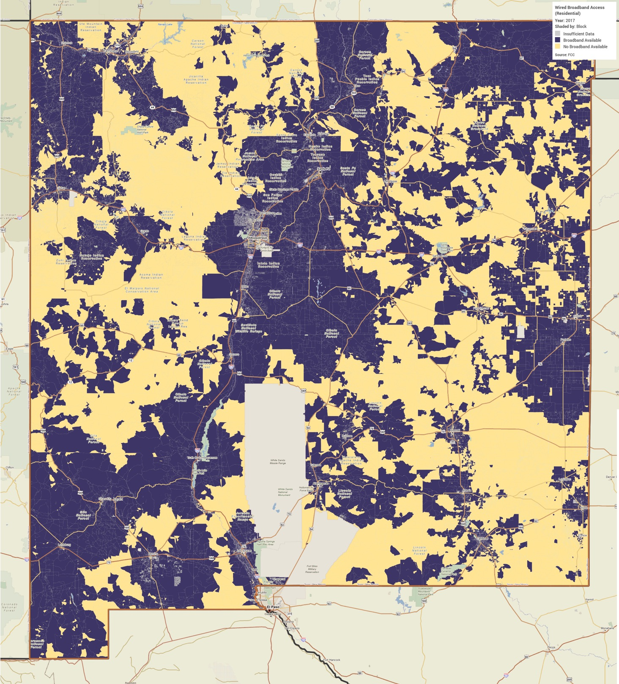

Digital Divide Map – Providers
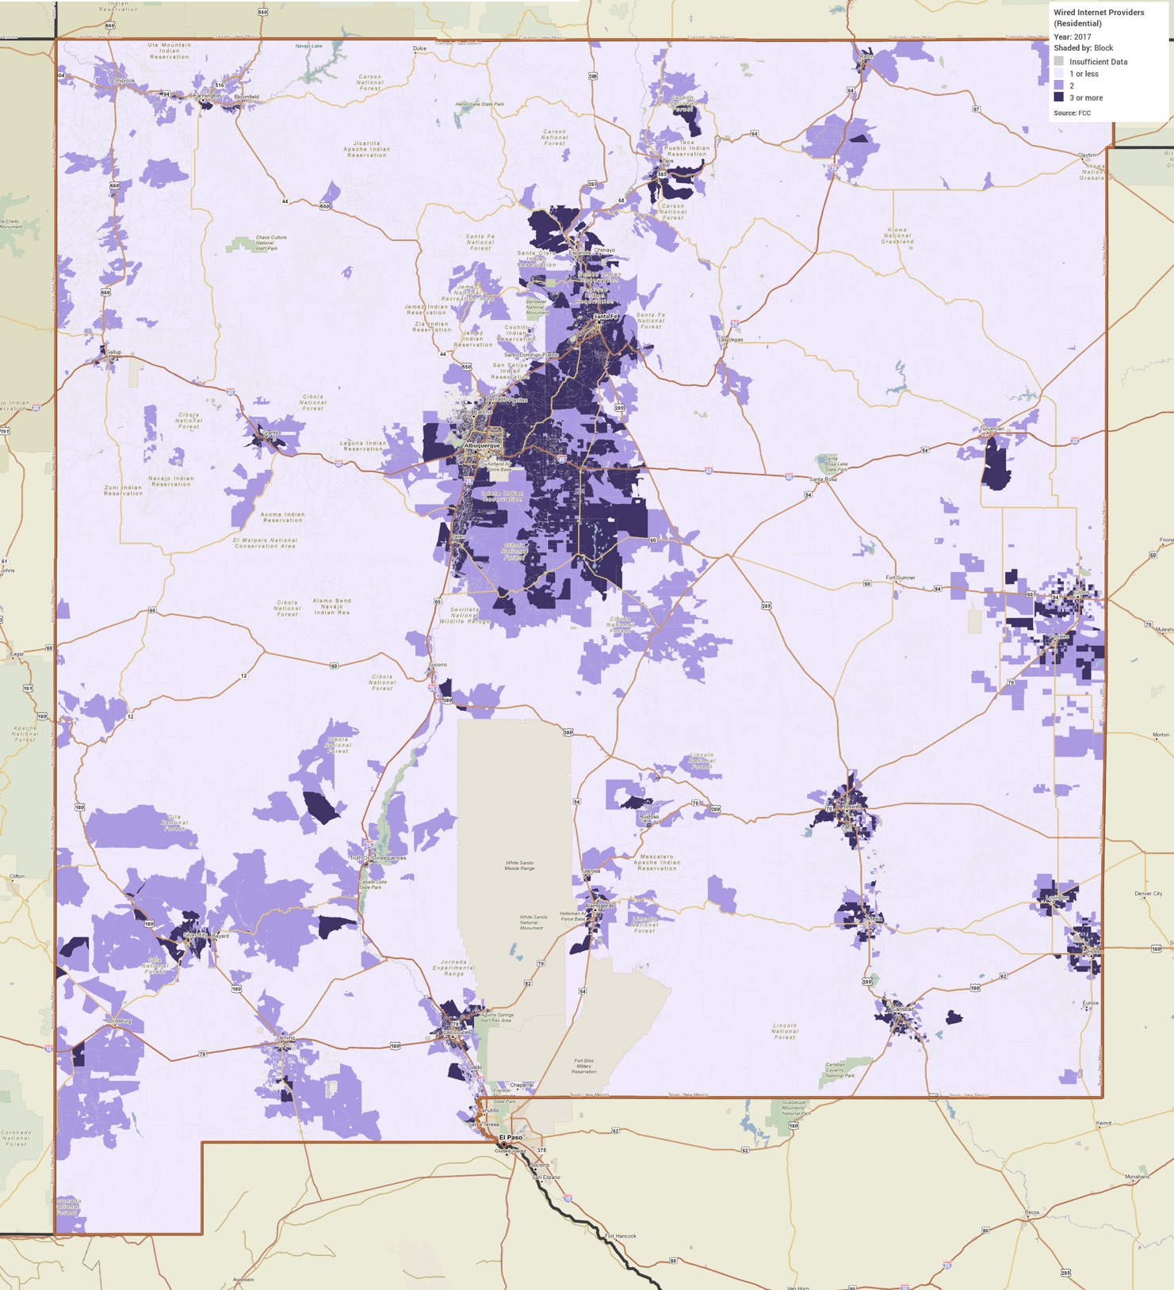

NA-15 Disproportionately Greater Need: Housing Problems - 91.305 (b)(2)
Assess the need of any racial or ethnic group that has disproportionately greater need in comparison to the needs of that category of need as a whole.
Introduction
This section compares the existence of housing problems amongst racial groups against that of the State as a whole in an effort to see if any group(s) share a disproportionate burden of the area's housing problems. For this purpose, HUD guidelines deem a disproportionately greater need to exist when persons of a particular racial or ethnic group experience housing problems at a rate at least 10 percentage points higher than the State as a whole.
As noted in this plan, cost burden (a household spending more than 30 percent of its income on housing costs) is the largest housing problem in the State. The following series of tables looks at the existence of housing problems amongst different racial and ethnic groups across the 0%-30%, 30%-50%, 50%-80%, and 80%-100% AMI cohorts.
0%-30% of Area Median Income
Housing Problems | Has one or more of four housing problems | Has none of the four housing problems | Household has no/negative income, but none of the other housing problems | Percent w/ one or more of four housing problems
State as a whole | 76,035 | 15,650 | 14,520 | 71.59%
White | 25,340 | 4,735 | 5,325 | 71.58%
Black / African American | 2,030 | 355 | 445 | 71.73%
Asian | 710 | 85 | 160 | 74.35%
American Indian, Alaska Native | 7,905 | 2,560 | 2,010 | 63.37%
Pacific Islander | 20 | 30 | 0 | 40.00%
Hispanic | 38,620 | 7,760 | 6,320 | 73.28%
Other | 1,415 | 125 | 260 | 78.61%
Table 13 - Disproportionally Greater Need 0 - 30% AMI

Alternate Data Source Name: 2011-2015 CHAS

Data Source Comments: The Percent column was added for public readability and will not be submitted to HUD through the IDIS system

*The four housing problems are:
1. Lacks complete kitchen facilities, 2. Lacks complete plumbing facilities, 3. More than one person per room, and 4. Cost burden greater than 30%.

30%-50% of Area Median Income
Housing Problems | Has one or more of four housing problems | Has none of the four housing problems | Household has no/negative income, but none of the other housing problems | Percent w/ one or more of four housing problems
State as a whole | 61,670 | 33,265 | N/A | 64.96%
White | 24,480 | 12,030 | N/A | 67.05%
Black / African American | 1,710 | 400 | N/A | 81.04%
Asian | 550 | 120 | N/A | 82.09%
American Indian, Alaska Native | 3,860 | 2,940 | N/A | 56.76%
Pacific Islander | 14 | 15 | N/A | 48.28%
Hispanic | 30,250 | 17,500 | N/A | 63.35%
Other | 815 | 255 | N/A | 76.17%
Table 14 - Disproportionally Greater Need 30 - 50% AMI

Alternate Data Source Name: 2011-2015 CHAS

Data Source Comments: There is no data available for column titled Household has no/negative income, but none of the other housing problems. The Percent column was added for public readability and will not be submitted to HUD through the IDIS system.

*The four housing problems are:
1. Lacks complete kitchen facilities, 2. Lacks complete plumbing facilities, 3. More than one person per room, and 4. Cost burden greater than 30%.

50%-80% of Area Median Income
Housing Problems | Has one or more of four housing problems | Has none of the four housing problems | Household has no/negative income, but none of the other housing problems | Percent w/ one or more of four housing problems
State as a whole | 56,475 | 67,815 | N/A | 45.44%
White | 24,070 | 28,150 | N/A | 46.09%
Black / African American | 1,080 | 795 | N/A | 57.60%
Asian | 725 | 515 | N/A | 58.47%
American Indian, Alaska Native | 3,410 | 5,175 | N/A | 39.72%
Pacific Islander | 19 | 20 | N/A | 48.72%
Hispanic | 26,120 | 32,300 | N/A | 44.71%
Other | 1,045 | 855 | N/A | 55.00%
Table 15 - Disproportionally Greater Need 50 - 80% AMI

Alternate Data Source Name: 2011-2015 CHAS

Data Source Comments: There is no data available for column titled Household has no/negative income, but none of the other housing problems. The Percent column was added for public readability and will not be submitted to HUD through the IDIS system..

*The four housing problems are:
1. Lacks complete kitchen facilities, 2. Lacks complete plumbing facilities, 3. More than one person per room, and 4. Cost burden greater than 30%.
80%-100% of Area Median Income
Housing Problems | Has one or more of four housing problems | Has none of the four housing problems | Household has no/negative income, but none of the other housing problems | Percent w/ one or more of four housing problems
State as a whole | 20,340 | 49,655 | N/A | 29.06%
White | 9,965 | 22,090 | N/A | 30.09%
Black / African American | 320 | 930 | N/A | 25.60%
Asian | 320 | 445 | N/A | 41.83%
American Indian, Alaska Native | 1,240 | 3,380 | N/A | 26.84%
Pacific Islander | 0 | 10 | N/A | 0.00%
Hispanic | 8,295 | 22,150 | N/A | 27.25%
Other | 200 | 655 | N/A | 23.39%
Table 16 - Disproportionally Greater Need 80 - 100% AMI

Alternate Data Source Name: 2011-2015 CHAS

Data Source Comments: There is no data available for column titled Household has no/negative income, but none of the other housing problems. The Percent column was added for public readability and will not be submitted to HUD through the IDIS system.

*The four housing problems are:
1. Lacks complete kitchen facilities, 2. Lacks complete plumbing facilities, 3. More than one person per room, and 4. Cost burden greater than 30%.
Discussion
By HUD’s definition of a disparity of 10% or higher, several different racial and ethnic groups experience a disproportionately greater need when it comes to housing problems.

0-30% AMI
No racial or ethnic groups had a disproportionately greater need with regards to housing problems for this income group.
30-50% AMI
There are three racial groups with a rate of housing problems at least 10% greater than the statewide rate of 64.96%:
- Black or African American – 81.04%
- Asian – 82.09%
- Other – 76.17%
Data Note: During the census process individuals and households may identify their race as “other” if they do not identify with the choices provided by the Census.
50-80% AMI
There are two racial groups with a rate of housing problems at least 10% greater than the statewide rate of 45.44%:
- Black or African American – 57.60%
- Asian – 58.47%
80-100% AMI
There is one racial group with a rate of housing problems at least 10% greater than the statewide rate of 29.06%
- Asian – 41.83%
Conclusion
The prevalence of housing problems decreases as income increases. There are two racial groups that stand out as having disproportionate housing needs, Black/African American and Asian households. The former had a disproportionate housing need in two income groups and the latter in three income groups.

NA-20 Disproportionately Greater Need: Severe Housing Problems – 91.305(b)(2)
Assess the need of any racial or ethnic group that has disproportionately greater need in comparison to the needs of that category of need as a whole.
Introduction
This section compares the existence of severe housing problems amongst racial groups against that of the State as a whole in an effort to see if any group(s) share a disproportionate burden of the area's severe housing problems. For this purpose, HUD guidelines deem a disproportionately greater need to exist when persons of a particular racial or ethnic group experience severe housing problems at a rate at least 10 percentage points higher than the State as a whole.
The following series of tables looks at the existence of severe housing problems amongst different racial and ethnic groups across the 0%-30%, 30%-50%, 50%-80%, and 80%-100% AMI cohorts.
0%-30% of Area Median Income
Severe Housing Problems* | Has one or more of four housing problems | Has none of the four housing problems | Household has no/negative income, but none of the other housing problems | Percent w/ one or more of four housing problems
State as a whole | 64,410 | 27,275 | 14,520 | 60.65%
White | 21,900 | 8,175 | 5,325 | 57.25%
Black / African American | 1,830 | 555 | 445 | 64.66%
Asian | 680 | 110 | 160 | 71.58%
American Indian, Alaska Native | 6,630 | 3,835 | 2,010 | 53.15%
Pacific Islander | 20 | 30 | 0 | 40.00%
Hispanic | 32,100 | 14,280 | 6,320 | 60.91%
Other | 1,250 | 285 | 260 | 69.63%
Table 17 – Severe Housing Problems 0 - 30% AMI

Alternate Data Source Name: 2011-2015 CHAS

Data Source Comments: The Percent column was added for public readability and will not be submitted to HUD through the IDIS system.

*The four severe housing problems are:
1. Lacks complete kitchen facilities, 2. Lacks complete plumbing facilities, 3. More than 1.5 persons per room, and 4. Cost Burden over 50%

30%-50% of Area Median Income
Severe Housing Problems* | Has one or more of four housing problems | Has none of the four housing problems | Household has no/negative income, but none of the other housing problems | Percent w/ one or more of four housing problems
State as a whole | 34,740 | 60,190 | N/A | 36.60%
White | 14,015 | 22,495 | N/A | 38.39%
Black / African American | 805 | 1,305 | N/A | 38.15%
Asian | 225 | 440 | N/A | 33.83%
American Indian, Alaska Native | 2,415 | 4,385 | N/A | 35.51%
Pacific Islander | 10 | 20 | N/A | 33.33%
Hispanic | 16,850 | 30,905 | N/A | 35.28%
Other | 430 | 640 | N/A | 40.19%
Table 18 – Severe Housing Problems 30 - 50% AMI

Alternate Data Source Name: 2011-2015 CHAS

Data Source Comments: There is no data available for the column titled Household has no/negative income, but none of the other housing problems. The Percent column was added for public readability and will not be submitted to HUD through the IDIS system.

*The four severe housing problems are:
1. Lacks complete kitchen facilities, 2. Lacks complete plumbing facilities, 3. More than 1.5 persons per room, and 4. Cost Burden over 50%

50%-80% of Area Median Income
Severe Housing Problems* | Has one or more of four housing problems | Has none of the four housing problems | Household has no/negative income, but none of the other housing problems | Percent w/ one or more of four housing problems
State as a whole | 20,780 | 103,515 | N/A | 16.72%
White | 8,150 | 44,065 | N/A | 15.61%
Black / African American | 495 | 1,385 | N/A | 26.33%
Asian | 350 | 895 | N/A | 28.11%
American Indian, Alaska Native | 2,140 | 6,445 | N/A | 24.93%
Pacific Islander | 0 | 44 | N/A | 0.00%
Hispanic | 9,420 | 49,000 | N/A | 16.12%
Other | 225 | 1,680 | N/A | 11.81%
Table 19 – Severe Housing Problems 50 – 80% AMI

Alternate Data Source Name: 2011-2015 CHAS
Data Source Comments: There is no data available for the column titled Household has no/negative income, but none of the other housing problems. The Percent column was added for public readability and will not be submitted to HUD through the IDIS system..

*The four severe housing problems are:
1. Lacks complete kitchen facilities, 2. Lacks complete plumbing facilities, 3. More than 1.5 persons per room, and 4. Cost Burden over 50%

80%-100% of Area Median Income
Severe Housing Problems* | Has one or more of four housing problems | Has none of the four housing problems | Household has no/negative income, but none of the other housing problems | Percent w/ one or more of four housing problems
State as a whole | 6,425 | 63,570 | N/A | 9.18%
White | 2,680 | 29,370 | N/A | 8.36%
Black / African American | 125 | 1,120 | N/A | 10.04%
Asian | 175 | 590 | N/A | 22.88%
American Indian, Alaska Native | 835 | 3,785 | N/A | 18.07%
Pacific Islander | 0 | 10 | N/A | 0.00%
Hispanic | 2,535 | 27,910 | N/A | 8.33%
Other | 70 | 780 | N/A | 8.24%
Table 20 – Severe Housing Problems 80 - 100% AMI

Alternate Data Source Name: 2011-2015 CHAS

Data Source Comments: There is no data available for the column titled Household has no/negative income, but none of the other housing problems. The Percent column was added for public readability and will not be submitted to HUD through the IDIS system..

*The four severe housing problems are:
1. Lacks complete kitchen facilities, 2. Lacks complete plumbing facilities, 3. More than 1.5 persons per room, and 4. Cost Burden over 50%

Discussion
By HUD’s definition of a disparity of 10% or higher, several different racial and ethnic groups experience a disproportionately greater need when it comes to severe housing problems.
0-30% AMI
There is one racial group with a rate of severe housing problems at least 10% greater than the statewide rate of 60.65%.
- Asian – 71.58%

30-50% AMI
- There are no racial or ethnic groups with disproportionately greater need when it comes to severe housing problems.
50-80% AMI
There is one racial group with a rate of severe housing problems at least 10% greater than the statewide rate of 16.72%.
- Asian – 28.11%
80-100% AMI
There is one racial group with a rate of severe housing problems at least 10% greater than the statewide rate of 9.18%.
- Asian – 22.88%
Conclusion
The prevalence of severe housing problems decreases as income increases. There is one racial group that stands out as having disproportionate severe housing needs, Asian households. Asian households showed a disproportionate need in three income groups. It should be noted that the Asian population is relatively small and there may be a significant margin of error in the CHAS provided estimates.

NA-25 Disproportionately Greater Need: Housing Cost Burdens – 91.305 (b)(2)
Assess the need of any racial or ethnic group that has disproportionately greater need in comparison to the needs of that category of need as a whole.
Introduction
This section compares the existence of housing cost burden and severe cost burden amongst racial and ethnic groups against that of the State as a whole in an effort to see if any group(s) share a disproportionate burden of the area's cost burden. For this purpose, HUD guidelines deem a disproportionately greater need to exist when persons of a particular racial or ethnic group experience housing problems at a rate at least 10 percentage points higher than the State as a whole.
A household is considered to be cost-burdened if they spend between 30% and 50% of monthly income on housing costs, and severely cost-burdened if they spend more than 50% of monthly income on housing costs.
Housing Cost Burden
Housing Cost Burden | <=30% | 30-50% | >50% | No/negative income (not computed)
State as a whole | 519,065 | 113,479 | 104,690 | 15,485
White | 269,820 | 50,930 | 44,950 | 5,585
Black / African American | 8,500 | 2,535 | 2,960 | 450
Asian | 5,990 | 1,295 | 1,275 | 185
American Indian, Alaska Native | 34,345 | 5,330 | 5,390 | 2,675
Pacific Islander | 190 | 54 | 30 | 0
Hispanic | 200,220 | 53,335 | 50,085 | 6,590
Table 21 – Greater Need: Housing Cost Burdens AMI

Alternate Data Source Name: 2011-2015 CHAS

Data Source Comments: The Percent columns were added for public readability and will not be submitted to HUD through the IDIS system.

Discussion
This section calculates the percentage of those who are cost-burdened and severely cost-burdened within each racial or ethnic group in the State, which is different from the above sections, in which housing problems and severe housing problems are calculated by comparing each racial group within its AMI cohort.
There are no disproportionately greater rates of cost burden or severe cost burden in any racial or ethnic group. The statewide cost burden rate is 15.08% and the racial/ethnic groups span from a low of 11.16% (American Indian, Alaska Native) to a high of 19.71% (Pacific Islander). Similarly, the rate of severe cost burden in the State is 13.91% and the racial ethnic groups span from a low of 10.95% (Pacific Islander) and a high of 20.49% (Black or African American).

NA-30 Disproportionately Greater Need: Discussion – 91.305 (b)(2)
Are there any Income categories in which a racial or ethnic group has disproportionately greater need than the needs of that income category as a whole?
Housing Problems
By HUD’s definition of a disparity of 10% or higher, several different racial and ethnic groups experience a disproportionately greater need when it comes to housing problems.
0-30% AMI
There is one racial group with a rate of severe housing problems at least 10% greater than the statewide rate of 60.65%.
- Asian – 71.58%
30-50% AMI
There are three racial groups with a rate of housing problems at least 10% greater than the statewide rate of 64.96%:
- Black or African American – 81.04%
- Asian – 82.09%
- Other – 76.17%
Data Note: During the census process individuals and households may identify their race as “other” if they do not identify with the choices provided by the Census.
50-80% AMI
There are two racial groups with a rate of housing problems at least 10% greater than the statewide rate of 45.44%:
- Black or African American – 57.60%
- Asian – 58.47%
80-100% AMI
There is one racial group with a rate of housing problems at least 10% greater than the jurisdiction wide rate of 29.06%:
- Asian – 41.83%

Conclusion
The prevalence of housing problems decreases as income increases. There are two racial groups that stand out as having disproportionate housing needs, Black/African American and Asian households. The former had a disproportionate housing need in two income groups and the latter in four income groups.
Severe Housing Problems
By HUD’s definition of a disparity of 10% or higher, several different racial and ethnic groups experience a disproportionately greater need when it comes to severe housing problems.
0-30% AMI
- No racial or ethnic groups had a disproportionately greater need with regards to housing problems for this income group
30-50% AMI
- There are no racial or ethnic groups with disproportionately greater need when it comes to severe housing problems.
50-80% AMI
There is one racial group with a rate of severe housing problems at least 10% greater than the statewide rate of 16.72%:
- Asian – 28.11%
80-100% AMI
There is one racial group with a rate of severe housing problems at least 10% greater than the statewide rate of 9.18%:
- Asian – 22.88%
Conclusion
The prevalence of severe housing problems decreases as income increases. There is one racial group, Asian households, that stands out as having disproportionate severe housing needs. Asian households showed a disproportionate need in two income groups. It should be noted that the Asian population is relatively small and there may be a significant margin of error in the CHAS provided estimates.
Cost Burden and Severe Cost Burden
This section calculates the percentage of those who are cost-burdened and severely cost-burdened within each racial or ethnic group in the State, which is different from the above sections, in which housing problems and severe housing problems are calculated by comparing each racial group within its AMI cohort.
There are no disproportionately greater rates of cost burden or severe cost burden in any racial or ethnic group. The statewide cost burden rate is 15.08% and the racial/ethnic groups span a low of 11.16% (American Indian, Alaska Native) to a high of 19.71% (Pacific Islander). Similarly, the rate of severe cost burden in the State is 13.91% and the racial ethnic groups span from a low of 10.95% (Pacific Islander) to a high of 20.49% (Black or African American).
If they have needs not identified above, what are those needs?
No additional needs have been identified
Are any of those racial or ethnic groups located in specific areas or neighborhoods in your community?
The State of New Mexico has several areas, including tribal lands and areas adjacent to tribal lands, with high concentrations of Native American residents. These, and other clusters based on race or ethnicity, are discussed later in this document in the Market Analysis.

NA-35 Public Housing – (Optional)
Introduction
Public housing was established to provide decent and safe rental housing for eligible low- and moderate-income families, the elderly and persons with disabilities. Public housing includes federally subsidized, affordable housing that is owned and operated by the public housing authorities. While public and assisted housing units also comprise a portion of the housing stock located throughout New Mexico, MFA and DFA do not operate public housing and therefore, have not developed a plan related to public housing or public housing initiatives. MFA does provide funding for emergency housing and shelters, domestic violence refuge, rent and utility assistance, homelessness prevention assistance, transitional housing and construction or rehabilitation of affordable rental housing, including specialized housing for individuals with physical and mental disabilities.
New Mexico has 28 public housing authorities (PHAs), and 25 of these PHAs are non-entitlement (the City of Albuquerque Housing Authority, Mesilla Valley Housing Authority and the Santa Fe Civic Housing Authority are entitlement PHAs). Since neither DFA nor MFA operate public housing, the agencies do not directly plan resident initiatives. Efforts to collaborate more extensively with PHAs are underway through the State’s three Regional Housing Authorities (RHAs), which MFA oversees on behalf of the State. In addition, PHAs and tribal housing authorities are eligible to apply for HOME and HTF funds for rehabilitation or new construction of affordable rental units, and, in the case of HTF, they are given preference over for-profit applicants. Tribal housing authorities are not among the PHAs analyzed and are not included in the State’s public housing strategy. The 21 tribal housing authorities operate independently within their sovereign nations.
Public housing data analyzed for this section is a compilation of the 28 PHAs and is based on information submitted by the public housing authorities to HUD. The below analysis is only a snapshot of public housing capacity in the State and is not intended to be comprehensive.
Households Eligible for Public Housing/Section 8 and Cost Burden
Using HUD’s Comprehensive Housing Affordability Strategy (CHAS) data set can assist in estimating how many households are eligible for publicly supported housing in the State, as well as how many of these households are also cost-burdened. Eligibility for the PHAs’ public housing and Section 8 programs in the State depends on several factors, including the size of the family and the individual or family’s total annual gross income, which in most cases may not exceed 50% (very low-income) of the area median income (AMI).
While the CHAS data set does not break down its households by family size, it provides the total number of households in the State that are very low-income and how many of these families are cost-burdened. Accounting for the deficiencies in comparing this data to PHA eligibility requirements, there were a total of 201,140 households in New Mexico with very low-incomes (less than 50% AMI). Approximately 68% of these households (136,905) were cost-burdened – spending at least 30% of their income on housing costs. Compared to the number of public housing units (approximately 3,597 for all 28 PHAs) and vouchers (approximately 11,869 for all 28 PHAs) currently in use, the needs of this group far outweigh what PHAs can provide.
Section 504 Needs Assessment: Describe the needs of public housing tenants and applicants on the waiting list for accessible units:
This section is not required per State grantee instruction in the Desk Guide for Using IDIS to Prepare the Consolidated Plan, Annual Action Plan and CAPER/PER version May 2018.
What are the number and type of families on the waiting lists for public housing and section 8 tenant-based rental assistance? Based on the information above, and any other information available to the jurisdiction, what are the most immediate needs of residents of public housing and Housing Choice voucher holders?
This section is not required per State grantee instruction in the Desk Guide for Using IDIS to Prepare the Consolidated Plan, Annual Action Plan and CAPER/PER version May 2018.
How do these needs compare to the housing needs of the population at large?
This section is not required per State grantee instruction in the Desk Guide for Using IDIS to Prepare the Consolidated Plan, Annual Action Plan and CAPER/PER version May 2018.

NA-40 Homeless Needs Assessment – 91.305(c)
Introduction:
Homelessness is a particularly complex issue for most communities across the United States. The causes of homelessness have overlapping and interrelated variables, and the cause of any single person’s homelessness often lies not in a single factor, but at the convergence of many events and conditions. From one perspective, homelessness is an economic problem caused by unemployment, lack of affordable housing options or poverty. From another perspective, homelessness is a health issue because many individuals experiencing homelessness struggle with mental illness, physical disabilities, HIV/AIDS, substance abuse or a combination of those health factors. A third perspective is to view homelessness as a social problem with factors such as domestic violence, educational attainment and race lying at the root. In reality, homelessness can be caused by all of these interrelated issues. Due to this complexity, addressing homelessness requires a collaborative and community-based approach.
The Stewart B. McKinney Homeless Assistance Act defines the “homeless” or “homeless individual” or “homeless person” as an individual who lacks a fixed, regular and adequate night-time residence and who has a primary night-time residence that is a space not designed to be a regular sleeping accommodation for humans, is a publicly or privately operated temporary shelter or is an institution that provide temporary residence. It also defines homelessness as an individual or family who will imminently lose their primary nighttime residence, provided that the primary nighttime residence will be lost within 14 days, no subsequent residence has been identified and there are no existing support networks such as family, friends or other networks to provide permanent housing. HUD also includes definitions for victims of domestic and sexual violence, unaccompanied youth under 25 years of age and families with children and youth to be homeless under certain conditions. In New Mexico, two CoCs address the needs of individuals experiencing homelessness in different regions of the State. The New Mexico Coalition to End Homelessness (NMCEH) was founded in 2000 as a statewide partnership between a group of nonprofit agencies and the New Mexico Mortgage Finance Authority, coordinates both CoCs. The majority of the State’s population falls under the Balance of State CoC. However, the Albuquerque CoC represents a significant portion of New Mexico’s population, with over a quarter of the State’s residents concentrated in the Albuquerque city limits.
Population
Compiling accurate counts of persons experiencing homelessness is a complex challenge faced by communities across the nation. The most common method used to count persons experiencing homelessness is a Point-in-Time (PIT) count. The two CoCs rely on PIT surveys to count the number of individuals experiencing homelessness. PIT counts involve counting all the people who are literally homeless on a given day or series of days and are designed to be statistically reliable and produce unduplicated numbers.
However, the National Coalition for the Homeless has pointed out that because Point-in-Time studies give just a “snapshot” of homelessness, they may miss people who are homeless at other times during the year. Other people may be missed because they are not in places researchers can easily find. These unsheltered or “hidden” homeless may be living in automobiles or campgrounds, for instance, or doubling up temporarily with relatives, friends or others. Additionally, the counts rely on persons accessing services on the day of the count, which many persons experiencing homelessness may not utilize on an on-going basis.
Despite the limitations, the PIT counts done by each CoC provide a helpful estimation of the homeless population in New Mexico. Combining the counts provided by the two CoCs, it was estimated that 2,551 persons were homeless in the State in 2018, as shown in the first three rows of the table below. This is compared to the 2,328 persons estimated to be homeless in the State in 2015.
Homeless Needs Assessment
Population | Estimate the # of persons experiencing homelessness on a given night |  | Estimate  the # experiencing homelessness each year | Estimate the # becoming homeless each year | Estimate the # exiting homelessness each year | Estimate the # of days persons experience homelessness
 | Sheltered | Unsheltered
Persons in Households with Adult(s) and Child(ren) | 524 | 78 | N/A | N/A | N/A | N/A
Persons in Households with Only Children | 72 | 1 | N/A | N/A | N/A | N/A
Persons in Households with Only Adults | 1,159 | 717 | N/A | N/A | N/A | N/A
Chronically Homeless Individuals | 540 | 351 | N/A | N/A | N/A | N/A
Chronically Homeless Families | 18 | 7 | N/A | N/A | N/A | N/A
Veterans | 177 | 113 | N/A | N/A | N/A | N/A
Unaccompanied Child | 72 | 1 | N/A | N/A | N/A | N/A
Persons with HIV | 8 | 5 | N/A | N/A | N/A | N/A
Table 22 – Homeless Needs Assessment

Data Source: 2018 CoC PIT (City of Albuquerque CoC PIT count report and the Balance of State CoC PIT count report is combined for a HUD CoC report. Not all data points are gathered in each PIT count)
Comments: Data is not available for Estimate the # experiencing homelessness each year, Estimate the # becoming homeless each year, Estimate the # exiting homelessness each year and Estimate the # of days persons experience homelessness
Population | Estimate the # of persons experiencing homelessness on a given night |  |  | Estimate  the # experiencing homelessness each year | Estimate the # becoming homeless each year | Estimate the # exiting homelessness each year | Estimate the # of days persons experience homelessness
 | Sheltered | Unsheltered
Persons in Households with Adult(s) and Child(ren) | 110 | 22 |  | N/A | N/A | N/A | N/A
Persons in Households with Only Children | 20 | 0 |  | N/A | N/A | N/A | N/A
Persons in Households with Only Adults | 464 | 341 |  | N/A | N/A | N/A | N/A
Chronically Homeless Individuals | 289 | 181 |  | N/A | N/A | N/A | N/A
Chronically Homeless Families | 9 | 5 |  | N/A | N/A | N/A | N/A
Veterans | 49 | 72 |  | N/A | N/A | N/A | N/A
Unaccompanied Child | 20 | 0 |  | N/A | N/A | N/A | N/A
Persons with HIV | 6 | 3 |  | N/A | N/A | N/A | N/A
Table 23 – Rural Homeless Needs Assessment

Data Source: 2018 Balance of State CoC PIT count report. Not all data points are gathered in each PIT count
Comments: Data is not available for Estimate the # experiencing homelessness each year, Estimate the # becoming homeless each year, Estimate the # exiting homelessness each year and Estimate the # of days persons experience homelessness
For persons in rural areas who are homeless or at risk of homelessness, describe the nature and extent of unsheltered and sheltered homelessness with the jurisdiction:
The Balance of State CoC PIT count shows that the majority of those experiencing homelessness outside the city of Albuquerque are sheltered. Those who are unsheltered are more likely to be in adult-only households. The sheltered and unsheltered are about equally likely to be chronically homeless.
If data is not available for the categories "number of persons becoming and exiting homelessness each year," and "number of days that persons experience homelessness," describe these categories for each homeless population type (including chronically homeless individuals and families, families with children, veterans and their families and unaccompanied youth):
Data was collected from the 2018 PIT count reports published by the Albuquerque CoC and Balance of State CoC (BoS). Data was not available in these reports for the “number of persons becoming and exiting homelessness each year” and “number of days that a person experiences homelessness”, however they still provide important information about the homeless population in the State. The purpose of the PIT count is to try to determine how many people experience homelessness on a given night in the State, and to learn more about their specific needs. While it does not report the exact number of persons experiencing homelessness in the State, the PIT count helps inform the community areas of need in the homeless population and potential areas where there are gaps in services. Further, the Balance of State CoC does not report on some of the homeless categories noted in this Consolidated Plan.
Chronically Homeless
Individuals experiencing chronic homelessness often have long-term health conditions such as mental health issues, physical disabilities and substance abuse disorders. When they experience homelessness, it can be difficult for them to escape the situation they are in and get back into stable housing. According to the Albuquerque CoC, historically unsheltered populations have reported as chronically homeless at a higher rate than sheltered populations. In the 2018 PIT Count, a total of 891 people self-reported as chronically homeless. This is an increase of 206 (30%) from the 2015 PIT.
Families with Children
Families with children may become homeless for a variety of reasons including loss of employment, housing that has become unaffordable or an experience of family crisis. It is especially important to assist these families, as homelessness negatively affects children and their ability to secure future success. The CoCs reported 602 persons in households with adults and children in the 2018 PIT, a decrease from the 2015 PIT count of 963, with the majority exiting transitional housing. Of this reported group, 212 were under the age of 18 years.
Veterans
The causes of homelessness among veterans are similar to those affecting the general population as they also involve issues such as loss of employment, economic hardships, a lack of affordable housing and other personal crises. However, veterans are also more likely to have disabilities, including traumatic brain injuries and post-traumatic stress disorders, which can cause added risk of homelessness. The CoC 2018 PIT reported 290 veterans who were experiencing homelessness. This is an increase of 12 (4%) since the 2015 PIT count.
Unaccompanied Youth
Youth experiencing homelessness are often youth living on their own without a permanent or stable place to call home. If not found in a shelter, they might be living with another family, residing with friends or living in another unstable situation. Youth become homeless for many reasons such as running away, aging out of foster care, abuse, abandonment or neglect, death of a family member or caretaker or economic hardship. Due to these reasons, homeless youth often lack the support they need to succeed and are more likely to drop out of school, experience poor health or become involved with crime or become victims of crime. The CoC 2018 PIT reported 182 unaccompanied youth were homeless with 73 (40%) under the age of 18 years. This represents a 6% decrease from 2015 PIT.

Nature and Extent of Homelessness: (Optional)
Race: | Sheltered: | Unsheltered (optional)
White | 1,009 | 486
Black or African American | 161 | 39
Asian | 10 | 4
American Indian or Alaska Native | 452 | 238
Pacific Islander | 10 | 3
Ethnicity: | Sheltered: | Unsheltered (optional)
Hispanic | 738 | 349
Not Hispanic | 1,017 | 447

Data Source: CoC 2018 PIT Count
Comments: Note that data was available for only part of the Continuum of Care, so information is limited. There were 113 sheltered homeless and 26 unsheltered homeless who identified as multiple races.

Estimate the number and type of families in need of housing assistance for families with children and the families of veterans.
The Albuquerque CoC and Balance of State CoC 2018 PIT count helps to determine how many people experience homelessness on a given night in the State. The PIT count is important as it helps the two CoCs determine where there are areas of need in the homeless population and where there might be gaps in services. PIT counts of people experiencing homelessness on a given night can be compared to the number of homeless facilities available in the State as reported by the two CoCs in the MA-30 of the Consolidated Plan.
With regard to the estimate of housing assistance needed by families, as reported by the 2018 PIT count, there are 261 households with children in emergency shelters, transitional shelters and unsheltered, and 80 of these households are considered chronically homeless.
The CoC 2018 PIT report does not break out veterans with families; however, there were three veteran households with a total of 12 persons reported in the City of Albuquerque CoC 2017 PIT count. The Balance of State CoC 2017 PIT count does not break down veteran households or report that there are veterans with children.
The two CoCs report their housing inventory to HUD’s CoC Homeless Assistance Programs each year for the Housing Inventory Count Report. According to the Housing Inventory Count Report, there were 478 emergency shelter beds and 240 transitional housing beds reserved for families with children.

Describe the Nature and Extent of Homelessness by Racial and Ethnic Group.
Information regarding race and ethnicity was not collected by the Balance of State PIT Count. This data is only available for the City of Albuquerque COC. No additional information is available.
Describe the Nature and Extent of Unsheltered and Sheltered Homelessness.
Sheltered homeless are homeless individuals or families living in a temporary living arrangement such as emergency shelters, transitional housing or permanent supportive housing and readily have access to programs and assistance to get out of homelessness.
Unsheltered homeless are individuals or families that are residing in places that are not meant for or ordinarily used for human habitation. They can be living out of their cars, on the street or in abandoned lots. As such, unsheltered homeless persons are much harder to count, and their numbers are more likely higher than the PIT counts. Also, according to the New Mexico Coalition to End Homelessness, the use of open space in the State may mean that unsheltered homeless people are also less visible than in a more urban state. As unsheltered homeless people in the State utilize wide open spaces, they may not be properly counted.
The PIT count shows the number of homeless persons reported on a given night, and how many of them were unsheltered. For the CoC, the 2018 PIT count reported 2,551 persons who were homeless with 31% of them unsheltered, or 796 persons. The number of homeless persons who were sheltered was 1,368 in emergency shelters and 387 in transitional housing.
Discussion:
Compiling accurate homeless counts is a complex challenge faced by communities across the nation. The most common method used to count persons experiencing homelessness is a Point-in-Time (PIT) count. The Albuquerque and Balance of State CoCs rely on PIT surveys to count the number of individuals experiencing homelessness. PIT counts involve counting all the people who are literally homeless on a given day or series of days and are designed to be statistically reliable and produce unduplicated numbers. Despite the statistical reliability, because these numbers are just a moment in time and homelessness often masks itself through finding occasional temporary shelter, the actual numbers of people experiencing homelessness in the State of New Mexico is likely larger than represented through these numbers.

NA-45 Non-Homeless Special Needs Assessment – 91.305 (b, d)
Introduction
Special needs populations may not be homeless but may require supportive housing, and may include the elderly, frail elderly, persons with disabilities (mental, physical, developmental), persons with alcohol or other drug addiction, persons with HIV/AIDS and their families, public housing residents and any other categories the State may specify. Because individuals in these groups face unique housing challenges and are vulnerable to becoming homeless, a variety of support services are needed in order for them to achieve and maintain a suitable and stable living environment. Each of these special needs populations will be discussed in terms of their size and characteristics, services and housing currently provided and services and housing still needed.
HOPWA
Current HOPWA formula use:
Cumulative cases of AIDS reported | 1,941
Area incidence of AIDS | N/A
Rate per population | 111
Number of new cases prior year (3 years of data) | 168
Rate per population (3 years of data) | 3.2

Current HIV surveillance data:
Number of Persons living with HIV (PLWH) | 1,501
Area Prevalence (PLWH per population) | 85.9
Number of new HIV cases reported last year | 134
Table 24 – HOPWA Data

Data Source Comments: Data from the New Mexico Department of Health, HIV Surveillance & Epidemiology Program, 2016 Annual Report. Cumulative cases of AIDS reported is total AIDS Stage 3 cases (not HIV infection). Rate per population is for 2016 and per 100,000 people. Number of new cases prior year (3 years of data) is number of new AIDS cases for 2014-2016 (HIV not included). Rate per population (3 years of data) is rate of new AIDS cases for 2014-2016. Number of persons living with HIV (PLWH) is the total diagnosed with HIV (not AIDS Stage 3). Area prevalence (PLWH per population) is the HIV rate.

HIV Housing Need (HOPWA Grantees Only)
Type of HOPWA Assistance | Estimates of Unmet Need
Tenant based rental assistance | 54
Short-term Rent, Mortgage and Utility | 98
Facility Based Housing (Permanent, short-term or transitional) | 0
Table 25 – HIV Housing Need
Data Source: | 2018 HOPWA CAPER and HOPWA Beneficiary Verification Worksheet.
Comments: As instructed by the HUD eCon Planning Suite Manual, the default data source is the HOPWA Performance Data based on the 2018 HOPWA CAPER and HOPWA Beneficiary Verification Worksheet submitted by the grantee 90 days following the end of the operating year. See discussion below for estimates of unmet need for HOPWA assistance.

Describe the characteristics of special needs populations in your community:
Elderly: According to the most recent data available, there are approximately 448,450 residents over the age of 60 in the State, making up 21.5% of the population. Approximately 157,000 residents over the age of 60 have a disability, or 35.6%, and approximately 56,000 (12.7%) are below the poverty level. Elderly residents are much more likely to live in owner-occupied residences than renter occupied residences, 82.6% and 17.4%, respectively. However, elderly residents face a high rate of cost-burdened housing, regardless of whether they are renting or in an owner-occupied home. Over 50% of elderly renters and 22.3% of owners are cost-burdened.
While elderly is defined as persons over 62, “extra elderly” persons are those over the age of 75. In New Mexico, 6.3% of the total population is extra elderly, or approximately 131,000 persons. The elderly population in New Mexico has grown since 2010. In 2010, 18.3% of the population was 60 or older and by 2016 they represented 21.5% of New Mexico’s residents.
Source: American Community Survey 5-Year Estimates 2012-2016 (S0102, S0101)
HIV/AIDS: See discussion below in this section.
Alcohol and Drug Addiction: Gathering accurate data about alcohol and drug addiction within a community is difficult. Addiction often goes unrecognized because people do not seek help. Only when someone overdoses, is arrested, or seeks treatment are they counted in statistics. The New Mexico Department of Health tracks substance abuse in the State through an epidemiology profile.
According to the 2017 profile, 8 of the 10 leading causes of death are at least partially caused by alcohol, tobacco or other drugs. New Mexico continues to have the highest alcohol-related death rate in the US. Between 2012 and 2016, there were 6,500 alcohol related deaths. Male American Indians between the ages of 25 and 64 have the highest death rate, by far. There are approximately 332 alcohol-related deaths per 100,000 for this group. Alcohol is undoubtedly the most socially harmful drug used in New Mexico.
For drugs other than alcohol, New Mexico still consistently has one of the highest rates of drug overdose deaths in the country. Deaths due to illicit drugs have remained steady during the last ten years but deaths due to prescription drugs have increased dramatically. In total, there were 2,465 drug overdose related deaths between 2012 and 2016, or a rate of 24.6 per 100,000. Hispanic males between the ages 25 and 64 had the highest rate of drug overdoses at 61.6 per 100,000. The most common drugs causing overdose death were prescription opioids (49%), non-prescription opioids (33%), benzodiazepines (25%), cocaine (13%) and methamphetamine (21%).
Source: New Mexico Department of Health
People with Disabilities: Within the State of New Mexico, there are approximately 305,601 people with a disability, which is 14.9% of the total population. Having a disability is heavily correlated with age; approximately 56% of those over 74 years of age have a disability. White, non-Hispanic residents have the highest overall disability rate at 17.2% and Asian residents have the lowest with 7%. Ambulatory difficulty is the most common disability and independent living is the second most common.
Source: 2012-2016 American Community Survey 5-Year Estimates (S1810)
Victims of Domestic Violence: In 2017 (the most recent year with analyzed data), there were 19,234 domestic violence incidents reported to law enforcement agencies statewide, a 3% decrease from the previous year. Of the reported incidents, 71% of the domestic violence victims were female. Black survivors (5%) and Native American survivors (13%) were disproportionately represented among victims compared to their proportion of the population in the State (2.5% and 10.9%, respectively). There were 28 domestic violence service providers that submitted data to the Central Repository for the 2017 Incidence and Nature of Domestic Violence In New Mexico XVII data analysis report. These service providers served 10,413 new clients during 2017.
Sources: New Mexico Coalition Against Domestic Violence, Incidence and Nature of Domestic Violence In New Mexico XVII Report.
Veterans: While not a HUD-defined special needs population, the State recognizes the special circumstances affecting many veterans. Within the State of New Mexico there are 157,413 veterans, or 10% of the population, compared to 8% nationally. Of these 46,791 are disabled.
Source: 2012-2016 American Community Survey 5-Year Estimates
What are the housing and supportive service needs of these populations and how are these needs determined?
Elderly: Providing secure, safe, affordable and stable housing for the elderly population is vitally important for this population. There are many factors that contribute to a healthy environment for the elderly including, but not limited to, access to health care, shopping and social networks. A robust public transportation network is extremely beneficial to assisting the elderly to remain active and independent. Additionally, elderly residents’ homes may need modifications to assist with any disabilities that may develop as a result of aging.
While there are a number of different housing and service programs that aid the elderly population in New Mexico, the general population is continuing to age and live longer, which will require additional services and resources to meet the ever-growing needs of the elderly. According to the New Mexico Aging and Long-Term Services Department, between 2013 and 2030 the New Mexico elderly population will double, and the State will have the 4th largest proportion of individuals aged 65+ in the country. This increase in the elderly population will require an expansion of services to meet the needs of this growing population.
HIV/AIDS: See discussion below in this section.
Alcohol and Drug Addiction: Individuals with substance abuse problems need a strong network in order to stay healthy and sober. Their housing needs include sober living environments, support for employment, access to health facilities and easy access to family and friend networks. Additionally, detoxification facilities are necessary when addiction is first recognized, as are wet shelters in certain situations for individuals experiencing homelessness. It is important that a science-supported harm reduction approach is used to address addiction in order to not unintentionally deter people from seeking help.
People with Disabilities: Individuals with disabilities encompass a wide range of skill levels and abilities and face many of the same barriers to housing as the general population but with the added needs that are unique to their capabilities. Individuals with disabilities usually have a fixed income and have limited housing options. Individuals who have more independent living skills tend to utilize subsidized housing options. Individuals requiring more support may find residences in publicly funded community homes or privately-owned personal care settings. Many individuals continue to reside with parents and families throughout adulthood. Depending on the level and type of disability, housing needs may range from accessibility adaptations to ongoing supportive services.
Victims of Domestic Violence: Given the high rates of domestic violence in the State, it is imperative that resources are available to help those trying to escape this situation. Everything from financial support to safe housing to legal representation to childcare is necessary to protect victims of domestic violence.
Veterans: According to Veterans Data Central, an estimated 25,231 New Mexico veterans live in homes with one or more major problem with quality, crowding, or cost. Further, as reported by the National Center for Veterans Analysis and Statistics, 48.6% of New Mexico veterans are over 65, meaning increased demand to modify homes to address mobility and other age-related issues.
Discuss the size and characteristics of the population with HIV/AIDS and their families within the Eligible Metropolitan Statistical Area:
People with HIV/AIDS and Their Families
National research has demonstrated that housing is the greatest unmet service need among people living with HIV/AIDS. Part of this can be attributed to several personal and structural factors unique to this population: loss of income due to progressive inability to maintain employment, disease progression requiring accessible facilities and policy requirements that limit residence in temporary or transitional programs. It is estimated that as many as half of all people living with HIV/AIDS will need housing assistance at some point in their illness.
In addition, homelessness is a barrier to outpatient care and HIV/AIDS specific therapies. The National Coalition for the Homeless reports that between one-third and one-half of all persons with HIV/AIDS are either homeless or at risk for becoming homeless. Research shows that among people with HIV/AIDS, there is a strong correlation between improved access and housing to, ongoing engagement in, and treatment success with health care. When people are housed, they can access and adhere to drug treatments and therapies, which in turn may result in fewer hospitalizations and trips to emergency care. This is partially due to the fact that complex medication regimens require that medicines be refrigerated and administered according to a strict schedule. Furthermore, homeless HIV positive individuals have a death rate that is five times greater than that of housed HIV positive people, 5.3 to 8 deaths per 100 people compared to 1 to 2 per 100 people.
Size and Characteristics
According to information gathered from the New Mexico Department of Health, a total of 3,442 persons were living with HIV/AIDS (1,501 with HIV and 1,941 with Stage-3 HIV/AIDS) in New Mexico by the end of the year in 2016. Of all persons living with HIV/AIDS in the State, 87.3% were male. The racial/ethnic group with the highest number of people living with HIV/AIDS was Hispanic at 46.7%, followed by White at 36.6%. The age demographic with the highest number of people living with HIV/AIDS was the 55+ category with 1,083 people (or 31.5%). They are followed closely by the 45-54 age group with 1,073 HIV/AIDS cases. Over 50% of these individuals lived in a metro area around Albuquerque.
There were 134 new diagnoses of HIV/AIDS in 2016. Of those newly diagnosed, 90.3% were male. Within new diagnoses, 56.7% were Hispanic, followed by White at 20.9%. The largest age group for new diagnoses was the 25 to 34-year-old demographic at 39.6% and the smallest age demographic for new diagnoses was the 55+ with 6%. The most common method of transmission for new cases was men who have sex with men with 58.7% of the diagnoses falling in that category. The most common transmission category for females was high-risk heterosexual contact at 25%.
Discussion:
HIV Housing Need
As reported in the 2018 HOPWA CAPER, the State had one-year goals of 98 individuals to be assisted in short-term rent, mortgage and utility assistance payments and 54 for tenant-based rental assistance (TBRA). Estimates of unmet needs in Table 25 above (HIV Housing Need) are based on the goals reported in the 2018 HOPWA CAPER. Data from the New Mexico Department of Health (NMDH) can also help determine the housing assistance needs of persons with HIV. NMDH’s most recent HIV Surveillance and Epidemiology Annual Report in 2016 reported a total of 3,442 persons living with HIV in the State. That is much higher than the estimates in the HIV Housing Need table and points to a larger potential unmet need for this group.
Another important indicator that can assist the State in determining the needs of this group is the number of new HIV diagnoses per year. As newly HIV infected individuals start to seek assistance and resources for their condition, the State can play a crucial role in meeting their needs. With the cost of care for HIV already stretching this group financially, assistance through housing programs such as short-term rent, mortgage and utility assistance can help to keep them living independently. As of 2016, NMDH reported 134 new HIV diagnoses of infection. That is relatively in line with the number of new HIV diagnoses from 2012 to 2015 which have ranged between 119 and 142 new diagnoses each year.

NA-50 Non-Housing Community Development Needs - 91.315 (f)
Describe the jurisdiction’s need for Public Facilities:
Through the online surveys, interviews and community focus groups conducted during the citizen participation process for this Consolidated Plan, participants indicated that community facilities for the aging population, at-risk groups and emergency shelter situations are a need in the State. It is necessary to prioritize public projects that have shown to be effective and to expand them when funds are available.
How were these needs determined?
These needs for public facilities were determined through meetings with various public officials and citizens throughout the State, analyzing the Capital Infrastructure Improvement Plans (ICIP) submitted by eligible communities, as well as quantitative research.
Describe the jurisdiction’s need for Public Improvements:
Interviews with key stakeholders and residents during the Citizen Participation process for this Consolidated Plan included a discussion of infrastructure improvements. Due to drought conditions that can exist within the State, water and wastewater projects not only help to provide much needed infrastructure and improvements, but also help to conserve the use of water. Street and road improvements are also important as they improve accessibility of residents as well as public safety officials. Public improvements are needed within the State because outdated or inadequate infrastructure negatively impacts economic development and the quality of life for citizens in the community.
How were these needs determined?
These needs for public facilities was determined through meetings with various public officials and citizens throughout the State, analyzing the Capital Infrastructure Improvement Plans (CIIP) for eligible communities as well as quantitative research.
Describe the jurisdiction’s need for Public Services:
Residents identified a need for human and public services in the State. Specifically, assistance for residents with mental health and addiction issues was mentioned. Additional services identified were fire rescue, childcare, transportation and employment services.

How were these needs determined?
These needs were determined through meetings with various public officials and citizens throughout the State, analyzing the Capital Infrastructure Improvement Plans (CIIP) for eligible communities as well as quantitative research.
Based on the needs analysis above, describe the State's needs in Colonias
All of the State’s needs, as identified above, are applicable in Colonias, where these needs are likely even greater. Most of these communities lack the administrative and financial resources to provide these services to their respective communities. Additionally, transitory population increases as the result of the oil and gas industry as well as immigration have put constraints on the existing infrastructure in some communities.

Market Analysis

MA-05 Overview
Housing Market Analysis Overview:
This Housing Market Analysis looks at the housing market and supply in the State by analyzing trends in structure, age, price and tenure. This section also looks at the supply of homeless shelter facilities, special needs services and housing and non-housing community development resources. The analysis in this section is supplemented by Geographic Information System (GIS) maps to provide geographical visualization of the data.

MA-10 Number of Housing Units – 91.310(a)
Introduction
This section examines the composition of the State’s housing stock in terms of housing type and tenure. Details are provided based on the number of units in the structure, multifamily housing distribution within the jurisdiction, unit size and tenure, as well as an analysis of owner-occupied and renter occupied housing.
All residential properties by number of units
Property Type | Number | %
1-unit detached structure | 590,140 | 65%
1-unit, attached structure | 33,879 | 4%
2-4 units | 49,830 | 5%
5-19 units | 49,857 | 5%
20 or more units | 36,408 | 4%
Mobile Home, boat, RV, van, etc. | 152,331 | 17%
Total | 912,445 | 100%
Table 26 – Residential Properties by Unit Number

Alternate Data Source Name:
2012-2016 ACS 5-Yr Estimates

Residential Properties by Number of Units
The table above breaks down the State’s housing stock by the number of units in each structure and by structure type. Traditional single-family, detached homes are most prominent, accounting for 65% of all housing units. Multi-family developments (5 or more units) account for only 9% of all housing units in the State, however the vast majority of these units are located in or near urban areas. Finally, 17% of housing units are classified as mobile home, boat, RV, van, etc.
Source: 2012-2016 American Community Survey 5-Year Estimates

Multifamily Development Distribution
The maps below display the distribution of small and medium multifamily developments and large multifamily developments in the jurisdiction. All multifamily developments are more common in urban areas. Many rural areas have less than 1% of their housing stock in small and medium multifamily developments and less than 0.5% in large developments
Source: 2012-2016 American Community Survey 5-Year Estimates

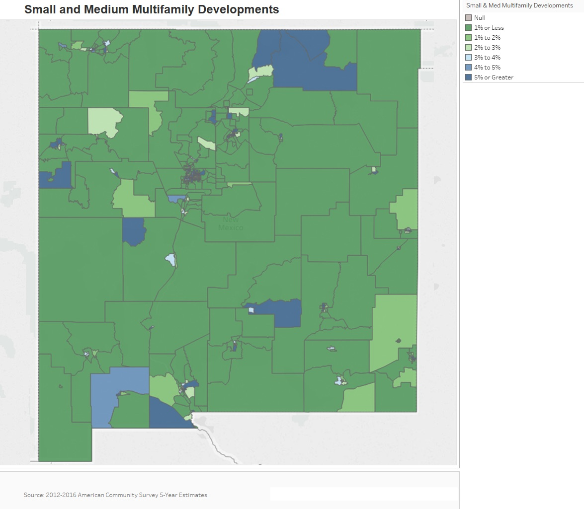
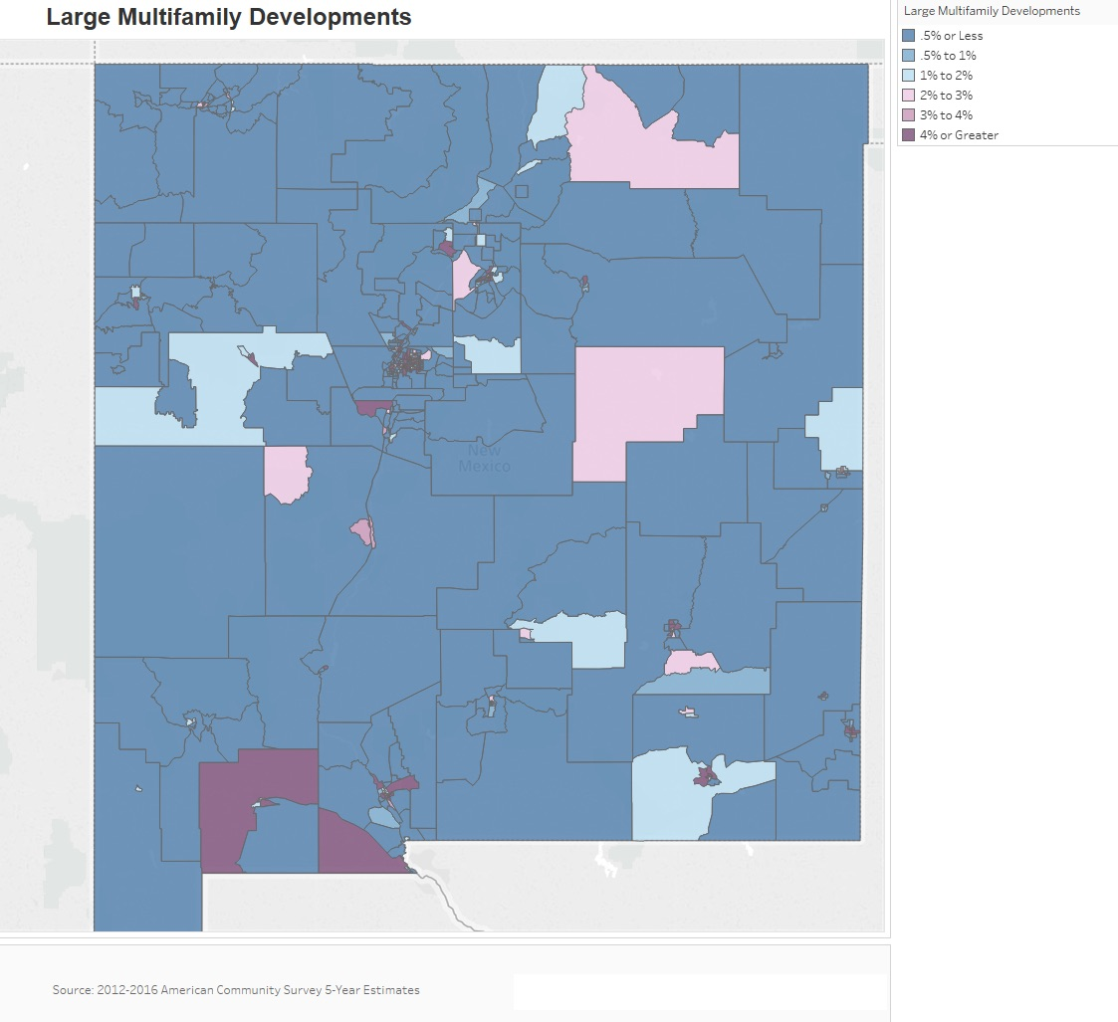

Unit Size by Tenure
 | Owners |  | Renters
 | Number | % | Number | %
No bedroom | 3,955 | 0.8% | 11,815 | 4.8%
1 bedroom | 13,290 | 2.6% | 48,669 | 19.8%
2 bedrooms | 91,142 | 17.6% | 88,631 | 36.1%
3 or more bedrooms | 408,432 | 79% | 96,617 | 39.3%
Total | 516,819 | 100% | 245,732 | 100%
Table 27 – Unit Size by Tenure

Alternate Data Source Name:
2012-2016 ACS 5-Yr Estimates

Unit Size by Tenure
Efficiency units represent a very small percentage of the overall occupied housing units in the State with less than 1% for owners and 5% for renters. For both owner and renter cohorts, units with 3 or more bedrooms make up the highest percent of housing with 79% for owners and 39.3% for renters. Renter properties are fairly evenly distributed between 2-bedroom units and those with 3 or more bedrooms while the bulk of owneroccupied units have 3 or more bedrooms.

Source: 2012-2016 American Community Survey 5-Year Estimates
Describe the number and targeting (income level/type of family served) of units assisted with federal, state and local programs.
MFA estimates 543 properties in New Mexico are assisted with federal, state and local programs. Of the 33,229 units at these properties, 31,337 are affordable. The affordable units, which serve families at 80% or below of AMI, can further be broken down as follows:
- Family Units: 25,479
- Senior and/or Disabled Units: 5,059
- Special Needs (Non-Senior) Units: 136
- All Other Affordable Units: 663

Provide an assessment of units expected to be lost from the affordable housing inventory for any reason, such as expiration of Section 8 contracts.
The State of New Mexico expects to lose part of the affordable housing inventory during this Consolidated Plan period. The source of this loss is primarily Qualified Contracts and the expiration of affordability periods.
MFA estimates that 5,453 units are at risk of being lost from the affordable housing inventory due to the ability to request a Qualified Contract. MFA has found the Qualified Contract purchase price formula almost certainly guarantees that the offering price will be above market value and thus will lead to the property being converted to market rate.
MFA also expects to lose units due to the end of affordability periods. Between January 1, 2020 and December 31, 2024, MFA estimates 277 LIHTC units will be coming out of the extended use period. Additionally, MFA estimates 2,589 other affordable units will be coming out of their affordability periods.
Though these figures are disconcerting, New Mexico will not lose all of the units described above for a variety of reasons, including:
- Developers may decide to maintain the affordability of the units due to their mission;
- Properties may renew contracts or seek additional affordable housing funding and thus keep the units in the state’s affordable housing inventory; and
- Some units may have multiple affordability restrictions; thus, one affordability period may end but another affordability period may still be in place.

In addition to the loss of rent-restricted units, some naturally-occurring affordable rental units have been lost in some markets recently due to the rise of the short-term rental market.
Does the availability of housing units meet the needs of the population?
Overall, there is a lack of decent affordable units throughout the state. From a quantitative standpoint, there is a sufficient number of housing units to house the entire population. However, there is a disconnect between the cost of what is available and the income of many residents. Cost burden is still a significant issue in New Mexico, particularly for renters. The 50% of renters who are cost burdened are in a position where they cannot properly save and become homeowners.
Describe the need for specific types of housing:
There is a great need for affordable housing units, particularly for renters. Multi-unit complexes tend to be more affordable, and an increase in their availability could allow for renters to no longer be cost burdened. Of course, the location of these units is of utmost importance as they must allow for access to jobs and other amenities.
Discussion
While the State largely has enough units to house the State’s residents, there is a disconnect between the cost of available units and the income of many residents, particularly renters. Across the State, 50% of renters experience housing cost burden. Coupled with the loss of affordable housing units anticipated in coming years, the availability of safe, decent, affordable housing for the State’s low- to moderate-income households is limited and will become scarcer unless additional affordable rental housing is identified or created.

MA-15 Cost of Housing – 91.310(a)
Introduction
Housing Prices
The following section examines the cost of housing for both homeowners and renters within the State of New Mexico. A review is made of current home values and rents as well as the recent changes to those home values and rents. Finally, a closer look is given to the affordability of the existing housing stock for the residents of the jurisdiction.
Cost of Housing
 | Base Year: 2000 | Most Recent Year: 2016 | % Change
Median Home Value | 108,100 | 161,600 | 49%
Median Contract Rent | 432 | 664 | 54%
Table 28 – Cost of Housing

Alternate Data Source Name:
2000 Census, 2012-2016 ACS

Rent Paid | Number | %
Less than $500 | 35,253 | 15.6%
$500-999 | 125,203 | 55.3%
$1,000-1,499 | 52,279 | 23%
$1,500-1,999 | 10,394 | 4.6%
$2,000 or more | 3,433 | 1.5%
Total | 226,562 | 100%
Table 29 - Rent Paid

Alternate Data Source Name:
2012-2016 ACS 5-Yr Estimates

Housing Costs
Housing costs have increased substantially in New Mexico with home values increasing by 49% and rents climbing by 54% since the 2000 Decennial Census.
The table above breaks out the rent paid by price cohorts in the state. Approximately 55% of all renters pay between $500 and $999 a month, the largest cohort by far. The next largest rent cohort is those paying between $1,000 and $1,499, with 23% of renters falling in this range. Later in this section, the report examines rental rates as a percentage of household income to determine the affordability of rental housing.

Home Value
The map below shows the median home value by census tract throughout the jurisdiction. Home value tends to be higher near urban centers. In some of these tracts, the median home value is over $200,000, while some rural tracts have a median home value of less than $50,000.
Source: 2012-2016 American Community Survey 5-Year Estimates
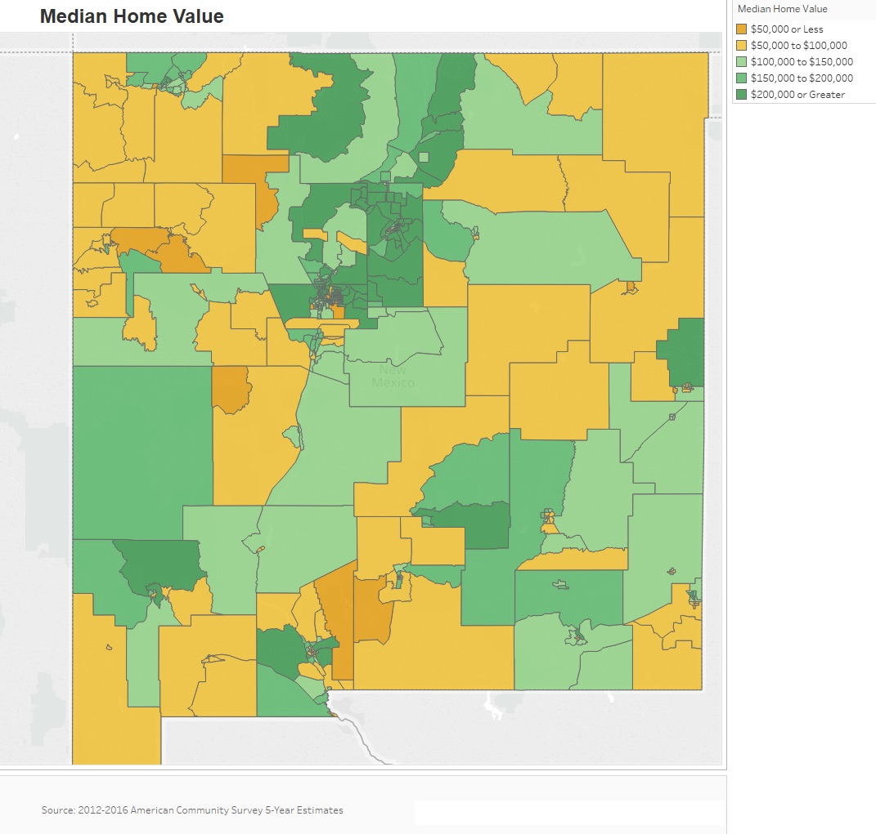

Median Rent
The map below displays the median rent by census tract. Similar to the median home value above, higher rents are located in urban areas while rural areas have lower median rents.
Source: 2012-2016 American Community Survey 5-Year Estimates
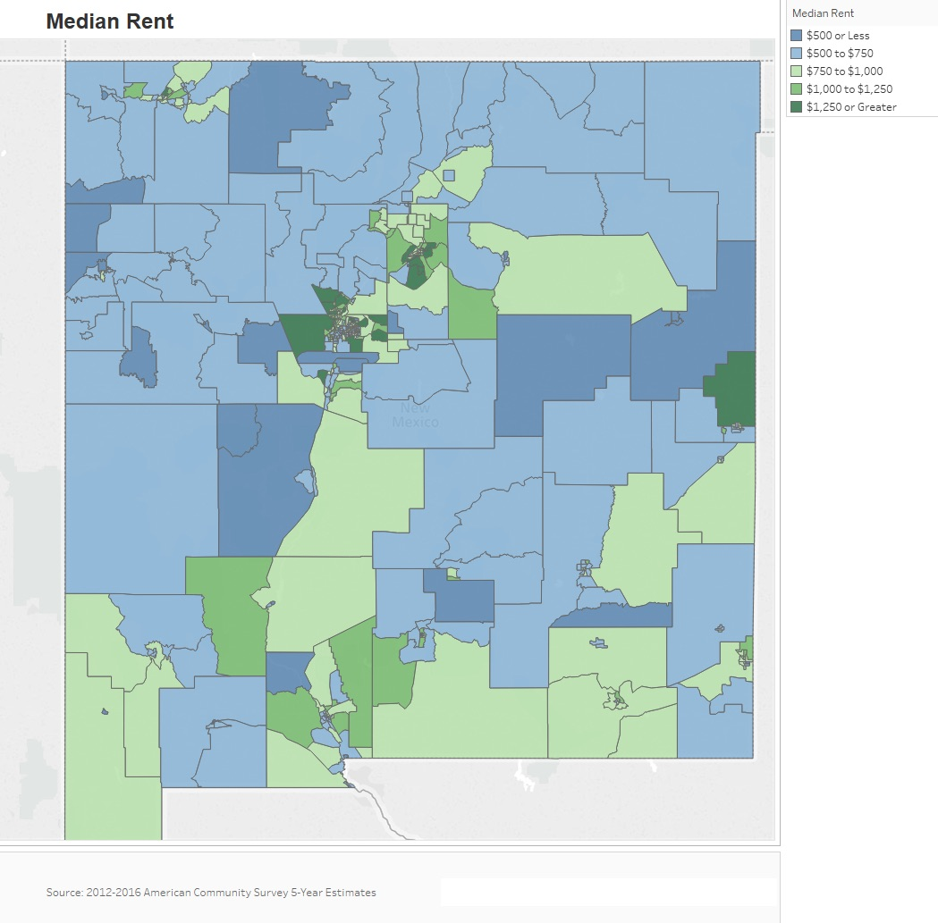

Housing Affordability
% Units affordable to Households earning | Renter | Owner
30% AMI | 17,175 | No Data
50% AMI | 57,270 | 46,730
80% AMI | 148,715 | 121,080
100% AMI | No Data | 178,575
Total | 223,160 | 346,385
Table 30 – Housing Affordability
Data Source: | 2011-2015 CHAS
Data Source Comments: | AMI refers to Area Median Income. In IDIS, this table uses the term HAMFI, or HUD Area Median Family Income, which is equivalent to AMI.

Housing Affordability
Not surprisingly, there are fewer housing units available for low-income households in New Mexico. Less than a third of rental housing is affordable for extremely low- and low-income renters, and while no data was available for extremely low-income owners, less than 14% of owner-occupied homes were affordable for homeowners.
Monthly Rent
As shown in Table 31, Fair Market Rents (FMRs) and HOME rents are not provided at the state level. However, the chart below Table 31 displays the FMR information at the county level. It is clear that the FMR can vary significantly. For efficiency units the lowest FMR is $480 in Luna County, while Santa Fe has the highest with $818.
Monthly Rent ($) | Efficiency (no bedroom) | 1 Bedroom | 2 Bedroom | 3 Bedroom | 4 Bedroom
Fair Market Rent | NA | NA | NA | NA | NA
High HOME Rent | NA | NA | NA | NA | NA
Low HOME Rent | NA | NA | NA | NA | NA
Table 31 – Monthly Rent

Data Source Comments: | There are no statewide FMRs and HOME Rents.
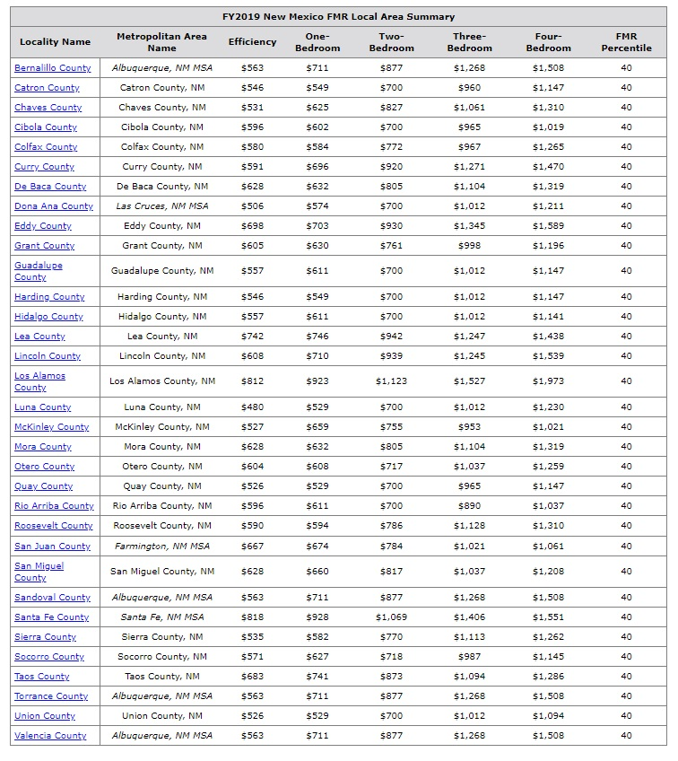
Is there sufficient housing for households at all income levels?
No, there is not sufficient affordable housing. As shown earlier in this document, housing cost burden is a significant problem in New Mexico, especially for renters. Households with extremely low incomes are in particular need of affordable units.
How is affordability of housing likely to change considering changes to home values and/or rents?
From 2000 to 2016, the State’s median home value increased 49%, from $108,100 to $161,600 and the median rent increased 54%, from $432 to $664. Over the same period, median income only went up 34%, going from $34,133 in 2000 to $45,674 in 2016. As such, housing cost burden has increased. The housing market has been increasingly expensive for many years, and it is unlikely to become more affordable in the future, particularly for renters. When the housing market adjusts to overproduction, the value of homes can decrease while rental costs continue to rise. A significant increase in the availability of low-cost rental units is needed to drive market rents down.
How do HOME rents / Fair Market Rent compare to Area Median Rent? How might this impact your strategy to produce or preserve affordable housing?
Fair Market Rents are not provided at the state level. However, the above chart displays the FMR information at the county level. It is clear that the FMR can vary significantly. For efficiency units the lowest FMR is $480 in Luna County, while Santa Fe has the highest with $818.
Discussion
In the State of New Mexico, there is a need for affordable housing. The price of housing is increasing at a faster rate than incomes, for both renters and homeowners. This has led to an increase in cost burden across the State, particularly for low-income households.

MA-20 Condition of Housing – 91.310(a)
Introduction:
The tables and maps in this section provide details on the condition of housing units throughout the state by looking at factors such as age, vacancy and the prevalence of housing problems.
As defined by HUD, the four housing problems are:
1) a home which lacks complete or adequate kitchen facilities;
2) a home which lacks complete or adequate plumbing facilities;
3) a home which is overcrowded (having more than one person per room); and
4) a household that is cost burdened (paying 30% or more of their income towards housing costs).
Definitions
The State of New Mexico uses the following descriptions that are commonly accepted definitions:
Standard Condition – Units that meet all state and/or local building or housing codes.
Substandard but Suitable for Rehabilitation – Units that do not meet all state and local codes but are both structurally and financially feasible to rehabilitate. The definition of substandard but suitable for rehabilitation may also include a quantifiable standard such as a dwelling in which the deficiencies are limited in number and magnitude such that the cost of rehabilitation would not exceed one hundred percent (100%) of the replacement cost of the dwelling. Examples of minor repairs may include disability access, lead-based paint abatement, foundation repair, wall repair, electrical repair and or roof repair.

Condition of Units
Condition of Units | Owner-Occupied |  | Renter-Occupied
 | Number | % | Number | %
With one selected Condition | 119,758 | 23% | 106,441 | 43%
With two selected Conditions | 5,485 | 1% | 8,695 | 4%
With three selected Conditions | 1,075 | 0% | 307 | 0%
With four selected Conditions | 27 | 0% | 29 | 0%
No selected Conditions | 390,474 | 76% | 130,260 | 53%
Total | 516,819 | 100% | 245,732 | 100%
Table 32 - Condition of Units

Alternate Data Source Name:
2012-2016 ACS 5-Yr Estimates

Housing Conditions
The table above details the number of owner and renter households that have at least one housing condition. As stated previously, HUD describes four housing conditions as being problems: 1) the home lacks complete or adequate kitchen facilities; 2) the home lacks complete or adequate plumbing facilities; 3) the home is overcrowded - defined as more than one person per room; and 4) the household is cost burdened by paying more than 30% of their income towards housing costs.
Twenty-three percent of all owner-occupied housing units and 43% of all renters face one housing condition. Generally speaking, there are relatively few households with multiple housing problems.
Year Unit Built
Year Unit Built | Owner-Occupied |  | Renter-Occupied
 | Number | % | Number | %
2000 or later | 106,204 | 21% | 39,576 | 16%
1980-1999 | 182,028 | 35% | 83,085 | 34%
1950-1979 | 187,747 | 36% | 100,754 | 41%
Before 1950 | 40,840 | 8% | 22,317 | 9%
Total | 516,819 | 100% | 245,732 | 100%
Table 33 – Year Unit Built

Alternate Data Source Name:
2012-2016 ACS 5-Yr Estimates

Year Unit Built
The largest percentage of housing units in New Mexico were built between 1950 and 1979. Those years account for 36% of owner-occupied units and 41% of renter-occupied units. Units built prior to 1978 have an increased risk of lead-based paint hazards. In New Mexico, approximately 44% of owner-occupied and 50% of renter-occupied homes may have that increased risk. That amounts to over 350,000 households.
Source: 2012-2016 American Community Survey 5-Year Estimate
Age of Rental Housing
The maps below depict the prevalence of older rental housing units in the State. The first map identifies the percentage of rental units built prior to 1950, while the second set of maps depicts rental units built prior to 1980. The darker shaded areas have higher concentrations of the housing stock being shown. Older units tend to be spread out throughout the State and newer units in the northwest and some urban areas.
Source: 2012-2016 American Community Survey 5-Year Estimate
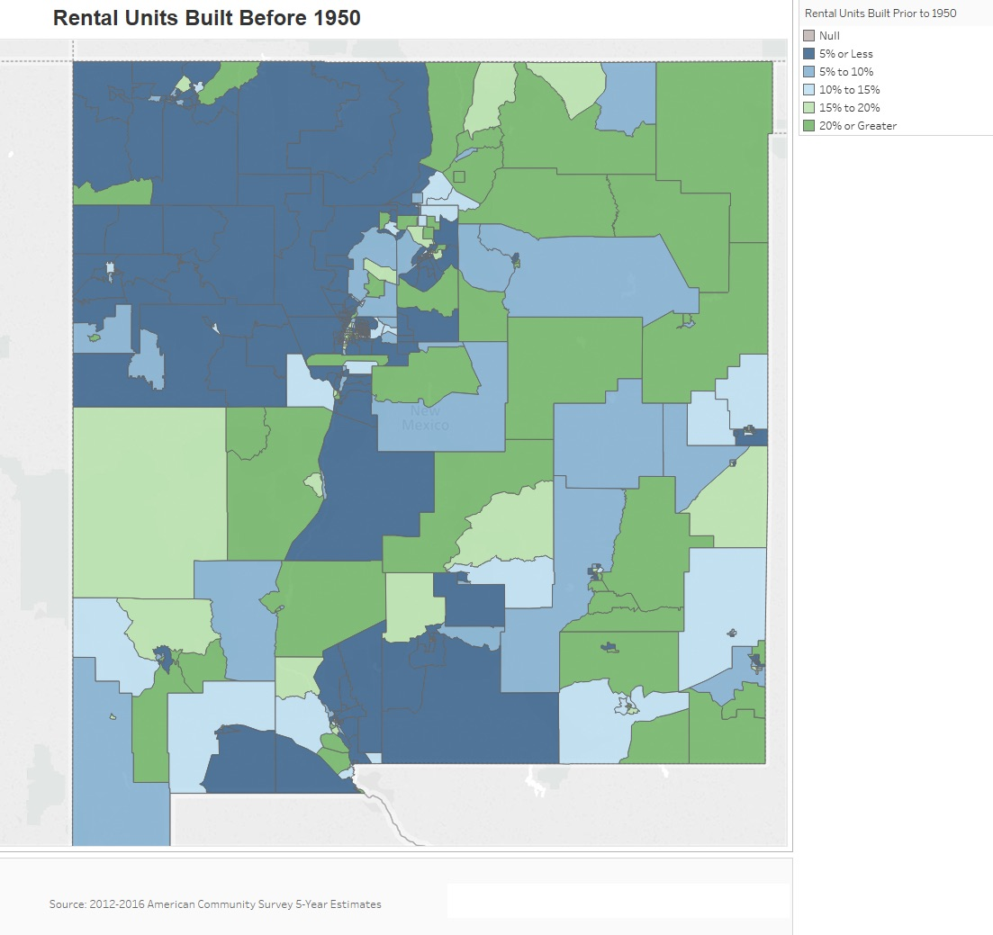
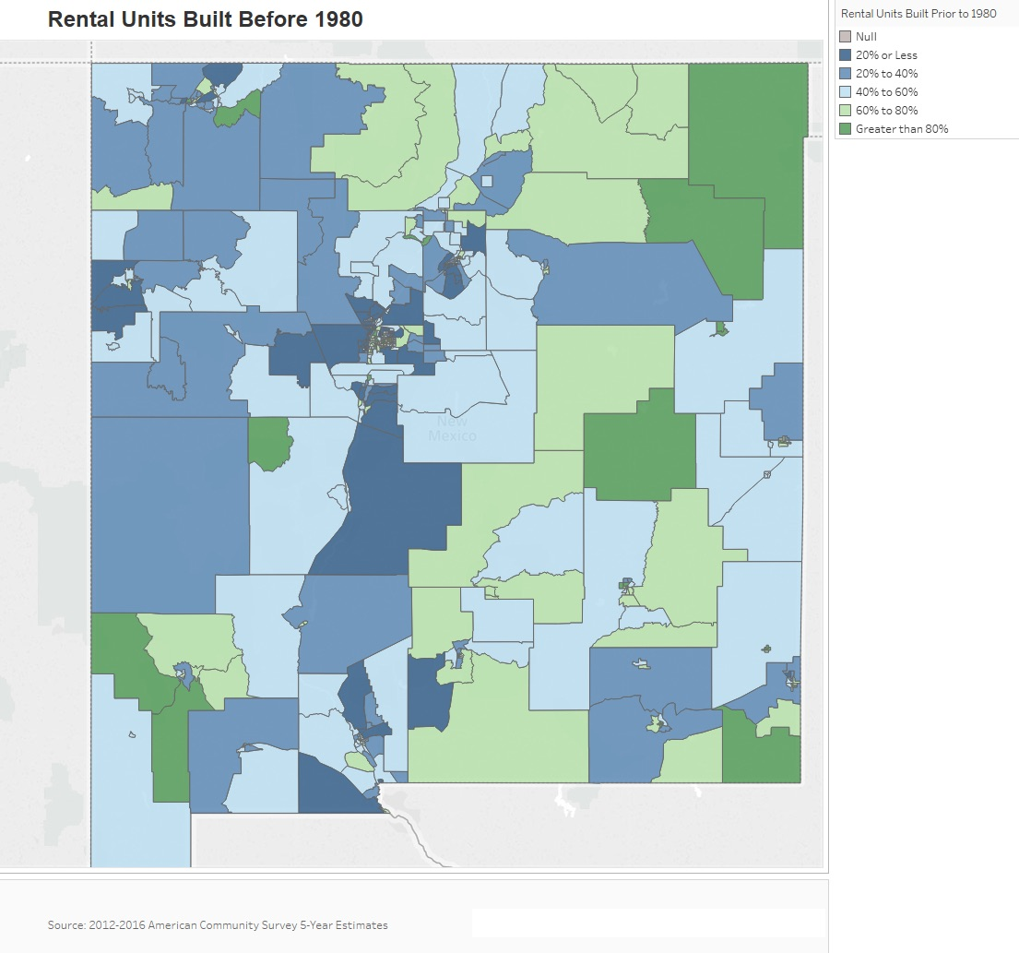

Risk of Lead-Based Paint Hazard
Risk of Lead-Based Paint Hazard | Owner-Occupied |  | Renter-Occupied
 | Number | % | Number | %
Total Number of Units Built Before 1980 | 228,587 | 44% | 123,071 | 50%

Housing Units built before 1980 with children present | 71,270 | 14% | 43,240 | 18%
Table 34 – Risk of Lead-Based Paint
Data Source: | 2011-2015 ACS (Total Units) 2011-2015 CHAS (Units with Children present)

Lead-Based Paint Hazard
As mentioned previously, any housing unit built prior to 1980 may contain lead-based paint in portions of the home. The most common locations are window and door frames, walls and ceilings and in some cases throughout the entire home. Thus, it is generally accepted that these homes at least have a risk of lead-based paint hazards and should be tested in accordance with HUD standards. Within the State there are 351,658 housing units built before 1980, and nearly 115,000 of them have children present.
Vacant Units

 | Suitable for Rehabilitation | Not Suitable for Rehabilitation | Total
Vacant Units | 114,167 | 216 | 114,383
Abandoned Vacant Units | Data Not Available | Data Not Available | Data Not Available
REO Properties | 2,344 | 95 | 2,489
Abandoned REO Properties | Data Not Available | Data Not Available | Data Not Available
Table 35 - Vacant Units
Data Source: | ACS 2012-2016; RealtyTrac

Discussion: Vacant units estimates used the ACS statewide vacancy rate of 15%. Vacant units suitable for rehabilitation estimates uses sum of all housing with one, two, or none of the housing conditions as listed in Table 35. A key assumption to estimating housing units that are not suitable for rehabilitation was to use the estimated total housing units with three or four conditions. These units often lack complete or adequate kitchen and plumbing and are often older homes built prior to 1950 and where efficient use of funds would be best used to demolish and rebuild. REO properties estimates comes from RealtyTrac website. Abandoned property data was not available. Not all vacant housing units are abandoned. New Mexico law states that property is generally presumed abandoned if it has remained unclaimed by the owner for more than five years after it becomes payable or distributable. However, due to the size of the state and the complexity of assessing abandoned housing units, the State does not currently estimate the number of abandoned housing units in New Mexico.

Vacancy Rate
The map below shows the average housing vacancy rates throughout the State. The darker shaded areas have higher vacancy rates, while the lighter shaded areas have lower vacancy rates. In most census tracts throughout New Mexico vacancy rates are at least 15%; however, they are highest in the west and northeast.
Source: 2012-2016 American Community Survey 5-Year Estimates
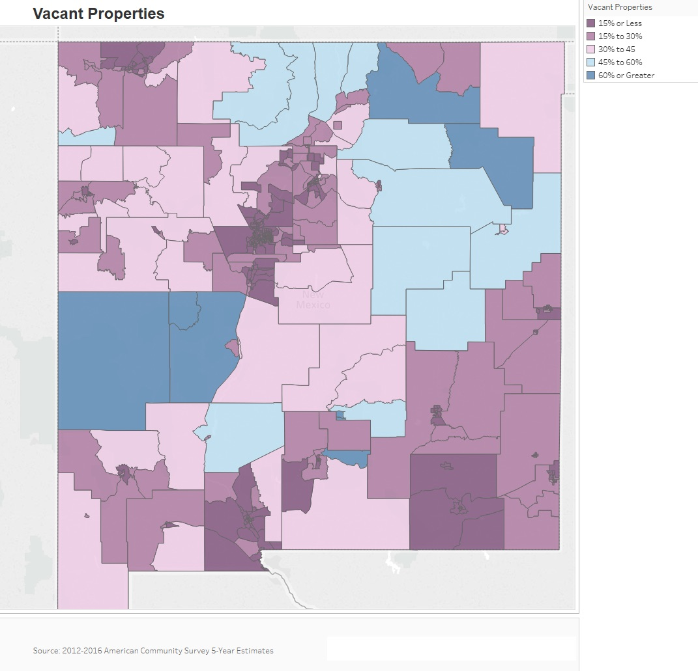
Need for Owner and Rental Rehabilitation
Generally, older units begin to need rehabilitation as the units age and it becomes harder to meet the minimum property maintenance standards. According to the latest ACS data, 44% of owner-occupied housing units and 50% of renter-occupied housing units were built before 1980. The local climate, which has high levels of heat and dust, may increase the cost of rehabilitation.
Estimated Number of Housing Units Occupied by Low or Moderate Income Families with LBP Hazards
The greatest potential for lead-based paint and other environmental and safety hazards is in homes built before 1980. Within the State there are over 350,000 housing units built before 1980, including nearly 115,000 with children present. Lower income residents are more likely to live in older homes, which may be in dilapidated condition.
Source: 2011-2015 ACS; 2011-2015 CHAS
Discussion:
Disaster Resiliency
New Mexico has historically been vulnerable to various natural hazard events including extreme heat, wildfires, flooding, tornadoes, earthquakes, and other natural disasters. The potential impacts of climate change—including an increase in prolonged periods of excessively high temperatures and more severe droughts—are often most significant for vulnerable communities. According to the US Environmental Protection Agency (EPA), in New Mexico, higher temperatures may also result in reduced water availability, higher risk of fires and a changing landscape such as an expanding desert.
Low- and moderate-income residents are at particular risk due to having fewer available resources. A dramatic rise in electricity or housing costs could put them at imminent risk of homelessness or living in substandard conditions. Residents in rural communities will have less access to public support in case of emergencies and will have fewer resources to repair or prevent damage to their homes.
New Mexico Department of Homeland Security and Emergency Management (NMHSEM) is the state agency responsible for emergency preparedness and mitigation. On its website and in its New Mexico Family Emergency Preparedness Guide, NMHSEM has outlined the State’s most common natural hazards and how to prepare citizens in disaster planning.
In 2018, the State of New Mexico adopted the 2018 Disaster Assistance Program Guide for Non-Federal Disasters, which was prepared by the NMHSEM. The purpose of the publication was to provide information on the State’s Disaster Assistance Program, which was outlined in the guide. The guide also served as a guide for application of the State of New Mexico Public Assistance grant, including eligibility criteria, damage assessment, the application process and grant management procedures.
Disaster Management
New Mexico has several public and private organizations that work to address any issues that come from natural disasters. The following organizations help with disaster mitigation and management in various ways.

New Mexico Department of Homeland Security and Emergency Management (NMDHSEM)
NMDHSEM is ready to assist local governments in recovering from the impacts of a disaster or emergency. In addition to supplementing local resources, NMDHSEM also manages the New Mexico Public Assistance reimbursable grant to supplement a local government’s recovery efforts following a disaster or emergency declared by the Governor.
Federal Emergency Management Agency (FEMA) Region VI
FEMA provides a disaster mitigation guide online for the State of New Mexico. Resources include flood recovery information, wildfire information, winter storm information, tornado and other natural hazards information help.
Local/Tribal Offices of Emergency Management
Local and tribal offices of emergency management provide information and work to reduce threats to residents. These include wildfire, flooding and major chemical spills.
New Mexico Department of Health
The State Department of Health provides extensive information online about emergency management and also provides training and emergency response education.
Southern Baptist Disaster Relief NM (SBDR)
SBDR exists to help victims of natural and man-made disasters—such as floods, earthquakes, hurricanes and tornadoes. In New Mexico, SBDR provides trained volunteers and disaster relief resources such as mobile kitchens, mobile generators, water purification, mobile showers, mobile childcare, clean up and a chaplain team.

MA-25 Public and Assisted Housing
Introduction:
Public housing was established to provide decent and safe rental housing for eligible low- and moderate-income families, the elderly and persons with disabilities. Public housing includes federally subsidized, affordable housing that is owned and operated by the public housing authorities. While public and assisted housing units comprise a portion of the housing stock located throughout New Mexico, MFA and DFA do not operate public housing and, therefore, have not developed a plan related to public housing or public housing initiatives. However, MFA encourages public housing authorities to apply for HOME and HTF funding to rehabilitate public housing units.
New Mexico has 28 public housing authorities (PHAs), and 25 of these PHAs are non-entitlement (the City of Albuquerque Housing Authority, Mesilla Valley Housing Authority and the Santa Fe Civic Housing Authority are entitlement PHAs). Since neither DFA nor MFA operate public housing, the agencies do not directly plan resident initiatives. Efforts to collaborate more extensively with PHAs are underway through the State’s three Regional Housing Authorities (RHAs), which MFA oversees on behalf of the State. MFA provides technical assistance to enhance the organizational and financial capacity of RHAs. This assistance helps the RHAs to preserve and enhance public housing, retain vouchers and expand affordable housing services and programs in rural communities where they are critically needed.
Tribal housing authorities are not among the PHAs analyzed and are not included in the State’s public housing strategy. The 21 tribal housing authorities operate independently within their sovereign nations.
Public housing data used for this section is a compilation of the 28 PHAs and is based on information submitted by the public housing authorities to HUD.
Describe the supply of public housing developments:
Describe the number and physical condition of public housing units in the jurisdiction, including those that are participating in an approved Public Housing Agency Plan:
There are approximately 3,597 public housing units across the State operated by 28 different public housing authorities. Non-entitlement PHAs operate approximately 2,189 of these units. Information on the physical condition of public housing units in the State was not readily available.
Describe the Restoration and Revitalization Needs of public housing units in the jurisdiction:
This section is not applicable to the State. The State does not own or operate public housing units, so it does not hold detailed information regarding the revitalization needs.
Describe the public housing agency's strategy for improving the living environment of low- and moderate-income families residing in public housing:
The State does not operate a public housing program.

MA-30 Homeless Facilities – 91.310(b)
Introduction
Addressing homelessness requires cooperation from both public and private organizations. There are currently a number of organizations in the State of New Mexico that offer a variety of services to both aid those who have become homeless and to prevent persons from becoming homeless.
Coordinating these organizations is the New Mexico Coalition to End Homelessness (NMCEH). NMCEH was founded in 2000 by a group of nonprofit agencies and MFA as there was a need for a statewide coalition to coordinate efforts to end homelessness in the State. NMCEH later merged with a similar coalition in Albuquerque in 2006. Its mission is to assist communities to create solutions to homelessness from prevention through permanent housing by using action, advocacy and awareness.
NMCEH coordinates the Continuum of Care (CoC) grant application process in the State. It coordinates both the Albuquerque CoC and the New Mexico Balance of State CoC. CoC funds are used to provide permanent supportive housing assistance, transitional housing assistance, rapid re-housing assistance and other services to individuals and families experiencing homelessness.
Each year, the two CoCs report to HUD’s Continuum of Care Homeless Assistance Programs the number of emergency shelter, transitional housing and permanent supportive housing beds, which is then compiled into the Housing Inventory Count for the State.
While there are seasonal beds that increase the number of shelter units during winter months, there is still a need for more emergency and transitional housing shelters. There are roughly only 1,100 emergency shelter and 600 transitional housing year-round beds in the State. The 2018 PIT Counts provided by the two CoCs reported that a total of 2,551 persons were homeless in the State with 1,755 being sheltered and 796 unsheltered.
The data below was provided by HUD from the 2018 Housing Inventory Count Report and MFA.

Facilities Targeted to Homeless Persons
 | Emergency Shelter Beds |  | Transitional Housing Beds | Permanent Supportive Housing Beds
 | Year Round Beds (Current & New) | Voucher / Seasonal / Overflow Beds | Current & New | Current & New | Under Development
Households with Adult(s) and Child(ren) | 478 | >300 | 240 | 1,870 | 0
Households with Only Adults | 548 | >300 | 284 | 1,640 | 82
Chronically Homeless Households | n/a | n/a | n/a | 1,421 | 0
Veterans | 15 | n/a | 70 | 687 | 0
Unaccompanied Youth | 85 | n/a | 54 | 15 | 0
Table 36 - Facilities Targeted to Homeless Persons

Data Source Comments: | HUD 2018 CoC Homeless Assistance Programs, Housing Inventory Count Report. This data is provided to HUD by the two CoCs in New Mexico: Albuquerque CoC and the New Mexico Balance of State CoC.  There are a total of 562 seasonal beds and 97 overflow/voucher beds, but they are not specified for family or adult only.  Data on beds available for Chronically Homeless Households, Veterans and Unaccompanied Youth are a subset of the total bed inventory.  Data on Permanent Supportive Housing beds for Households with Only Adults are from MFA. These beds may overlap with the Chronically Homeless Households category.

Describe mainstream services, such as health, mental health and employment services to the extent those services are used to complement services targeted to homeless persons
The two Continuums of Care (Balance of State and Albuquerque) have integrated into their policies plans to assist persons experiencing homelessness in accessing mainstream services. This includes, for example, ensuring that eligible persons are enrolled in Medicare or Medicaid and Veteran benefits, so that persons have access to reliable health and other systems of care. These services are used to complement the services already provided by the current homeless service providers.
The New Mexico Human Services Department (HSD) administers an array of mainstream services that complement homeless services through programs such as:

- Behavioral Health Services
- Community Services Block Grants (CSBG)
- General Assistance (cash assistance for low-income individuals with disabilities)
- Low-Income Home Energy Assistance Program (LIHEAP)
- Medicaid and Children’s Health Insurance Program (CHIP)
- Refugee Resettlement Program (RRP)
- School Commodity Foods Program
- Supplemental Nutrition Assistance Program (SNAP)
- Temporary Assistance for Needy Families (TANF)
- The Emergency Food Assistance Program (TEFAP)
MFA also partners with HSD on the Behavioral Health Collaborative and works across State agencies to collaborate on behavioral health issues, supportive services and housing.
New Mexico Workforce Connection, with 21 centers statewide, and the New Mexico Division of Vocational Rehabilitation (NM DVR), with over 25 offices statewide, provide training, career placement, internships, apprenticeship and veteran services in the area of vocational development and supportive employment. Both Workforce Connection and NM DVR accept direct-referrals from healthcare providers, clinicians, case managers and homeless service providers.
List and describe services and facilities that meet the needs of homeless persons, particularly chronically homeless individuals and families, families with children, veterans and their families and unaccompanied youth. If the services and facilities are listed on screen SP-40 Institutional Delivery Structure or screen MA-35 Special Needs Facilities and Services, describe how these facilities and services specifically address the needs of these populations.
As shown in SP-40, Table 50, a wide variety of services are offered to meet the needs of individuals and families experiencing homelessness. These are provided by a number of different organizations, many of which coordinate street outreach, which serves as a vehicle for making resources more accessible.
Below is a list of some of the prominent services and facilities that work to meet the needs of individuals and families experiencing homelessness in New Mexico:
New Mexico Coalition to End Homelessness (NMCEH) has 70 member organizations that provide housing and services to individuals and families experiencing homelessness. NMCEH carries out its mission through advocacy, trainings and coordinated grant-writing and fundraising. It also maintains a database that tracks progress in ending homelessness and operates a coordinated assessment system that helps people experiencing homelessness quickly connect to housing. This system, the New Mexico Coordinated Entry System (NMCES), has assessed over 16,000 individuals since its inception using the Vulnerability Index - Service Prioritization Decision Assistance Tool (VI-SPDAT), which helps to determine each applicant's acuity, relative need for housing and the type of housing that would be most appropriate to assist their needs. The assessments are done at the NMCEH as well as CoC and ESG-funded agencies, health centers, veteran programs, correctional facilities and during street outreach.
Some of NMCEH’s member agencies across the State include: Adelante Development Center, Catholic Charities, Crossroads for Women, Family Promise of Albuquerque, Good Shepard Center, Heading Home, HopeWorks (formerly St. Martin’s Hospitality Center), S.A.F.E House, Valencia Shelter for Victims of Domestic Violence, Family Crisis Center, PATH – Shelter Operations, Haven House , Healthcare for the Homeless of Santa Fe, Santa Fe Need and Deed, the Life Link, Samaritan House, La Casa, Mesilla Valley Community of Hope and Dreamtree Project. A full list of members is included on NMCEH’s website.
Chronically Homeless:
Interfaith Community Shelter in Santa Fe operates a minimal entry overnight shelter available year-round for women and children and during the winter months for men as well. It also offers a wide variety of daytime services, such as meals, showers, clothing, haircuts, behavioral health services, assistance with applications for public benefits, legal assistance and employment assistance. It also hosts a meditation group, a chorus and an open art studio.
HopeWorks conducts extensive street outreach and operates a day shelter that provides meals, showers, clothing, a mail room, short- and long-term storage and referrals to additional services. It also provides behavioral health services, employment assistance and a range of rental assistance and housing placement services. In addition, it operates the Hope Cafe, a job training site for clients experiencing homelessness.
Families with Children:
S.A.F.E. House operates an emergency shelter for families fleeing domestic violence, which offers 90 days of free lodging, meals and services, including case management, therapy for adults and children, enrichment classes, a children's program and safety planning.
HopeWorks has recently launched HopeFound, a program model designed to rapidly re-house families with children who are experiencing homelessness. HopeWorks provides the program infrastructure, intensive case management and employment services, while area communities of faith and local businesses sponsor rental assistance for up to six months per family.

Veterans:
The Veterans Integration Centers, with four locations across the State, offer supportive services for veterans experiencing homelessness and their families including access to a food pantry, Rapid Re-Housing services, case management, homelessness prevention and temporary financial assistance for such needs as furniture rental, utility payment, deposits (security or utility), moving costs and transportation and child care assistance.
The New Mexico Veterans Affairs (VA) Health Care System’s Health Care for Homeless Veterans (HCHV) program addresses the needs of veterans experiencing, or at risk of, homelessness. Assistance is provided in helping veterans in gaining access to VA Medical Services, financial benefits and discharge documents. Services include referrals to medical and psychiatric assessments, alcohol and drug treatment, case management and assistance with basic needs such as food, clothing and temporary shelter. HCHV staff also provides linkages to transitional housing through VA and community providers, assists with finding affordable housing and assists with finding employment. The HCHV team also performs numerous rural outreach programs throughout New Mexico in order to help homeless Veterans.
Unaccompanied Youth:
In July 2018 NMCEH was provisionally awarded $3.37 million to develop a system to address youth homelessness in 14 northern New Mexico counties. The counties included are Cibola, McKinley, San Juan, Sandoval, Rio Arriba, Santa Fe, Los Alamos, Taos, Colfax, San Miguel, Mora, Union, Harding and Quay. The population to be served is youth experiencing homelessness, including unaccompanied and pregnant or parenting youth, where no member of the household is older than 24. The funding will pay for outreach, housing and supportive services to assist the several hundred youth who become homeless each year in this 14 county region.
New Day Youth & Family Services began as Albuquerque’s first and only runaway shelter, and for the past 40 years, has been meeting the needs of young people in trouble by providing “safe refuge for the present, adult allies for the future and the basic skills needed to carve a healthy and positive path forward.”
Youth Development, Inc. (YDI) is a nationally recognized youth service organization assisting youth and families in central and northern New Mexico. YDI operates Amistad Crisis Shelter for youth ages 12 to 17, and Casa Hermosa, an 18-month transitional living program for youth aged 16-21 that are runaway, homeless or aging out of state custody (foster care, institutional care).
DreamTree Project in Taos operates an emergency shelter for youth ages 12 to 17, as well as apartments for young adults ages 16 to 24. Case managers assist youth with setting and reaching goals, and weekly life skills classes are provided.

MA-35 Special Needs Facilities and Services – 91.310(c)
Introduction
There are six primary groups with non-homeless special needs in the State. They are the elderly, those with HIV/AIDS and their families, those with alcohol and/or drug addiction, the mentally or physically disabled, victims of domestic violence and veterans. Note that while veterans are not considered special needs population under HUD’s definition of the limited clientele national objective, the State recognizes the unique circumstances facing veterans. This section will explain the characteristics of these special needs populations, what their needs are and how the jurisdiction is accommodating (or should accommodate) those needs. Additional details about the facilities and services available are included later in this section.
HOPWA funding is a primary source of funding for serving the housing needs of those with HIV/AIDS and their families. The following table required by HUD shows baseline figures for HOPWA assistance provided in the State.
HOPWA Assistance Baseline Table
Type of HOPWA Assistance | Number of Units Designated or Available for People with HIV/AIDS and their families
TBRA | 90
PH in facilities | 0
STRMU | 104
ST or TH facilities | 0
PH placement | 54
Table 37 – HOPWA Assistance Baseline
Data Source: | HOPWA CAPER and HOPWA Beneficiary Verification Worksheet
Data Note: As instructed by the HUD eCon Planning Suite Manual, the default data source for the HOPWA Assistance Baseline Table is from the HOPWA Performance Data based on the 2018 HOPWA CAPER and HOPWA Beneficiary Verification Worksheet submitted by the grantee 90 days following the end of the operating year. The data provided is based on actual performance of units and type of HOPWA assistance. This data is provided by the 2018 CAPER.

To the extent information is available, describe the facilities and services that assist persons who are not homeless but who require supportive housing and programs for ensuring that persons returning from mental and physical health institutions receive appropriate supportive housing
Elderly: The supportive housing needs for this population can vary widely depending on the health and fitness of the individuals. In general, disabilities and other health issues become more common as people age. Because of this, supportive housing must include access to health professionals and housing modifications to assist the resident. It is important to help residents stay independent and in their own homes for as long as possible if they prefer that.
In New Mexico, support for the elderly population is provided by the New Mexico Aging and Long-Term Services Department. The role of this organization is to promote independence and dignity for elderly persons and individuals living with a disability in New Mexico. The Department’s 2017-2021 New Mexico State Plan for Aging and Long-Term Services outlines various goals for the department over those five years. The Plan includes goals and objectives for supportive services, nutrition, health promotion, caregiver support, elders’ rights, along with other goals and objectives. Further, New Mexico’s four Area Agencies on Aging, or AAAs, administer, plan and support community based services for individuals 60 and older, or age 55 and older in tribal programs. Most of the services coordinated through the AAAs are provided at the local level.
People with HIV/AIDS and Their Families: Medical and social support is important for residents living with HIV/AIDS. While there have been great advances in the medical treatment of HIV/AIDS, it is still important to provide specialized support. Family and friends must be accessible and medical facilities should be nearby. A combination of private non-profit providers and the New Mexico Department of Health provide HIV/AIDS services in New Mexico. The Department of Health administers the HIV/AIDS Prevention Program, which exists to reduce the incidence of HIV transmission in New Mexico through planning, funding, coordination and evaluation of HIV prevention activities for at-risk populations across New Mexico.
Alcohol and/or Other Drug Addiction: Individuals dealing with addiction often require housing options that will provide a safe, sober place for recovery. A strong network is necessary to maximize the chance they will stay healthy and sober. It is important that these persons have access to health services, support groups, employment assistance and access to family and friends. Additionally, detoxification facilities are necessary when addiction is first recognized.
Substance abuse centers are available throughout the State, particularly in urban areas. Publicly-funded services for drug and alcohol addiction are administered by the New Mexico Human Services Department, Division of Behavioral Health Services (BHSD). The BHSD operates the Office of Substance Abuse Prevention (OSAP). For the fiscal year 2019, there are 29 organizations throughout New Mexico that are receiving prevention funds from the Office of Substance Abuse Prevention. MFA is a member agency of the New Mexico Behavioral Health Collaborative which allows state agencies and resources involved in behavioral health prevention, treatment and recovery to work as one in an effort to improve mental health and substance abuse services in New Mexico.
People with Disabilities: Individuals with disabilities encompass a wide range of skill levels and abilities. Therefore, they have many of the same issues as the general population with the added needs that are unique to their situation. Often times, individuals with disabilities have a fixed income and limited housing options. Individuals with more independent skills can utilize subsidized housing but individuals that need more support or specialized housing have fewer options. Many individuals continue to reside with parents and families throughout adulthood, which can put additional financial burden on the family. Regardless of the housing situation, a common thread is the need for continuous support services dependent on the level of capabilities.
The Aging and Disability Resource Center, through the New Mexico Aging and Long-Term Services Department, provides information and referrals to organizations throughout the State that aid persons with disabilities. The Aging and Disability Resource Center is available to assist elders, persons with disabilities and caregivers to find services and resources to help them live well and independently. The Department of Health also offers services through the Developmental Disabilities Support Division, which offers case management, day services, therapy, employment support, nutritional care, counseling, accessibility adaptations and community engagement opportunities.
Victims of Domestic Violence: The New Mexico Coalition Against Domestic Violence exists to provide a coordinated local, regional and statewide response to domestic violence in the State. With more than 30 member organizations, the Coalition advocates for positive social change, provides training, builds alliances, secures resources and develops public policy in New Mexico. Services for survivors of domestic abuse or violence are provided by a variety of nonprofit and faith-based organizations across the State. Many of the shelters have 24-hour crisis lines and offer temporary housing, advocacy, referral programs, counseling and transportation, as well as many other services.
Veterans: The urgent need for veterans housing rehabilitation/modification is widely recognized in New Mexico and far outstrips available funds. Federally supported adaptive housing grants through the US Department of Veterans Affairs are available to veterans in New Mexico; however, these are nationally competitive funds in limited supply and with different disabilities eligibility. While New Mexico offers a range of benefits to veterans, such as a veteran-owned business preference for state contracts and some tax exemptions, MFA is the only agency in the State that specifically targets veterans’ housing rehabilitation, which it does through the Veterans Home Rehabilitation and Modification pilot program.
Describe programs for ensuring that persons returning from mental and physical health institutions receive appropriate supportive housing
The two CoCs in New Mexico offer services that help identify housing opportunities for those being released from mental and physical health institutions. The CoCs also coordinate efforts between hospitals and local service providers to assess and place individuals with any necessary additional services.
Specify the activities that the jurisdiction plans to undertake during the next year to address the housing and supportive services needs identified in accordance with 91.215(e) with respect to persons who are not homeless but have other special needs. Link to one-year goals. 91.315(e)
New Mexico will continue to incentivize the use of HTF funds for development of rental housing for special needs populations. HOME rental development funds may be used for development of rental housing for special needs populations. HOPWA funds will be used for Short-Term Rent, Mortgage and Utility (STRMU), tenant-based rental assistance (TBRA) and Permanent Housing Placement (PHP) for persons with HIV/AIDS.

MA-40 Barriers to Affordable Housing – 91.310(d)
Negative Effects of Public Policies on Affordable Housing and Residential Investment
Public policies are meant to address the overall needs of citizens in the State. Yet, there are times where they may have a negative effect on certain aspects of the community, specifically affordable housing and residential investment. Affordable housing and public and private residential investments are key components in furthering fair housing in any community. The primary tool communities have for identifying contributing factors for these barriers to housing is an assessment of fair housing and fair housing choice. In 2019, the State of New Mexico is updating the previous 2015 assessment. Analysis from the 2019 update has found:
- A limited supply of affordable housing and extensive cost burden in New Mexico, especially for extremely low- and very low- income renters, causing those renters to face significant affordability “gaps”; and
- Specific elements of fair housing planning and zoning, land use planning and administrative policies appear to impede the development of affordable housing and these elements must be better understood.

The State plans corresponding actions designed to strengthen the supply of affordable housing and narrow the affordability “gaps.” Elements of those actions appear within this Consolidated Plan and beyond. Additionally, the State anticipates a review of public policies that may impede the development of affordable housing and to improve the understanding of their consequences.

MA-45 Non-Housing Community Development Assets -91.315(f)
Introduction
This section provides insight into the economic development landscape of New Mexico. The table below details the extent of business sector employment throughout the State. Unemployment, commuting times and education are also analyzed in this section.
Economic Development Market Analysis
Business Activity
Business by Sector | Number of Workers | Number of Jobs | Share of Workers  % | Share of Jobs  % | Jobs less workers  %
Agriculture, Mining, Oil & Gas Extraction | 39,103 | 36,681 | 4 | 5 | 1
Arts, Entertainment, Accommodations | 97,501 | 104,527 | 11 | 13 | 2
Construction | 59,855 | 47,587 | 7 | 6 | -1
Education and Health Care Services | 220,235 | 216,639 | 25 | 27 | 2
Finance, Insurance and Real Estate | 39,658 | 32,805 | 5 | 4 | -1
Information | 13,681 | 15,969 | 2 | 2 | 0
Manufacturing | 41,183 | 28,656 | 5 | 4 | -1
Other Services | 42,100 | 20,840 | 5 | 3 | -2
Professional, Scientific, Management Services | 98,163 | 102,895 | 11 | 13 | 2
Public Administration | 67,203 | 52,324 | 8 | 7 | -1
Retail Trade | 99,211 | 96,908 | 11 | 12 | 1
Transportation and Warehousing | 39,036 | 26,892 | 4 | 3 | -1
Wholesale Trade | 19,106 | 21,712 | 2 | 3 | 1
Total | 876,035 | 804,435 | -- | -- | --
Table 38 - Business Activity

Alternate Data Source Name: 2011-2015 ACS (Workers), 2015 Longitudinal Employer-Household Dynamics (LEHD) (Jobs)

Data Source Comments: | The most recent LEHD data was from 2015. For comparison, 2011-2015 ACS data was used.

Labor Force
Total Population in the Civilian Labor Force | 957,385
Civilian Employed Population 16 years and over | 876,210
Unemployment Rate | 8.50
Unemployment Rate for Ages 16-24 | 20.10
Unemployment Rate for Ages 25-65 | 6.70
Table 39 - Labor Force

Alternate Data Source Name: 2012-2016 ACS 5-Yr Estimates
Unemployment
According to the 2012-2016 American Community Survey, the statewide unemployment rate was 8.5% for all persons in the civilian workforce. Approximately 20.1% of persons between the ages of 16 and 24 were unemployed. The State’s total overall unemployment rate was over the 7.4% national unemployment rate. The map below displays unemployment throughout the State by census tract. Unemployment rates are generally higher in the northwest area of New Mexico than elsewhere throughout the State. Though differences between regions have likely not changed, the statewide unemployment rate as of July 2019 is 4.9% according to the Bureau of Labor Statistics.
Source: 2012-2016 American Community 5-Year Estimates

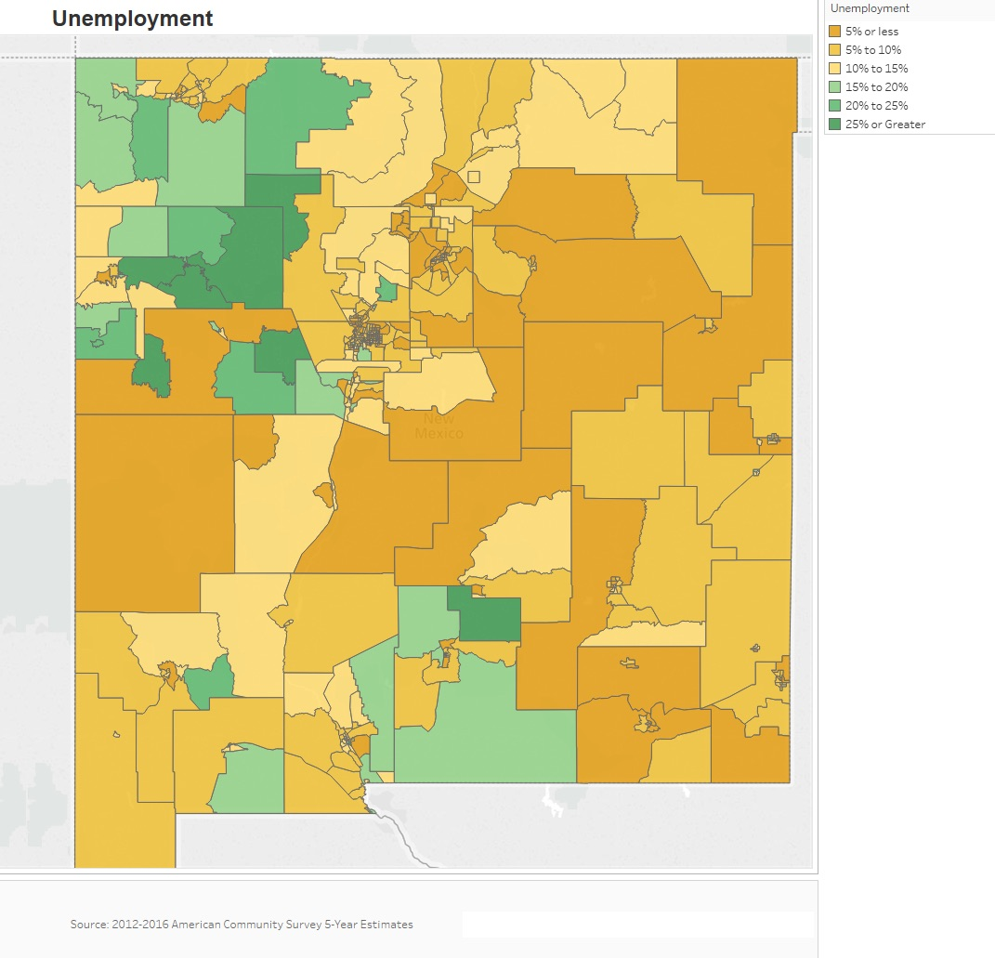

Occupations by Sector | Number of People
Management, business and financial | 310,997
Farming, fisheries and forestry occupations | 8,363
Service | 181,579
Sales and office | 204,638
Construction, extraction, maintenance and repair | 89,684
Production, transportation and material moving | 80,949
Table 40 – Occupations by Sector

Alternate Data Source Name: 2012-2016 ACS 5-Yr Estimates

Occupations by Sector
The largest employment sector is the management, business and financial sector, employing 310,997 persons throughout the State. This sector is followed closely by the sales and office sector with 204,638 persons employed and the service sector with 181,579.
Travel Time
Travel Time | Number | Percentage
< 30 Minutes | 566,763 | 68%
30-59 Minutes | 221,054 | 27%
60 or More Minutes | 43,214 | 5%
Total | 831,031 | 100%
Table 41 - Travel Time

Alternate Data Source Name:
2012-2016 ACS 5-Yr Estimates

Commute Travel Time
Sixty-eight percent of all persons commuting to work have a commute of less than 30 minutes each way. Approximately 5% of all employed persons have a commute of 60 minutes or more, to and from work each day.
Source: 2012-2016 American Community Survey 5-Year Estimates

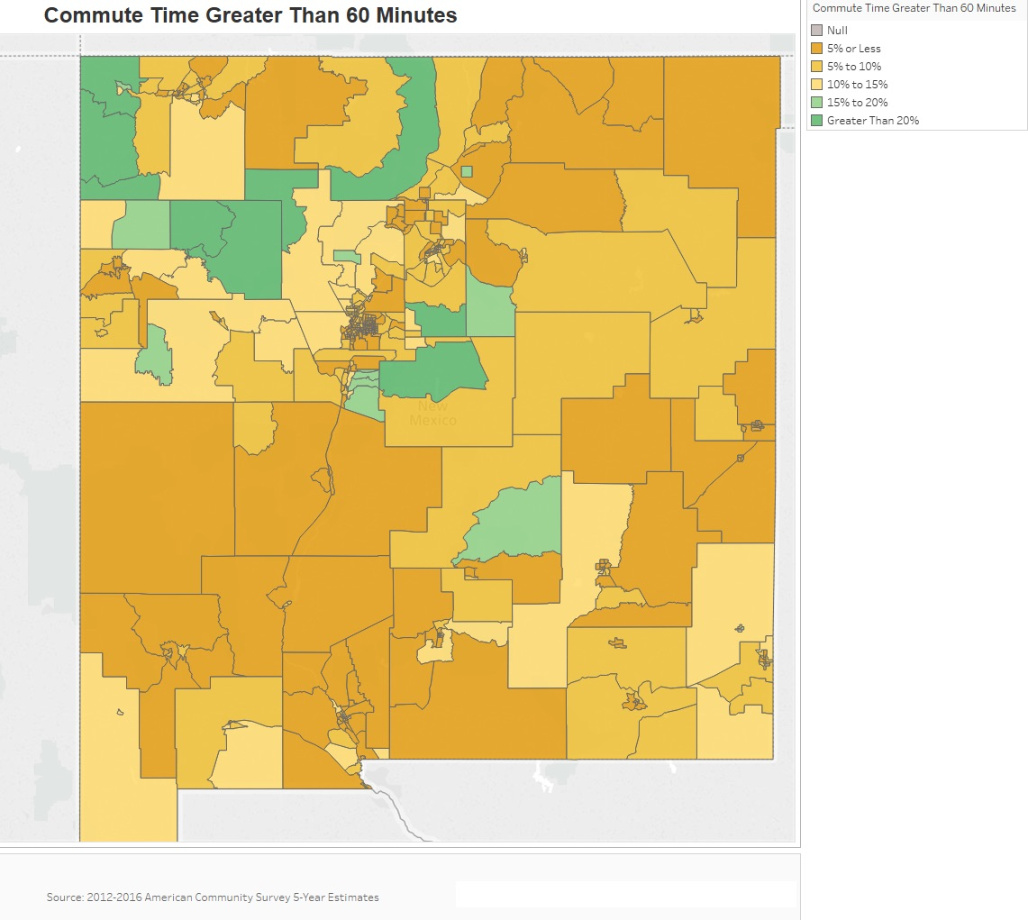
Education:
Educational Attainment by Employment Status (Population 16 and Older)
Educational Attainment | In Labor Force
 | Total | Civilian Employed |  | Unemployed |  | Not in Labor Force
 | # | # | % | # | % | # | %
Less than high school graduate | 149,920 | 74,660 | 49.8% | 20,089 | 13.4% | 63,716 | 42.5%
High school graduate (includes equivalency) | 279,282 | 172,596 | 61.8% | 23,460 | 8.4% | 90,487 | 32.4%
Some college or Associate's degree | 352,550 | 241,144 | 68.4% | 22,916 | 6.5% | 92,016 | 26.1%
Bachelor's degree or higher | 273,882 | 216,093 | 78.9% | 9,312 | 3.4% | 47,655 | 17.4%

Table 42 - Educational Attainment by Employment Status

Alternate Data Source Name:
2012-2016 ACS 5-Yr Estimates

Educational Attainment by Age
 | Age
 | 18–24 yrs |  | 25–34 yrs |  | 35–44 yrs |  | 45–65 yrs |  | 65+ yrs
 | # | % | # | % | # | % | # | % | # | %
Total | 206,999 | 100.0% | 276,750 | 100.0% | 244,759 | 100.0% | 534,125 | 100.0% | 318,286 | 100.0%
Less than 9th grade | 3,974 | 1.9% | 9,232 | 3.3% | 13,373 | 5.5% | 34,817 | 6.5% | 35,396 | 11.1%
9th to 12th grade, no diploma | 34,538 | 16.7% | 29,167 | 10.5% | 23,777 | 9.7% | 39,554 | 7.4% | 25,885 | 8.1%
High school grad, GED, or alternative | 59,628 | 28.8% | 70,792 | 25.6% | 63,230 | 25.8% | 145,260 | 27.2% | 83,345 | 26.2%
Some college, no degree | 88,278 | 42.7% | 76,989 | 27.8% | 57,923 | 23.7% | 122,407 | 22.9% | 65,561 | 20.6%
Associate's degree | 9,771 | 4.7% | 28,185 | 10.2% | 23,365 | 9.5% | 43,681 | 8.2% | 15,743 | 4.9%
Bachelor's degree | 9,943 | 4.8% | 41,661 | 15.1% | 37,274 | 15.2% | 82,262 | 15.4% | 45,050 | 14.2%
Graduate or professional degree | 867 | 0.4% | 20,724 | 7.5% | 25,817 | 10.6% | 66,144 | 12.4% | 47,306 | 14.9%

Table 43 - Educational Attainment by Age

Alternate Data Source Name:
2012-2016 ACS 5-Yr Estimates

Educational Attainment – Median Earnings in the Past 12 Months
Educational Attainment | Median Earnings in the Past 12 Months
Less than high school graduate | 17,886
High school graduate (includes equivalency) | 26,050
Some college or Associate's degree | 30,233
Bachelor's degree | 43,247
Graduate or professional degree | 56,643
Table 44 – Median Earnings in the Past 12 Months

Alternate Data Source Name:
2012-2016 ACS 5-Yr Estimates

Median Earnings by Educational Attainment
Not surprisingly, the median earnings of individuals in the State are closely tied to educational attainment. Average median earnings increases as individuals attain higher education. A person with a Bachelor's degree can expect to earn over twice that of a person without a high school degree. A person with a graduate or professional degree can expect to earn more than twice somebody with only a high school degree.
Based on the Business Activity table above, what are the major employment sectors within the state?
As shown in Table 38, the largest business sector in New Mexico is, by far, the Education and Health Care Services. This sector has over 220,000 workers in nearly 217,000 jobs. This is more than twice the number of workers and jobs than the next three sectors - Arts, Entertainment and Accommodations; Professional, Scientific, Management Services; and Retail Trade - which all have approximately 100,000 workers and 100,000 jobs.
Describe the workforce and infrastructure needs of business in the state.
The State of New Mexico has an aging workforce that will need to be replaced as the Boomer generation retires. This workforce will need to be adequately trained and educated to adapt to an Information Economy. Investments in attracting new businesses, expanding existing businesses and job training will help provide economic stability throughout the State. It is increasingly difficult for both small and large towns to maintain a workforce or businesses because they are now competing with communities on a global scale. Qualified employees are now able to pick and choose from a wide variety of locations and move to places that suit their need for affordable housing, walkable communities and safety.

Describe any major changes that may have an economic impact, such as planned public or private sector investments or initiatives that have affected or may affect job and business growth opportunities during the planning period. Describe any needs for workforce development, business support or infrastructure these changes may create.
Permian Basin Development: The oil industry in the Permian Basin is expected to expand in the next few decades. ExxonMobil predicts that in the next 40 years approximately $64 billion will benefit New Mexico.
Film Industry: In recent years the State of New Mexico has become an increasingly common place for movie and film producers to operate. This trend is likely to continue and may spur economic growth, particularly in rural areas that are rich in landscapes but lack urban economic centers. New Mexico offers a film production tax credit for film production companies that have direct production and direct post-production expenditures that are subject to taxation by the State of New Mexico. As of June 3, 2019, Fiscal Year 2019, film production refunds totaled 46 claims for $50,000,000. Source: New Mexico Department of Tax and Revenue.
For both of these major changes, New Mexico must be prepared with an adequate workforce trained in the industry.
How do the skills and education of the current workforce correspond to employment opportunities in the State?
Rural communities, in particular, struggle with attracting or maintaining an educated workforce. It takes affordable housing and amenities to attract newly educated workers to the communities where they may start to build a family. In general, there is a need for a more educated workforce to match with potential employment in the State.
In particular, there is an acute lack of trained health care providers, such as physician assistants, medical assistants, nurses, physicians, occupational therapists, physical therapists and respiratory therapists, to staff health care facilities in these rural areas.
Describe current workforce training initiatives supported by the state. Describe how these efforts will support the state's Consolidated Plan.
The New Mexico Department of Workforce Solutions provides a variety of services to the labor force and employers. This includes helping to match qualified candidates with openings and training and educational opportunities. This plan is helping in the effort to recruit and maintain qualified candidates by helping to provide adequate and affordable housing, as well as the required infrastructure to meet the needs of growing businesses.
Describe any other state efforts to support economic growth.
New Mexico’s Economic Development Department has employed a variety of tools to attract and retain businesses in the State. They offer a job training incentive program, an office of business advocacy, an office of international trade, ISO 9001 Training, an office of science and technology and a finance development department. These programs are all tasked with helping grow business in New Mexico. Further, the State of New Mexico oversees the Local Economic Development Act (LEDA), which allows public support of economic development to foster, promote and enhance local government development efforts. Since 2002, 83 New Mexico communities have passed LEDA legislation.
Discussion
While certain sectors of the State’s economy continue to expand, rural areas still struggle with maintaining an educated workforce. Job training and workforce development programs coupled with affordable housing opportunities will be necessary to assist these areas in growing and maintaining vibrant economies.

MA-50 Needs and Market Analysis Discussion
Are there areas where households with multiple housing problems are concentrated? (include a definition of "concentration")
As discussed throughout this report, areas with high levels of poverty and low income are likely to have housing problems, particularly cost burden. For this report, the definition of a concentration of multiple housing problems is a census tract with two or more housing problems that are disproportionately greater than the jurisdiction as a whole. There is a higher geographic area of concentrated housing problems in the northwest quadrant of the State. Other census tracts throughout the State also have concentrated housing problems as depicted in the map below.
Jurisdiction Housing Problems
Lack of Complete Plumbing: 1.0%
Lack of Kitchen Facilities: 1.0%
Overcrowding: 3.6%
Cost Burden: 31.1%
Disproportionate Rate
Lack of Complete Plumbing: 3.0%
Lack of Kitchen Facilities: 3.0%
Overcrowding: 10.0%
Cost Burden: 50%
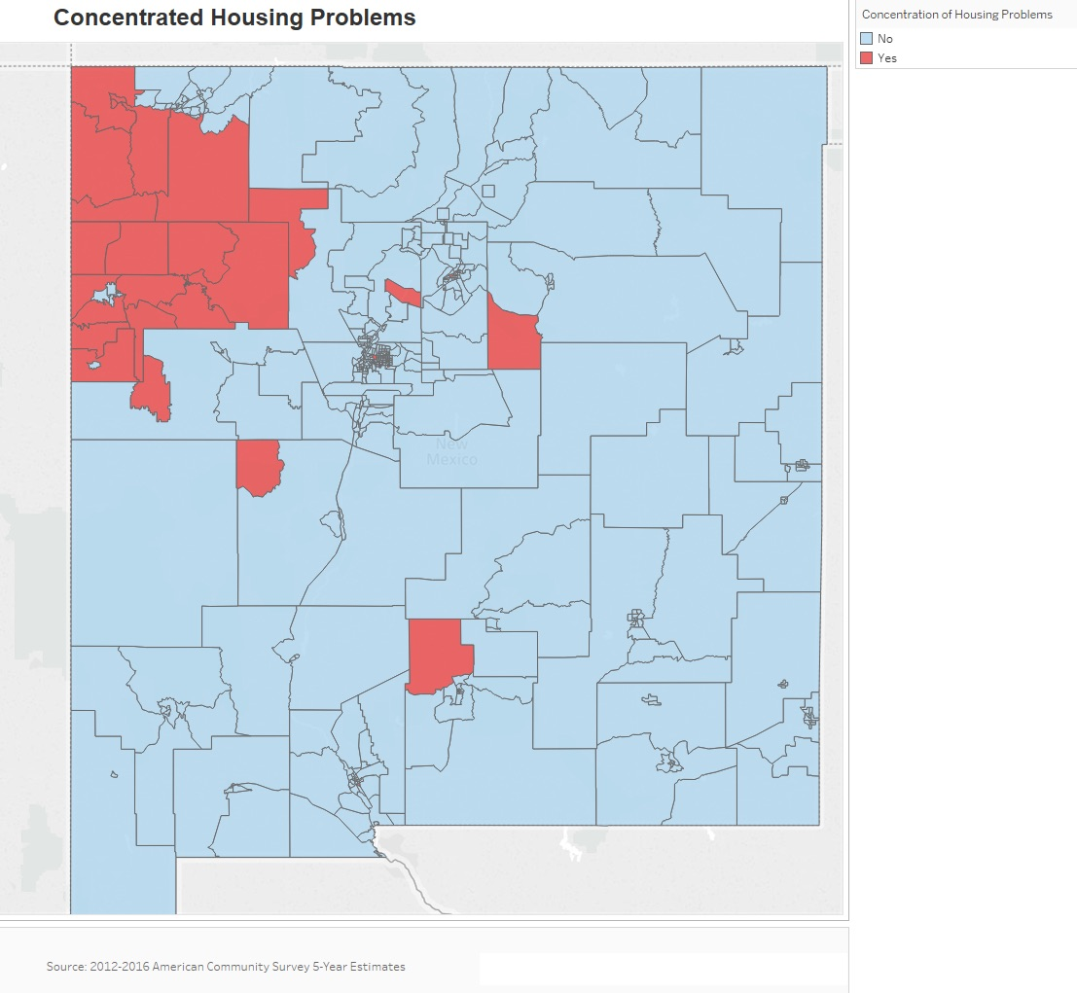

Are there any areas in the jurisdiction where racial or ethnic minorities or low-income families are concentrated? (include a definition of "concentration")
A concentration is a census tract with 10% more of a racial or ethnic group than the State average. The two most prominent non-white demographics are analyzed.
Statewide
Hispanic: 48.16%
American Indian: 9.46%
Poverty: 20.56%
Concentration
Hispanic: 58.16%
American Indian: 19.46%
Poverty: 30.56%
The Hispanic population has two areas of concentration in New Mexico. The first are the counties north and east of Santa Fe. The second concentration is to the south of Albuquerque. These areas have census tracts with a Hispanic population between 60% and 82.08%.
The northwest corner of the State shows a high concentration of Native Americans. Three counties (San Juan, McKinley and Cibola) all have disproportionately large Native American populations.
As shown in the Needs Assessment section of this document, poverty does show some concentration throughout the State. Specifically, tracts in the northwest with high Native American populations sometimes have poverty rates of over 40%. Similarly, some tracts near the border with Mexico show high levels of poverty.
What are the characteristics of the market in these areas/neighborhoods?
Areas with high concentrations of racial or ethnic minorities, low-income families and housing problems are found across the State of New Mexico. They tend to be near the border with Mexico or in the northwest where there are high concentrations of Native American households.
Are there any community assets in these areas/neighborhoods?
Many of the areas described earlier in this section are in the northwest quadrant of the State. San Juan, McKinley and Cibola overlap with tribal lands, including the Navajo Nation, Zuni Pueblo, Acoma Pueblo and Laguna Pueblo. San Juan County has the largest portion overlapping with tribal lands at 63% with the Navajo Nation. Due to land ownership rights, the majority of the tribal lands are rural and consist of mainly Native American populations. These areas include many physical community spaces that are assets for residents such as tribal chapter houses, historic landmarks, national parks and recreational sites, locally owned stores/trading posts and public secondary and primary schools. Other assets that promote cultural knowledge and cultural resources include land, wildlife, livestock, natural resources (coal), water, cultural and religious sites and single-family homes.
Are there other strategic opportunities in any of these areas?
Strategic opportunities in the northwest quadrant of the State include improved and expanding transportation infrastructure, creation of affordable housing (both traditional and modern) and development of clean energy production via solar and wind farms. Additionally, there are opportunities for economic development through expansion and improvements to public infrastructure including broadband and telecommunication systems. Further opportunities for community improvements include community festivals and fairs like the Navajo Nation Fair, community rodeos and outdoor flea markets, which are popular throughout the State.
Based on the needs analysis above, describe the State's needs in Colonias
Within the State of New Mexico, the Colonias at the Mexican border have high concentrations of low income persons and housing problems. These areas need a greater supply of safe and secure affordable housing and sufficient infrastructure. Resources in this area can have a relatively high impact.

Strategic Plan

SP-05 Overview
Strategic Plan Overview
The following list presents the overriding priority needs and associated goals of the New Mexico Five-Year Consolidated Plan for Housing and Community Development. Furthermore, there may be a need to direct such resources by use of project selection criteria, which may be updated annually, based upon year-to-year need and local circumstances.
The Consolidated Plan 2020-2024 priority needs and associated goals include:
Public Infrastructure and Facilities:
1A. Expand & Improve Public Infrastructure and Facilities
Affordable Housing Development and Rehabilitation:
2A. Rehabilitate Owner-Occupied Housing
2B. Increase Homeownership Opportunities
2C. Develop Affordable Rental Housing
2D. Develop Housing for Vulnerable Populations
Economic Development:
3A. Provide Assistance for Job Creation
Housing Assistance for Vulnerable Populations:
4A. Provide Assistance to Reduce Homelessness
4B. Provide Assistance for Shelters
4C. Provide Housing Assistance to Persons w/ HIV/AIDS

With the exception of (1) the 10% set-aside for Colonias under the CDBG program and (2) the specific use of the City of Albuquerque’s HOPWA grant within the City of Albuquerque, the State does not prioritize funds geographically. State CDBG funds are not used on state tribal reservations, otherwise, all other funds are available statewide to meet the goals established in this Consolidated Plan.

SP-10 Geographic Priorities – 91.315(a)(1)
Geographic Area
Table 45 - Geographic Priority Areas

1 | Area Name: | COLONIAS NEIGHBORHOOD
 | Area Type: | Local Target Area
 | Other Target Area Description: | A goal of at least ten percent of CDBG funds will be set aside for the Colonias communities.
 | HUD Approval Date: | To be determined
 | % of Low/ Mod: | <51% LMI
 | Revitalization Type: | Infrastructure improvements, economic development, housing and planning.
 | Other Revitalization Description:
 | Identify the neighborhood boundaries for this target area. | The U.S. Department of Housing and Urban Development (HUD) defines Colonias as rural communities in close proximity to the U.S-Mexico border, lacking access to basic services such as water, sewer, or housing. Communities must be designated Colonias and be within 150 miles of the U.S./Mexico border.
 | Include specific housing and commercial characteristics of this target area. | Housing and commercial activities in these communities are generally underserved. Fluctuations in transitory residents are due to the volatility of the oil and gas industry and other economic factors.
 | How did your consultation and citizen participation process help you to identify this neighborhood as a target area? | Although the need for housing and infrastructure is commonplace in Colonias, consultations and citizen participation confirmed these needs.
 | Identify the needs in this target area. | Housing and infrastructure.
 | What are the opportunities for improvement in this target area? | Combining local, state and federal funding to create more impactful and meaningful projects.
 | Are there barriers to improvement in this target area? | Lack of administrative capacity and financial resources serve as common barriers to improving this target area.
2 | Area Name: | Statewide
 | Area Type: | With the exception of (1) the 10% set-aside for Colonias under the CDBG program and (2) the specific use of the City of Albuquerque’s HOPWA grant within the City of Albuquerque, the State does not prioritize funds geographically. State CDBG funds are not used on state tribal reservations, otherwise, all other funds are available statewide.
 | Other Target Area Description:
 | HUD Approval Date: | To be determined
 | % of Low/ Mod: | <51% LMI
 | Revitalization Type: | Infrastructure improvements, economic development, housing and planning.
 | Other Revitalization Description:
 | Identify the neighborhood boundaries for this target area. | There are no neighborhood boundaries, and the funds are available statewide.
 | Include specific housing and commercial characteristics of this target area. | There are no specific housing and/or commercial characteristics for the target area, as the funds are available statewide.
 | How did your consultation and citizen participation process help you to identify this neighborhood as a target area? | Does not apply.
 | Identify the needs in this target area. | No target area exists.
 | What are the opportunities for improvement in this target area? | Does not apply.
 | Are there barriers to improvement in this target area? | The biggest barriers to improvement in the statewide area are the lack of funding and the lack of capacity.

General Allocation Priorities
Describe the basis for allocating investments geographically within the jurisdiction (or within the EMSA for HOPWA)
CDBG: A set-aside of ten percent of CDBG funds will be allocated for the Colonias communities. State CDBG funds are not used on state tribal reservations, otherwise, all other funds are available statewide to eligible entities. The State does not prioritize CDBG funds geographically.
HOME: All HOME funds are available statewide.
ESG: All ESG funds are available statewide.
HOPWA: MFA and the City of Albuquerque have signed a Memorandum of Understanding that allows for MFA to manage the City of Albuquerque funding received for the HOPWA program. These HOPWA funds will be used within the City of Albuquerque.
HTF: All HTF funds are available statewide.

SP-25 Priority Needs – 91.315(a)(2)
Priority Needs
Table 46 – Priority Needs Summary
1 | Priority Need Name | Expand & Improve Public Infrastructure & Facilities
 | Priority Level | High
 | Population | Extremely Low  Low  Moderate
 | Geographic Areas Affected | With the exception of a 10% set-aside of CDBG funds for the Colonias and funds received from the City of Albuquerque’s HOPWA program under an MOU with the City, the State does not prioritize funds geographically. State CDBG funds are not used on state tribal reservations, but otherwise funds are available statewide.
 | Associated Goals | 1A. Expand & Improve Public Infrastructure and Public Facilities
 | Description | Construction and rehabilitation of public facilities and public infrastructure through the CDBG program. Activities may include water and sewer infrastructure, drainage infrastructure, streets, sidewalks, parkways, parks, community centers, senior centers, youth centers, libraries, health centers, social service centers, rehabilitation centers, food banks, solid waste disposal, police and fire stations and equipment, ADA improvements and historic preservation.
 | Basis for Relative Priority | Perspectives collected through community survey, community focus groups and stakeholder interviews.
2 | Priority Need Name | Preserve & Develop Affordable Housing
 | Priority Level | High
 | Population | Extremely Low  Low  Moderate  Rural  Chronic Homelessness  Individuals  Families with Children  Mentally Ill  Chronic Substance Abuse  Veterans  Persons with HIV/AIDS  Victims of Domestic Violence  Unaccompanied Youth  Elderly  Persons with Mental Disabilities  Persons with Physical Disabilities  Persons with Developmental Disabilities  Persons with Alcohol or Other Addictions  Persons with HIV/AIDS and their Families  Persons with HIV/AIDS and their Families  Victims of Domestic Violence
 | Geographic Areas Affected | With the exception of a 10% set-aside of CDBG funds for the Colonias and funds received from the City of Albuquerque’s HOPWA program under an MOU with the City, the State does not prioritize funds geographically. State CDBG funds are not used on state tribal reservations, but otherwise funds are available statewide.
 | Associated Goals | 2A. Rehabilitate Owner-Occupied Housing  2B. Increase Homeownership Opportunities  2C. Develop Affordable Rental Housing  2D. Develop Housing for Vulnerable Populations
 | Description | Rehabilitation of owner-occupied single-family housing, new construction of single-family housing for homeownership, provision of down payment assistance, development of affordable rental housing, development of housing for vulnerable populations, which may include special needs housing and housing for persons experiencing homelessness. Funding sources include HOME, CDBG and HTF. Activities may include ADA improvements, weatherization, mobile home replacement, reconstruction, historic preservation, new construction for rental and homeownership, rehabilitation for rental and homeownership, acquisition, disposition, demolition, clearance, down payment assistance, closing costs, homebuyer education and housing for special populations such as veterans, persons experiencing homelessness, the elderly, ex-offenders, vulnerable populations etc.
 | Basis for Relative Priority | Data and Market Analysis; perspectives collected through community survey, community focus groups and stakeholder interviews.
3 | Priority Need Name | Economic Development Opportunities
 | Priority Level | High
 | Population | Extremely Low  Low  Moderate  Non-housing Community Development
 | Geographic Areas Affected | With the exception of a 10% set-aside of CDBG funds for the Colonias and funds received from the City of Albuquerque’s HOPWA program under an MOU with the City, the State does not prioritize funds geographically. State CDBG funds are not used on state tribal reservations, but otherwise funds are available statewide.
 | Associated Goals | 3A. Provide Assistance for Job Creation
 | Description | Promote job growth and retention through investment into local economies. Funding source is CDBG. Activities may include job training and business assistance.
 | Basis for Relative Priority | Data and Market Analysis; perspectives collected through community survey, community focus groups and stakeholder interviews.
4 | Priority Need Name | Housing Assistance for Vulnerable Populations
 | Priority Level | High
 | Population | Extremely Low  Low  Rural  Chronic Homelessness  Individuals  Families with Children  Mentally Ill  Chronic Substance Abuse  Veterans  Persons with HIV/AIDS  Victims of Domestic Violence  Unaccompanied Youth  Elderly  Persons with Mental Disabilities  Persons with Physical Disabilities  Persons with Developmental Disabilities  Persons with Alcohol or Other Addictions  Persons with HIV/AIDS and their Families  Persons with HIV/AIDS and their Families  Victims of Domestic Violence
 | Geographic Areas Affected | With the exception of a 10% set-aside of CDBG funds for the Colonias and funds received from the City of Albuquerque’s HOPWA program under an MOU with the City, the State does not prioritize funds geographically. State CDBG funds are not used on state tribal reservations, but otherwise funds are available statewide.
 | Associated Goals | 4A. Provide Assistance to Reduce Homelessness  4B. Provide Assistance to Shelters  4C. Provide Housing Assistance to Persons w/ HIV/AIDS
 | Description | Provide assistance to individuals and families experiencing or at-risk of homelessness and persons with HIV/AIDS. Funding sources are ESG and HOPWA. Activities include permanent housing placement, Short-Term Rent, Mortgage, and Utility (STRMU) assistance, Tenant-Based Rental Assistance (TBRA), emergency shelter operating costs and essential services, rapid re-housing assistance and homelessness prevention assistance.
 | Basis for Relative Priority | Data and Market Analysis; perspectives collected through community survey, community focus groups and stakeholder interviews.

SP-30 Influence of Market Conditions – 91.315(b)
Influence of Market Conditions
Affordable Housing Type | Market Characteristics that will influence  the use of funds available for housing type
Tenant Based Rental Assistance (TBRA) | Due to limited HOME funding, the State does not utilize HOME funds for Tenant Based Rental Assistance. All of MFA's rental assistance programs are funded with ESG, HOPWA or State funding.
TBRA for Non-Homeless Special Needs | The Non-Homeless Special Needs populations within the State have a variety of housing needs throughout the State. The increase in demand for rentals and the increase in the price of rentals will place a high need for special need populations within the State. These increases make rentals unaffordable to many special needs populations. Due to limited HOME funding, the State does not utilize HOME funds for Tenant Based Rental Assistance. MFA utilizes HOPWA to fund TBRA for persons with HIV/AIDS.
New Unit Production | As shown by the Needs Assessment and Market Analysis sections, housing production has not kept pace with the rate of demand, resulting in an increase in price. From a statewide quantitative standpoint, there is a sufficient supply of housing units available for the entire population; however, a closer look at the production of units and housing needs for individual locales across the state shows there is a geographic misalignment and a shortage of new unit production to cover the gaps in supply.  Single-family housing production has been relatively steady since 2010 with 3,200-4,000 new units per year. This is a relatively low production rate when compared to the previous decade. For example, from 2002 to 2006 over 10,000 single-family homes were produced annually. The State has also seen a slowdown in rental housing production – especially in smaller multi-family buildings with 2-4 units. The number of households in the State continues to increase, particularly non-family households. Non-family households tend to increase demand for smaller units, particularly 1-bedroom and 2-bedroom rental units. (Source: US Census Bureau, Building Permits Survey)  New unit production is primarily needed in areas where the population growth has been greatest. Since 2000, the high growth areas have been urban areas like Albuquerque/Santa Fe, Las Cruces and the southeastern part of the State (Lea County). In comparison, the rural areas have seen very slow population growth or even decline. As a result, housing vacancy is also much more prominent in most of the same rural areas of the State. This in part explains that while overall there is adequate housing to supply the entire population, it does not meet the needs of the population of where housing is needed.  New units, particularly rental units, produced in the areas with the most demand will increase the number of affordable units available to New Mexico households.
Rehabilitation | As mentioned previously, there is a need to increase new housing production to meet the demands of the population in the State. Equally important is to maintain the current housing stock through repair, minor rehabilitation or, in some cases, major rehabilitation of owner and renter housing units. As the housing stock ages, it becomes increasingly important to maintain the homes. Older homes are at more risk of becoming dilapidated and not suitable for living, and in turn cause more stress on the housing market supply and increase the demand for affordable housing.  In New Mexico, there is a large percentage of homes built before 1980. In general, older housing units are more susceptible to higher maintenance, the need for repairs and/or rehabilitation and lead-based paint hazards. From a statewide view, approximately 44% of owner-occupied housing (228,587 units) and 50% of renter-occupied housing (123,071 units) were built before 1980. However, homes in rural areas are generally older than in urban areas, especially in the northeast areas of the State and in particular Union, Harding and Quay Counties. Further, with an aging population, there will be a need for rehabilitation associated with accessibility improvements.  This necessitates rehabilitation of existing units, both rental and homeowner, in order to meet the needs of households throughout the State.
Acquisition, including preservation | Vacant housing, which is most common in rural areas, is most at risk of deteriorating and falling into dilapidated conditions. Acquisition of vacant or dilapidated housing units will allow for rehabilitation and new unit development.  In addition, providing funds for acquisition can help lower the total cost of development and leverage limited funding to create much needed affordable housing units. Planning efforts with developers will work towards the efficient use or resources and cost effective development of housing.  As shown previously in this Plan, there are a number of subsidized units at risk of expiring. As the demand for affordable rental units continues to increase, the loss of these units will place additional households in need. This, in addition to survey results, have indicated a high level of need for preservation of affordable units.
Table 47 – Influence of Market Conditions

SP-35 Anticipated Resources - 91.315(a)(4), 91.320(c)(1,2)
Introduction
Housing and community development resources are expected to be available to the State of New Mexico through HUD under several federal block grant programs. These block grants include the CDBG, HOME, ESG, HOPWA and HTF programs. The CDBG program provides much needed infrastructure improvements, planning grants, opportunities for economic development and housing. Other anticipated resources for the CDBG program include other federal funds, state and local funds as well as investments from local businesses. The HOME program will produce program income that will also be available for program-specific housing and community development activities in the State. MFA and its partner agencies may compete for additional resources under the Supportive Housing Program, Shelter Plus Care, Section 811 Housing, Section 202 Housing, Rural Innovation Fund, Housing Counseling or other types of programs. Many partners leverage their resources with other funding sources that they receive directly such as Self-Help Homeownership Opportunity Program (SHOP) and Native American Housing Assistance and Self Determination Act NAHASDA funding.
Additional federal resources utilized by MFA, DFA and their partners will include HUD’s Recovery Housing Program, Victims of Crime Act grants, assistance from the Federal Emergency Management Agency, HUD Veterans Housing Rehabilitation Program, USDA Section 502 Program, FHA loan programs, Mortgage Revenue Bonds (MRBs), Low Income Housing Tax Credits (LIHTC) available from the Internal Revenue Service (IRS), HUD 542(c) Risk Sharing Program, United States Department of Agriculture (USDA) programs (i.e. Section 538, USDA Preservation Revolving Loan Fund), HUD Section 8 Project-Based Rental Assistance, HUD Section 811 Project Rental Assistance and the Federal Home Loan Bank (FHLB) Affordable Housing Program.
Other nonfederal resources that could be available to MFA, DFA and their partners include resources from State legislative allocations, New Mexico Human Services Department funding, New Mexico Children, Youth & Families Department funding, the New Mexico Housing Trust Fund, the Affordable Housing Charitable Trust, the MFA Primero Fund and the New Mexico Affordable Housing Tax Credit. Further, local governments may provide resources, and private support may be available from organizations such as the United Way and the Ventana Fund (a Community Development Financial Institution), or from developer contributions (e.g. - land, deferred developer fee, loans) and private donations.
As part of the Coronavirus Aid Relief and Economic Securities Act (CARES Act), MFA and DFA received funding from HUD that is available to CDBG, ESG and HOPWA. These funds will be identified as CDBG-CV, ESG-CV and HOPWA-CV. Unless otherwise noted or depicted separately, references in the Strategic Plan to CDBG, ESG and HOPWA also refer to CDBG-CV1, ESG-CV1 and HOPWA-CV1, respectively for the first allocation and CDBG-CV2 and ESG-CV2, respectively for the second allocation.
MFA received $4,140,483.00 in ESG-CV1 funding. The focus of the program is to assist people to quickly regain stability in permanent housing after experiencing a housing crisis and/or homelessness. The allowable activities for this funding are maintaining and updating of the Homeless Management Information System (HMIS), Shelter Operations, Essential Services, Homeless Prevention and Rapid Re-Housing. The program is intended to be used for the most vulnerable populations who meet the eligibility criteria as outlined in the ESG regulation under 24 CFR Part 576.
HUD awarded HOPWA-CV1 funding to the City of Albuquerque in the amount of $76,795 and to MFA in the amount of $69,375 for a total of $146,170. HOPWA funds are used to provide housing assistance for low-income individuals living with HIV/AIDS and their families. Services can be in the form of Tenant Based Rental Assistance (TBRA), Short Term Rent, Mortgage, and Utility Assistance (STRMU) and Permanent Housing Placement (PHP). TBRA pays a portion of the clients monthly rent, STRMU provides temporary assistance to prevent homelessness and PHP is used to pay for security deposits, utility connection fees and first month’s rent.
DFA received $6,802,356 in CDBG-CV1 funding and $5,528,301 in CDBG-CV2 funding. The CARES Act adds additional flexibility for CDBG in these unprecedented times. The objective, as such, shall be to help New Mexicans to the greatest extent possible, the majority of whom are low to moderate income.
The chart below describes how each HUD program is supported by additional funds from other federal sources and state, local and private funding.

PROGRAM | POTENTIAL ADDITIONAL SOURCES OF FUNDS
 | Other Federal or Federally Subsidized | State | Local | Private
CDBG | United States Department of Agriculture (USDA) | State legislative allocation, Colonias Infrastructure funds and Water Trust Board funds | Local government contributions | Community Assistance Corporation and private funding (economic development)
ESG – Rental Assistance Program (RAP) | None | State legislative allocation, New Mexico Human Services Department funding | Local government contributions | None
ESG – Emergency Homeless Assistance Program (EHAP) | Victims of Violent Crime Act (VOCA)  Federal Emergency Management Agency (FEMA) | State legislative allocation, New Mexico Children, Youth & Families Department funding | Local government contributions | United Way, private donations
HOPWA | None | None | None | None
HOME - Homeowner Rehabilitation | Community Development Block Grant (CDBG), HUD Veterans Housing Rehabilitation Program | None | Local government contributions | None
HOME - Single Family Homeownership Development | Self-Help Homeownership Opportunity Program (SHOP), USDA Section 502 Program, Federal Housing Administration (FHA) loan programs | New Mexico Housing Trust Fund, MFA Primero Fund, New Mexico Affordable Housing Tax Credit | Local government contributions | Private lenders, private donations
HOME - Rental | Low Income Housing Tax Credit (LIHTC), tax-exempt bonds, HUD 542(c) Risk Sharing Program, USDA programs (i.e. Section 538, USDA Preservation Revolving Loan Fund), HUD Section 8 Project-Based Rental Assistance, Section 811 Project Rental Assistance, Federal Home Loan Bank (FHLB) Affordable Housing Program | New Mexico Housing Trust Fund, MFA Primero Fund, New Mexico Affordable Housing Tax Credit | Local government contributions | Private lenders, Ventana Fund (Community Development Financial Institution- CDFI), developer contributions (land, deferred developer fee, loans), private donations
HTF | LIHTC, tax-exempt bonds, HUD 542(c) Risk Sharing Program, USDA programs (i.e. Section 538, USDA Preservation Revolving Loan Fund), HUD Section 8 Project-Based Rental Assistance, Section 811 Project Rental Assistance, FHLB Affordable Housing Program | New Mexico Housing Trust Fund, MFA Primero Fund, New Mexico Affordable Housing Tax Credit | Local government contributions | Private lenders, Ventana Fund (CDFI), developer contributions (land, deferred developer fee, loans), private donations

Anticipated Resources
Because the citizen participation process was conducted prior to receiving the 2020 allocations of funding amounts from HUD, the draft Consolidated Plan published for comment was based on estimated funding amounts and included contingency provisions stating that all proposed budgets would be proportionally increased or decreased from the estimated funding levels to match actual allocation amounts. Once the final allocations were made, the State adjusted its funding amounts accordingly before submission of the Consolidated Plan to HUD.
Program | Source of Funds | Uses of Funds | Expected Amount Available Year 1 |  |  |  | Expected Amount Available Remainder of ConPlan  $ | Narrative Description
 |  |  | Annual Allocation: $ | Program Income:  $ | Prior Year Resources: $ | Total:  $
CDBG | public - federal | Admin and Planning  Acquisition  Economic Development  Housing  Public Improvements  Public Facilities Homelessness Prevention | 11,577,987 | 250,000 | 400,000 | 12,227,987 | 47,229,545 | The State will set side 10% of its CDBG allocation for Colonias. State CDBG funds are not used on state tribal reservations.  The State anticipates receiving approval from HUD to transfer program income received from the Neighborhood Stabilization Program to the CDBG Program. In Year 1, this is projected to be $250,000, and in Years 2-5, this is projected to be $917,597.
HOME | public - federal | Admin and Planning  Acquisition  Homebuyer assistance  Homeowner rehab  Multifamily rental new construction  Multifamily rental rehab  New construction for ownership | 5,245,062 | 1,181,284 | 5,594,331 | 12,020,677 | 20,980,248 | Funds may be used statewide.
HOPWA | public - federal | Permanent housing placement  Short-Term Rent, Mortgage and Utility (STRMU) assistance  Tenant-Based Rental Assistance (TBRA) | 1,004,413 | 0 | 0 | 1,004,413 | 4,017,652 | In addition to its direct allocation, MFA administers the City of Albuquerque HOPWA allocation under a memorandum of understanding as well, and those funds are used specifically in the City of Albuquerque.
ESG | public - federal | Financial Assistance  Overnight shelter  Rapid re-housing (rental assistance)  Rental Assistance  Services | 1,200,740 | 0 | 0 | 1,200,740 | 4,802,960 | Funds may be used statewide.
Housing Trust Fund | public - federal | Multifamily rental new construction  Multifamily rental rehab | 3,000,000 | 0 | 1,830,000 | 4,830,000 | 12,000,000 | Funds may be used statewide.
CDBG-CV1 | public - federal | To prevent, prepare for and respond to the Coronavirus | 6,802,356 | 0 | 0 | 6,802,356 | 0 | CDBG-CV1 funds to be used to prevent, prepare for and respond to the Coronavirus.
ESG-CV1 | public - federal | To prevent, prepare for and respond to the Coronavirus | 4,140,483 | 0 | 0 | 4,140,483 | 0 | ESG-CV1 funds to be used to prevent, prepare for and respond to the Coronavirus.
HOPWA-CV1 | public - federal | To prevent, prepare for and respond to the Coronavirus | 146,170 | 0 | 0 | 146,170 | 0 | HOPWA-CV1 funds to be used to prevent, prepare for and respond to the Coronavirus.
CDBG-CV2 | public - federal | To prevent, prepare for and respond to the Coronavirus | 5,528,301 | 0 | 0 | 5,528,301 | 0 | CDBG-CV2 funds to be used to prevent, prepare for and respond to the Coronavirus.
Table 48 - Anticipated Resources

Explain how federal funds will leverage those additional resources (private, state and local funds), including a description of how matching requirements will be satisfied
Federal funds in the programs shown above are leveraged in many ways. CDBG funds are leveraged primarily with appropriations from the state legislature and the local government. This leverage equates to a dollar to dollar match after the first $100,000. HOME and HTF funds are leveraged with HUD’s Veterans Housing Rehabilitation and Modification Program, SHOP, USDA Section 502 Program, FHA loan programs, Mortgage Revenue Bonds (MRBs), LIHTC available from the IRS, HUD 542(c) Risk Sharing Program, USDA programs (i.e. Section 538, USDA Preservation Revolving Loan Fund), HUD Section 8 Project-Based Rental Assistance, the FHLB Affordable Housing Program, the state’s General Fund, the New Mexico Housing Trust Fund, the New Mexico Affordable Housing Tax Credit, the Primero Fund, the Ventana Fund, and a variety of private and local funding sources.
ESG is leveraged with appropriations from the state legislature and is used in conjunction with VOCA, FEMA, New Mexico Children, Youth & Families Department funding, New Mexico Human Services Department funding, local government contributions, United Way funding and private donations. After the first $100,000, all expenses must be matched dollar for dollar. Cash, non-cash, and program income must meet requirements of § 576.201. Matching funds must be contributed to the ESG program and expended for the subrecipient's allowable ESG costs. Emergency Homeless Assistance program (EHAP) subrecipients shall be required to provide matching funds in an amount at least equal to their approved ESG funding amounts for eligible program activities. Eligible match sources include: cash; the value or fair rental value of any donated material or building; the value of any lease on a building; any salary paid to staff to carry out the program of the recipient and the value of the time and services contributed by volunteers to carry out the program of the subrecipient at a current rate of $5 per hour. Volunteers providing professional services such as medical or legal services are valued at the reasonable or customary rate in the community. Match requirements for the Rental Assistance Program (RAP) are met by MFA’s legislative appropriations for state homeless programs.
Match requirements of the HOME program will be met by three primary sources: 1) Resources committed by grantees and local governments; 2) Proceeds from mortgage revenue bonds; and 3) MFA general fund interest subsidy. Eligible forms of HOME match are documented by MFA and reported to HUD as part of the Consolidated Annual Performance and Evaluation Report (CAPER) each year.
If appropriate, describe publicly owned land or property located within the state that may be used to address the needs identified in the plan
This section is not applicable.
Discussion
The State receives CDBG, HOME, ESG, HOPWA and HTF funds. With the exception of a 10% set-aside of CDBG funds for Colonias and the specific use of HOPWA funds administered on behalf of the City of Albuquerque, the State does not prioritize funds geographically. State CDBG funds are not used on state tribal reservations, but otherwise funds are available statewide. The State makes special efforts to leverage all funds through other federal, state, local and private sources to further address the needs identified in this Consolidated Plan.

SP-40 Institutional Delivery Structure – 91.315(k)
Explain the institutional structure through which the jurisdiction will carry out its Consolidated Plan including private industry, non-profit organizations and public institutions.
Responsible Entity | Responsible Entity Type | Role | Geographic Area Served
New Mexico Mortgage Finance Authority | Government | Homelessness  Ownership  Rental  Planning  Special Needs | State
Department of Finance and Administration | Government | Economic Development  Planning  Neighborhood Improvements  Public Facilities  Ownership  Rental | State
Table 49 - Institutional Delivery Structure

Assess of Strengths and Gaps in the Institutional Delivery System
MFA and DFA take initiatives to address potential gaps in the institutional delivery system by instilling capacity through funding initiatives, outreach and training and other capability building endeavors. Further, MFA and DFA engage in proactive efforts to ensure continued strength of their program delivery. A noted strength is that MFA and DFA are aware that despite these efforts, some gaps exist and have taken the following steps to address them and build strength:
ADMINISTRATIVE FUNDS: DFA recognizes that deficient administrative capacity at the local level can hinder the success of CDBG projects. In an effort to overcome this obstacle, DFA allows communities to use CDBG funding (up to 3% of each project) for professional administrative service providers.
TRAINING AND TECHNICAL ASSISTANCE PROGRAM: The mission of MFA is to ensure funding and resources are available to New Mexico communities to address problems of substandard housing, housing affordability and lack of housing services. While limited funding is an obstacle, the greater challenge is local capacity. The greatest capacity deficiencies exist in the rural areas of the State. Large established non-profits that provide services regionally often become the default providers for these areas. MFA provides training and technical assistance to help address gaps in rural areas.
Further, DFA provides technical assistance and training on federal and legislative funding. DFA’s Local Government Division (LGD) provides two CDBG workshops every year. Once per year DFA/LGD conducts a CDBG Application Workshop to train counties, municipalities and special districts on how to prepare a CDBG application. A CDBG Implementation Workshop is conducted for these applicants once per year to provide technical assistance on implementing a CDBG grant. DFA/LGD provides additional CDBG training at the following conferences: New Mexico Municipal League, New Mexico Association of Counties, Infrastructure Finance Conference and DFA Financial Conference. These training opportunities help to address weaknesses but also seek to build capacity and provide proactive assistance to subrecipients.
USE OF ADVISORY AND OVERSIGHT COMMITTEES: A strength of the institutional delivery system is the use of advisory and oversight committees. The MFA initiates and provides communication opportunities in many venues. For example, MFA receives input several times per year from a number of external advisory and oversight committees comprising representatives from various housing-related industries, governing entities and geographic areas of the State to advise and comment on activities undertaken with federal dollars. These committees include the Mortgage Finance Authority Act Legislative Oversight Committee, the New Mexico Planning Team, the New Mexico Housing Trust Fund Advisory Committee, the Land Title Trust Fund Advisory Committee, the MFA Homeownership Advisory Committee and the Tax Credit Allocation Committee. By keeping open lines of communication and working collaboratively with the committees, the State is able to build stronger networks are service delivery and leverage resources across all programs.
Assess the strengths and gaps in the institutional delivery system working within the Colonias
Oftentimes, the Colonias lack the capacity to be able to apply for or implement funding due to a lack of local governments and resources. The state has three experienced providers for the Colonias (Tierra del Sol, Southwestern Regional Housing and Community Development Corporation and White Sands Habitat for Humanity.) Of the three providers mentioned, all three provide housing rehabilitation. While all three are able to deliver new housing development, only one has been able to deliver on a subdivision scale. Unfortunately, not all Colonias are covered by these organizations, and the State would need additional providers or providers to expand their service area to meet those needs. Providers are stretched thin and capacity is a challenge. The State has a need for additional funding, but the current delivery system would not be able to execute too much more additional funding due to the limited number of providers.
Availability of services targeted to homeless persons and persons with HIV and mainstream services
Homelessness Prevention Services | Available in the Community | Targeted to Homeless | Targeted to People with HIV
Homelessness Prevention Services
Counseling/Advocacy | X | X | X
Legal Assistance | X |  | X
Mortgage Assistance | X |  | X
Rental Assistance | X | X | X
Utilities Assistance | X |  | X

Street Outreach Services
Law Enforcement | X
Mobile Clinics | X
Other Street Outreach Services | X | X

Supportive Services
Alcohol & Drug Abuse | X | X
Child Care | X | X
Education | X | X
Employment and Employment Training | X | X
Healthcare | X | X | X
HIV/AIDS | X | X | X
Life Skills | X | X | X
Mental Health Counseling | X | X | X
Transportation | X | X

Table 50 - Homeless Prevention Services Summary

Describe the extent to which services targeted to homeless persons and persons with HIV and mainstream services, such as health, mental health and employment services are made available to and used by homeless persons (particularly chronically homeless individuals and families, families with children, veterans and their families and unaccompanied youth) and persons with HIV within the jurisdiction
A number of organizations in the State of New Mexico offer a variety of services targeted to individuals and families experiencing homelessness. Coordinating these organizations is the New Mexico Coalition to End Homelessness (NMCEH), which staffs the two Continuums of Care (CoCs) operating in the State. Many of these organizations conduct outreach to those experiencing homelessness, and the implementation of a coordinated assessment system managed by NMCEH is facilitating the provision of services.
The CoCs also assist persons experiencing homelessness in accessing mainstream services, such as the services provided by the following agencies:
The NM Human Services Department (HSD) administers an array of mainstream services which complement homeless services through programs such as behavioral health services, cash assistance for low-income individuals with disabilities, Medicaid, the Supplemental Nutrition Assistance Program (SNAP), Temporary Assistance for Needy Families (TANF), among others. MFA also partners with HSD on the Behavioral Health Collaborative and works across state agencies to collaborate on behavioral health issues, supportive services and housing.

New Mexico Workforce Connection, with 21 centers statewide, and the New Mexico Division of Vocational Rehabilitation (NM DVR), with over 25 offices statewide, provide training, career placement, internships, apprenticeship and veteran services in the area of vocational development and supportive employment. Both Workforce Connection and NM DVR accept direct referrals from healthcare providers, clinicians, case managers and homeless service providers.
A combination of private non-profit providers and the NM Department of Health provide HIV/AIDS services in New Mexico. The Department of Health administers the HIV/AIDS Prevention Program, which exists to reduce the incidence of HIV transmission in New Mexico through planning, funding, coordination and evaluation of HIV prevention activities for at-risk populations across New Mexico.
Describe the strengths and gaps of the service delivery system for special needs population and persons experiencing homelessness, including, but not limited to, the services listed above
The State’s homeless and behavioral health services have improved in recent years, but the challenges are so great that resources will always lag behind the needs. Gaps in the service delivery system include limited service capacity due to inadequate funding, limited proximity/accessibility to services due to transportation needs, insufficient supply of permanent supportive housing units, limited housing options for individuals living with alcohol or substance abuse and limited housing and employment opportunities for those exiting incarceration. Strengths include the various community, healthcare and housing programs coordinating street outreach and supportive services across the State; “one-stop” programs offered through various agencies that provide resources and supportive services in single locations, thereby alleviating transportation barriers and fostering more continuity of care for recipients of services; the data collection system managed by the New Mexico Coalition to End Homelessness (NMCEH), which tracks progress in ending homelessness; the coordinated assessment system managed by NMCEH that helps those experiencing homelessness to quickly connect to housing and the Albuquerque and Balance of State CoCs that provide planning and coordination among service providers.
Provide a summary of the strategy for overcoming gaps in the institutional structure and service delivery system for carrying out a strategy to address priority needs
In addition to the strategies noted in above in the question addressing the strengths and weaknesses in the institutional delivery system, MFA and DFA recognize that many times, the difference between success and failure in a partnership is in the ability to operate with an effective communication system. In an effort to help organizations develop that capacity, MFA and DFA will continue their outreach to a variety of agencies and entities involved with housing and community development activities in New Mexico, including the Behavioral Health Collaborative, the New Mexico Department of Mental Health, New Mexico Professional Technical Advisory Board (PTAB), Councils of Governments (COG), New Mexico Environment Department (NMED), New Mexico Department of Transportation (NMDOT), USDA Rural Development (USDA-RD), New Mexico Aging and Long-Term Services (ALTSD), New Mexico State Fire Marshal Office (SFMO), New Mexico Department of Health (NMDOH), Children Youth and Families Department (CYFD), New Mexico Governor’s Commission on Disability (GCD), New Mexico Office of the State Engineer (OSE), New Mexico Finance Authority (NMFA) and New Mexico Public Regulation Commission (PRC).
MFA receives input throughout the year from a number of external advisory and oversight committees comprising representatives from various housing-related industries, political parties and geographic areas of the State to advise and comment on activities undertaken with federal dollars. These committees include the Mortgage Finance Authority Act Legislative Oversight Committee, the New Mexico Housing Trust Fund Advisory Committee, the Land Title Trust Fund Advisory Committee, the MFA Homeownership Advisory Committee and the Allocation Review Committee. MFA will continue to work with and consult with these committees regarding activities undertaken or proposed changes in activities to be undertaken throughout the tenure of this plan. MFA also coordinates periodic meetings of participating jurisdictions to provide training and support and to coordinate resources. MFA also facilitates the New Mexico Tribal Homeownership Coalition, which coordinates the various tribes and pueblos on housing-related issues.
DFA continually seeks input from the Community Development Council (CDC), Council of Governments, Mayors, County Commissioners, County Managers, Grants Administrators, other Local and County officials, as well as other state agencies on infrastructure, public facilities, planning, economic development, emergency and housing needs across the State. DFA is also in the process of collaborating with other state agencies to streamline the funding, application and program processes across the State. In the future, these efforts will help maximize funding and mainstream the grants administration process for all municipalities and counties.

SP-45 Goals Summary – 91.315(a)(4)
Goals Summary Information
Because the citizen participation process was conducted prior to receiving the 2020 allocations of funding amounts from HUD, the draft Consolidated Plan published for comment was based on estimated funding amounts and included contingency provisions stating that all proposed budgets would be proportionally increased or decreased from the estimated funding levels to match actual allocation amounts. Once the final allocations were made, the State adjusted its funding amounts accordingly before submission of the Consolidated Plan to HUD.

Sort Order | Goal Name | Start Year | End Year | Category | Geographic Area | Needs Addressed | Funding | Goal Outcome Indicator
1 | 1A. Expand & Improve Public Infrastructure and Facilities | 2020 | 2024 | Non-Housing Community Development | Statewide | Expand & Improve Public Infrastructure & Facilities | CDBG: $53,951,057 | Public Facility or Infrastructure Activities other than Low/Moderate Income Housing Benefit:  162,708 Persons Assisted
2 | 2A. Rehabilitate Owner-Occupied Housing | 2020 | 2024 | Affordable Housing | Statewide | Preserve & Develop Affordable Housing | HOME: $19,007,016  CDBG: $1,627,079 | Homeowner Housing Rehabilitated:  193 Household Housing Units
3 | 2B. Increase Homeownership Opportunities | 2020 | 2024 | Affordable Housing | Statewide | Preserve & Develop Affordable Housing | HOME: $1,435,135  [Pending Separate 30-Day Public Comment Period - $1,167,597 of CDBG] | Homeowner Housing Added:  8 Household Housing Units [Pending Separate 30-Day Public Comment Period – Changed to 16 Households]  Direct Financial Assistance to Homebuyers: 8 Households Assisted
4 | 2C. Develop Affordable Rental Housing | 2020 | 2024 | Affordable Housing | Statewide | Preserve & Develop Affordable Housing | HOME: $12,558,774  CDBG: $1,084,720 | Rental units constructed:  21 Household Housing Units  Rental units rehabilitated:  28 Household Housing Units
5 | 2D. Develop Housing for Vulnerable Populations | 2020 | 2024 | Affordable Housing | Statewide | Preserve & Develop Affordable Housing | Housing Trust Fund: $16,830,000 | Rental units constructed:  28 Household Housing Units  Rental units rehabilitated: 28 Household Housing Units
6 | 3A. Provide Assistance for Job Creation | 2020 | 2024 | Non-Housing Community Development | Statewide | Economic Development Opportunities | CDBG: $596,454 | Jobs created/retained:  17Jobs  Businesses assisted:  1 Businesses Assisted
7 | 4A. Provide Assistance to Reduce Homelessness | 2020 | 2024 | Homeless | Statewide | Housing Assistance for Vulnerable Populations | ESG: $2,852,615  ESG-CV1: $2,404,290  CDBG: $1,030,625  CDBG-CV1: $6,802,356  CDBG-CV2: $5,528,301 | Tenant-based rental assistance / Rapid Rehousing:  1,532 Households Assisted  Homelessness Prevention:  9,896 Persons Assisted
8 | 4B. Provide Assistance for Shelters | 2020 | 2024 | Homeless | Statewide | Housing Assistance for Vulnerable Populations | ESG: $3,151,085  ESG-CV1: $1,736,193 | Homeless Person Overnight Shelter:  33,422 Persons Assisted
9 | 4C. Provide Housing Assistance to Persons w/ HIV/AIDS | 2020 | 2024 | Non-Homeless Special Needs | Statewide | Housing Assistance for Vulnerable Populations | HOPWA: $5,022,065  HOPWA-CV1: $146,170 | Tenant-based rental assistance / Rapid Rehousing:  426 Households Assisted  Homelessness Prevention:  752 Households Assisted
Table 51 – Goals Summary

Goal Descriptions
1 | Goal Name | 1A. Expand & Improve Public Infrastructure and Public Facilities
 | Goal Description | The State will focus on providing a suitable living environment through improvements to and creation of infrastructure and facilities.
2 | Goal Name | 2A. Provide for Owner-Occupied Housing Rehab
 | Goal Description | The state’s aging housing stock is in need of assistance, and this goal can be addressed by facilitating owner-occupied housing rehabilitation and exploring funding for emergency repair, weatherization or accessibility improvements to owner-occupied units.
3 | Goal Name | 2B. Increase Homeownership Opportunities
 | Goal Description | In New Mexico, many people wish to have the financial capability to be homeowners, and there remains a need to provide affordable new construction for single-family homeownership, homebuyer financial assistance and homebuyer education.
4 | Goal Name | 2C. Develop Affordable Rental Housing
 | Goal Description | Because New Mexico’s population is expanding in the more urban areas and a portion of this population may not be ready for homeownership, there remains a need to provide affordable new construction rental opportunities. Furthermore, in areas of static, or potentially declining populations, there remain opportunities to develop and redevelop sites with desirable rental housing, thereby assisting to resuscitate communities in New Mexico. In addition, throughout the state, there is a need for rehabilitation of aging rental properties.
5 | Goal Name | 2D. Develop Housing for Vulnerable Populations
 | Goal Description | To address the housing challenges of vulnerable populations with extremely low incomes, including those experiencing homelessness and those with special needs, the State will provide funds for new construction or rehabilitation of rental units targeted to these populations.
6 | Goal Name | 3A. Provide Assistance for Job Creation
 | Goal Description | The State will provide assistance for job creation efforts to support capacity building and self-sufficiency for low and moderate income individuals.
7 | Goal Name | 4A. Provide Assistance to Reduce Homelessness
 | Goal Description | The State will provide funds for the provision of homelessness prevention and rapid re-housing assistance, including rental assistance, homeownership assistance and utility assistance.
8 | Goal Name | 4B. Provide Assistance for Shelters
 | Goal Description | The State will provide assistance for emergency shelter operations and services.
9 | Goal Name | 4C. Provide Housing Assistance to Persons w/ HIV/AIDS
 | Goal Description | The State will provide funds for the provision of short term rent, mortgage and utility payments, continued rental assistance for low-income households, and permanent housing placement assistance for individuals who are HIV-positive and/or are living with AIDS.

Estimate the number of extremely low-income, low-income and moderate-income families to whom the jurisdiction will provide affordable housing as defined by HOME 91.315(b)(2)
We estimate that the combined HOME, HTF and CDBG resources listed above will, through either new construction or rehabilitation, provide affordable housing to 28 extremely low-income families and 312 low-income families. Due to the high need for affordable housing for extremely low-income and low-income families, we will not target moderate-income families.

SP-50 Public Housing Accessibility and Involvement – 91.315(c)
Need to Increase the Number of Accessible Units (if Required by a Section 504 Voluntary Compliance Agreement)
This section is not applicable to the State of New Mexico CDBG, HOME, ESG and HOPWA programs, however, the State is committed to working with public housing authorities to support public housing accessibility improvements. Further, the State is supportive of PHAs requesting funding for accessibility improvements.
Activities to Increase Resident Involvement
This section is not applicable to the State as the State is not responsible for resident involvement in public housing authority-owned properties because it does not own these facilities. Local administrators are responsible for these activities.
Is the public housing agency designated as troubled under 24 CFR part 902?
Within the State of New Mexico, the Northern Regional Housing Authority has been designated as “troubled” by HUD. While not directly responsible for the activities and performance of this housing authority, the State is committed to assisting it improve its operations as discussed in the next question.
Plan to remove the ‘troubled’ designation
The State will provide assistance to the Northern Regional Housing Authority, which has been designated as “troubled” by HUD, to improve the public housing agency's operations and remove the “troubled” designation. The State will assist by providing oversight, training and technical assistance to support the housing authority in its effort to remove the troubled designation.

SP-55 Barriers to Affordable Housing – 91.315(h)
Barriers to Affordable Housing
Public policies are meant to address the overall needs of citizens in the State. Yet, there are times where they may have a negative effect on certain aspects of the community, specifically affordable housing and residential investment. Affordable housing and public and private residential investments are key components in furthering fair housing in any community. The primary tool communities have for identifying contributing factors to these barriers to housing is an assessment of fair housing and fair housing choice. In 2019, the State of New Mexico updated the previous 2015 assessment. Analysis from the 2019 update has found:
- A limited supply of affordable housing and extensive cost burden in New Mexico, especially for extremely low- and very low- income renters, causing those renters to face significant affordability “gaps”; and
- Specific elements of fair housing planning and zoning, land use planning and administrative policies appear to impede the development of affordable housing and these elements must be better understood.

The State plans corresponding actions designed to strengthen the supply of affordable housing and narrow the affordability “gaps.” Elements of those actions appear within this Consolidated Plan and beyond. Additionally, the State anticipates a review of public policies that may impede the development of affordable housing and to improve the understanding of their consequences.
Strategy to Remove or Ameliorate the Barriers to Affordable Housing
As noted, the State plans corresponding actions designed to strengthen the supply of affordable housing and narrow the affordability “gaps.” Elements of those actions appear within this Consolidated Plan and beyond but may include actions that improve fair housing knowledge, focus on housing for low-income and extremely low-income households and lessen the impact of disproportionate housing problems.

SP-60 Homelessness Strategy – 91.315(d)
Reaching out to homeless persons (especially unsheltered persons) and assessing their individual needs
As a member of the governing boards of the Albuquerque and Balance of State CoCs, MFA contributes to the CoCs’ outreach planning. In addition, MFA requires that outreach be conducted by service providers receiving ESG funds under MFA’s Rental Assistance Program (RAP), which provides Rapid Re-Housing services. These outreach efforts may include street outreach, outreach at shelters, outreach to clients receiving services targeted toward those experiencing homelessness and outreach to clients of behavioral health providers.
MFA serves on the New Mexico Coordinated Entry System (NMCES) Governing Committee, which meets quarterly to address issues and strategies for the NMCES, which was launched in June 2014 by the New Mexico Coalition to End Homelessness (NMCEH). The NMCES has assessed over 16,000 individuals since its inception, using the Vulnerability Index - Service Prioritization Decision Assistance Tool (VI-SPDAT), which helps to determine each applicant's acuity, relative need for housing and the type of housing that would be most appropriate to assist their needs. The assessments are done at the NMCEH as well as CoC and ESG-funded agencies, health centers, veteran programs, correctional facilities and during street outreach. All of MFA’s RAP and EHAP providers are expected to be fully trained in the use of NMCES by the end of 2020; however, victim services providers may elect not to use NMCES.
Addressing the emergency and transitional housing needs of homeless persons
To address the emergency housing needs of persons experiencing homelessness, MFA provides ESG funds for:
- Emergency shelter operating costs;
- Hotel/motel vouchers when shelter beds are unavailable; and
- Eligible essential services to those in shelters, such as case management, childcare, education services, employment assistance and job training, outpatient health services, legal services, life skills training, mental health services, substance abuse treatment services and transportation.

Helping homeless persons (especially chronically homeless individuals and families, families with children, veterans and their families and unaccompanied youth) make the transition to permanent housing and independent living, including shortening the period of time that individuals and families experience homelessness, facilitating access for homeless individuals and families to affordable housing units and preventing individuals and families who were recently homeless from becoming homeless again.
MFA provides ESG funds for rapid re-housing assistance for persons experiencing homelessness, including:
- Financial assistance with costs such as rental application fees, security deposits, moving costs, utility deposits and payments;
- Housing search and placement services;
- Case management to assess, arrange, coordinate and monitor delivery of services to facilitate housing stability; and
- Short- to medium-term rental assistance.
The Balance of State CoC and the Albuquerque CoC both have both adopted the Housing First approach to addressing homelessness. This means that service organizations make every attempt to offer housing with limited restrictions, shortening the time persons experience homelessness. This has had a great success rate of reducing the number of individuals and families that return to homelessness. This also means that the CoCs make every attempt to place persons with housing and services that most appropriately meets their needs.
Further, MFA is aware that vulnerable individuals are most likely to succeed when services are coupled with housing and therefore incentivizes the development of permanent supportive housing using HTF funds. In addition, MFA has held “toolkit” workshops to encourage the development of permanent supportive housing using a variety of funding sources.
Help low-income individuals and families avoid becoming homeless, especially extremely low-income individuals and families who are likely to become homeless after being discharged from a publicly funded institution or system of care, or who are receiving assistance from public and private agencies that address housing, health, social services, employment, education or youth needs
MFA provides ESG funds for homelessness prevention, including:
- Financial assistance with costs such as rental application fees, security deposits, moving costs, utility deposits and payments;
- Housing search and placement services;
- Case management to assess, arrange, coordinate and monitor delivery of services to facilitate housing stability; and
- Short- to medium-term rental assistance.
The Balance of State CoC and the Albuquerque CoC both have policies in place to address the housing needs of persons being discharged from publicly funded institutions and systems of care. This includes assessing needs prior to discharge and helping locate sufficient housing upon release. The CoCs are committed to ensuring that persons are not discharged into homelessness. Further, the State of New Mexico Human Services Department has discharge planning policies in place for people exiting mental health facilities, health care facilities and foster care.

SP-65 Lead based paint Hazards – 91.315(i)
Actions to address LBP hazards and increase access to housing without LBP hazards
The State will employ the following overall strategies to address lead-based paint (LBP) hazards and increase access to housing without LBP hazards:
        - Continue to meet HUD lead-based paint abatement standards in housing rehabilitation programs;
        - Continue to train its partners throughout the State in the Lead-Safe Housing Rule and encourage sub-grantees and professionals statewide to receive formal training and any applicable lead-based paint certifications in an effort to improve the efficiency of the rehabilitation services delivery system;
        - Seek funding as it becomes available to provide training, educational awareness and testing and abatement of lead-based paint hazards where young children are present; and
        - Expand the stock of lead safe housing units through housing development initiatives.

How are the actions listed above integrated into housing policies and procedures?
MFA requires that all partners receiving HOME and HTF funding comply with all applicable LBP requirements.
As part of its HOME-funded owner-occupied rehabilitation program, MFA allocates a portion of its HOME funds to eligible LBP assessment and remediation activities. This effort has encouraged agencies and contractors to take all steps necessary to keep residents and staff safe from LBP exposure. Further, service providers are required to conduct lead hazard evaluation and reduction activities for any home constructed before 1978. Homeowners must be provided with appropriate disclosures prior to the commencement of any rehabilitation work. Homeowners must also be notified of any lead hazard evaluation results (or the presumption of lead-based paint/hazards), lead hazard reduction activities and achievement of clearance. Additionally, MFA works in partnership with the regional Environmental Protection Agency office, DFA, public housing authorities and other local partners to increase the number of trained, licensed and certified personnel able to determine the risks of lead hazards and any corresponding remediation measures of pre-1978 housing in New Mexico.
Under MFA’s HOME and HTF rental rehabilitation programs, any property built before 1978 must undergo an environmental site assessment that includes an LBP assessment by a certified LBP risk assessor or technician. If LBP is found, the rehabilitation must comply with the requirements of 24 CFR Part 35. Following rehabilitation, MFA monitors rental properties to ensure that appropriate LBP disclosures are provided to tenants.
DFA mandates that all rehabilitated public facilities and housing domiciles (prior to 1978) funded with CDBG explicitly address LBP hazards. Addressing LBP hazards is an activity that is incorporated into the grant agreements under the scope of work to ensure that these problems are identified and properly addressed.

SP-70 Anti-Poverty Strategy – 91.315(j)
Jurisdiction Goals, Programs and Policies for reducing the number of Poverty-Level Families
Poverty is a serious challenge in New Mexico. While many urban area census tracts have poverty rates below 10%, many rural census tracts have 40% or more of their residents who live below the poverty line. In an effort to meaningfully address this challenge, the goals of the 2020-2024 Strategic Plan aim to support activities that promote the availability of affordable housing and that provide essential services and infrastructure directly benefitting low- and moderate-income residents. In the implementation of the Plan, MFA will prioritize funding for activities that most effectively address the Plan goals over the next five years.
The role MFA performs in reducing poverty is to foster and promote self-sufficiency and independence and to promote healthy, safe and decent living environments. More specifically, MFA aims to reduce poverty through:
- Expanding and improving public infrastructure and facilities in low- and moderate-income neighborhoods to promote public safety, improve the livable environment, catalyze economic development and ensure all residents, particularly those with disabilities, remain connected to the community;
- Supporting activities that expand the housing choices available to low- and moderate-income households and improving current housing to ensure residents have a suitable living environment, including, but not limited to:
- Assisting households in achieving housing stabilities;
- Supporting the development of rental housing that provides meaningful services to tenants that promote self-sufficiency;
- Supporting housing preservation programs to benefit both renters and homeowners, assuring low-income households have safe, decent and appropriate places to live; and
- Assisting low-income households in reducing energy costs;
- Promoting sustainable economic development through affordable housing and other community development activities;
- Enhancing efforts to educate the public and interested persons about available supportive services that foster self-sufficiency and independent living arrangements;
- Supporting a continuum of housing and supportive services programs that addresses the needs of the State’s most vulnerable residents through homelessness intervention and rapid rehousing as well as by means of integrated services that maintain the housing stability, health and general well-being of “at-risk” populations; and
- Maintaining a strong relationship with the New Mexico Coalition to End Homelessness to enhance and promote stabilization of individuals and families experiencing homelessness and to encourage transition to stable, permanent housing situations.
How are the Jurisdiction poverty reducing goals, programs and policies coordinated with this affordable housing plan?
The MFA’s anti-poverty strategy is integrated in this plan through providing goals that align with the strategy. This includes the development of affordable housing, reducing housing instability, and promoting self-sufficiency. These are incorporated in both the planning process and the implementation of this plan.

SP-75 Colonias Strategy – 91.315
Describe the State's homeless strategy within Colonias.
The State is committed to reducing and ending homelessness in all parts of New Mexico, including the Colonias. The State has set-aside 10% of its CDBG allocation for the Colonias. Further, the State supports providers located in the Colonias through investments in development and redevelopment projects. Finally, the State’s homeless strategy extends into the Colonias as well.
Describe the barriers to affordable housing in Colonias.
In addition to the barriers to affordable housing faced across the State of New Mexico, the Colonias have the additional barrier of the lack of capacity. Many of these communities do not have established local governments, tax bases, or the organizational structure to compete for and implement funding.
Describe the State’s strategy for addressing barriers to affordable housing (including substandard housing) in Colonias.
The State’s strategy for addressing barriers to affordable housing in the Colonias is through building capacity through partnerships with county and jurisdiction governments to apply for funds to direct at the Colonias. In addition, the State of New Mexico employs its statewide strategy for addressing affordable housing to the Colonias as well. MFA and DFA will take the following actions to remove barriers to affordable housing:
- Prioritize and/or incentivize existing providers and new providers to work in Colonias;
- Strengthen delivery channels and build capacity to develop and rehabilitate housing in underserved areas; and
- Promote the development of new organizations to provide housing counseling and financial fitness education around the State.

Describe the State’s goals/programs/policies for reducing the number of poverty level families in Colonias.
The State’s goals for reducing poverty in the Colonias are in line with the anti-poverty strategy for the State. The statewide goals for reducing poverty are reiterated below:
- Expanding and improving public infrastructure and facilities in low- and moderate-income neighborhoods to promote public safety, improve the livable environment, catalyze economic development and ensure all residents, particularly those with disabilities, remain connected to the community;
- Supporting activities that expand the housing choices available to low- and moderate-income households and improving current housing to ensure residents have a suitable living environment, including, but not limited to:
- Assisting households in achieving housing stabilities;
- Supporting the development of rental housing that provides meaningful services to tenants that promote self-sufficiency;
- Supporting housing preservation programs to benefit both renters and homeowners, assuring low-income households have safe, decent and appropriate places to live; and
- Assisting low-income households in reducing energy costs;
- Promoting sustainable economic development through affordable housing and other community development activities;
- Enhancing efforts to educate the public and interested persons about available supportive services that foster self-sufficiency and independent living arrangements;
- Supporting a continuum of housing and supportive services programs that addresses the needs of the State’s most vulnerable residents through homelessness intervention and rapid rehousing as well as by means of integrated services that maintain the housing stability, health and general well-being of “at-risk” populations; and
- Maintaining a strong relationship with the New Mexico Coalition to End Homelessness to enhance and promote stabilization of individuals and families experiencing homelessness and encourage transition to stable, permanent housing situations.
Describe how the State’s goals/programs/policies for producing and preserving affordable housing in the Colonias will be coordinated with other programs and services.
DFA supports housing efforts in the Colonias by setting aside CDBG funding each year for use in the Colonias communities. While DFA actively requests proposals for Colonias housing projects, in some cases, supporting infrastructure must be in place prior to housing development. DFA invests in infrastructure to indirectly support housing, as other state funding allocated to those regions can then be used for housing.
MFA will continue to apply for CDBG Colonias set-aside funds and leverage those funds with HOME owner-occupied rehabilitation funds and other available funds in order to assist a greater number of households. As an advisory member to the Colonias Infrastructure Board (CIB), MFA will continue to advise the CIB on best uses for CIB funds to assist Colonias residents in gaining access to housing infrastructure. City and county governments will be able to apply for funds that will be directed to serve the needs of Colonias.

SP-80 Monitoring – 91.330
Describe the standards and procedures that the state will use to monitor activities carried out in furtherance of the plan and will use to ensure long-term compliance with requirements of the programs involved, including minority business outreach and the comprehensive planning requirements
MFA and DFA monitor on a risk-based approach with the goal of ensuring that all Consolidated Plan and regulatory requirements are met. Monitoring responsibilities are an ongoing process, involving continuing communication, evaluation and follow-up. Monitoring efforts are designed to identify deficiencies and promote corrections in order to improve and reinforce performance. Deficiencies will be corrected through discussion, negotiation, or technical assistance. The three stages utilized for addressing problem areas are early identification of problems, intervention for more serious or persistent problems and sanctions. It is essential that each review be adequately documented and that the documentation supports the conclusion reached. Forms and checklists will permit monitors to use their judgment in determining which specific issues will be covered in greater detail. Monitoring plans can be found in the Grantee Unique Appendices.

Action Plan

AP-15 Expected Resources – 91.320(c)(1,2)
Introduction
Housing and community development resources are expected to be available to the State of New Mexico through HUD under several federal block grant programs. These block grants include the CDBG, HOME, ESG, HOPWA and the HTF programs. The HOME program will produce program income that will also be available for program specific housing and community development activities in the State. MFA and its partner agencies may compete for additional resources under the Supportive Housing Program, Shelter Plus Care, Section 811 Housing, Section 202 Housing, Rural Innovation Fund and Housing Counseling. Many partners leverage their resources with other funding sources that they receive directly such as Self-Help Homeownership Opportunity Program (SHOP) and Native American Housing Assistance and Self-Determination Act (NAHASDA) grants.
MFA’s additional federal resources include HUD’s Recovery Housing Program, HUD’s Veterans Housing Rehabilitation Program, the Capital Magnet Fund, United States Department of Agriculture (USDA) programs, Federal Housing Administration (FHA) loan programs, Mortgage Revenue Bonds (MRBs), Low Income Housing Tax Credits (LIHTC) available from the IRS, the HUD 542(c) Risk Sharing Program and HUD Section 811 Project Rental Assistance.
Other nonfederal resources expected to be available through MFA include resources from State legislative allocations, the New Mexico Housing Trust Fund, MFA’s Primero Fund and the New Mexico Affordable Housing Tax Credit. Many partners also leverage other state resources, such as funding from the New Mexico Human Services Department and the New Mexico Children, Youth & Families Department. Further, local governments may provide resources, and private support may be available from organizations such as the United Way and the Ventana Fund (CDFI), or from developer contributions (land, deferred developer fee, loans) and private donations.
As part of the Coronavirus Aid Relief and Economic Securities Act (CARES Act), MFA and DFA received funding from HUD that is available to CDBG, ESG and HOPWA. These funds will be identified as CDBG-CV, ESG-CV and HOPWA-CV. Unless otherwise noted or depicted separately, references in the Action Plan to CDBG, ESG and HOPWA also refer to CDBG-CV1, ESG-CV1 and HOPWA-CV1, respectively for the first allocation and CDBG-CV2 and ESG-CV2, respectively for the second allocation.
MFA received $4,140,483.00 in ESG-CV1 funding. The focus of the program is to assist people to quickly regain stability in permanent housing after experiencing a housing crisis and/or homelessness. The allowable activities for this funding are maintaining and updating of the Homeless Management Information System (HMIS), Shelter Operations, Essential Services, Homeless Prevention and Rapid Re-Housing. The program is intended to be used for the most vulnerable populations who meet the eligibility criteria as outlined in the ESG regulation under 24 CFR Part 576.
HUD awarded HOPWA-CV1 funding to the City of Albuquerque in the amount of $76,795 and to MFA in the amount of $69,375 for a total of $146,170. HOPWA funds are used to provide housing assistance for low-income individuals living with HIV/AIDS and their families. Services can be in the form of Tenant Based Rental Assistance (TBRA), Short Term Rent, Mortgage, and Utility Assistance (STRMU) and Permanent Housing Placement (PHP). TBRA pays a portion of the clients monthly rent, STRMU provides temporary assistance to prevent homelessness and PHP is used to pay for security deposits, utility connection fees and first month’s rent.
DFA received $6,802,356 in CDBG-CV1 funding and $5,528,301 in CDBG-CV2 funding. The CARES Act adds additional flexibility for CDBG in these unprecedented times. The objective, as such, shall be to help New Mexicans to the greatest extent possible, the majority of whom are low to moderate income.
The chart below describes how each HUD program is supported by additional funds from other federal sources and state, local and private funding.

PROGRAM | POTENTIAL ADDITIONAL SOURCES OF FUNDS
 | Other Federal or Federally Subsidized | State | Local | Private
CDBG | US Department of Agriculture (USDA) | State legislative allocation, Colonias Infrastructure funds and Water Trust Board funds | Local government contributions | Community Assistance Corporation and private funding (economic development)
ESG - RAP |  | State legislative allocation, New Mexico Human Services Department funding | Local government contributions
ESG - EHAP | Victims of Crime Act (VOCA)  Federal Emergency Management Agency (FEMA) | State legislative allocation, New Mexico Children, Youth & Families Department funding | Local government contributions | United Way, private donations
HOPWA | None | None | None | None
HOME - Owner-Occupied Rehab | Community Development Block Grant (CDBG)  HUD Veterans Housing Rehabilitation Program |  | Local government contributions
HOME - Single Family Homeownership Development | Self-Help Homeownership Opportunity Program (SHOP), USDA Section 502 Program,  Federal Housing Administration (FHA) loan programs | New Mexico Housing Trust Fund, MFA Primero Fund, New Mexico Affordable Housing Tax Credit | Local government contributions | Private lenders, private donations
HOME - Rental | Low Income Housing Tax Credit (LIHTC) tax-exempt bonds, HUD 542(c) Risk Sharing Program, USDA programs (i.e. Section 538, USDA Preservation Revolving Loan Fund), HUD Section 8 Project-Based Rental Assistance, HUD Section 811 Project Rental Assistance, Federal Home Loan Bank (FHLB) Affordable Housing Program | New Mexico Housing Trust Fund, MFA Primero Fund, New Mexico Affordable Housing Tax Credit | Local government contributions | Private lenders, Ventana Fund (Community Development Financial Institution- CDFI), developer contributions (land, deferred developer fee, loans), private donations
HTF | LIHTC, tax-exempt bonds, HUD 542(c) Risk Sharing Program, USDA programs (i.e. Section 538, USDA Preservation Revolving Loan Fund), HUD Section 8 Project-Based Rental Assistance, HUD Section 811 Project Rental Assistance, FHLB Affordable Housing Program | New Mexico Housing Trust Fund, MFA Primero Fund, New Mexico Affordable Housing Tax Credit | Local government contributions | Private lenders, Ventana Fund (CDFI), developer contributions (land, deferred developer fee, loans), private donations

Anticipated Resources
Because the citizen participation process was conducted prior to receiving the 2020 allocations of funding amounts from HUD, the draft Consolidated Plan published for comment was based on estimated funding amounts and included contingency provisions stating that all proposed budgets would be proportionally increased or decreased from the estimated funding levels to match actual allocation amounts. Once the final allocations were made, the State adjusted its funding amounts accordingly before submission of the Consolidated Plan to HUD.

Program | Source of Funds | Uses of Funds | Expected Amount Available Year 1 |  |  |  | Expected Amount Available Reminder of ConPlan  $ |  | Narrative Description
 |  |  | Annual Allocation: $ | Program Income: $ | Prior Year Resources: $ | Total:  $
CDBG | public - federal | Admin and Planning  Acquisition  Economic Development  Housing  Public Improvements  Public Facilities Homelessness Prevention | 11,577,987 | 250,000 | 400,000 | 12,227,987 | 47,229,545 | The State will set aside 10% of its CDBG allocation for Colonias. CDBG funds are not used on tribal reservations.  The State anticipates receiving approval from HUD to transfer program income received from the Neighborhood Stabilization Program to the CDBG Program. In Year 1, this is projected to be $250,000.
HOME | public - federal | Admin and Planning  Acquisition  Homebuyer assistance  Homeowner rehab  Multifamily rental new construction  Multifamily rental rehab  New construction for ownership | 5,245,062 | 1,181,284 | 5,594,331 | 12,020,677 | 20,980,248 | Funds may be used statewide.
HOPWA | public - federal | Permanent housing placement  Short-Term Rent, Mortgage, and Utility (STRMU) assistance  Tenant-Based Rental Assistance (TBRA) | 1,004,413 | 0 | 0 | 1,004,413 | 4,017,652 | MFA administers the City of Albuquerque HOPWA allocation under a memorandum of understanding as well, and those funds are used specifically in the City of Albuquerque.
ESG | public - federal | Financial Assistance  Overnight shelter  Rapid re-housing (rental assistance)  Rental Assistance Services | 1,200,740 | 0 | 0 | 1,200,740 | 4,802,960 | Funds may be used statewide
Housing Trust Fund | public - federal | Multifamily rental new construction  Multifamily rental rehab | 3,000,000 | 0 | 1,830,000 | 4,830,000 | 12,000,000 | Funds may be used statewide.
CDBG-CV1 | public - federal | To prevent, prepare for and respond to the Coronavirus | 6,802,356 | 0 | 0 | 6,802,356 | 0 | CDBG-CV1 funds to be used to prevent, prepare for and respond to the Coronavirus.
ESG-CV1 | public - federal | To prevent, prepare for and respond to the Coronavirus | 4,140,483 | 0 | 0 | 4,140,483 | 0 | ESG-CV1 funds to be used to prevent, prepare for and respond to the Coronavirus.
HOPWA-CV1 | public - federal | To prevent, prepare for and respond to the Coronavirus | 146,170 | 0 | 0 | 146,170 | 0 | HOPWA-CV1 funds to be used to prevent, prepare for and respond to the Coronavirus.
CDBG-CV2 | public - federal | To prevent, prepare for and respond to the Coronavirus | 5,528,301 | 0 | 0 | 5,528,301 | 0 | CDBG-CV2 funds to be used to prevent, prepare for and respond to the Coronavirus.
Table 52 - Expected Resources – Priority Table

Explain how federal funds will leverage those additional resources (private, state, and local funds), including a description of how matching requirements will be satisfied
Federal funds in the programs shown above are leveraged in many ways. CDBG funds are leveraged with appropriations from the state legislature and local governments. This leverage equates to a dollar to dollar match after the first $100,000. HOME and HTF funds are leveraged with HUD’s Veterans Housing Rehabilitation Program, Self-Help Homeownership Opportunity Program (SHOP), USDA Section 502 Program, FHA loan programs, Mortgage Revenue Bonds (MRBs), Low Income Housing Tax Credits (LIHTC) available from the IRS, HUD 542(c) Risk Sharing Program, USDA programs (i.e. Section 538, USDA Preservation Revolving Loan Fund), HUD Section 8 Project-Based Rental Assistance, FHLB Affordable Housing Program, the state’s General Fund, the New Mexico Housing Trust Fund, the New Mexico Affordable Housing Tax Credit, the Primero Fund, the Ventana Fund, and a variety of private and local funding sources.
ESG is leveraged with appropriations from the state legislature, and is used in conjunction with VOCA, FEMA, New Mexico Children, Youth & Families Department funding, New Mexico Human Services Department funding, local government contributions, United Way funding and private donations. After the first $100,000, all expenses must be matched dollar for dollar. Cash, non-cash, and program income must meet requirements of § 576.201. Matching funds must be contributed to the ESG program and expended for the subrecipient's allowable ESG costs. Emergency Homeless Assistance program (EHAP) subrecipients shall be required to provide matching funds in an amount at least equal to their approved ESG funding amounts for eligible program activities. Eligible match sources include: cash; the value or fair rental value of any donated material or building; the value of any lease on a building; any salary paid to staff to carry out the program of the recipient and the value of the time and services contributed by volunteers to carry out the program of the subrecipient at a current rate of $5 per hour. Volunteers providing professional services such as medical or legal services are valued at the reasonable or customary rate in the community. Match requirements for the Rental Assistance program (RAP) are met by MFA’s legislative appropriations for state homeless programs.
Match requirements of the HOME program will be met by three primary sources: resources committed by grantees and local governments, proceeds from mortgage revenue bonds and MFA general fund interest subsidy. Eligible forms of HOME match are documented by MFA and reported to HUD as part of the Consolidated Annual Performance and Evaluation Report (CAPER) each year.
If appropriate, describe publicly owned land or property located within the jurisdiction that may be used to address the needs identified in the plan
This section is not applicable.
Discussion
The State receives CDBG, HOME, ESG, HOPWA and HTF funds. With the exception of a 10% set -aside of CDBG funds for Colonias and the specific use of HOPWA funds administered on behalf of the City of Albuquerque, all funds are eligible for use statewide. The State makes special efforts to leverage all funds through other federal, state, local and private sources to further address the needs identified in this Action Plan.

AP-20 Annual Goals and Objectives – 91.320(c)(3)&(e)
Goals Summary Information
Because the citizen participation process was conducted prior to receiving the 2020 allocations of funding amounts from HUD, the draft Consolidated Plan published for comment was based on estimated funding amounts and included contingency provisions stating that all proposed budgets would be proportionally increased or decreased from the estimated funding levels to match actual allocation amounts. Once the final allocations were made, the State adjusted its funding amounts accordingly before submission of the Consolidated Plan to HUD.

Sort Order | Goal Name | Start Year | End Year | Category | Geographic Area | Needs Addressed | Funding | Goal Outcome Indicator
1 | 1A. Expand & Improve Public Infrastructure and Public Facilities | 2020 | 2020 | Non-Housing Community Development | Statewide | Expand & Improve Public Infrastructure & Facilities | CDBG: $10,396,406 | Public Facility or Infrastructure Activities other than Low/Moderate Income Housing Benefit: 33,057 Persons Assisted
2 | 2A. Rehabilitate Owner Occupied Housing | 2020 | 2020 | Affordable Housing | Statewide | Preserve & Develop Affordable Housing | HOME: $6,673,651  CDBG: $550,956 | Homeowner Housing Rehabilitated: 68 Household Housing Units
3 | 2B. Increase Homeownership Opportunities | 2020 | 2020 | Affordable Housing | Statewide | Preserve & Develop Affordable Housing | HOME: $937,450  [Pending Separate 30-Day Public Comment Period - $250,000 of CDBG] | Homeowner Housing Added: 5 Household Housing Units [Pending Separate 30-Day Public Comment Period – Changed to 6 Households]  Direct Financial Assistance to Homebuyers: 5 Households Assisted [Pending Separate 30-Day Public Comment Period – Changed to 6 Households]
4 | 2C. Develop Affordable Rental Housing | 2020 | 2020 | Affordable Housing | Statewide | Preserve & Develop Affordable Housing | HOME: $4,409,576 | Rental units constructed: 7 Household Housing Units  Rental units rehabilitated: 7 Household Housing Units
5 | 2D. Develop Housing for Vulnerable Populations | 2020 | 2020 | Affordable Housing | Statewide | Preserve & Develop Affordable Housing | Housing Trust Fund: $4,830,000 | Rental units constructed: 8 Household Housing Units  Rental units rehabilitated: 8 Household Housing Units
6 | 3A. Provide Assistance for Job Creation | 2020 | 2020 | Non-Housing Community Development | Statewide | Economic Development Opportunities | CDBG: $0 | Jobs created/retained: 0 Jobs  Businesses assisted: 0 Business Assisted
7 | 4A. Provide Assistance to Reduce Homelessness | 2020 | 2020 | Homeless | Statewide | Housing Assistance for Vulnerable Populations | ESG: $570,523  ESG-CV1: $2,404,290  CDBG: $1,030,625  CDBG-CV1: $6,802,356  CDBG-CV2: $5,528,301 | Tenant-based rental assistance / Rapid Rehousing: 1,050 Households Assisted  Homelessness Prevention: 8,339 Persons Assisted
8 | 4B. Provide Assistance for Shelters | 2020 | 2020 | Homeless | Statewide | Housing Assistance for Vulnerable Populations | ESG: $630,217  ESG-CV1: $1,736,193 | Homeless Person Overnight Shelter: 6,684 Persons Assisted
9 | 4C. Provide Assistance to Persons w/ HIV/AIDS | 2020 | 2020 | Non-Homeless Special Needs | Statewide | Housing Assistance for Vulnerable Populations | HOPWA: $1,004,413  HOPWA-CV1: $146,170 | Tenant-based rental assistance / Rapid Rehousing: 95 Households Assisted  Homelessness Prevention: 171 Households Assisted
Table 53 – Goals Summary

AP-25 Allocation Priorities – 91.320(d)
Introduction
The following section describes the allocation priorities by goals in this plan.
Funding Allocation Priorities
 | 1A. Expand & Improve Public Infrastructure & Public Facilities (%) | 2A. Rehabilitate Owner- Occupied Housing (%) | 2B. Increase Homeownership Opportunities (%) | 2C. Develop Affordable Rental Housing (%) | 2D. Develop Housing for Vulnerable Populations (%) | 3A. Provide Assistance for Job Creation (%) | 4A. Provide Assistance to Reduce Homelessness (%) | 4B. Provide Assistance for Shelters (%) | 4C. Provide Assistance to Persons w/ HIV/AIDS (%) | Colonias Set-Aside | Total (%)
CDBG | 75 | 5 | 2 | 0 | 0 | 0 | 8 | 0 | 0 | 10 | 100
HOME | 0 | 55 | 8 | 37 | 0 | 0 | 0 | 0 | 0 | 0 | 100
HOPWA | 0 | 0 | 0 | 0 | 0 | 0 | 0 | 0 | 100 | 0 | 100
ESG | 0 | 0 | 0 | 0 | 0 | 0 | 48 | 52 | 0 | 0 | 100
HTF | 0 | 0 | 0 | 0 | 100 | 0 | 0 | 0 | 0 | 0 | 100
CDBG-CV1 | 0 | 0 | 0 | 0 | 0 | 0 | 100 | 0 | 0 | 0 | 100
ESG-CV1 | 0 | 0 | 0 | 0 | 0 | 0 | 58 | 42 | 0 | 0 | 100
HOPWA-CV1 | 0 | 0 | 0 | 0 | 0 | 0 | 0 | 0 | 100 | 0 | 100
CDBG-CV2 | 0 | 0 | 0 | 0 | 0 | 0 | 100 | 0 | 0 | 0 | 100
Table 54 – Funding Allocation Priorities

Reason for Allocation Priorities
Through experience, data analysis and consultation, the allocation priorities for CDBG and HOME have been identified as noted above. These priorities reflect the estimated amount of funds necessary to meet the goals set forth in this Plan and address the priority needs identified by the State. HUD funds are being targeted to priority housing and community development needs, including owner-occupied rehabilitation, homeownership opportunities, affordable rental housing, homelessness, rapid rehousing, job creation and infrastructure needs. These funds will be leveraged by other state and federal funds.
For the traditional State CDBG program, the allocation percentages are based on totals given the demand-driven nature of the program and HUD regulation. Most CDBG funds are allocated through annual competition. This competitive process prioritizes funding in part to applicants that describe and document significant need. This need-based review prevents DFA from predicting the ultimate geographic distribution of assistance, as areas of need can change over the course of a year. This method of distribution ensures that the funding is allocated to eligible, non-entitlement, low-income areas with demonstrated need and capacity. CDBG-CV funds are to be used in response to complications associated with COVID-19 and add additional flexibility in these unprecedented times to include waivers and alternative requirements. CDBG-CV1 and CDBG-CV2 activities shall provide assistance to reduce homelessness in the most general sense possible in an effort to help New Mexico in these difficult and unforeseen times.
HOME funds are allocated to activities as indicated above on an annual basis, after MFA learns the amount of funding from HUD for the upcoming year. Applications for HOME funds for multifamily developments can be made through the competitive LIHTC process. HOME multifamily funding applications without LIHTC can be submitted at any time. HOME funding for homeowner rehabilitation or homebuyer assistance is provided on a first-come, first-served basis for as long as funding is available.
HTF funds will be allocated to applicants selected based on the criteria described in the HTF Allocation Plan and the Notice of Funding Availability issued by MFA.
ESG funds are allocated to the Emergency Homeless Assistance Program (EHAP) and the Rental Assistance Program (RAP). EHAP funds are provided to emergency shelters that assist homeless individuals as well as those fleeing domestic violence. Shelters receiving EHAP funds are selected through a competitive process that includes a number of criteria, such as the shelter’s capacity and previous performance. These criteria ensure that the highest number of individuals will be served by shelters that are most qualified to serve them. RAP funds are awarded to agencies providing homeless prevention and rapid rehousing services. These agencies are selected through a competitive process that includes criteria such as agency experience and level of need in the agency’s service area. Annual funding allocations received by these agencies are determined through a combination of factors, including past performance and poverty levels in the geographic areas served. These criteria ensure that services are targeted according to need and are provided by agencies that are qualified and experienced. ESG-CV1 funding will be awarded to EHAP and RAP. Sub-recipients that are selected from the competitive EHAP RFP will be awarded ESG-CV1 funding thus eliminating the process of completing another lengthy RFP. Additionally, eligible shelters that were not selected in the EHAP RFP will be offered a portion of the ESG-CV1 funding. These eligible shelters will receive the portion of ESG-CV1 funding if they successfully followed ESG regulations and have previously received EHAP funding. Sub-recipients that are currently administering RAP will be awarded ESG-CV1 funding thus eliminating the lengthy RFP process. Information will be collected from previously selected RAP sub-recipients to determine how to distribute the funds. RAP sub-recipients will be awarded ESG-CV1 funding for each responded request based on the information collected.
HOPWA funds are used for housing assistance for persons with HIV/AIDS and are allocated to agencies selected through a competitive process that includes criteria such as the agency’s capacity and experience. Annual funding amounts received by these agencies are proportional to the numbers of persons at or below the federal poverty level who are diagnosed with HIV/AIDS in the counties served by each agency. These criteria ensure that services are targeted according to need and are provided by agencies that are qualified and experienced. HOPWA-CV1 funding will be awarded to sub-recipients that are currently administering HOPWA thus eliminating the lengthy RFP process. A designated amount of HOPWA-CV1 funding is awarded and used only for the City of Albuquerque. The remaining HOPWA-CV1 funding is awarded to the Balance of State. In order to determine the Balance of State funding allocations, the Department of Health provides MFA the number of persons living with HIV/AIDS with incomes below the federal poverty level. Depending on the number provided, the funding will be allocated for each region to be served across the state.
How will the proposed distribution of funds will address the priority needs and specific objectives described in the Consolidated Plan?
The proposed distribution of funds will address the priority needs of the plan by meeting the objectives designed to meet those needs. The funds allocated to different goals are designed to effectively meet needs across the State as distributed through the various methods of distribution.

AP-30 Methods of Distribution – 91.320(d)&(k)
Introduction
New Mexico has designed its Method of Distribution (MOD) according to the State’s vision of how CDBG funds and other formula grants should be distributed within the State, consistent with State program requirements and HUD Notice CPD-06-11. The MOD only summarizes selection criteria in this section of the Consolidated Plan because details are promulgated in official state publications that are widely disseminated to eligible applicants. This includes criteria used to select applications for funding including relative importance of the criteria. The MOD also includes, where appropriate, a description of how all resources will be allocated among funding categories and the threshold factors and grant size limits that are to be applied, including funding thresholds, number of applications allowed per grantee, as well as any grant limits that the State has imposed.
Distribution Methods
1 | State Program Name: | Community Development Block Grant (CDBG) Program
 | Funding Sources: | CDBG and CDBG-CV
 | Describe the state program addressed by the Method of Distribution. | DFA uses CDBG funds to address local community development needs. DFA provides assistance and oversight to local officials and other eligible applicants with the implementation of needed infrastructure, public buildings, housing rehabilitation, economic development, planning and other critical projects. Ten percent of each allocation is set aside for activities in the Colonias.  The CARES Act adds additional flexibility for CDBG-CV grants in these unprecedented times. The objective, as such, shall be to help New Mexicans to the greatest extent possible, the majority of whom are low to moderate income.
 | Describe all of the criteria that will be used to select applications and the relative importance of these criteria. | DFA determines areas of CDBG funding based on need, readiness to proceed, uniform grant guidance and other current ranking criteria identified in the CDBG Rules and Regulations (NMAC 2.110.2).  DFA has created a vetting process to ensure that set-aside funds for economic development and housing are efficiently utilized. Subrecipients are given an application after all parties involved agree that the project is eligible and has a low degree of risk. This process is designed to save time and eliminate unnecessary work.  All CDBG-CV funds will be used as part of a needs-based response to COVID-19.
 | If only summary criteria were described, how can potential applicants access application manuals or other state publications describing the application criteria? (CDBG only) | DFA maintains CDBG applications, manuals and other necessary information on its website at http://www.nmdfa.state.nm.us/CDBG_Information_1.aspx-
 | Describe how resources will be allocated among funding categories. | Under the CDBG program, eligible applicants can apply for one of the following categories, contingent on funding availability: community infrastructure, housing, public facility capital outlay, economic development, public services or planning. Any of the funding categories above may be used in the Colonias
 | Describe threshold factors and grant size limits. | Traditional CDBG Funds (Non-CARES Act CDBG Funding)  - Eligible applicants can have one open project at any time for up to $750,000 in CDBG infrastructure funds.  - Eligible applicants can apply throughout the year for up to $500,000 in housing funds, as long as funds are available.  - Eligible applicants can have one open project at any time for up to $750,000 for CDBG public facilities.  - Eligible applicants can have one open project at any time for up to $500,000 for CDBG economic development funds, as long as funds are available.  - Eligible applicants may apply for up to $50,000 for CDBG planning funds throughout the year, as long as funds are available.  - Eligible applicants do not have a grant size limit for CDBG public services funding.  CDBG-CV  - Eligible subrecipients of CDBG-CV funding will receive assistance relative to the size of the organization and impact upon low and moderate income persons.
 | What are the outcome measures expected as a result of the method of distribution? | - Number of persons assisted with public infrastructure and facilities funds  - Number of rental units rehabilitated with housing funds  - Number of owner-occupied homes rehabilitated with housing funds  - Number of jobs created or retained with economic development funds  - Number of businesses assisted with economic development funds  - Number of persons assisted with homelessness prevention funds
2 | State Program Name: | HOME Rental Development
 | Funding Sources: | HOME
 | Describe the state program addressed by the Method of Distribution. | The HOME Rental Development program provides below-market-rate loans to developers to finance the production, acquisition and/or rehabilitation of rental units for households whose incomes do not exceed 60% of Area Median Income (AMI). Forgivable loans may be awarded for projects targeting 30% AMI.
 | Describe all of the criteria that will be used to select applications and the relative importance of these criteria. | Projects must have demonstrated financial feasibility and will be subject to underwriting standards that, among other criteria, verify that HOME funds are needed and will enhance affordability. This assessment includes a subsidy layering review. Market studies, or other evidence of market need, are required at MFA’s discretion. Projects using HOME funds in conjunction with Low Income Housing Tax Credits (LIHTCs) must meet all conditions and requirements set forth in the application LIHTC Qualified Allocation Plan.
 | Describe how resources will be allocated among funding categories. | Projects intending to use HOME funds in conjunction with 9% LIHTCs must meet all the conditions and requirements set forth in the applicable QAP. Projects receiving LIHTC awards will be awarded HOME funds simultaneously. Award amounts and payment structures will be determined by the debt capacity of the individual project and must meet the standards adopted for the LIHTC and HOME programs.  Applications for HOME funds for all projects outside of the 9% LIHTC round will be accepted and reviewed on a first-come, first-served basis. MFA will conduct outreach to Community Housing Development Organizations (CHDOs) to encourage them to apply.
 | Describe threshold factors and grant size limits. | Awards of HOME funds to projects that receive 9% LIHTCs are generally limited to the lowest of (a) $15,000 per unit for CHDOs/$7,500 for non-CHDOs, (b) $1,000,000 per project for CHDOs/$400,000 for non-CHDOs or (c) 80 percent of the project’s total development cost. Awards of HOME funds to all other projects are generally limited to the lesser of (a)$15,000 per residential unit for CHDOs/$7,500 for non-CHDOs, (b)$1,000,000 per project for CHDOs/$800,000 for non-CHDOs, or (c) 80 percent of the project’s total development cost. However, depending on fund availability, higher awards may be allowed, at MFA’s discretion.
 | What are the outcome measures expected as a result of the method of distribution? | - Number of rental units constructed for eligible households  - Number of rental units rehabilitated for eligible households
3 | State Program Name: | Homeowner Rehabilitation Program
 | Funding Sources: | HOME
 | Describe the state program addressed by the Method of Distribution. | The Homeowner Rehabilitation Program provides funding for the rehabilitation of homes occupied by homeowners whose annual household income does not exceed 60 percent of the area median income, adjusted for family size. In the event that substandard units are in such poor repair that rehabilitation is not appropriate, funds may also be used for reconstruction or replacement. Substandard units may be replaced with a new site-built home or new manufactured housing that is affixed to a permanent foundation.
 | Describe all of the criteria that will be used to select applications and the relative importance of these criteria. | Subrecipients are selected based on organizational capacity, financial management capacity, construction experience, quality of program implementation plans, community need and other ranking criteria identified in a Request for Proposals (RFP) issued by MFA. Homeowners must occupy the home to be rehabilitated and must have annual household incomes at or below 60% of AMI adjusted for family size as determined by HUD.
 | Describe how resources will be allocated among funding categories. | Resources will be allocated on a competitive basis in accordance with the scoring criteria described in the RFP issued by MFA. Three percent of HOME funds are designated for subgrantee administrative fees.
 | Describe threshold factors and grant size limits. | Hard construction costs are generally limited to an average of $55,000 per home. Funding for soft costs of between $10,000 - $13,000 per home, depending on the home’s location, may be available to subgrantees. These limits may change slightly, at MFA’s discretion.
 | What are the outcome measures expected as a result of the method of distribution? | Number of eligible homes rehabilitated according to the program’s standards.
4 | State Program Name: | HOME Single Family Development Program
 | Funding Sources: | HOME
 | Describe the state program addressed by the Method of Distribution. | The HOME Single Family Development Program provides below-market-rate loans to developers for land purchase, infrastructure development and construction of single-family homes for purchase by low-income households. Developers receiving such loans may also apply for grant funding for principal reduction of single family mortgages obtained by purchasers of the constructed homes. Developers of new construction will be made aware of the construction accessibility requirements of both the federal Fair Housing Act and Section 504 of the Rehabilitation Act of 1973.
 | Describe all of the criteria that will be used to select applications and the relative importance of these criteria. | HOME single-family development loans and any associated principal reduction grants are provided on a first-come, first-served basis, provided that the project meets MFA’s underwriting criteria.
 | Describe how resources will be allocated among funding categories. | Resources will be allocated on a first-come, first-served basis for development activities and developers receiving loan awards are eligible to receive grants for principal reduction of homebuyers’ mortgages. MFA will outreach to CHDOs to encourage them to apply.
 | Describe threshold factors and grant size limits. | Underwriting will take place to ensure that homebuyers are not over-subsidized; grant amounts will vary based on financial need.
 | What are the outcome measures expected as a result of the method of distribution? | - Number of homes constructed for eligible homebuyers  - Number of eligible homebuyers receiving down payment assistance
5 | State Program Name: | Rental Assistance Program (RAP)
 | Funding Sources: | ESG and ESG-CV1
 | Describe the state program addressed by the Method of Distribution. | The Rental Assistance Program (RAP) provides funds to subrecipients across the state who deliver emergency assistance to individuals and households experiencing homelessness or at risk of becoming homeless. Assistance can be used for rent, rental arrears, security deposits, application fees, housing relocation and stabilization services, housing search and placement and utilities and utility arrears and is intended to restore stability for a specific time period.
 | Describe all of the criteria that will be used to select applications and the relative importance of these criteria. | Sub-recipient applicants are selected based on community need, past performance and agency experience and capacity, including financial management capacity. These criteria are described in detail in a Request for Proposals (RFP) issued by MFA. Beneficiaries of rapid re-housing assistance must meet the definition of homelessness set forth in 24 CFR §576.104. Beneficiaries of homelessness prevention assistance must have incomes at or below 30% AMI and have documentation that they will lose their housing within 14 days.  Sub-recipients that are currently administering RAP will be awarded ESG-CV1 funding thus eliminating the lengthy RFP process.
 | Describe the process for awarding funds to state recipients and how the state will make its allocation available to units of general local government, and non-profit organizations, including community and faith-based organizations. (ESG only) | Traditional ESG Funds (Non-CARES Act ESG Funding)  RAP funds are currently available to subrecipients through an RFP process. Nonprofit 501(c)(3) organizations and units of general purpose local government are eligible to apply. Selected subrecipients are eligible to receive funds for up to 6 years on an annual basis if the renewal criteria are met each year.  ESG-CV1  Information will be collected from previously-selected RAP sub-recipients to determine how to distribute the funds, including:  - Funding amount the organization can expend;  - Staff and equipment capability for additional workload;  - Ability to serve counties outside the one in which they reside; and  - Administrative funds needed for the program.  RAP sub-recipients will be awarded ESG-CV1 funding for each responded request based on the information collected.
 | Describe how resources will be allocated among funding categories | Traditional ESG Funds (Non-CARES Act ESG Funding)  Resources will be allocated on a competitive basis in accordance with the scoring criteria described in the RFP issued by MFA. Up to 7.5 percent of MFA’s allocation will be used for eligible administrative costs incurred by MFA.  ESG-CV1  As described above, RAP sub-recipients will be awarded ESG-CV1 funding for each responded request based on the information collected. The maximum amount of administrative funds available for this grant is 10 percent of total funding. MFA is retaining 2.5 percent to cover the administrative costs of operating this program and is awarding 7.5 percent to the RAP program subrecipients.
 | Describe threshold factors and grant size limits. | Annual funding allocations received by subrecipients are determined through a combination of factors, including past performance and population of the counties served.
 | What are the outcome measures expected as a result of the method of distribution? | - Number of eligible households receiving rapid re-housing assistance  - Number of eligible persons receiving homelessness prevention assistance
6 | State Program Name: | Emergency Homeless Assistance Program (EHAP)
 | Funding Sources: | ESG and ESG-CV1
 | Describe the state program addressed by the Method of Distribution. | The Emergency Homeless Assistance Program (EHAP) provides funding for emergency shelter operations, essential services and data collection using HMIS or Osnium.
 | Describe all of the criteria that will be used to select applications and the relative importance of these criteria. | Traditional ESG Funds (Non-CARES Act ESG Funding)  Applicants are selected based on community need, past performance and agency experience and capacity, including financial management capacity. These criteria are described in detail in a Request for Proposals (RFP) issued by MFA. Individuals qualifying for assistance must meet HUD’s definition of homelessness.  ESG-CV1  Sub-recipients that are selected from the competitive EHAP RFP will be awarded ESG-CV1 funding thus eliminating the process of completing another lengthy RFP. Additionally, eligible shelters that were not selected in the EHAP RFP will be offered a portion of the ESG-CV1 funding. These eligible shelters will receive a portion of ESG-CV1 funding if they have previously received EHAP funding and have successfully followed ESG regulations.
 | Describe the process for awarding funds to state recipients and how the state will make its allocation available to units of general local government, and non-profit organizations, including community and faith-based organizations. (ESG only) | Traditional ESG Funds (Non-CARES Act ESG Funding)  EHAP funds are currently available to subrecipients through an RFP process. Nonprofit 501(C)(3) organizations and units of general purpose local government are eligible to apply. Selected sub-recipients are eligible to receive funds for up to 5 years on an annual basis if the renewal criteria are met each year.  ESG-CV1  Sub-recipients that are selected from the competitive EHAP RFP will be awarded ESG-CV1 funding thus eliminating the process of completing another lengthy RFP. Additionally, eligible shelters that were not selected in the EHAP RFP will be offered a portion of the ESG-CV1 funding as described above.
 | Describe how resources will be allocated among funding categories. | Traditional ESG Funds (Non-CARES Act ESG Funding)  Resources will be allocated on a competitive basis in accordance with the scoring criteria described in the RFP issued by MFA. Up to 7.5 percent of MFA’s ESG allocation will be used for eligible administrative costs incurred by MFA.  ESG-CV1  ESG-CV1 awards for EHAP sub-recipients will be determined by the size of each shelter which is based on their number of available beds. Shelters that did not receive the additional EHAP program funding will be offered ESG-CV1 funding if they provide a list of specific items that they could spend this money on within six months.  The maximum amount of administrative funds available for this grant is 10 percent of total funding, which will be used for eligible administrative costs incurred by MFA.
 | Describe threshold factors and grant size limits. | Annual funding allocations received by subrecipients are determined through a combination of factors, including past performance and population of the counties served.
 | What are the outcome measures expected as a result of the method of distribution? | Number of eligible persons assisted
7 | State Program Name: | Housing Opportunities for Persons with AIDS (HOPWA) Program
 | Funding Sources: | HOPWA and HOPWA-CV1
 | Describe the state program addressed by the Method of Distribution. | The HOPWA program provides tenant-based rental assistance; short-term rent, mortgage, and utilities payments (STRMU); and permanent housing placement assistance to income-eligible individuals who have medical documentation of a diagnosis of HIV/AIDS and their families. An individual or family is income-eligible if their incomes do not exceed 80 percent of the area median income as determined by HUD. MFA administers both the City of Albuquerque allocation and the New Mexico Balance of State allocation.
 | Describe all of the criteria that will be used to select applications and the relative importance of these criteria. | Traditional HOPWA Funds (Non-CARES Act HOPWA Funding)  Subrecipient applicants are selected based on organizational capacity, including financial management capacity, housing experience and plans for proposed areas to be served. These criteria are described in detail in a Request for Proposals (RFP) issued by MFA. Recipients of assistance must be income-eligible individuals who have medical documentation of a diagnosis of HIV/AIDS and their families. An individual or family is income-eligible if their incomes do not exceed 80 percent of the area median income as determined by HUD.  HOPWA-CV1  Sub-recipients that are currently administering HOPWA will be awarded HOPWA-CV1 funding thus eliminating the lengthy RFP process. In order to determine funding allocations, the Department of Health provides MFA the number of persons living with HIV/AIDS with incomes below the federal poverty level in the regions to be served across the state.
 | Identify the method of selecting project sponsors (including providing full access to grassroots faith-based and other community-based organizations). (HOPWA only) | Project sponsors are selected through a competitive RFP process that evaluates organizational capacity, including financial management capacity, housing experience and plans for proposed areas to be served. Nonprofit organizations, including grassroots and community-based organizations, are eligible to apply.
 | Describe how resources will be allocated among funding categories. | Traditional HOPWA Funds (Non-CARES Act HOPWA Funding)  Resources will be allocated on a competitive basis in accordance with the scoring criteria described in the RFP issued by MFA. Up to 3% of MFA’s HOPWA allocation will be used for eligible administrative costs incurred by MFA.  HOPWA-CV1  Resources will be allocated on a competitive basis in accordance with the scoring criteria described in the RFP issued by MFA. Up to 6% of HOPWA-CV1 allocation will be used for eligible administrative costs incurred by MFA. Up to 10% of HOPWA-CV1 allocation will be used for eligible administrative costs incurred by project sponsors.
 | Describe threshold factors and grant size limits. | The HOPWA award for the City of Albuquerque allocation is limited to the allocation less administrative costs incurred by MFA. Award limits for the Balance of State are based on need, or the percentage of persons with HIV/AIDS that are below the federal poverty level in the region to be served.
 | What are the outcome measures expected as a result of the method of distribution? | - Number of eligible households receiving rental assistance  - Number of eligible households receiving sort-term rent, mortgage, and utility assistance (STRMU)
8 | State Program Name: | National Housing Trust Fund (HTF)
 | Funding Sources: | HTF
 | Describe the state program addressed by the Method of Distribution. | The HTF program provides forgivable or cash flow loans to developers to finance the production, acquisition and/or rehabilitation of rental units for households whose incomes do not exceed the greater of 30% Area Median Income (AMI) or the federal poverty line.
 | Describe all of the criteria that will be used to select applications and the relative importance of these criteria. | All projects must meet the following threshold criteria:  - HTF-assisted units must provide permanent rental housing for extremely low income (ELI) families.  - HTF-assisted units must remain affordable to ELI families for at least 30 years.  - The applicant must certify that HTF-assisted units will comply with all HTF requirements.  - The project must be financially feasible.  - HTF-assisted rehabilitation projects must comply with the rehabilitation standards found in the HTF allocation plan in the Grantee Unique Appendices.  All projects that meet the threshold criteria will be evaluated according to the following criteria:  - Geographic diversity  - Duration of the affordability period beyond the required 30 years  - Organization type  - Absence of project-based assistance  - Transit-oriented development  - Rural location  - Creation of new units serving ELI households, through new construction, adaptive reuse or conversion of market rate units  - Applicant's ability to obligate HTF funds and undertake eligible activities in a timely manner  - Use of state, local and private funding sources  - Extent to which the project provides permanent supportive housing
 | Describe how resources will be allocated among funding categories. | Resources will be allocated on a competitive basis in accordance with the scoring criteria described in the Notice of Funding Availability issued by MFA, which elaborates on the guidelines described in MFA’s HTF Allocation Plan. Up to 10 percent of MFA’s allocation and future program income will be used for eligible administrative and planning costs, in accordance with 24 CFR 93.202.
 | Describe threshold factors and grant size limits. | All awards are limited by the maximum per-unit subsidy limits described in MFA’s HTF Allocation Plan and by MFA’s underwriting guidelines. Awards of HTF funds to projects that receive 9% LIHTCs are generally limited to $400,000 per project; however, depending on fund availability higher awards may be allowed, at MFA’s discretion. Limits on awards of HTF funds to all other projects may be established by MFA based on availability of funds. Projects that will include accommodations for individuals with disabilities are likely to have higher development costs. Projects will be evaluated separately for cost-efficiency.
 | What are the outcome measures expected as a result of the method of distribution? | - Number of units constructed for eligible households  - Number of units rehabilitated for eligible households
Table 55 - Distribution Methods by State Program
Discussion
Additionally, it should be noted that because the citizen participation process was conducted prior to receiving the 2020 allocations of funding amounts from HUD, the draft Consolidated Plan published for comment was based on estimated funding amounts and included contingency provisions stating that all proposed budgets would be proportionally increased or decreased from the estimated funding levels to match actual allocation amounts. Once the final allocations were made, the State adjusted its funding amounts accordingly before submission of the Consolidated Plan to HUD.

AP-35 Projects – (Optional)
Introduction
MFA and DFA wait to allocate funding on the project level until after HUD has published the FY formula allocations. When DFA receives notice of the CDBG allocation, they will make their allocation/funding decisions, which will be entered into IDIS through the AP-35 screen by DFA. Likewise, MFA will follow their normal allocation/funding decision process after receiving notice from HUD. Those projects will be entered into IDIS through the AP-35 screen by MFA. This is the normal process and does not cause a substantial amendment to the Action Plan. No further public notice will be required.

Describe the reasons for allocation priorities and any obstacles to addressing underserved needs
HUD funds are being targeted to priority housing and community development needs, including owner-occupied rehabilitation, homeownership opportunities, affordable rental housing, homelessness, rapid rehousing, job creation and infrastructure needs. These funds will be leveraged by other state and federal funds.
CDBG allocation percentages are based on a competitive process given the demand-driven nature of the program and HUD regulation. This process prioritizes funding in part to applicants that describe and document significant needs, preventing DFA from predicting the ultimate geographic distribution of assistance, as areas of need can change over the course of a year. This method of distribution ensures that the funding is allocated to eligible, non-entitlement, low-income areas with demonstrated need and capacity. The State has set-aside 10% of its CDBG allocation to support providers located in the Colonias through investments in development/redevelopment projects and for homeless strategy. The Colonias have the additional barrier of the lack of capacity. Many of these communities do not have established local governments, tax bases or the organizational structure to compete for and implement funding. CDBG-CV1 funding will be used in used to mitigate damage as the result of COVID-19, which mandates the expeditious utilization of funds in response a rapidly changing health and economic environment.
HOME funds for multifamily developments can be made through the competitive annual LIHTC process. HOME multifamily funding applications without LIHTC can be submitted at any time. HOME funding for homeowner rehabilitation or homebuyer assistance is provided on a first-come, first-served basis for as long as funding is available.
HTF funds will be allocated to applicants selected based on the criteria described in the HTF Allocation Plan and the Notice of Funding Availability issued by MFA.
ESG funds are allocated to the Emergency Homeless Assistance Program (EHAP) and the Rental Assistance Program (RAP). EHAP funds are provided to emergency shelters that assist homeless individuals as well as those fleeing domestic violence. Shelters are selected through a competitive process that includes a number of criteria, such as the shelter’s capacity and previous performance. RAP funds are awarded to agencies providing homeless prevention and rapid rehousing services. These agencies are selected through a competitive process that includes criteria such as agency experience and level of need in the agency’s service area. Annual funding allocations received by these agencies are determined through a combination of factors, including past performance and poverty levels in the geographic areas served.
HOPWA funds are used for housing assistance for persons with HIV/AIDS and are allocated to agencies selected through a competitive process that includes criteria such as the agency’s capacity and experience. Annual funding amounts received by these agencies are proportional to the numbers of persons at or below the federal poverty level who are diagnosed with HIV/AIDS in the counties served by each agency. These criteria ensure that services are targeted according to need and are provided by agencies that are qualified and experienced.
The State endures obstacles addressing underserved needs due to not enough funding to meet the full need and service provider capacity, especially in remote rural areas. MFA and DFA will remove barriers to affordable housing by prioritizing and/or incentivizing existing providers and new providers to work in Colonias; strengthening delivery channels and building capacity to develop and rehabilitate housing in underserved areas; and promoting the development of new organizations to provide housing counseling and financial fitness education around the State.

AP-38 Project Summary
Project Summary Information
MFA and DFA wait to allocate funding on the project level until after HUD has published the FY formula allocations. When DFA receives notice of the CDBG allocation, they will make their allocation/funding decisions, which will be entered into IDIS through the AP-35 screen by DFA. Likewise, MFA will follow their normal allocation/funding decision process after receiving notice from HUD. Those projects will be entered into IDIS through the AP-35 screen by MFA. This is the normal process and does not cause a substantial amendment to the Action Plan. No further public notice will be required.

AP-40 Section 108 Loan Guarantee – 91.320(k)(1)(ii)
Will the state help non-entitlement units of general local government to apply for Section 108 loan funds?
The State will not help non-entitlement units of general local government apply for Section 108 loan funds.
Available Grant Amounts
N/A
Acceptance process of applications
N/A

AP-45 Community Revitalization Strategies – 91.320(k)(1)(ii)
Will the state allow units of general local government to carry out community revitalization strategies?
Yes. The State will allow units of general local government to carry out community revitalization strategies.
State’s Process and Criteria for approving local government revitalization strategies
Depending on funding availability and the State’s ability to support the request, the State will choose eligible applicants to carry out community revitalization strategies as long as the strategy is in accordance with the eligible applicant’s Comprehensive Plan, Infrastructure Capital Improvement Plan (ICIP) and meets the low-to-moderate income requirement.

AP-48 Method of Distribution for Colonias Set-aside – 91.320(d)&(k)
Distribution Methods
State Program Name | Funding Sources
DFA Administered CDBG Program | CDBG
Table 56 - Distribution Methods by State Program for Colonias Set-aside
State programs Addressed
DFA uses CDBG funds to address local community development needs. DFA provides assistance and oversight to local officials with the implementation of needed infrastructure, public facilities, housing rehabilitation, economic development, planning and other critical projects.
Criteria and their importance
The Community Development Council (CDC) and DFA have developed rating and ranking criteria for evaluation of all CDBG projects with 10 percent being allocated for Colonias projects. The selection criteria in the rating and ranking system will give priority to projects that firmly demonstrate the following: need, appropriateness, impact and benefit to low- and moderate-income persons. These criteria are outlined in the State’s rules and regulations in the New Mexico Administrative Code (NMAC 2.110.2). All CDBG applicants are rated and ranked on these criteria, with preference given to Colonias for the set-aside. In order to qualify as a Colonias project, the project must be located within 150 miles of the US/Mexico border, be designated as a Colonias and address one of the following needs: lack of potable water supply; lack of adequate sewage systems; or lack of decent, safe and sanitary housing.
CDBG only: Access of application manuals
The CDBG Implementation manual and other CDBG application information can be found at http://www.nmdfa.state.nm.us/CDBG_Information_1.aspx and http://www.nmdfa.state.nm.us/CDBG_Planning_Grants.aspx.
ESG only: Process for awarding funds to state recipients
N/A
HOPWA only: Method of selecting project sponsors
N/A
Resource Allocation among Funding Categories
CDBG funding is not allocated among the funding categories until after applications are received, rated/ranked and allocation awards are made.

Threshold Factors and Grant Size Limits
Threshold factors and grant size limits for the Colonias are exactly the same as other non-entitlement communities outside the Colonias.
Outcome Measures expected as results of Distribution Method
Number of people assisted within the Colonias
Discussion
DFA will set aside 10 percent of CDBG funding for the Colonias. Counties with Colonias can apply for funding to direct to problem areas in the Colonias.

AP-50 Geographic Distribution – 91.320(f)
Description of the geographic areas of the state (including areas of low-income and minority concentration) where assistance will be directed
DFA will set aside 10 percent of CDBG funds for Colonias neighborhoods. Further, pursuant to a memorandum of understanding, the State administers the City of Albuquerque’s HOPWA funds and those funds must be used within the City of Albuquerque. Because these funds are administered on behalf of the City and not direct allocations to the State, they are not included in the percentage distributions for State allocations below. The table below represents CDBG funds only.
Geographic Distribution
Target Area | Percentage of Funds
COLONIAS NEIGHBORHOOD | 10
Statewide | 90
Table 57 - Geographic Distribution

Rationale for the priorities for allocating investments geographically
The Colonias have a variety of housing and community development needs that create opportunities for strategic investment. CDBG funds will be targeted for all communities, but particularly in Colonias communities.
Discussion
DFA will set aside 10 percent of CDBG funds for Colonias neighborhoods.

AP-55 Affordable Housing – 24 CFR 91.320(g)
Introduction
The below tables reflect one-year goals for the State’s HOME funds.
One Year Goals for the Number of Households to be Supported
Homeless | 0
Non-Homeless | 81
Special-Needs | 0
Total | 81
Table 58 - One Year Goals for Affordable Housing by Support Requirement

One Year Goals for the Number of Households Supported Through
Rental Assistance |  | 0
Production of New Units |  | 12
Rehab of Existing Units |  | 69
Acquisition of Existing Units |  | 0
Total |  | 81
Table 59 - One Year Goals for Affordable Housing by Support Type

Discussion
The most important impediment to affordable housing revolves around insufficient federal and state resources for affordable housing initiatives. The lack of full funding for programs and resources to reduce excessive rent or mortgage burdens to qualified persons is a key factor. As a result, the State’s goals include a variety of housing approaches that attempt to meet the demand for affordable housing to the fullest extent possible given the limited resources.

AP-60 Public Housing - 24 CFR 91.320(j)
Introduction
The State of New Mexico has 37 public housing authorities (PHAs) within the jurisdiction of the State Consolidated Plan. Twenty-seven of these housing authorities are located outside of metropolitan areas. Neither DFA nor MFA operate public housing, therefore, neither agency directly plans resident initiatives. Efforts to collaborate more extensively with PHAs are underway through the State’s three Regional Housing Authorities (RHAs), which MFA oversees on behalf of the State. These RHAs are Northern Regional, Western Regional and Eastern Regional.
The actions below encompass the 37 PHAs identified in this plan.
There are three PHAs in New Mexico that are not among the PHAs listed in this plan: the City of Albuquerque Housing Authority, the Housing Authority of the City of Las Cruces and the Santa Fe Civic Housing Authority. All three PHAs are from HUD entitlement communities and plan public housing strategies within their grantee’s jurisdiction. This plan does not include information from these three public housing authorities.
Tribal Housing Authorities are also not among the PHAs listed in this plan and are not included in the State’s public housing strategy. The 20 Tribal Housing Authorities operate independently within their sovereign nations. This plan does not include information from Tribal Housing Authorities.
Actions planned during the next year to address the needs to public housing
To the extent possible, MFA will make funding available to PHAs pursuing the redevelopment of blighted public housing.
Actions to encourage public housing residents to become more involved in management and participate in homeownership
Neither DFA nor MFA operate public housing, therefore, neither agency directly plans resident initiatives. Local administrators are responsible for these activities. However, MFA is aware that some PHAs provide opportunities for residents to participate in homeownership, including first-time homebuyer counseling.
If the PHA is designated as troubled, describe the manner in which financial assistance will be provided or other assistance
Not applicable to the State directly, however, within the State of New Mexico, the Northern Regional Housing Authority has been designated as “troubled” by HUD. While not directly responsible for the activities and performance of this housing authority, the State is committed to supporting it in improving its operations. The State will assist by providing oversight, training and technical assistance to support the housing authority in its effort to remove the troubled designation.
Discussion
No additional discussion beyond points covered above.

AP-65 Homeless and Other Special Needs Activities – 91.320(h)
Introduction
The State aims to reduce homelessness and address the housing needs of individuals with special needs through the following overall strategies:
- Supporting a continuum of housing and supportive services programs that addresses the needs of the State’s most vulnerable residents through homelessness intervention and rapid rehousing as well as by means of integrated services that maintain the housing stability, health and general well-being of “at-risk” populations; and
- Maintaining a strong relationship with the New Mexico Coalition to End Homelessness (NMCEH) to enhance and promote stabilization of individuals and families experiencing homelessness and encourage transition to stable, permanent housing situations.
ESG funds allow MFA to provide emergency assistance as well as rental assistance and in-house case management to ensure efficient client transition from homelessness to self-sustainability. HOPWA funds allow MFA to provide housing assistance for people living with HIV/AIDS.
Describe the jurisdiction’s one-year goals and actions for reducing and ending homelessness including reaching out to homeless persons (especially unsheltered persons) and assessing their individual needs
As a member of the governing boards of the Albuquerque and Balance of State CoCs, MFA contributes to the CoCs’ outreach planning. In addition, MFA requires that outreach be conducted by service providers receiving ESG funds under MFA’s Rental Assistance Program (RAP), which provides Rapid Re-Housing services. These outreach efforts may include street outreach, outreach at shelters, outreach to clients receiving services targeted toward those experiencing homelessness and outreach to clients of behavioral health providers. MFA serves on the New Mexico Coordinated Entry System (NMCES) Governing Committee, which meets quarterly to address issues and strategies for the NMCES, which was launched in June 2014 by the New Mexico Coalition to End Homelessness (NMCEH). The NMCES has assessed over 16,000 individuals since its inception, using the Vulnerability Index - Service Prioritization Decision Assistance Tool (VI-SPDAT), which helps to determine each applicant's acuity, relative need for housing and the type of housing that would be most appropriate to assist their needs. The assessments are done at the NMCEH as well as CoC and ESG-funded agencies, health centers, veteran programs, correctional facilities and during street outreach. All of MFA’s RAP and EHAP providers are expected to be fully trained in the use of NMCES by the end of 2020; however, victim services providers may elect not to use NMCES.
MFA uses ESG funding to support shelter operations, essential services for those residing in shelters, homelessness prevention assistance and rapid rehousing assistance throughout the State. Our goals are to:

- Serve over 6,400 persons with overnight shelter and essential services;
- Serve over 370 persons with homelessness prevention assistance; and
- Serve approximately 110 households people with homelessness prevention assistance.

Note that goals may be modified upon receipt of allocations as the amount of funding will affect the number of persons that can be served.
Addressing the emergency shelter and transitional housing needs of homeless persons
MFA provides ESG funds for:
- Emergency shelter operating costs;
- Hotel/motel vouchers when shelter beds are unavailable; and
- Eligible essential services to those in shelters, such as case management, childcare,
education services, employment assistance and job training, outpatient health services, legal
services, life skills training, mental health services, substance abuse treatment services and
transportation.

NMCEH and MFA are working together to find ways to implement a program of diversion as part of the crisis response system in order to lessen the burden on shelters and help some people avoid homelessness all together. NMCEH and MFA are also working on a plan to more effectively link the crisis response system to the system of permanent housing using coordinated entry.

Helping homeless persons (especially chronically homeless individuals and families, families with children, veterans and their families, and unaccompanied youth) make the transition to permanent housing and independent living, including shortening the period of time that individuals and families experience homelessness, facilitating access for homeless individuals and families to affordable housing units, and preventing individuals and families who were recently homeless from becoming homeless again
MFA provides ESG funds for:
- Rapid re-housing assistance for persons experiencing homelessness, including:
  - Financial assistance with costs such as rental application fees, security deposits, moving costs, utility deposits and payments;
  - Housing search and placement services;
  - Case management to assess, arrange, coordinate and monitor delivery of services to facilitate housing stability; and
  - Short- to medium-term rental assistance.

NMCEH is working in the three largest communities of Santa Fe, Albuquerque and Las Cruces to use the by-name lists created through coordinated entry along with regular case conferencing meetings to house chronically homeless people persons as quickly as possible and to determine what changes need to be made in existing programs to shorten the time between identification of a chronically homeless household and placement into appropriate housing. NMCEH is working with programs to lower any artificial barriers that lengthen the time it takes to get housed. They use the by-name lists to help communities plan for additional permanent supportive housing to meet the need. For many years NMCEH has been helping programs adopt a housing first approach that serves to keep people housed by avoiding unhelpful evictions from programs.
Helping low-income individuals and families avoid becoming homeless, especially extremely low-income individuals and families and those who are: being discharged from publicly funded institutions and systems of care (such as health care facilities, mental health facilities, foster care and other youth facilities, and corrections programs and institutions); or, receiving assistance from public or private agencies that address housing, health, social services, employment, education, or youth needs
MFA provides ESG funds for:
- Homelessness prevention, including:
  - Financial assistance with costs such as rental application fees, security deposits, moving costs, utility deposits and payments;
  - Housing search and placement services;
  - Case management to assess, arrange, coordinate and monitor delivery of services to facilitate housing stability; and
  - Short- to medium-term rental assistance.
NMCEH works with the State Housing Leadership group, a committee staffed by the New Mexico Human Services Department that includes other state departments. This group looks at what the State response needs to be to meet the housing needs of people with behavioral health diagnoses, people exiting the correctional system, those exiting foster care and others. In 2019 there was a change in the State administration, which is expected to present an opportunity to look at these issues with a fresh perspective and new energy.
Discussion
NMCEH has noted a 25% decrease in the statewide Point in Time count (PIT) between 2011 and 2018. It seems that this is in part due to the efforts being made to expand housing opportunities and to get people into housing more efficiently.

AP-70 HOPWA Goals – 91.320(k)(4)
One year goals for the number of households to be provided housing through the use of HOPWA for:
Short-term rent, mortgage, and utility assistance to prevent homelessness of the individual or family | 87
Tenant-based rental assistance | 75
Units provided in permanent housing facilities developed, leased, or operated with HOPWA funds | 0
Units provided in transitional short-term housing facilities developed, leased, or operated with HOPWA funds | 0
Total | 162

Note that goals may be modified upon receipt of allocations as the amount of funding will affect the number of persons that can be served.

AP-75 Barriers to Affordable Housing – 91.320(i)
Introduction
Public policies are meant to address the overall needs of citizens in the State. Yet, there are times where they may have a negative effect on certain aspects of the community, specifically affordable housing and residential investment. Affordable housing and public and private residential investments are key components in furthering fair housing in any community. The primary tool communities have for identifying contributing factors to these barriers to housing is an assessment of fair housing and fair housing choice. In 2019, the State of New Mexico is updating the previous 2015 assessment. Analysis from the 2019 update has found:
- A limited supply of affordable housing and extensive cost burden in New Mexico, especially for extremely low- and very low- income renters, causing those renters to face significant affordability “gaps”; and
- Specific elements of fair housing planning and zoning, land use planning and administrative policies appear to impede the development of affordable housing and these elements must be better understood.

The State plans corresponding actions designed to strengthen the supply of affordable housing and narrow the affordability “gaps.” Elements of those actions appear within this Consolidated Plan and beyond. Additionally, the State anticipates a review of public policies that may impede the development of affordable housing and to improve the understanding of their consequences.
Actions it planned to remove or ameliorate the negative effects of public policies that serve as barriers to affordable housing such as land use controls, tax policies affecting land, zoning ordinances, building codes, fees and charges, growth limitations, and policies affecting the return on residential investment
As noted, the State plans corresponding actions designed to strengthen the supply of affordable housing and narrow the affordability “gaps.” Elements of those actions appear within this Consolidated Plan and beyond but may include actions that improved fair housing knowledge, focus on housing for low-income and extremely low-income households and lessen the impact of disproportionate housing problems.
Discussion
Though there are several barriers to affordable housing, the main barrier is lack of affordable housing units. The State will continue its efforts to supply housing for low-income and extremely low-income households.

AP-80 Colonias Actions – 91.320(j)
Introduction
A qualified Colonia is a rural community with a population of 25,000 or less located within 150 miles of the US-Mexico border that has been designated as a Colonia by the county or municipality due to:
- Lack of potable water;
- Lack of adequate sewage systems;
- Lack of decent, safe and sanitary housing; and
- Has been in existence as a Colonia prior to November 1990.
Many Colonias in New Mexico are not units of local government. As such, these communities do not have the capacity to apply for and implement funding on their own accord. County and local governments that contain Colonias communities are able to apply for funding that can be directed towards needs in these communities.
DFA will target CDBG funds for Colonias communities to help ensure that low-income households have access to adequate infrastructure and services. MFA will continue to apply for CDBG Colonias set-aside funds and leverage those funds with HOME owner-occupied rehabilitation funds and other available funds in order to assist a greater number of households. As an advisory member to the Colonias Infrastructure Board (CIB), MFA will continue to advise the CIB on best uses for CIB funds to assist Colonias residents in gaining access to housing infrastructure. County and local governments will be able to apply for funds that will be directed to serve the needs of Colonias.
Actions planned to address obstacles to meeting underserved needs
The greatest obstacle to meeting underserved need in the Colonias is the lack of capacity to apply for and implement funding. In order to meet the needs of Colonias, the State will call upon cities, counties and other eligible entities to assist in aligning and administering funds. These eligible entities will be able to apply for funds that will be directed to serve the needs of Colonias.
Actions the state plans to take to reduce the number of poverty-level families
Colonias communities have a high concentration of low-income households as well as a variety of infrastructure and public service needs. DFA will set aside CDBG funds for Colonias to help ensure that low-income households have access to adequate infrastructure and services.
MFA will continue to apply for CDBG Colonias set-aside funds and leverage those funds with HOME owner-occupied rehabilitation funds and other available funds in order to assist a greater number of households. As an advisory member to the Colonias Infrastructure Board (CIB), MFA will continue to advise the CIB on best uses for CIB funds to assist Colonias residents in gaining access to housing infrastructure.

Actions the state plans to take to develop the institutional structure
In order to facilitate a system that will meet the needs of the Colonias, the State will work with cities and counties that contain Colonias communities to administer funding. This will develop the responsiveness of the counties to meet the needs of the Colonias.
Specific actions the state plans to take to enhance coordination between public and private housing and social service agencies
Public and private housing and social service agencies that coordinate plans will have preference when funding is awarded by MFA. MFA will prioritize funding to entities (public, for-profit private and non-profit private) that serve those of lower incomes and coordinate and leverage services and resources.
Discussion
DFA will target 10% of its CDBG allocation for Colonias communities to help ensure that low-income households have access to adequate infrastructure and services. MFA will continue to apply for CDBG Colonias set-aside funds and leverage those funds with HOME owner-occupied rehabilitation funds and other available funds in order to assist a greater number of households. As an advisory member to the Colonias Infrastructure Board (CIB), MFA will continue to advise the CIB on best uses for CIB funds to assist Colonias residents in gaining access to housing infrastructure.

AP-85 Other Actions – 91.320(j)
Introduction
The greatest obstacle to meeting underserved needs in New Mexico is the lack of funding. The need is far greater than the supply. The State will continue to seek additional sources of funding to expand the scope of its activities and implement other improvements as described below.
Actions planned to address obstacles to meeting underserved needs
In New Mexico, some communities outside of the metropolitan areas lack service providers to administer a full range of affordable housing and infrastructure improvement programs. Partners often request resources and training to build capacity in addressing local needs. DFA/MFA allocate and prioritize funds for underserved areas. MFA will seek to apply for additional funds, leverage resources when possible, and ensure funds that are available are used efficiently. As part of our program management, MFA and DFA will provide training workshops during the year and technical assistance on a one-to-one basis to organizations working in underserved areas. Additionally, MFA and DFA will use funds, if available, to provide capacity building via training, operational funding and awards of federal funds.
Actions planned to foster and maintain affordable housing
MFA will continue to fund efforts to create and maintain affordable housing through dedicating HOME and HTF funds to rental development, single-family development combined with homeownership assistance and rehabilitation of owner-occupied housing. The State will also develop a program to use Recovery Housing Program funds to provide stable, transitional housing for individuals in recovery from a substance-use disorder.
Actions planned to reduce lead-based paint hazards
MFA and DFA will continue to meet HUD lead-based paint abatement standards in its CDBG, HOME and HTF rehabilitation programs. Through financing new construction of rental units under its HOME and HTF programs, MFA will continue to expand the stock of lead-safe housing units. MFA will also continue to train its partners throughout the State in the Lead-Safe Housing Rule and encourage sub-grantees and professionals statewide to receive formal training and any applicable lead-based paint certifications; in addition, it will seek funding as it becomes available to provide training, educational awareness and testing and abatement of lead-based paint hazards.
Actions planned to reduce the number of poverty-level families
In creating additional affordable housing options and community development opportunities throughout the State, MFA will be a part of the larger network that supports families on the road to self-sufficiency. The State has a variety of programs available to poverty-level families, and the funds administered in this Plan will continue to support efforts to create affordable housing, suitable living environments and economic opportunities for those households. MFA will continue to coordinate and collaborate with other Participating Jurisdictions (PJs) to focus our efforts in assisting those with the most need. MFA will host regular meetings with the other PJs.
Actions planned to develop institutional structure
MFA plans on holding bi-annual housing summits which bring providers across the full housing continuum to include private, public and social service agencies. This summit is the preeminent housing summit in the State and serves as a venue to coordinate and collaborate on housing programs and services. Additionally, MFA regularly holds focus group meetings on its various programs to get feedback on how programs can be improved and to highlight best practices among the providers. Further, MFA will host regular meetings with the other PJs.
Actions planned to enhance coordination between public and private housing and social service agencies
As part of its biannual Housing Summit, MFA will bring together both public and private housing and social service agencies to collaborate and participate in workshops together. The next Housing Summit will occur in October 2020.
Discussion
Though New Mexico lacks funding to meet all the needs of underserved populations, the State is committed to seeking additional funding and implementing other improvements.

AP-90 Program Specific Requirements – 91.320(k)(1,2,3)
Introduction
In the implementation of programs and activities under the 2020 Action Plan, MFA will follow all HUD regulations concerning the use of program income, forms of investment, overall low- and moderate-income benefit for the CDBG program, recapture requirements for the HOME program, ESG performance standards, HOPWA project goals and HTF evaluation criteria. MFA certifies that it will pursue all resources indicated in this Plan and will not willingly or knowingly hinder the implementation of any planned activities. Grant-specific CDBG, HOME, ESG, HOPWA and HTF requirements are addressed on the following pages.
Community Development Block Grant Program (CDBG)
Reference 24 CFR 91.320(k)(1)

Projects planned with all CDBG funds expected to be available during the year are identified in the Projects Table. The following identifies program income that is available for use that is included in projects to be carried out.

1. The total amount of program income that will have been received before the start of the next program year and that has not yet been reprogrammed | 0
2. The amount of proceeds from section 108 loan guarantees that will be used during the year to address the priority needs and specific objectives identified in the grantee's strategic plan. | 0
3. The amount of surplus funds from urban renewal settlements | 0
4. The amount of any grant funds returned to the line of credit for which the planned use has not been included in a prior statement or plan | 0
5. The amount of income from float-funded activities | 0
Total Program Income: | 0

Other CDBG Requirements
1. The amount of urgent need activities | $3,082,664 (CDBG-CV)

2. The estimated percentage of CDBG funds that will be used for activities that benefit persons of low and moderate income. Overall Benefit - A consecutive period of one, two or three years may be used to determine that a minimum overall benefit of 70% of CDBG funds is used to benefit persons of low and moderate income. Specify the years covered that include this Annual Action Plan. | 70.00%
Years covered: 2020-2022

HOME Investment Partnership Program (HOME)
Reference 24 CFR 91.320(k)(2)

- A description of other forms of investment being used beyond those identified in Section 92.205 is as follows:
HOME funding is not being used for any form of investment other than those identified in Section 92.205.
- A description of the guidelines that will be used for resale or recapture of HOME funds when used for homebuyer activities as required in 92.254, is as follows:
MFA's recapture and affordability guidelines, revised on March 9, 2016, are included in the Grantee Unique Appendices.
- A description of the guidelines for resale or recapture that ensures the affordability of units acquired with HOME funds? See 24 CFR 92.254(a)(4) are as follows:
MFA's recapture and affordability, revised on March 9, 2016, are included in the Grantee Unique Appendices.
- Plans for using HOME funds to refinance existing debt secured by multifamily housing that is rehabilitated with HOME funds along with a description of the refinancing guidelines required that will be used under 24 CFR 92.206(b), are as follows:
MFA may, at its discretion, use HOME funds for refinancing only when needed in order to permit or continue affordability of rental units when rehabilitation is the primary activity. Rehabilitation expenditures must be at least $7,100 per unit being rehabilitated, indexed annually for inflation. Such investments are permitted to maintain current affordable units, create additional affordable units, or both. MFA’s underwriting standards for an initial investment of HOME funds would apply, which include: adequacy of management and owner, feasibility of project to meet operational and debt service requirements, consistency with market and review of total development costs and sources available to meet these needs. In addition, MFA will review management practices to demonstrate that disinvestment in the property has not occurred, that the long-term needs of the project can be met and that the feasibility of serving the targeted population over an extended affordability period can be demonstrated. The required period of affordability will be at least fifteen years. HOME funds for this purpose may be used statewide. However, HOME funds cannot be used to refinance multifamily loans made or insured by any federal program, including CDBG. Any unpaid balance of these loans is due in full at maturity or upon the sale or transfer to an ineligible party.

Emergency Solutions Grant (ESG)
Reference 91.320(k)(3)

- Include written standards for providing ESG assistance (may include as attachment)
MFA’s ESG written standards can be found in the Grantee Unique Appendices.
- If the Continuum of Care has established centralized or coordinated assessment system that meets HUD requirements, describe that centralized or coordinated assessment system.

The New Mexico Coalition to End Homelessness (NMCEH) launched a statewide coordinated assessment project, the New Mexico Coordinated Entry System (NMCES), in June 2014 and has assessed over 16,000 individuals since then. The NMCES uses the Vulnerability Index - Service Prioritization Decision Assistance Tool (VI-SPDAT), which helps to determine each applicant's acuity, relative need for housing and the type of housing that would be most appropriate to assist their needs. Assessments are done at the NMCEH as well as CoC- and ESG-funded agencies, health centers, veteran programs, in correctional facilities and during street outreach. All of MFA’s RAP and EHAP providers are expected to be fully trained in the use of NMCES by the end of 2020; however, victim services providers may elect not to use NMCES.

- Identify the process for making sub-awards and describe how the ESG allocation available to private nonprofit organizations (including community and faith-based organizations).
ESG funds are currently available to subrecipients through a competitive RFP process. Nonprofit 501(c)(3) organizations are eligible to apply. Selected subrecipients are eligible to receive funds for up to 5 years on an annual basis if the renewal criteria are met each year.
- If the jurisdiction is unable to meet the homeless participation requirement in 24 CFR 576.405(a), the jurisdiction must specify its plan for reaching out to and consulting with homeless or formerly homeless individuals in considering policies and funding decisions regarding facilities and services funded under ESG.

This requirement does not apply to states.

- Describe performance standards for evaluating ESG.

MFA’s performance standards include placement of homeless individuals into permanent housing, services provided, individuals assisted and efficient utilization of funds. General performance standards are being reported, such as the unduplicated number of persons or households prevented from becoming homeless and the unduplicated number of those exiting homeless shelters into permanent housing.
Housing Opportunities for Persons with AIDS (HOPWA) Project Sponsors
HOPWA funding is allocated to project sponsors based upon a competitive Request for Proposals (RFP) including a renewal option. Further, MFA and the City of Albuquerque have signed a Memorandum of Understanding that allows for MFA to administer the City of Albuquerque’s HOPWA allocation. MFA issued an RFP for the funding in 2018 for both the City of Albuquerque allocation and the New Mexico non-entitlement allocation, and project sponsors were awarded one-year contracts with the option to renew for two additional years, which will end in 2021. The HOPWA one-year goals are described in AP-20 and AP-70.
The one year goals for program year 2020 include:
- Tenant-based rental assistance / Rapid Rehousing: 95 Households Assisted
- Homelessness Prevention: 171 Households Assisted

Housing Trust Fund (HTF)
Reference 24 CFR 91.320(k)(5)
- How will the grantee distribute its HTF funds? Select all that apply:
☑ Applications submitted by eligible recipients
Subgrantees that are State Agencies
Subgrantees that are HUD-CPD entitlement grantees
- If distributing HTF funds through grants to subgrantees, describe the method for distributing HTF funds through grants to subgrantees and how those funds will be made available to state agencies and/or units of general local government. If not distributing funds through grants to subgrantees, enter “N/A”.
N/A
- If distributing HTF funds through grants to subgrantees, describe the method for distributing HTF funds through grants to subgrantees and how those funds will be made available to state agencies and/or units of general local government. If not distributing funds through grants to subgrantees, enter “N/A”.
N/A
- If distributing HTF funds by selecting applications submitted by eligible recipients:
a. Describe the eligibility requirements for recipients of HTF funds (as defined in 24 CFR § 93.2). If not distributing funds by selecting applications submitted by eligible recipients, enter “N/A”.
Eligible recipients include nonprofit entities, for-profit entities, public housing agencies and tribally designated housing entities. Participating recipients must be approved by MFA and must have demonstrated experience and capacity to conduct eligible activities that meet the requirements of 24 CFR 93.200. To be eligible to receive NHTF assistance:
- Applicant must not currently be suspended, debarred or otherwise restricted by any department or agency of the federal government or state government from doing business with such department or agency because of misconduct or alleged misconduct.
- Applicant and all members of the development team (developer, general partner, contractor, management company, consultant(s), architect, attorney and accountant, etc.) of the proposed project must be in good standing with MFA and all other state and federal affordable housing agencies or departments. For example, debarment from HUD, MFA, or other federal housing programs, bankruptcy, criminal indictments or convictions, poor performance on prior MFA or federally-financed projects (for example, late payments within the 18-month period prior to the application deadline, misuse of reserves and/or other project funds, default, fair housing violations, non-compliance (e.g. with the terms of Land Use Restriction Agreements on other projects), or failure to meet development deadlines or documentation requirements) on the part of any proposed development team member or project owner or other principal may result in rejection of an application by MFA.
- If applicant has an audited financial statement, the following types of audit findings may disqualify applicant from funding:
  - Repeat of unresolved audit findings, as determined by MFA;
  - If applicant has received greater than $750,000 in federal funds during its most recent fiscal year and its single audit did not meet the requirements of 2 CFR 200 Subpart F;
    - For any such single audit, no proof of Federal Audit Clearinghouse submission (FOR SF-SAC);
  - If referenced in audit as a separate communication, no submission of management; response letter and management response to concerns noted in the management letter; and
  - If any findings, no submission of management response to findings.

b. Describe the grantee’s application requirements for eligible recipients to apply for HTF funds. If not distributing funds by selecting applications submitted by eligible recipients, enter “N/A”.
Entities seeking HTF dollars for eligible projects may submit MFA’s Rental Development Project Application to MFA, which is posted on MFA’s website.
Subject to fund availability, final funding decisions will be made by MFA’s Board of Directors. Applications must be received no later than 60 days prior to a regularly scheduled meeting of the MFA Board of Directors in order to be considered at that meeting. Meetings of the MFA Board of Directors are generally held every third Wednesday of the month. All applications submitted by the deadline for a particular meeting of the MFA Board of Directors will be treated as one funding round and evaluated concurrently. If sufficient funds are not available to fund all projects in a funding round that meets the requirements outlined in this NOFA, the project receiving the highest score will be recommended to the Board for approval, followed by the next highest scoring project, etc. until the remaining funds are no longer sufficient to fulfill the next highest scoring project’s requested loan amount.
At a minimum, applications will require information on the following:
• Applicant’s development capacity and experience
• Applicant’s financial condition
• Capacity and experience of all other members of the development team
• Development cost budget
• Proposed sources of financing
• Unit mix and projected rents
• Operating cost budget
• Cash flow projection
• Narrative description of the project
• Architectural plans
c. Describe the selection criteria that the grantee will use to select applications submitted by eligible recipients. If not distributing funds by selecting applications submitted by eligible recipients, enter “N/A”.
All projects must meet the following threshold criteria:
- HTF-assisted units must provide permanent rental housing for ELI families
- HTF-assisted units must remain affordable to ELI families for at least 30 years
- The applicant must certify that HTF-assisted units will comply with all HTF requirements
- The project must be financially feasible
- HTF-assisted rehabilitation projects must comply with the rehabilitation standards found in the 2020 HTF Allocation Plan in the Grantee Unique Appendices.
- The project must include at least four (4) rental units.
All projects that meet the threshold criteria will be evaluated according to the following criteria:
Scoring Criteria | Priority
Geographic diversity  No other Low Income Housing Tax Credit, public housing, or federally-subsidized housing projects within:  - ¼ mile radius  - ½ mile radius | Low
Duration of the affordability period beyond the required 30 years  Projects committed to an additional five or more years | Low
Organization type  Developer/general partner is a New Mexico nonprofit organization, a Tribal Designated Housing Entity (TDHE), or a public housing authority | Low
Absence of pre-existing project-based rental assistance  Projects without project-based rental assistance or projects that have or will have project-based rental assistance covering less than or equal to 25% of the total units | Low
Transit-oriented development  Projects within ½-mile radius of public transportation  Public transportation must be established and provided on a fixed route with scheduled service. Alternative forms of transportation may be acceptable, provided sufficient documentation is submitted that establishes the alternative form of transportation is acceptable to MFA. A future promise to provide service does not satisfy this scoring criterion. | Medium
Rural location  Projects located in cities with populations of 50,000 or less (per latest U.S. Census) | Medium
Creation of new units serving ELI households, through new construction, adaptive reuse or conversion of market-rate units | Medium
Applicant’s ability to obligate HTF funds and undertake eligible activities in a timely manner  Projects that have  (1) evidence of site control  (2) evidence that the current zoning of the proposed site does not prohibit multifamily housing  (3) evidence of all other non-MFA funding sources  a.) letters of interest from all other non-MFA funding  b.) commitment letters from all other non-MFA funding sources | High
Use of state, local and private funding sources  Projects that have funding sources outside of federal funding sources, Low Income Housing Tax Credits, bond financing and MFA funding sources | High
Extent to which the project provides permanent supportive housing | High

d. Describe the grantee’s required priority for funding based on geographic diversity (as defined by the grantee in the Consolidated Plan). If not distributing funds by selecting applications submitted by eligible recipients, enter “N/A”.
Points within this scoring criterion are given based on the project’s distance from another Low Income Housing Tax Credit, public housing, or federally-subsidized housing project. This scoring criterion falls within the Low Priority category.
e. Describe the grantee’s required priority for funding based on the applicant’s ability to obligate HTF funds and undertake eligible activities in a timely manner. If not distributing funds by selecting applications submitted by eligible recipients, enter “N/A”.
Applicant’s ability to obligate HTF funds and undertake eligible activities in a timely manner is awarded points based on the following criteria:
(1) Evidence of site control
(2) Evidence that the current zoning of the proposed site does not prohibit multifamily housing
(3) Evidence of all other non-MFA funding sources, such as:
a. Letters of interest from all other non-MFA funding
b. Commitment letters from all other non-MFA funding sources
This scoring criterion falls within the High Priority category.
f. Describe the grantee’s required priority for funding based on the extent to which the rental project has Federal, State, or local project-based rental assistance so that rents are affordable to extremely low-income families. If not distributing funds by selecting applications submitted by eligible recipients, enter “N/A”.
Applicants are awarded points for projects that either do not have project-based rental assistance or projects that have or will have project-based rental assistance cover less than or equal to 25 percent of the total units. This scoring criterion falls within the Low Priority category.
g. Describe the grantee’s required priority for funding based on the financial feasibility of the project beyond the required 30-year period. If not distributing funds by selecting applications submitted by eligible recipients, enter “N/A”.
Applicants are awarded points if the duration of the affordability period beyond the required 30 years is an additional five (5) years or more. This scoring criterion falls within the Low Priority category.
h. Describe the grantee’s required priority for funding based on the merits of the application in meeting the priority housing needs of the grantee (such as housing that is accessible to transit or employment centers, housing that includes green building and sustainable development features, or housing that serves special needs populations). If not distributing funds by selecting applications submitted by eligible recipients, enter “N/A”.
One of the State’s priority housing needs, as described in SP-25, is to preserve and develop affordable housing. Applications selected to receive HTF funding will meet this priority housing need and will specifically fulfill the State’s goal, associated with that priority need, of developing housing for vulnerable populations.
- Describe the grantee’s required priority for funding based on the extent to which the application makes use of non-federal funding sources. If not distributing funds by selecting applications submitted by eligible recipients, enter “N/A”.
Applicants whose projects have funding sources outside of federal funding sources, Low Income Housing Tax Credits, bond financing and MFA funding sources are awarded points.

5. Does the grantee’s application require the applicant to include a description of the eligible activities to be conducted with HTF funds? If not distributing funds by selecting applications submitted by eligible recipients, select “N/A”.
[X] Yes [ ] No [ ] N/A
6. Does the grantee’s application require that each eligible recipient certify that housing units assisted with HTF funds will comply with HTF requirements? If not distributing funds by selecting applications submitted by eligible recipients, select “N/A”.
[X] Yes [ ] No [ ] N/A
7. Performance Goals and Benchmarks. The grantee has met the requirement to provide for performance goals and benchmarks against which the grantee will measure its progress, consistent with the grantee’s goals established under 24 CFR 91.315(b)(2), by including HTF in its housing goals in the housing table on the SP-45 Goals and AP-20 Annual Goals and Objectives screens.
[X] Yes [ ] No [ ] N/A
8. Maximum Per-unit Development Subsidy Amount for Housing Assisted with HTF Funds. Enter or attach the grantee’s maximum per-unit development subsidy limits for housing assisted with HTF funds.
The limits must be adjusted for the number of bedrooms and the geographic location of the project. The limits must also be reasonable and based on actual costs of developing non-luxury housing in the area.
If the grantee will use existing limits developed for other federal programs such as the Low Income Housing Tax Credit (LIHTC) per unit cost limits, HOME’s maximum per-unit subsidy amounts and/or Public Housing Development Cost Limits (TDCs), it must include a description of how the HTF maximum per-unit development subsidy limits were established or a description of how existing limits developed for another program and being adopted for HTF meet the HTF requirements specified above.
MFA will use the maximum per-unit subsidy limits for HUD’s HOME program in effect at the time of commitment of HTF funds.
MFA examined the development cost budgets of recent MFA-funded projects and determined that all were well within these subsidy limits, and that these limits would allow cost premiums that may be necessary in developing housing for certain ELI populations.
9. Rehabilitation Standards. The grantee must establish rehabilitation standards for all HTF-assisted housing rehabilitation activities that set forth the requirements that the housing must meet upon project completion. The grantee’s description of its standards must be in sufficient detail to determine the required rehabilitation work including methods and materials. The standards may refer to applicable codes or they may establish requirements that exceed the minimum requirements of the codes. The grantee must attach its rehabilitation standards below.
In addition, the rehabilitation standards must address each of the following: health and safety; major systems; lead-based paint; accessibility; disaster mitigation (where relevant); state and local codes, ordinances and zoning requirements; Uniform Physical Condition Standards; and Capital Needs Assessments (if applicable).
See attached HTF Allocation Plan in the Grantee Unique Appendices for the HTF rehabilitation standards.
10. Resale or Recapture Guidelines. Below, the grantee must enter (or attach) a description of the guidelines that will be used for resale or recapture of HTF funds when used to assist first-time homebuyers. If the grantee will not use HTF funds to assist first-time homebuyers, enter “N/A”.
N/A
11. HTF Affordable Homeownership Limits. If the grantee intends to use HTF funds for homebuyer assistance and does not use the HTF affordable homeownership limits for the area provided by HUD, it must determine 95 percent of the median area purchase price and set forth the information in accordance with §93.305. If the grantee will not use HTF funds to assist first-time homebuyers, enter “N/A”.
N/A
12. Grantee Limited Beneficiaries or Preferences. Describe how the grantee will limit the beneficiaries or give preferences to a particular segment of the extremely low- or very low-income population to serve unmet needs identified in its Consolidated Plan or Annual Action Plan. If the grantee will not limit the beneficiaries or give preferences to a particular segment of the extremely low- or very low-income population, enter “N/A.”
Any limitation or preference must not violate nondiscrimination requirements in § 93.350, and the grantee must not limit or give preferences to students. The grantee may permit rental housing owners to limit tenants or give a preference in accordance with § 93.303(d)(3) only if such limitation or preference is described in the action plan.
HTF applicants are permitted to limit occupancy to or provide preference to the following populations in accordance with 24 CFR 93.303(d):
• Households or individuals experiencing homelessness;
• Individuals with disabilities;
• Individuals with severe mental illnesses;
• Individuals with alcohol or other addictions;
• Individuals with HIV/AIDS;
• Victims of domestic violence;
• Senior housing;
• Veterans;
• Individuals on public housing waiting lists;
• Youth transitioning out of foster care; and
• Ex-offenders
While not required to limit occupancy or provide preference to the populations described above, owners of HTF-assisted projects who do must do so in accordance with 24 CFR 93.303(d). The intent is merely to allow owners of HTF-assisted projects to limit occupancy to or provide preference to populations identified within this section as well as the priority housing needs identified in the New Mexico Consolidated Plan. Any limitation or preference must not violate nondiscrimination requirements. Federal fair housing requirements, including the duty to affirmatively further fair housing, are applicable to the HTF program. A limitation does not violate nondiscrimination requirements if the project also receives funding from a federal program that limits eligibility to a particular segment of the population (e.g. Housing Opportunity for Persons Living with AIDS program, the Section 202 and Section 811 programs) or the Housing for Older Persons Act.
13. Refinancing of Existing Debt. Enter or attach the grantee’s refinancing guidelines below. The guidelines describe the conditions under which the grantee will refinance existing debt. The grantee’s refinancing guidelines must, at minimum, demonstrate that rehabilitation is the primary eligible activity and ensure that this requirement is met by establishing a minimum level of rehabilitation per unit or a required ratio between rehabilitation and refinancing. If the grantee will not refinance existing debt, enter “N/A.”
MFA may, at its discretion, use HTF funds for refinancing only when needed in order to permit or continue affordability of rental units when (1) rehabilitation is the primary activity, (2) the use of HTF funds is proportional to the number of HTF-assisted units in the project, and (3) the rehabilitation cost attributable to the HTF units is greater than the amount of debt to be refinanced that is attributed to the HTF units. To ensure that refinancing of existing debt with HTF funds meets the requirements of 24 CFR 93.201(b)(1), the rehabilitation cost proportional to the number of HTF-assisted units in the rental project must be greater than the amount of refinanced debt proportional to the number of HTF-assisted units. Rehabilitation expenditures must be at least $7,100 per unit being rehabilitated, indexed annually for inflation. MFA’s minimum affordability period and underwriting standards for an initial investment of HTF funds would apply, which include: adequacy of management and owner, feasibility of project to meet operational and debt service requirements, consistency with the market and review of total development costs and sources available to meet these needs. HTF funds for this purpose may be used statewide.

Discussion:
Please see the 2020 HTF Allocation Plan in the Grantee Unique Appendices.

Data Sources
1 | Data Source Name  2012-2016 ACS 5-Yr Estimates
List the name of the organization or individual who originated the data set.
US Census Bureau
Provide a brief summary of the data set.
The American Community Survey (ACS) is an ongoing survey that provides data every year -- giving communities the current information they need to plan investments and services. Information from the survey generates data that help determine how more than $400 billion in federal and state funds are distributed each year. The ACS is accessed through the American FactFinder website, which provides data about the United States, Puerto Rico and the Island Areas.
What was the purpose for developing this data set?
Information from the ACS helps determine how more than $400 billion in federal and state funds are distributed each year to help communities, state governments, and federal programs.
How comprehensive is the coverage of this administrative data? Is data collection concentrated in one geographic area or among a certain population?
The State of New Mexico
What time period (provide the year, and optionally month, or month and day) is covered by this data set?
2012-2016 ACS 5-Year Estimates
What is the status of the data set (complete, in progress, or planned)?
Complete
2 | Data Source Name  2011-2015 CHAS
List the name of the organization or individual who originated the data set.
US Census Bureau, American Community Survey (ACS) and U.S. Department of Housing and Urban Development (HUD)
Provide a brief summary of the data set.
Each year, the U.S. Department of Housing and Urban Development (HUD) receives custom tabulations of American Community Survey (ACS) data from the U.S. Census Bureau. These data, known as the “CHAS” data (Comprehensive Housing Affordability Strategy), demonstrate the extent of housing problems and housing needs, particularly for low income households.
What was the purpose for developing this data set?
The CHAS data are used by local governments to plan how to spend HUD funds, and may also be used by HUD to distribute grant funds.
How comprehensive is the coverage of this administrative data? Is data collection concentrated in one geographic area or among a certain population?
The State of New Mexico
What time period (provide the year, and optionally month, or month and day) is covered by this data set?
2011-2015 CHAS
What is the status of the data set (complete, in progress, or planned)?
Complete
3 | Data Source Name  2000 Census, 2012-2016 ACS
List the name of the organization or individual who originated the data set.
US Census Bureau
Provide a brief summary of the data set.
The US Census 2000 contains detailed tables presenting data for the United States, 50 states, the District of Columbia and Puerto Rico focusing on age, sex, households, families, and housing units. These tables provide in-depth figures by race and ethnicity.
The American Community Survey (ACS) is an ongoing survey that provides data every year – giving communities the current information they need to plan investments and services. Information from the survey generates data that help determine how more than $400 billion in federal and state funds are distributed each year. The ACS is accessed through the American FactFinder website, which provides data about the United States, Puerto Rico and the Island Areas.
What was the purpose for developing this data set?
Census information affects the numbers of seats a state occupies in the U.S. House of Representatives. An accurate count of residents can also benefit the community. The information the census collects helps to determine how more than $400 billion dollars of federal funding each year is spent on infrastructure and services. Among other things, Census data is used to advocate for causes, rescue disaster victims, prevent diseases, research markets, locate pools of skilled workers and more.
ACS: Information from the ACS help determine how more than $400 billion in federal and state funds are distributed each year to help communities, state governments, and federal programs.
How comprehensive is the coverage of this administrative data? Is data collection concentrated in one geographic area or among a certain population?
The State of New Mexico
What time period (provide the year, and optionally month, or month and day) is covered by this data set?
2000 Census
2012-2016 ACS 5-Year Estimates
What is the status of the data set (complete, in progress, or planned)?
Complete
4 | Data Source Name  2011-2015 ACS (Workers), 2015 LEHD (Jobs)
List the name of the organization or individual who originated the data set.
2011-2015 ACS and 2015 Longitudinal Employee-Household Dynamics: United States Census Bureau
Provide a brief summary of the data set.
The American Community Survey (ACS) is an ongoing survey that provides data every year -- giving communities the current information they need to plan investments and services. Information from the survey generates data that help determine how more than $400 billion in federal and state funds are distributed each year. The ACS is accessed through the American FactFinder website, which provides data about the United States, Puerto Rico and the Island Areas.
The Longitudinal Employer-Household Dynamics (LEHD) program is part of the Center for Economic Studies at the U.S. Census Bureau. The LEHD program produces new, cost effective, public-use information combining federal, state and Census Bureau data on employers and employees under the Local Employment Dynamics (LED) Partnership.
What was the purpose for developing this data set?
ACS: Information from the ACS help determine how more than $400 billion in federal and state funds are distributed each year to help communities, state governments, and federal programs.
LEHD: Information from the LEHD helps state and local authorities who increasingly need detailed local information about their economies to make informed decisions. The LEHD Partnership works to fill critical data gaps and provide indicators needed by state and local authorities. LEHD’s mission is to provide new dynamic information on workers, employers, and jobs with state-of-the-art confidentiality protections and no additional data collection burden.
How comprehensive is the coverage of this administrative data? Is data collection concentrated in one geographic area or among a certain population?
The State of New Mexico
What time period (provide the year, and optionally month, or month and day) is covered by this data set?
2011-2015 ACS (Workers), 2015 LEHD (Jobs)
What is the status of the data set (complete, in progress, or planned)?
Complete
5 | Data Source Name  2018 CoC PIT
List the name of the organization or individual who originated the data set.
The City of Albuquerque CoC and the Balance of State CoC.
Provide a brief summary of the data set.
The Point-in-Time (PIT) count is data on the number of sheltered and unsheltered people and their characteristics experiencing homelessness on a given night as reported by the Continuums of Care.
What was the purpose for developing this data set?
To identify the number and characteristics of homeless individuals and families on a given night in the state to assess the available resources and inform the CoCs of program needs.
How comprehensive is the coverage of this administrative data? Is data collection concentrated in one geographic area or among a certain population?
The State of New Mexico is covered by the City of Albuquerque CoC and the Balance of State CoC.
What time period (provide the year, and optionally month, or month and day) is covered by this data set?
January 2018
What is the status of the data set (complete, in progress, or planned)?
Complete
6 | Data Source Name  NM HIV Surveillance & Epidemiology Program, 2016 Annual Report
List the name of the organization or individual who originated the data set.
New Mexico Department of Health
Provide a brief summary of the data set.
The New Mexico Department of Health’s HIV Surveillance & Epidemiology Program collects, analyzes, and disseminates surveillance data on HIV infection in New Mexico. This data is collected into an HIV surveillance annual report and includes HIV infection population counts, characteristics, regional impacts and yearly trends.
What was the purpose for developing this data set?
The annual surveillance report summarizes information about diagnosed HIV infections of which this information is used by the New Mexico Department of Health’s partners including other agencies, health departments, nonprofits, academic institutions and healthcare providers to help optimize efforts, plan services, allocate resources, develop policy and monitor trends in HIV infection.
How comprehensive is the coverage of this administrative data? Is data collection concentrated in one geographic area or among a certain population?
The State of New Mexico
What time period (provide the year, and optionally month, or month and day) is covered by this data set?
2016
What is the status of the data set (complete, in progress, or planned)?
Complete
7 | Data Source Name  2018 HOPWA CAPER
List the name of the organization or individual who originated the data set.
MFA Community Development Department
Provide a brief summary of the data set.
The 2018 HOPWA CAPER is an annual report providing program accomplishments for serving persons with HIV/AIDS and is part of the 2018 Consolidated Annual Performance and Evaluation Report that is submitted to HUD 90 days following the end of the program year. The HOPWA CAPER provides beneficiary counts and demographic and economic characteristics.
What was the purpose for developing this data set?
The 2018 HOPWA CAPER provides annual information on program accomplishments that supports program evaluation and the ability to measure program beneficiary outcomes as related to maintaining housing stability, prevent homelessness and improve access to care and support for persons with HIV/AIDS.
How comprehensive is the coverage of this administrative data? Is data collection concentrated in one geographic area or among a certain population?
The State of New Mexico
What time period (provide the year, and optionally month, or month and day) is covered by this data set?
2018
What is the status of the data set (complete, in progress, or planned)?
Complete
8 | Data Source Name  HUD 2019 Fair Market Rents (FMR)
List the name of the organization or individual who originated the data set.
US Department of Housing and Urban Development (HUD)
Provide a brief summary of the data set.
Fair Market Rents (FMRs) are set by HUD and used to determine payment standard amounts for HUD Programs. HUD annually estimates FMRs for Office of Management and Budget (OMB) defined metropolitan areas, some HUD defined subdivisions of OMB metropolitan areas and each nonmetropolitan county. FMRs are displayed for efficiency (studio), 1-bedroom, 2-bedroom, 3-bedroom and 4-bedroom units by local counties as there is no statewide FMR.
What was the purpose for developing this data set?
Fair Market Rents (FMRs) are set by HUD and used to determine payment standard amounts for HUD Programs such as HOME.
How comprehensive is the coverage of this administrative data? Is data collection concentrated in one geographic area or among a certain population?
The State of New Mexico
What time period (provide the year, and optionally month, or month and day) is covered by this data set?
2019
What is the status of the data set (complete, in progress, or planned)?
Complete
9 | Data Source Name  HUD 2018 CoC Homeless Assistance Programs, Housing Inventory Count Report
List the name of the organization or individual who originated the data set.
This data is provided to HUD by the two CoCs in New Mexico: Albuquerque CoC and the New Mexico Balance of State CoC.
Provide a brief summary of the data set.
The CoC Homeless Assistance Programs, Housing Inventory Count (HIC) Report is a count of all the emergency shelter beds, transitional housing beds and permanent supportive housing beds in the state.
What was the purpose for developing this data set?
HIC counts provide a snapshot of the homeless housing inventory in the state. The HIC reports from each CoC tally the number of beds and units available on the night designated for the count by program type, and include beds dedicated to serve persons who are homeless as well as persons in Permanent Supportive Housing.
How comprehensive is the coverage of this administrative data? Is data collection concentrated in one geographic area or among a certain population?
The State of New Mexico
What time period (provide the year, and optionally month, or month and day) is covered by this data set?
2018
What is the status of the data set (complete, in progress, or planned)?
Complete

