REPORT NAME:

TRIAL BALANCE REPORT (A611)

NAVIGATION TO REPORT:

General Ledger, General Reports, NMS Trial Balance by Acct Dist

File Name: NMS005GL_#####.PDF

RUNNING THE REPORT:

(Note: All reports are run from the respective Module)

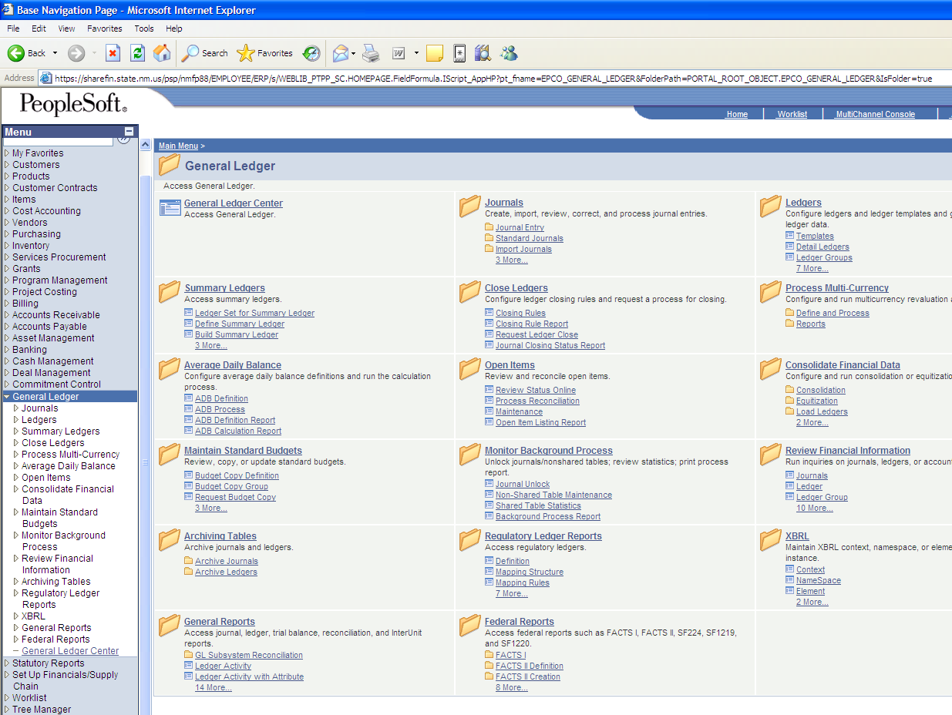
(1.)
(2.)

- Click on “General Ledger” in the Menu.
- Click on the “General Reports” link.

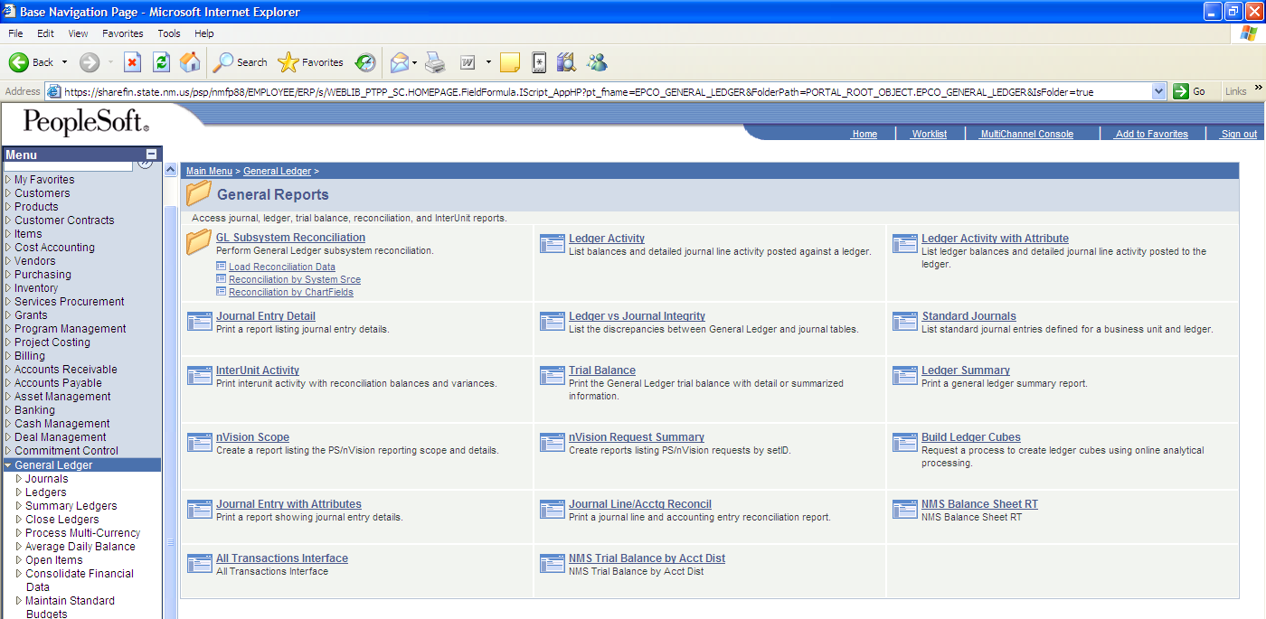
(3.)

- Click on the “NMS Trial Balance by Acct Dist” link.

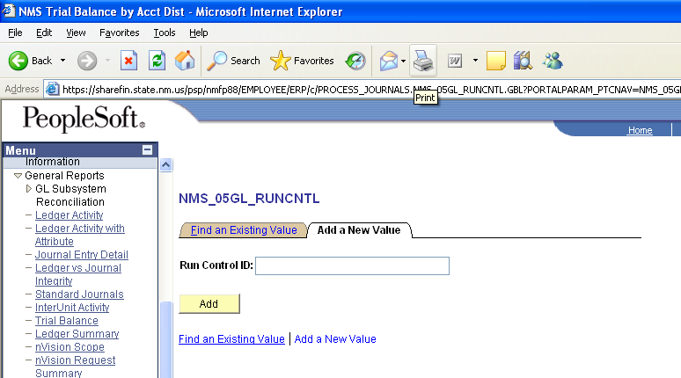
(6.)
(5.)
(4.)

- Click on “Add a New Value” folder to create and save report as a new file.*

(*Click on “Find an Existing Value” folder to open an existing file – see page 16 & 17, steps 3 – 6.)

- Create a file name (of your choosing) in “Run Control ID” (no spaces permitted).
- Click on “Add” icon.

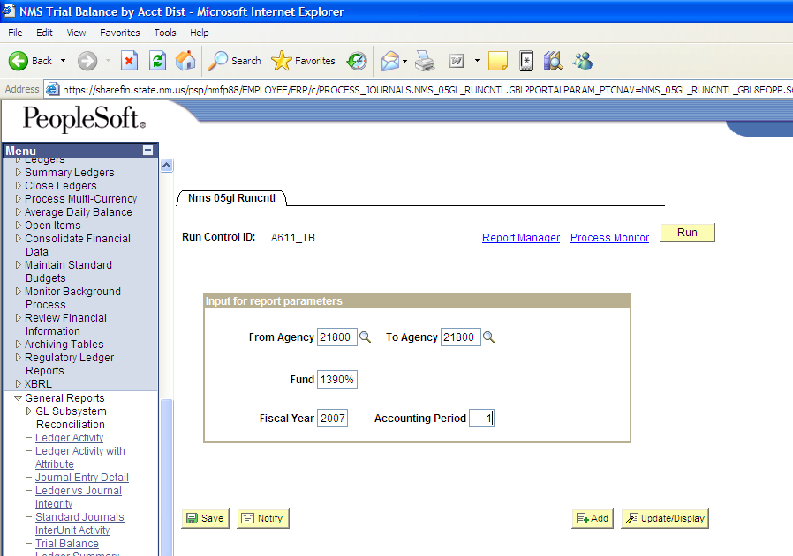
(7.)
(8.)

- Enter Parameters of report:

  - From Agency/To Agency (enter the same agency# in both fields if you wish to view only one agency.)
  - Fund (enter Fund# followed by “%” to view all the activity in a single fund (e.g. for Fund 13900, enter 1390%). To view all agency funds, enter “%” only (no Fund#).

(Note: % = all values)

  - Fiscal Year (e.g. Current fiscal year is 2007)
  - Accounting Period (e.g. July = 1, Aug. = 2, etc.)

- Click on “Run” icon.

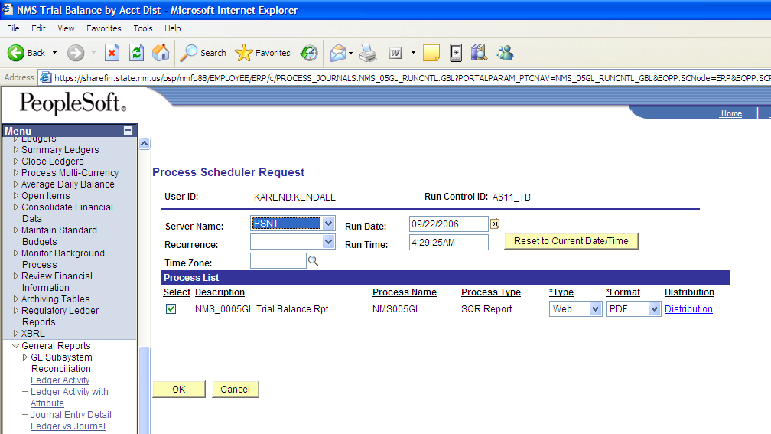
(9.)
(10.)

- Enter “PSNT” in “Server Name” field.
- Click on “OK” icon.

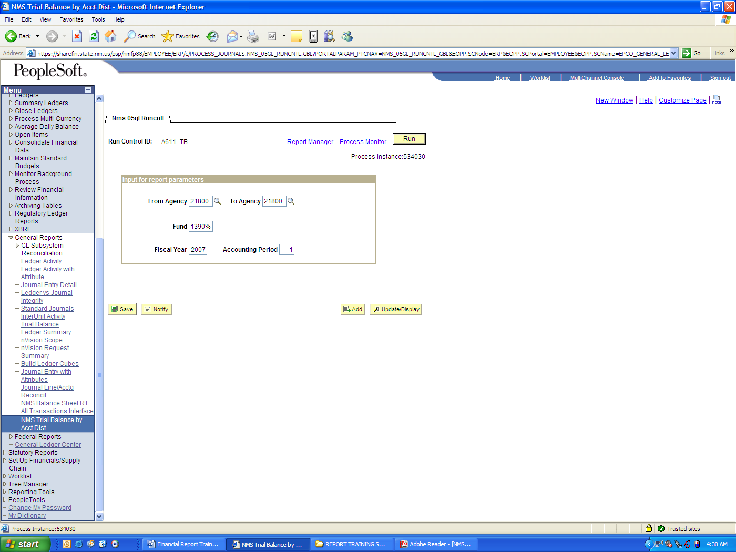
(11.)

- Click on “Process Monitor” link.

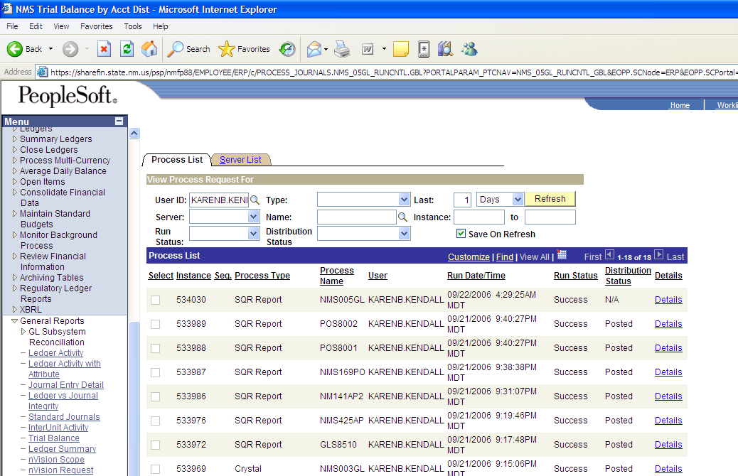
(12.)
(13.)
(12a.)
(12b.)

(12.) Click on “Refresh” icon until:

  - “Run Status” = “Success” and
  - “Distribution Status” = “posted”

(13.) Click on the “Details” link for the “Instance” number you wish to view.

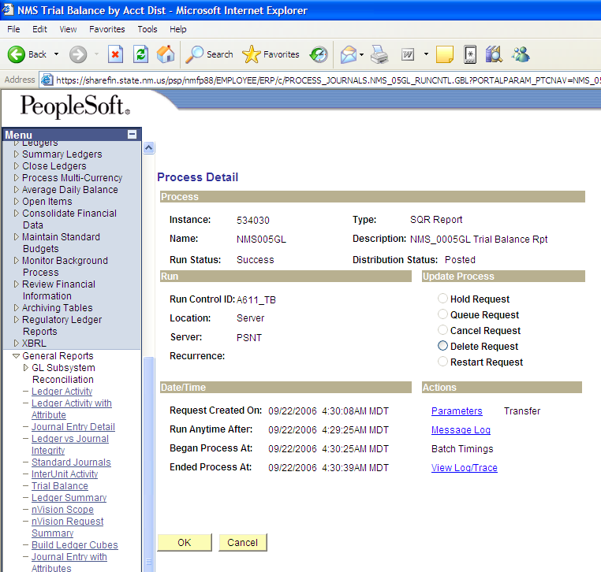
(14.)

(14) Click on the “View Log/Trace” link.

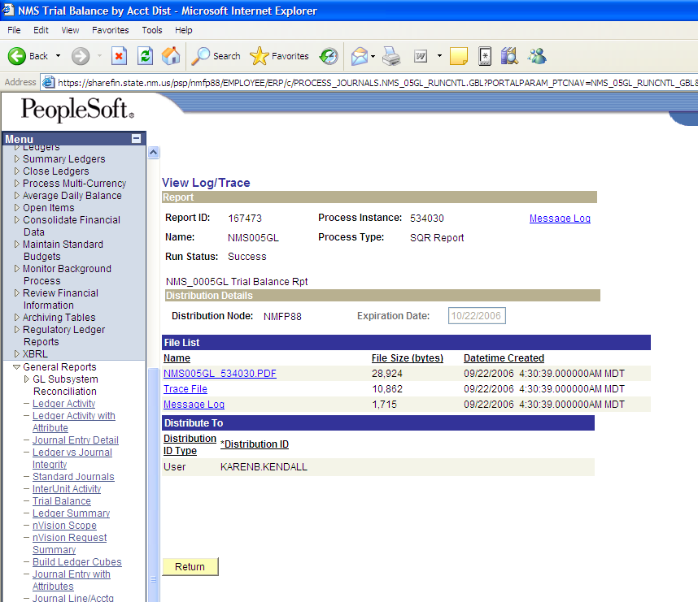
(15.)

(15.) Click on “.pdf” file.

(Note: Adobe Reader is needed to view the .pdf file. Once open, the .pdf file can be saved to your computer.)

INQUIRY NAME:

Trial Balance

NAVIGATION TO INQUIRY:

General Ledger, Review Financial Information, Ledger

RUNNING THE REPORT:

(Note: All inquiries are run from the respective Module)

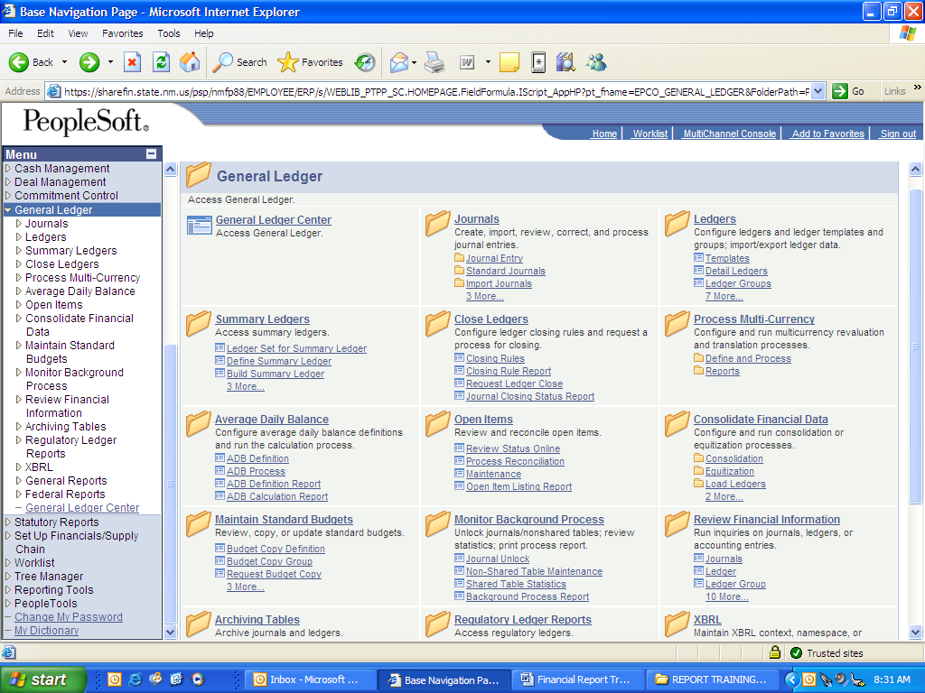
(2.)
(1.)

- Click on “General Ledger” in Menu.
- Click on the “Review Financial Information” link.
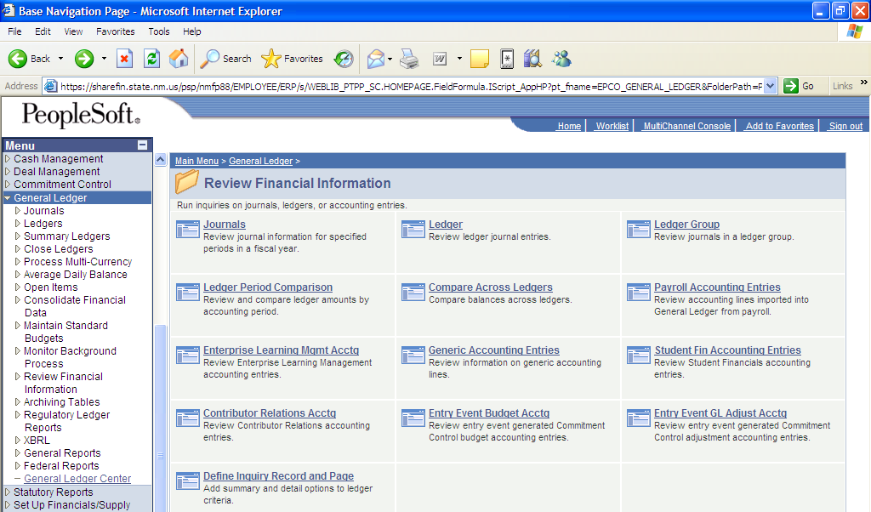
(3.)

(3) Click on the “Ledger” link.

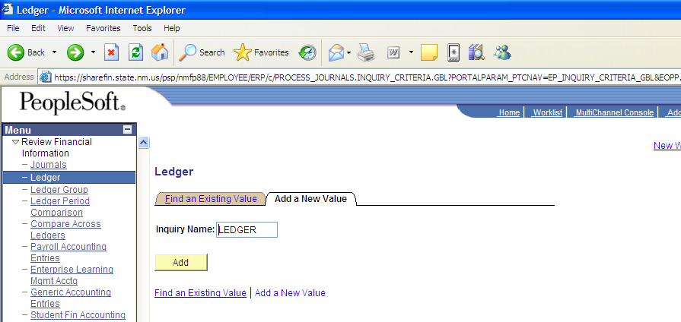
(4.)
(5.)
(6.)

(4.) Click on “Add a New Value” folder to create and save report as a new file.*

(*Click on “Find an Existing Value” folder to open an existing file – see page 15 & 16, steps 3 – 6.)

(5.) Create a file name (of your choosing) in “Run Control ID” (no spaces permitted).
(6.) Click on “Add” icon.
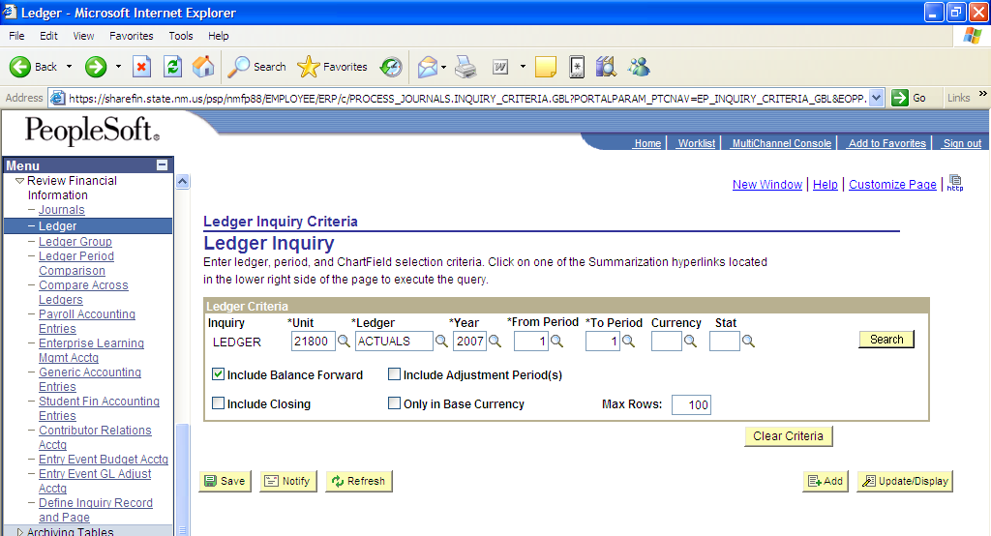
(7a.)
(7b.)
(7c.)
(7d.)
(7e.)
(8.)
(9.)

- Enter all ledger criteria for the fields marked with an asterisk:

        - *Unit (click on magnifying glass icon and select agency#);
        - *Ledger (click on magnifying glass icon and click on “ACTUALS” link);
        - *Year (fiscal year);
        - *From Period (start of the accounting period you wish to view - e.g. July = 1, Aug. = 2, etc.); and
        - *To Period (end of the accounting period you wish to view - e.g. July = 1, Aug. = 2, etc.).

- Check “Include Balance Forward” box.
- Click on “Search” icon.

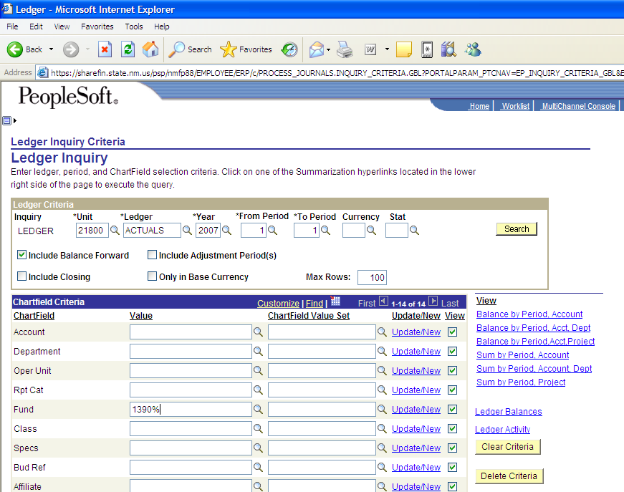
(10.)
(11.)

  - Enter the fund value (Fund# followed by “%” will yield all fund values).

(Note: Values can be selected for individual or groups of accounts, departments, or funds (e.g. to select all Asset Accounts enter: 1%).

Assets = 1
Liabilities = 2
Equity/Fund Balance = 3
Revenues = 4
Expenditures = 5

  - Click on the “Balance by Period Account” link.

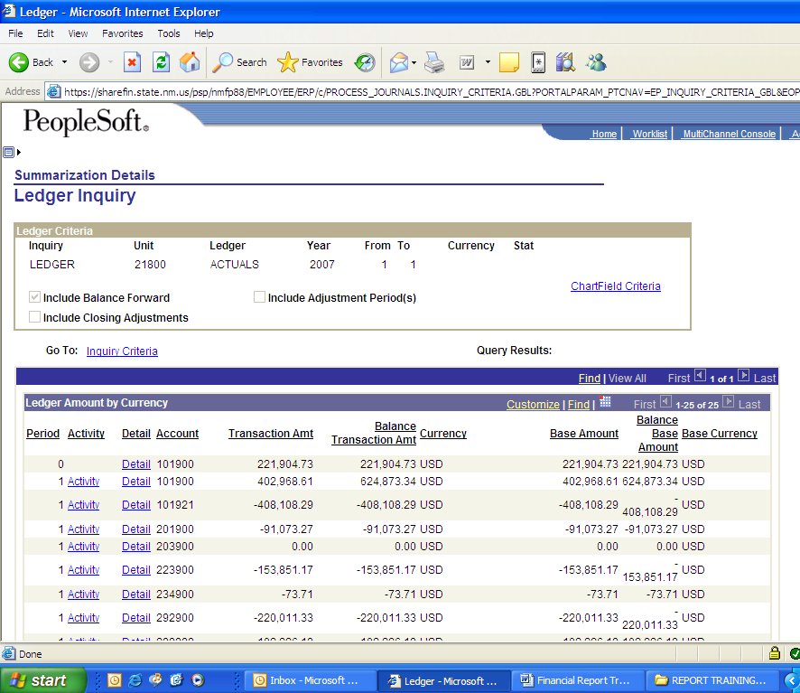
(12.)

(12.) Click on Excel icon to download inquiry in MS Excel.

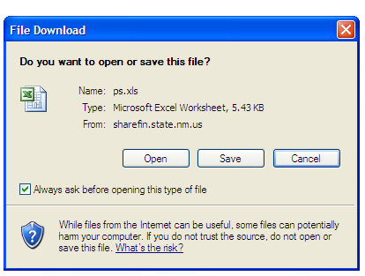
(13.)

(13.) Click on “Save” icon to save into MS Excel.
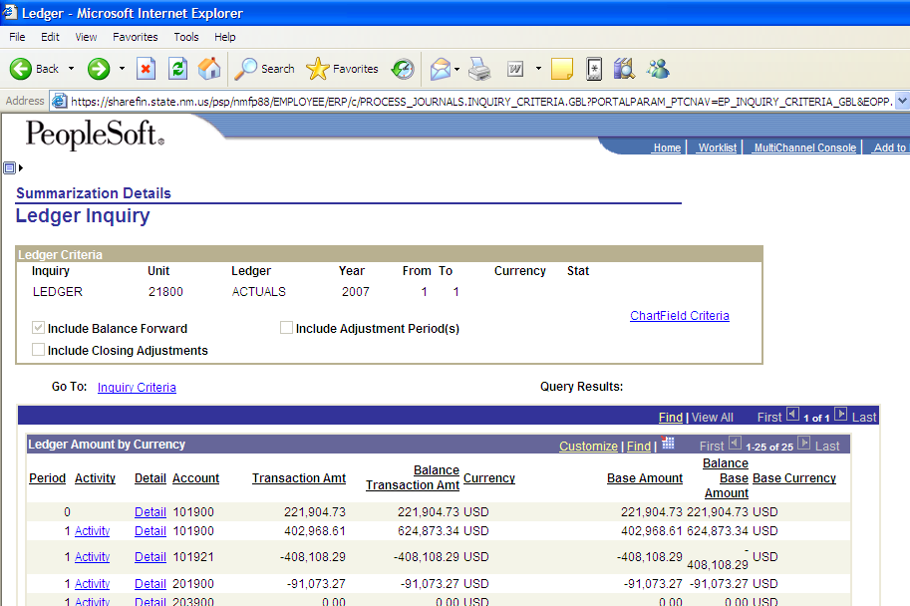
(14.)

(14.) For a list of Journal Entries that make up the transaction amounts, click the “Activity” link.

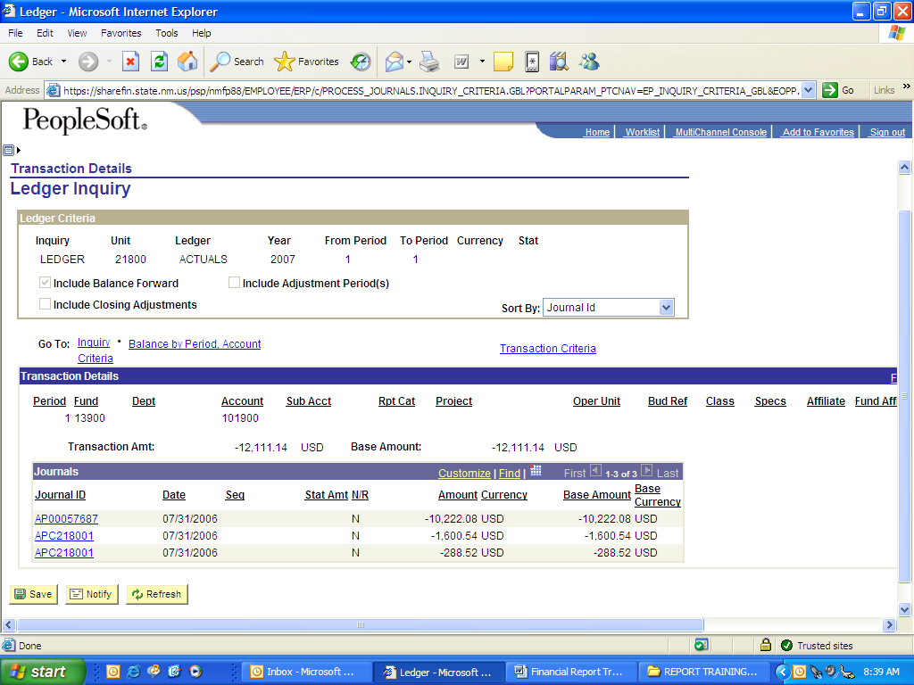
(15.)

(15.) This screen allows you to drilldown to the original transaction.

REPORT NAME:

Trial Balance

NAVIGATION TO REPORT:

General Ledger, General Reports, Trial Balance,

File Name: GLS_7012#####.PDF

RUNNING THE REPORT:

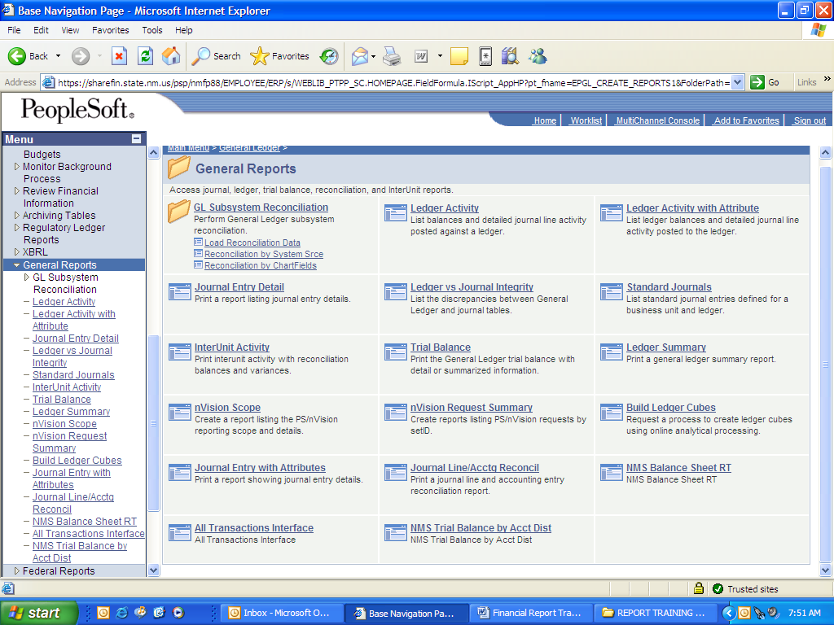
(1.)
(2.)

- Click on “General Reports” in Menu.
- Click on “Trial Balance” link.
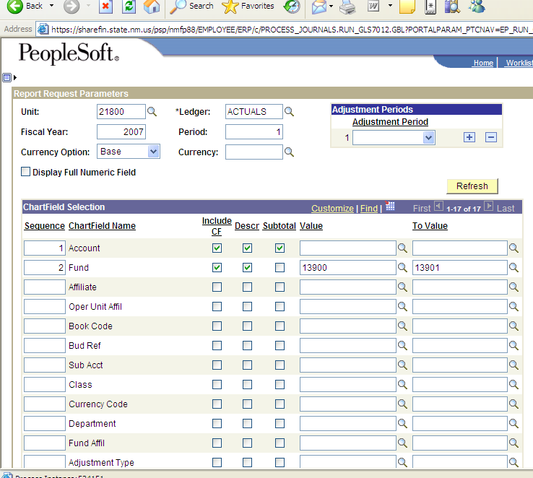
(3.)
(4.)
(5.)
(6a.)
(6b.)
(6c.)
(7.)

  - To set the parameters of the Trial Balance Report, enter:

    - Unit (use magnifying glass for dropdown options – select agency#);
    - *Ledger (use magnifying glass for dropdown options – select ACTUALS);
    - Fiscal Year; and
    - Period for accounting period (e.g. July = 1, Aug. = 2, etc.).

  - Click on “Refresh” icon (Chartfield selection portion of screen will appear).
  - Enter the order in which you wish to view the chart-fields under “Sequence” (Optional).
  - Check:

    - “Include CF” box to include as a chartfield (CF)
    - “Descr” box to include the description of the chartfield
    - “Subtotal” box to include a subtotal by the chartfield

  - Enter “Values” (e.g. from fund 13900 to fund 13901).*

(*Note: for agencies with a range of Funds, enter specific range (e.g. 13900-13905); or enter Fund and “%” for all Fund values (e.g. 1390%).)

REPORT NAME:

AP JOURNAL DETAIL (A611)

NAVIGATION TO REPORT:

Accounts Payable, Reports, NMS AP Journal Detail

File Name: NMS425AP_xxxxx.PDF

RUNNING THE REPORT:

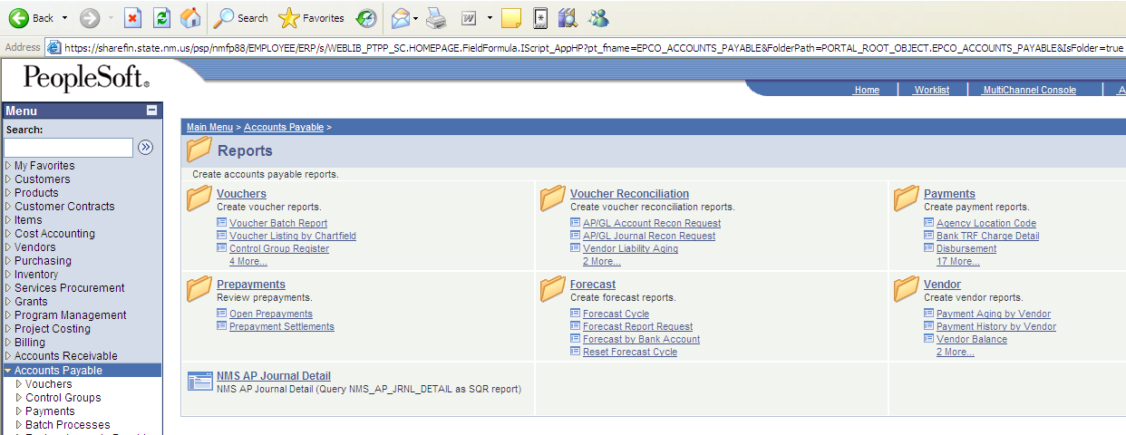
(1.)
(2.)

- Click on “Accounts Payable” in Menu.
- Click on “NMS AP Journal Detail” link.

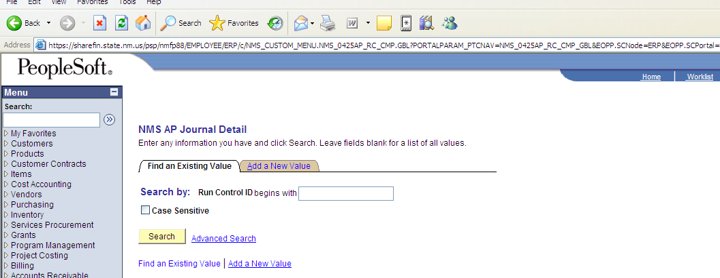
(3.)
(4.)

- Click on “Find an Existing Value” folder to open an existing file.*

(*Click on “Add a New Value” folder to create and save report as a new file – See page 2.)

- Click on “Search” icon.

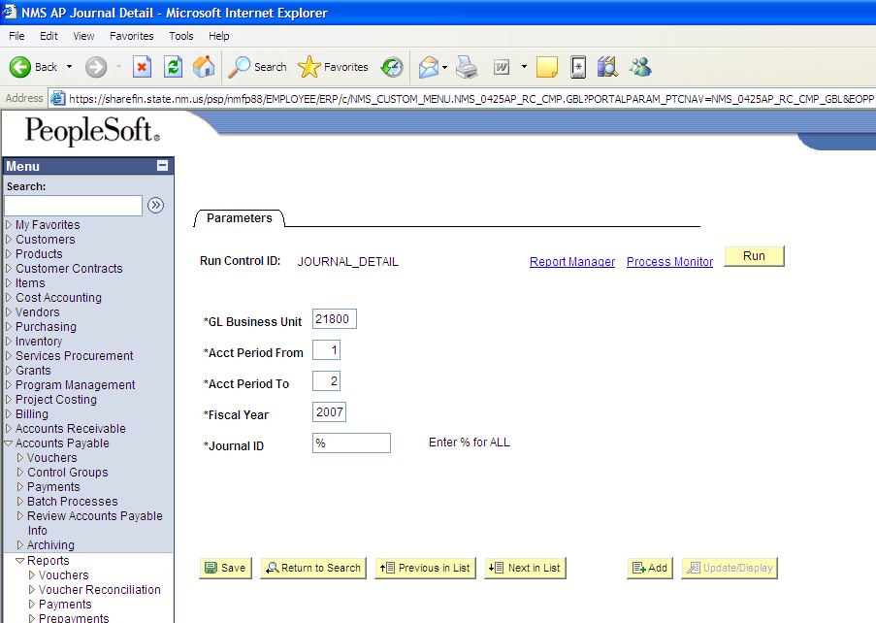
(5a.)
(5b.)
(5c.)
(5d.)
(5e.)
(6.)

- Enter parameters fields:

  - *GL Business Unit (enter agency#)
  - *Acct Period From (e.g. July = 1, Aug. = 2, etc.).
  - *Acct Period To (e.g. July = 1, Aug. = 2, etc.).
  - *Fiscal Year
  - *Journal ID

- Click on “Run” icon.

The AP Journal Detail report will provide details for the entire agency for the period specified. To obtain AP details for a specific Account (e.g. 299999 – Prior Year AP) or a specific Fund, see Query Instructions (pages 17- 21).

QUERY NAME:

NMS_AP_JRNL_DETAIL_ACCT | AP Detail by Account

or

NMS_AP_JRNL_DETAIL_FUND | AP Detail by Fund

NAVIGATION TO QUERY:

Reporting Tools, Query, Query Viewer, NMS_AP_JRNL

RUNNING THE QUERY:

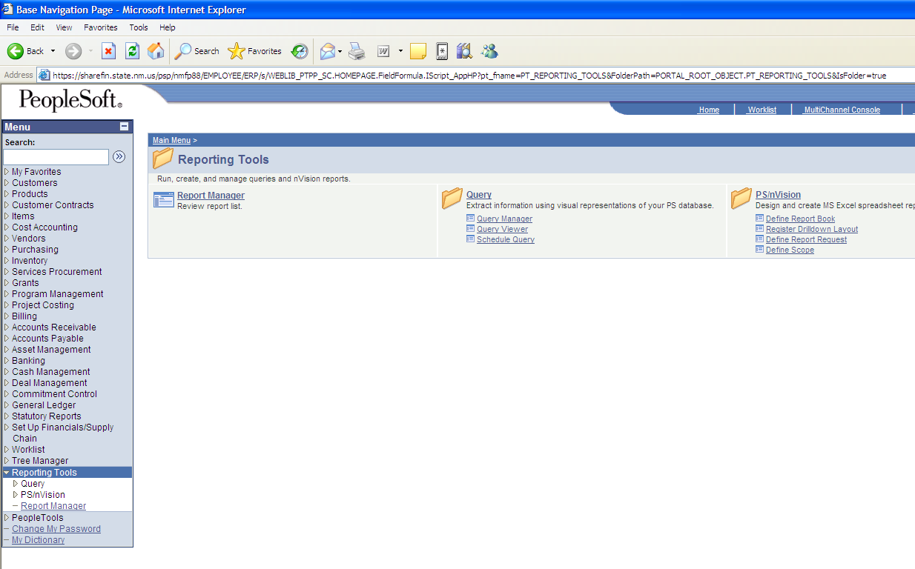
(1.)
(2.)

(1.) Click on “Reporting Tools” in Menu.
(2.) Click on “Query Viewer” link.

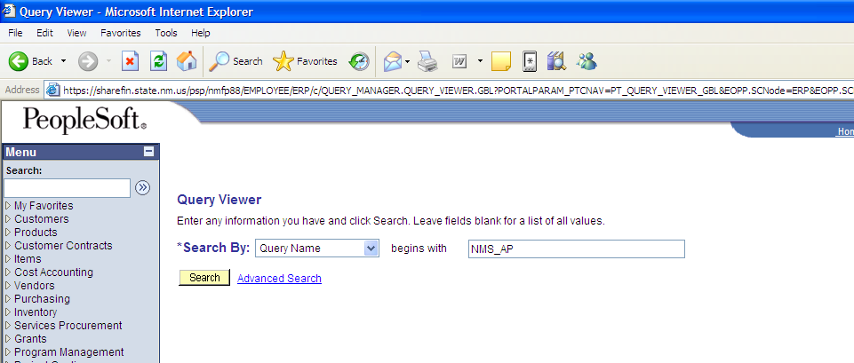
(3.)
(4.)

(3.) Enter “NMS_” (for all queries) and the Module extension (no spaces are permitted) for all available Module queries.
(4.) Click on the “Search” icon.

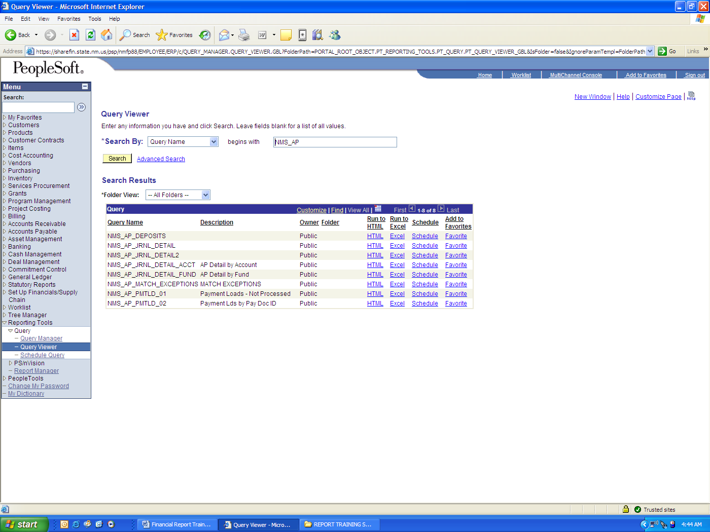
(5.)

  - To run and download a query, select the desired query and click on the “Excel” link.

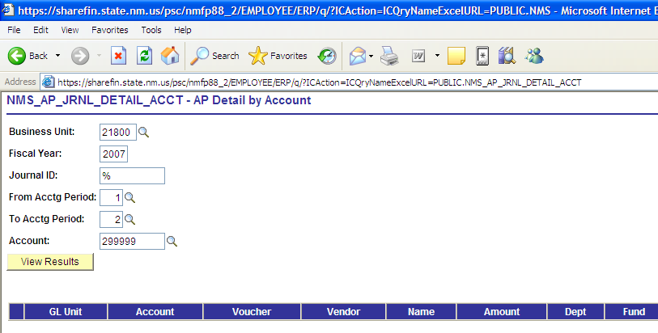
(6.)
(7.)

- Enter the parameters: Business Unit; Fiscal Year, Journal ID (enter “%” for all values); From Accounting Period (e.g. July = 1, Aug. = 2, etc.), To Accounting Period (e.g. July = 1, Aug. = 2, etc.), and Account.
- Click on “View Results” icon.

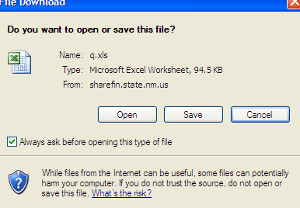
(8.)

(8.) Click on “Open” to view the query only, or “Save” to download the query.

(1.)

To run and download a query by FUND:

(1.) See description: “AP Detail by Fund” and click on the “Excel” link.

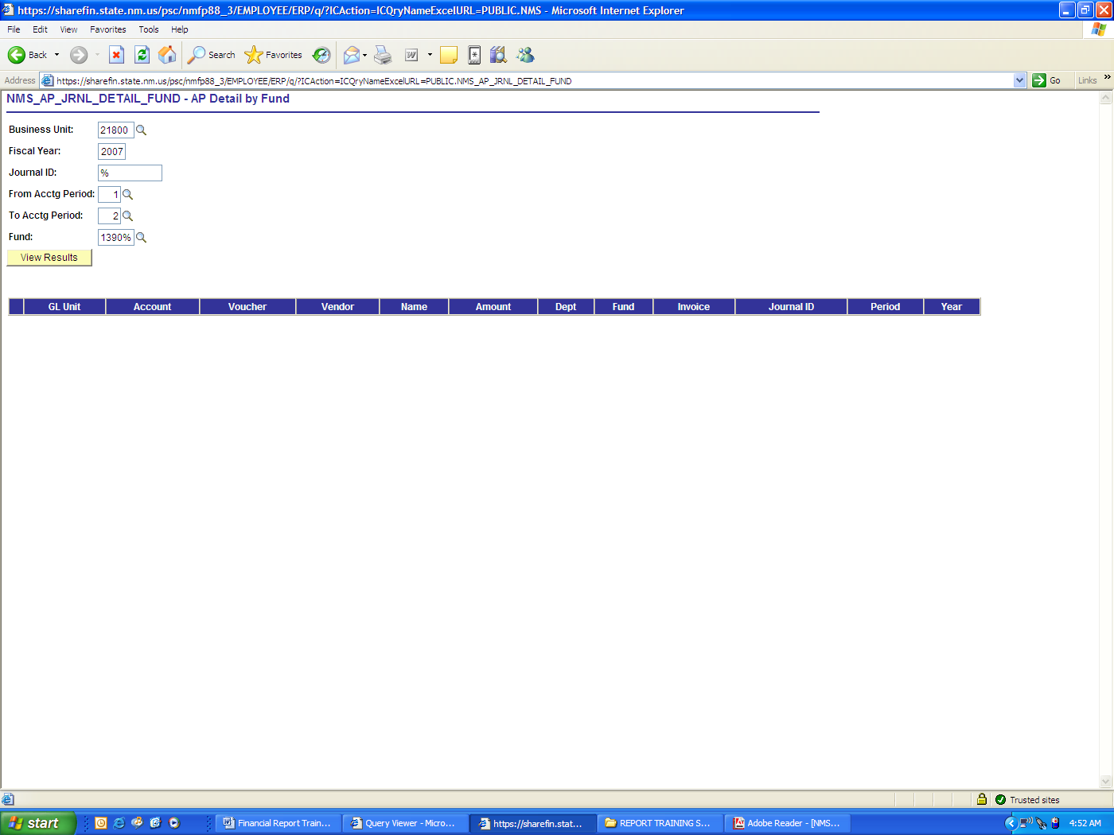
(2.)
(3.)
(4.)

(2.) (See page 20, #6)
(3.) Enter Fund and “%” (to view all Fund values)
(4.) Click on “View Results” icon.

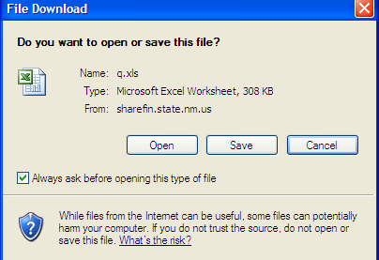
(5.)

(5.) Click on “Open” to view the query only, or “Save” to download the query.)

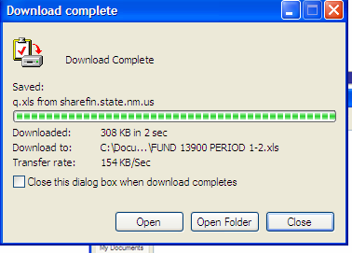
(6.)

(6.) You may open the query once the download is completed.

REPORT NAME:

MO BUDGET STATUS REPORT (NM02)

NAVIGATION TO REPORT:

Commitment Control, Budget Reports, NMS Monthly Budget Status Rt

File Name: NMS007GL_xxxxx.PDF

RUNNING THE REPORT:

(Note: All reports are run from the respective Module)

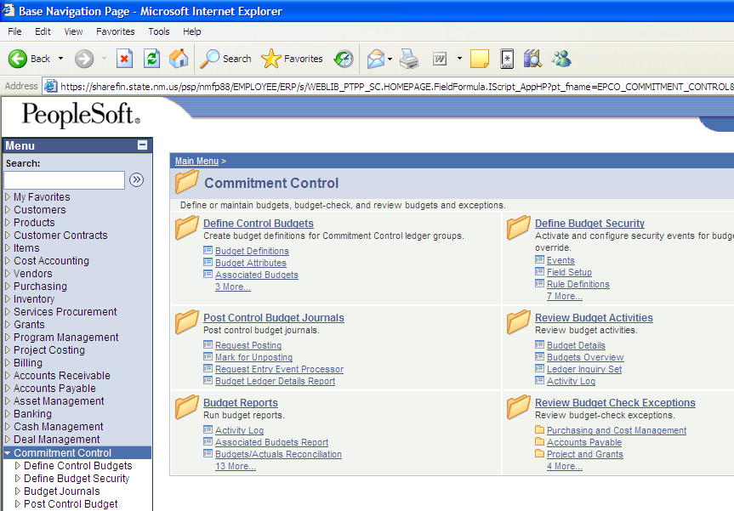
(1.)
(2.)

- Click on “Commitment Control” in the Menu.
- Click on the “Budget Reports” link.

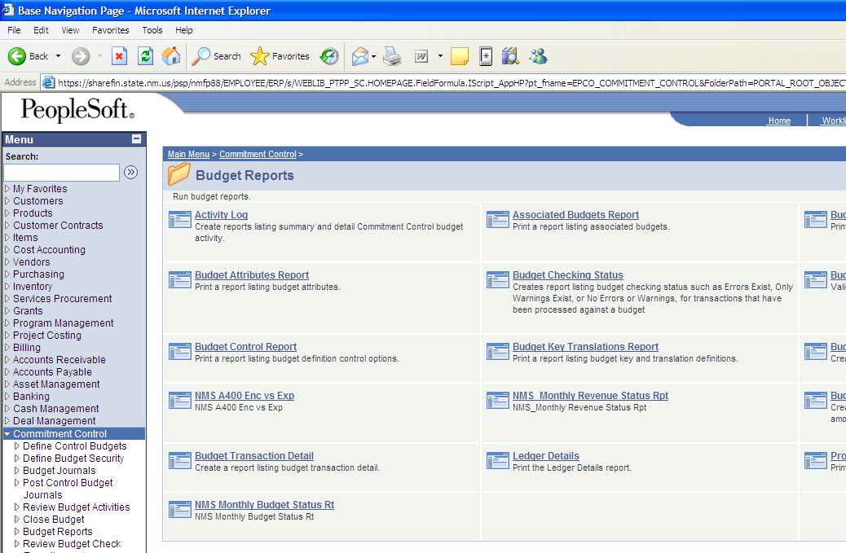
(3.)

- Click on “NMS Monthly Budget Status Rt” link.

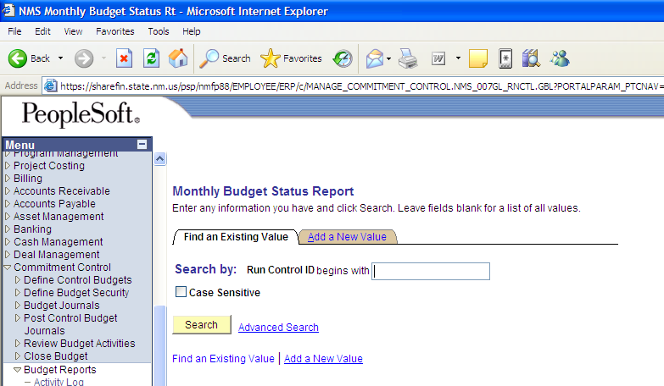
(4.)
(5.)

(4.) Click on “Find an Existing Value” folder to open an existing file.*

(*Click on “Add a New Value” folder to create and save report as a new file – See page 2.)

(5.) Click on “Search” icon.

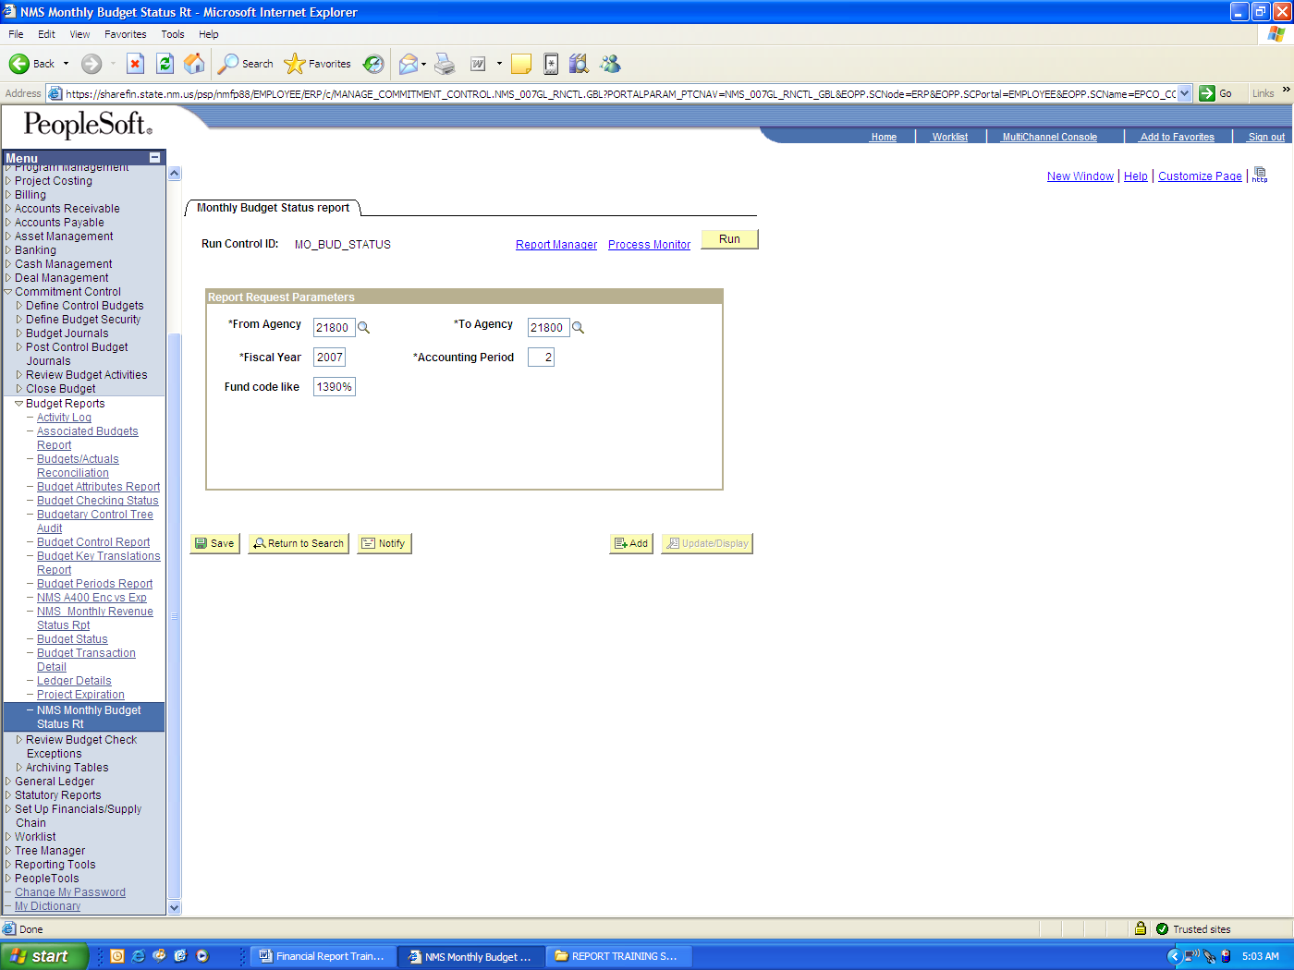
(6.)

(6.) Enter parameters: From Agency; To Agency; Fiscal Year; Accounting Period (e.g. July = 1, Aug. = 2, etc.); and Fund Code Like (“wildcard” – will find all similar Fund #s).

REPORT NAME:

MO REVENUE STATUS (A203)

NAVIGATION TO REPORT:

Commitment Control, Budget Reports, NMS Monthly Revenue Status Rpt

File Name: NMS003GL_xxxxx.PDF

RUNNING THE REPORT:

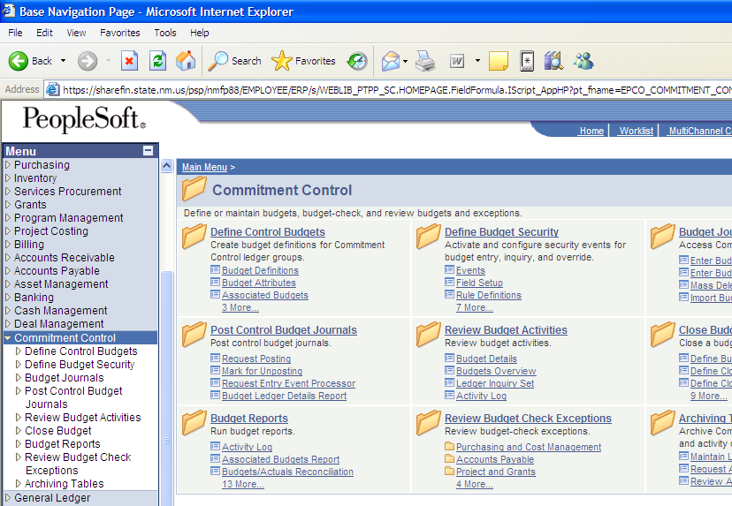
(1.)
(2.)

- Click on “Commitment Control” in the Menu.
- Click on the “Budget Reports” link.

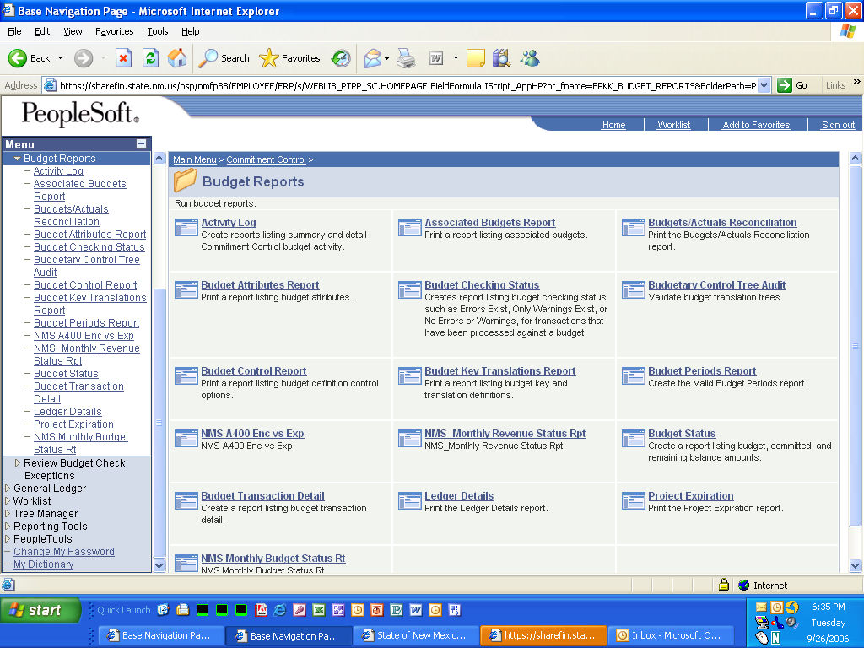
(3.)

- Click on the “NMS Monthly Revenue Status Report” link.
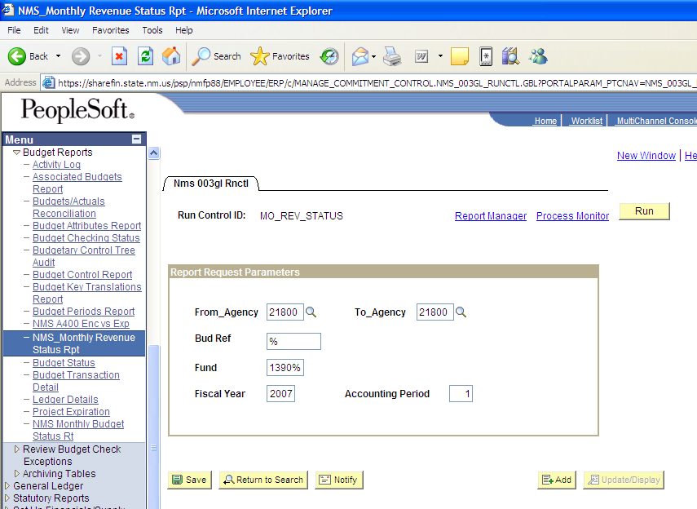
(4.)
(5.)

- Enter the parameters: From Agency; To Agency; Budget Reference*; Fund; Fiscal Year; Accounting Period (e.g. July = “1,” Aug. = “2,” etc.); and Fund Code Like.

(*Note: Enter “%” to view all values)

- Click on the “Run” icon (the steps are essentially the same as pages 2 – 7).

REPORT NAME:

Balance Sheet RT (F100)

NAVIGATION TO REPORT:

General Ledger, General Reports, NMS Balance Sheet RT

File Name: NMS006GL_xxxxx.PDF

RUNNING THE REPORT:

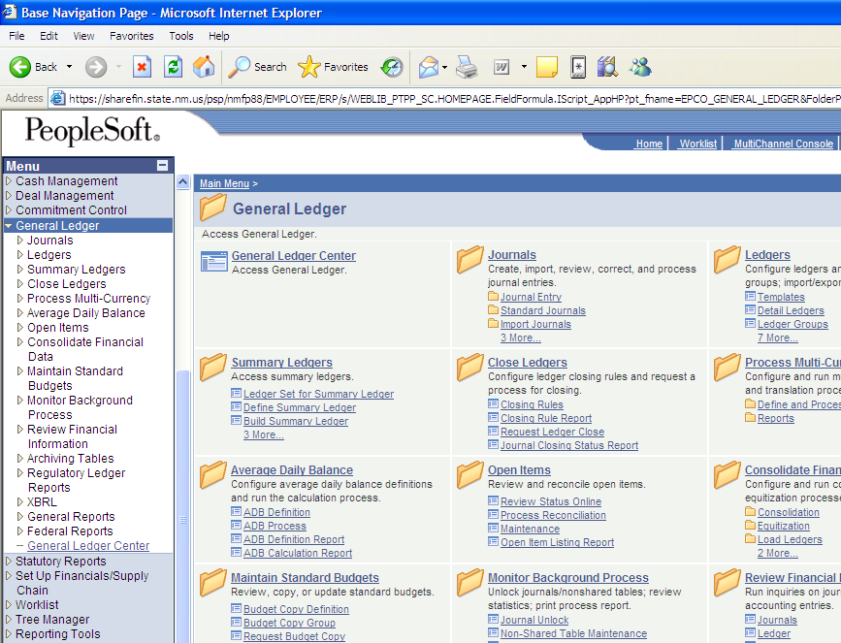
(2.)
(1.)

- Click on “General Ledger” in the Menu.
- Click on the “General Reports” link.
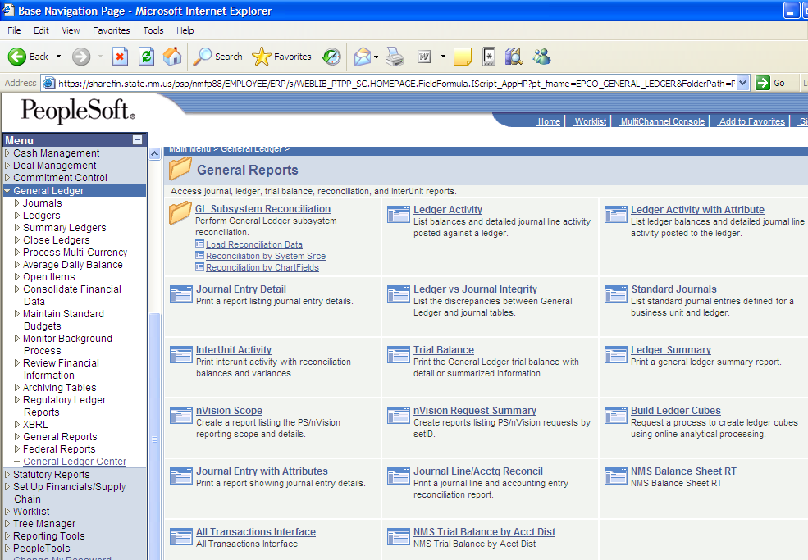
(3.)

- Click on “NMS Balance Sheet Report” link.

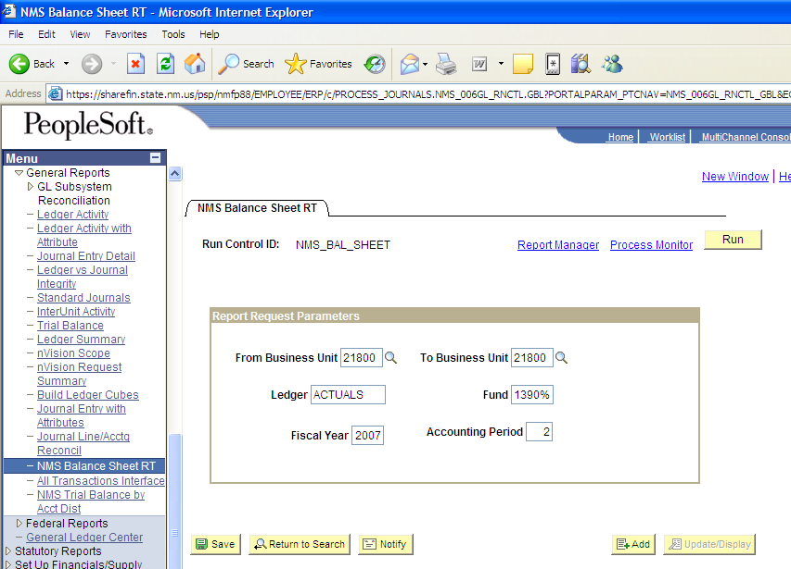
(4.)
(5.)

- Enter the parameters:

  - From Business Unit (enter agency#);
  - To Business Unit (enter agency#);
  - Ledger (enter ACTUALS);
  - Fund; (enter Fund and “%” to view all Fund values)
  - Fiscal Year; and
  - Accounting Period (e.g. July = 1, Aug. = 2, etc.).

- Click the “Run” icon.

REPORT NAME:

NMS DETAIL ENCUMBRANCE REPORT (NM03)

NAVIGATION TO REPORT:

Purchasing, Purchase Orders, Reports, NMS Detail Encumbrance Report

File Name: NMS169PO_xxxxx.PDF

RUNNING THE REPORT:

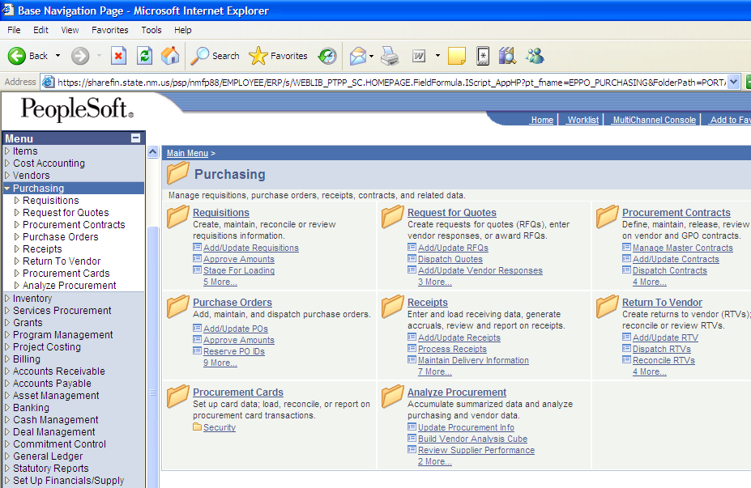
(1.)
(2.)

- Click on “Purchasing” in the Menu.
- Click on the “Purchase Orders” link.
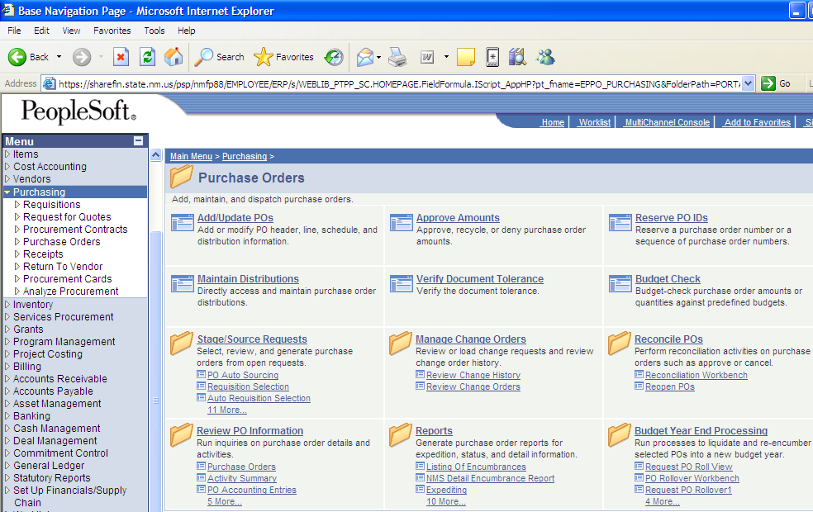
(3.)

(3.) Click on the “Reports” link.

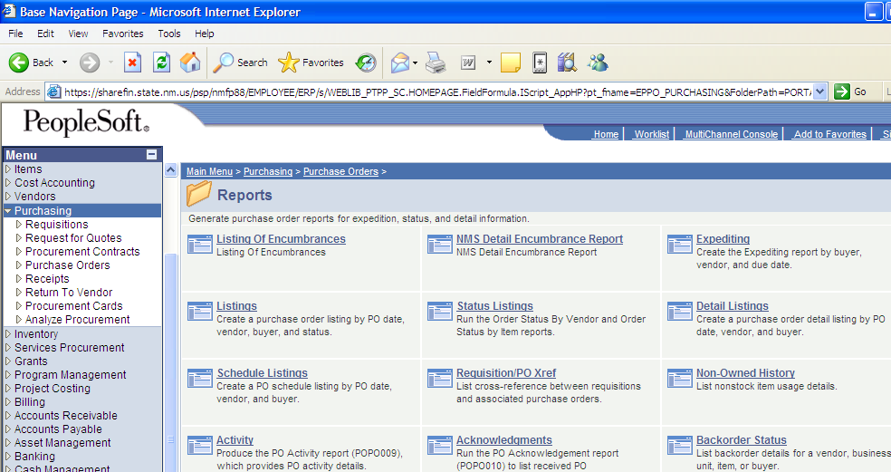
(4.)

(4.) Click on the “NMS Detail Encumbrance Report” link.
(5.) (Follow the steps to “Add a New Value” on page 2.)
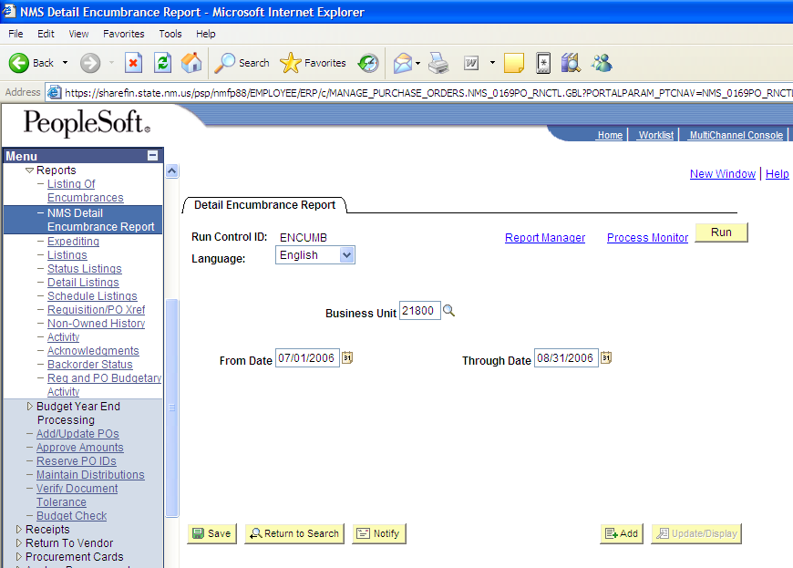
(6.)
(7.)
(8.)

(6.) Enter the Parameters: Language; Business Unit; From Date (use calendar dropdown); and Through date (use calendar dropdown).
(7.) Click on “Run” icon.
- (For “Process Monitoring” follow the steps on pages 4 & 5.)

