Identifying Voucher Budget Errors
The following was issued as a memo to all Chief Financial Officers on approximately December 20, 2006

To Agency Chief Financial Officers,
We have identified an issue that is impacting the completion of the budget checking batch process in the SHARE system. There are a growing number of vouchers being entered and submitted for budget checking that have budget errors. If the errors are not corrected by the Agency, the budget checking batch processes will continue to process slowly for the entire state. These errors prevent the budget checking process from completing and affect ALL state agencies, even those that do not have any vouchers with errors.
There is an immediate need to clear the vouchers currently sitting in the system with budget errors. Therefore, below are the steps needed to view the budget errors that currently exist. To further assist with this process, we have attached a query spreadsheet that identifies vouchers that have budget errors. The vouchers listed on the attached Excel spreadsheet need to be corrected as soon as possible by the respective agencies.
You are receiving this information as your agency's Chief Financial Officer. It is imperative that you share this information with your appropriate staff immediately.
IDENTIFYING BUDGET ERRORS IN VOUCHERS
Navigation:
- Commitment Control
- Review Budget Check Exceptions
- Accounts Payable
- Voucher
Instructions:
- Enter the Business Unit
- From the Process Status drop-down list, select ‘Errors Exist”
- Press yellow SEARCH button
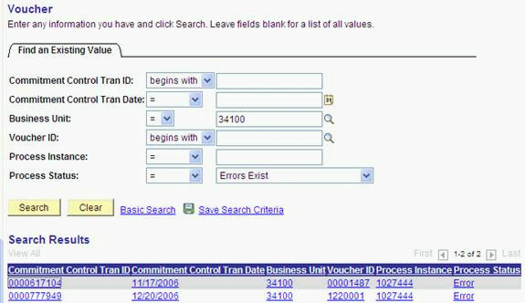

A list of vouchers that are in an error status will appear beneath the search button. Press the View All hyper link to see additional vouchers.
To view the reason for the budget error, select one of the vouchers, by clicking on the blue underlined hyper link.
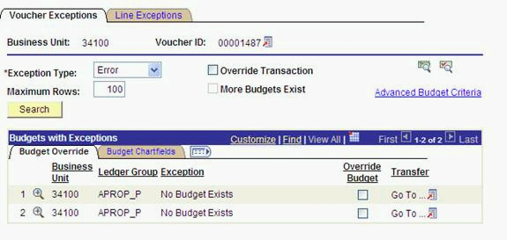
The ledger group listed on the “budget override” tab will indicate which budget ledger has the error (e.g., appropriation, department or project). To view the budget chartfields, click on the “show all columns” link.
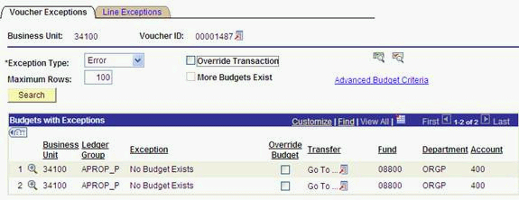
The voucher above indicates that a budget has not been established for the FUND, DEPT, ACCOUNT combination at the Appropriation level. This voucher does not include a Budget Reference or Class and will cause the budget checking to error out. All Appropriation level budgets for this agency included a Bud Ref and Class that must be referenced on the vouchers.
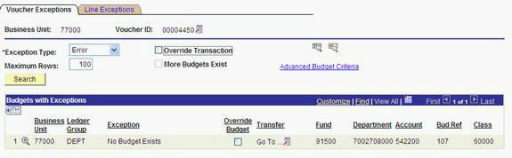
The voucher above passed the Appropriation level budget, but has an error on the Department level budget. The Fund, Department, Account, Bud Ref, Class combination does not have a corresponding budget. Either a department level budget must be established or the voucher must be modified to be charged to a different Fund, Department, Account, Bud Ref, Class combination that does have a department level budget.
Back to Purchasing and Accounts Payable

