FMLA Accumulator

New FMLA Accumulator has been created to help you determine how many FMLA hours an employee has used. FMLA accumulator adds all entries of FMLA TRC’s(FMACT,FMDAT,FMDST,FMHAT,FMHCT,FMHOL,FMLAN,FMLCT,FMLFT,
FMLSK,FMLUP,FMPER) entered onto the employee timesheet and provides a total based on date range selected.

Navigation: Manager Self Service/Time Management/View Time/Accumulators

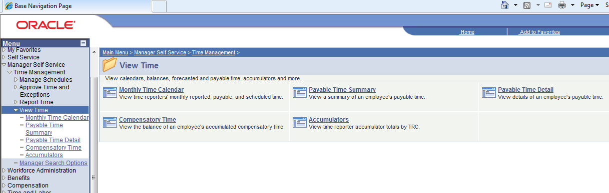

Click on Accumulators

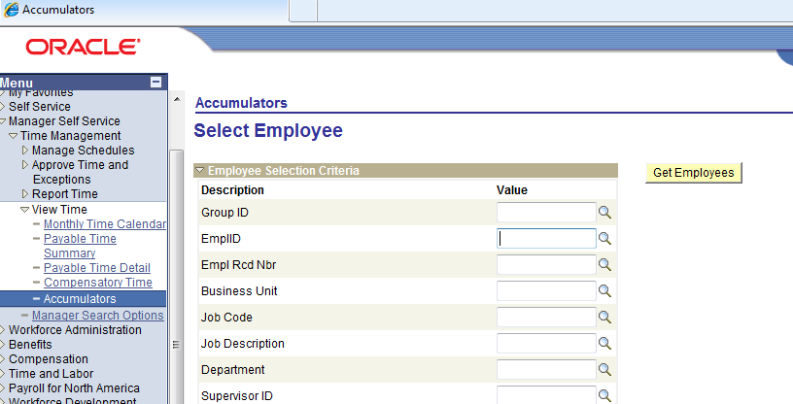

Enter emplid and click
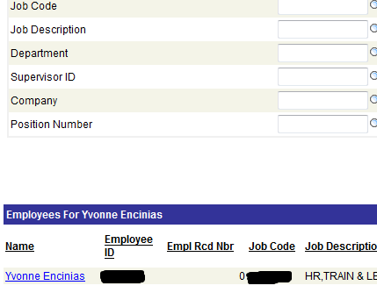
Click on employee name

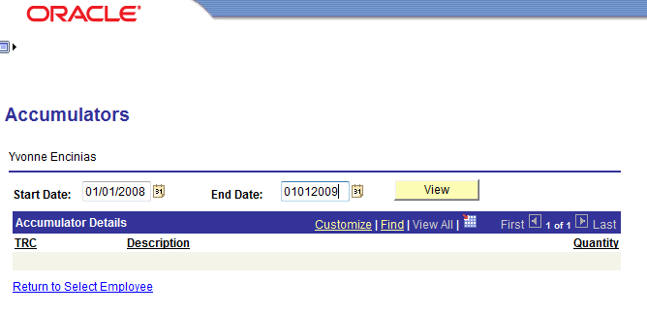

Select the date range

click

