Guide to Creating an Expansion Request in BFM
Note: Please follow DFA and LFC guidance regarding the submission of expansion requests as part of your annual budget request, which can change from year to year.
- To establish an expansion request, navigate to the Expansion Request (3200) Form and click on Add New.
- Stage: Initial Entry
- Select the Pcode the expansion request would be added to.
- Give the expansion request a short name.
- Click Save.

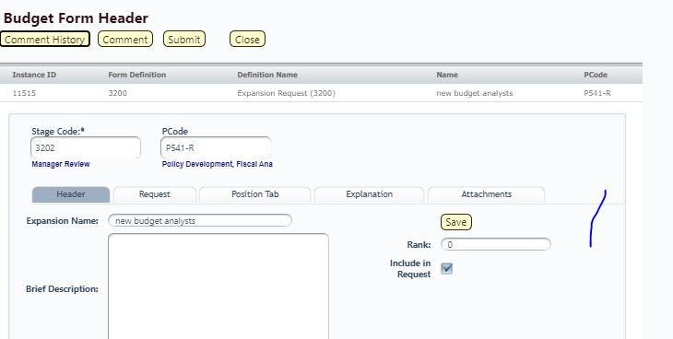

- The Budget Form Header Page for the expansion will pop up. On this page:
- Enter a brief description of the request.
- Enter a rank in importance/priority if you have more than one expansion request.
- Include in request: Uncheck this box if your agency management decides not to include this expansion in your budget request. You can also use this feature to experiment with costs of new positions, etc. without actually adding them to your budget request.

- Request Tab/Detail Page:
- Click on Add New to add a new expenditure or revenue line to the expansion request.
- Enter the desired department and fund.

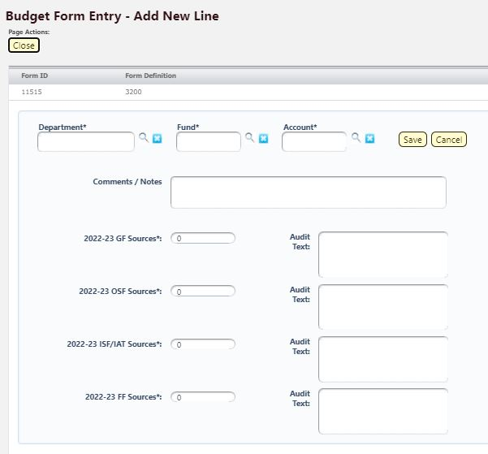

- Account: Use this field to enter both expenditure and revenue lines for the expansion request, one at a time. For example, if the expansion is funded by general fund, add a line with account 499105 and the requested general fund amount. Then add further lines with the correct expenditure account codes. BFM will recognize revenue and expenditure accounts appropriately and total them so you can ensure the request is balanced.
- Sources boxes: Enter the requested amount in the appropriate revenue source. Note that you cannot just add an expenditure line in the correct funding source. In order for the expansion request to account for revenues, you must add revenue lines as well as described above.
- Can use export/import feature as with other BFM forms.

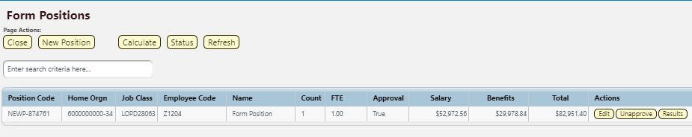
- Positions Tab: Use this tab to calculate the cost of new positions you want to include in this expansion request.
- In Form Positions window, click on New Position.
- Search for the desired job class and click on Advance to Finish.

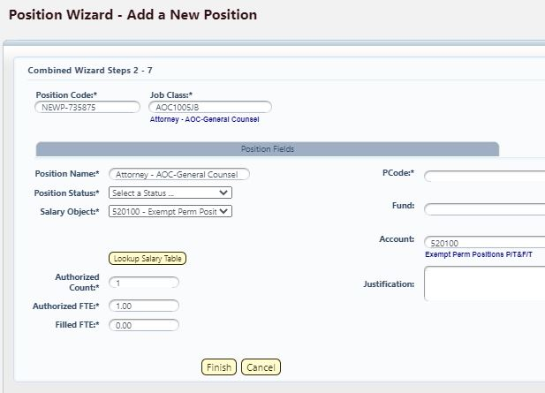

- In Position Wizard window:
- Select Position Status (regular, temporary, term, etc).
- Salary Object: Select account that would pay the position’s salary and match this in the Account field at right.
- Authorized Count and Authorized FTE will be auto-filled to 1.0, adjust down if less than 1.0 FTE is desired. Filled FTE will be 0.0 which should be correct since you are creating a new position.
- Enter Pcode/department, fund, account, justification.
- Click on Finish.

- The new position will be added to the Form Positions window.
- Click on Calculate for BFM to calculate the projected salary and benefits costs for this position at midpoint of the salary range. This may take up to 30 seconds.
- Click on Refresh until salary and benefits costs are populated.

- Click on Close and return to the Request tab. The projected salary and benefits costs for the position you created will be added in the PCF Projection column. You will need to enter in the amounts you are requesting in those lines in the source columns to the right.

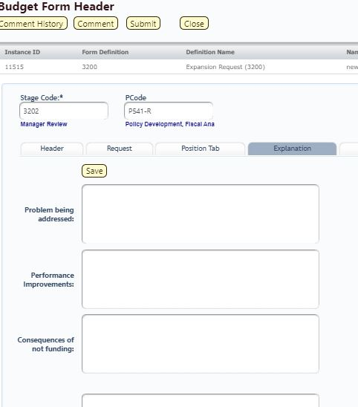

- Explanation Tab: Additional narrative fields to justify the expansion request: Problem being addressed, Performance Improvements, Consequences of not funding, Assumptions and Methodology, Performance Measure Narrative. Complete as thoroughly as possible.

- Attachments Tab: As with other BFM forms, opportunity to attach supplemental reports, data, etc. in support of the expansion request.

- Also as with other BFM forms, when you are finished entering data for the expansion request, click on Submit from the Form 3200 base page to move it on to the next stage.

- Reporting: In BFM Reporting module, navigate to EB Expansion Reports.
- As with other BFM reports, enter your business unit and desired Pcode, then click OK. BFM will bring up all expansion reports for that Pcode.
- All expansion reports are printed here: note 3 tabs at the bottom: EB-1 Expansion Justification, EB-2 Expansion Fiscal Summary, and EB-3 Expansion Line Item Detail.

