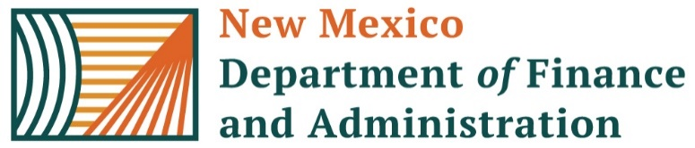 | REQUEST FOR ADDITIONAL PAY FORM  Version 12 Revised 05.01.2025

Instructions for completing this form

This form is used to compensate employees for non-standard payments such as lump sum or out-of-cycle payments, retroactive pay increases, and other payments that cannot be entered on the employee’s timesheet. Pay rate changes must be entered into Job Data before submitting this form to Central Payroll.

An explanation is required and must include specific details as to why the employee is owed additional pay. In addition to the Request form please provide a Summary Page. If the request is a Lump sum payout also include an “Out of Cycle Increase Request for the DA’s Form”.

The Summary Page: should include the following information: a breakdown by pay period, current and former rate of pay, total number of hours per pay period that were impacted. Remember to separate the hours that contribute to PERA/ERA and the hours that don’t contribute to PERA/ERA. Use Earn Code ADL for hours that contribute to PERA/ERA and NAD for hours that will not contribute to PERA/ERA. The total appearing in the Summary Page must match the Request for Additional Pay form.

Supporting documentation for lump sum: Request for Out-of-Cycle Salary Increase must include a completed “Out of Cycle Increase for the DA’s office Form”.

Today’s Date: | Requested By: | Telephone Number: | Pay Group:
Click or tap to enter a date. | Click here to enter text. | Click here to enter text. | Choose an item.
Current Pay Period Ending: | Employee Name: | EMPLID#: | Business Unit:
Click here to enter a date. | Click here to enter text. | Click here to enter text. | Choose an item.
Job Code: | Department #: | Combo Code (1 code only):
Click or tap here to enter text. | Click or tap here to enter text. | Click or tap here to enter text.
Earn Code: | Amount: | FLSA Status:
Choose an item. | Click here to enter text. | Choose an item.
Choose an item. | Click here to enter text. | Re-submitting ☐
Explanation for the request REQUIRED:
Click here to enter text.

This document must be reviewed and signed by the HR manager or an HR supervisor other than the requestor.

HR Manager Signature: |  | Date: Click here to enter a date.
HR Manager Printed Name: | Click here to enter text. | Telephone Number: Click here to enter text.

If the request includes prior FY’s, please include agency CFO signature: ____________________________________________________

Final Instructions:
The person requesting, reviewing, and approving this form cannot be recipients of the request. Requestor and approver may not be the same person. Forms must be submitted via Central Payroll Bureau’s Form Submission System (FSS) at the following website: https://platform.dfa.nm.gov
Deadline for submission is 5:00 pm on Tuesday Pay Period End

