

AGENCY HCM – PR – AP RECONCILIATION

SUMMARY GUIDE

Contents
OVERVIEW 3
PAYROLL RUN DATES 4
HR ACCT LINE DETAIL 5
PR JOURNALS ..23
AP JOURNALS 48
DIFFERENCES 70
IDENTIFYING EMPLOYEE TRANSFERS 71
CHART OF ACCOUNTS………………………………………………………………………………………………………………87

OVERVIEW

Before you begin reconciling payroll for a pay period the PR Journals and AP Journals must be posted to the General Ledger.

There are two parts to the Reconciliation:

PART ONE: Reconcile the HR ACCT LINE DETAIL cash, liabilities and expenditures to the PR JOURNAL cash, liabilities and expenditures.

PART TWO: Reconcile the PR JOURNAL cash and liabilities to the AP JOURNAL cash and liabilities.

NOTE:
The payroll data for Child Support EFT’s (Electronic File Transfer) does not get sent from HCM to FINANCIALS:
Manual processes were developed in HCM to extract the child support EFT data, where a file is created and then loaded in FINANCIALS and posted to the General Ledger.

PAYROLL RUN DATES

The payroll run date is derived from the PAYGL02A process and is used as a parameter for extracting payroll data from HCM.
To obtain the From Run date and To Run Date

Click on: http://nmdfa.state.nm.us/Central_Payroll_Bureau.aspx

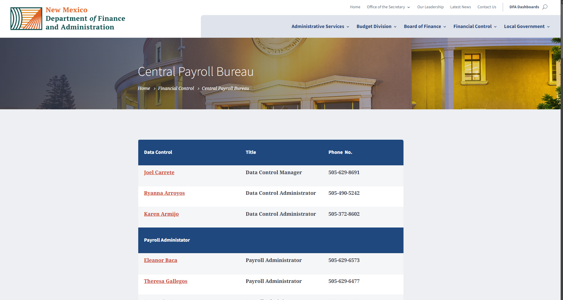

Scroll all the way down till you see Payroll Run Dates
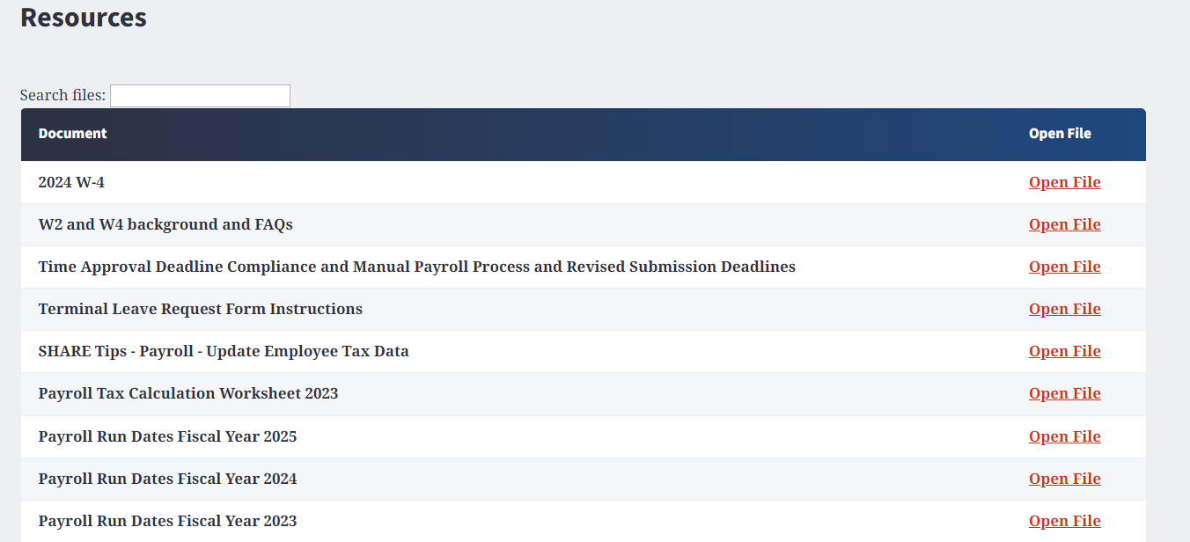

Click on: [Payroll Run Dates Fiscal Year (current year)]

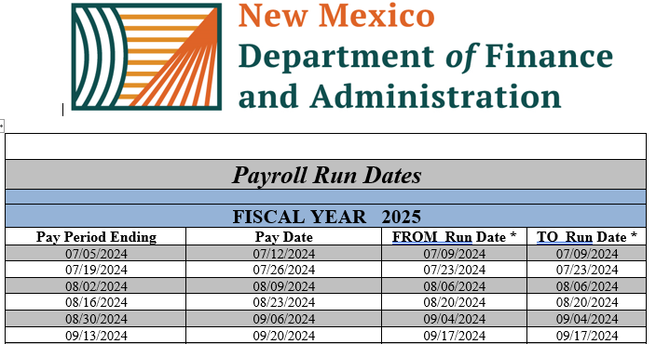

HR ACCT LINE DETAIL

HR Account Line Detail data is created from the batch process PAYGL02A, which consists of account information such as gross pay, net pay, benefits and taxes.

In order to extract the HR_ACCT_LINE_DETAIL data you will need to run the following query:
Query: NMS_PY_ACCOUNTING_LINE_DETAILS
Due to the way security is set up in HCM, you can only see your agency’s data.
If an employee transfers from your agency to another agency and you run the NMS_PY_ACCOUNTING_LINE_DETAILS query, then you will no longer be able to see that employees HR_ACCT_LINE_DETAIL data.

Navigation Path: REPORTING TOOLS > QUERY > QUERY VIEWER >
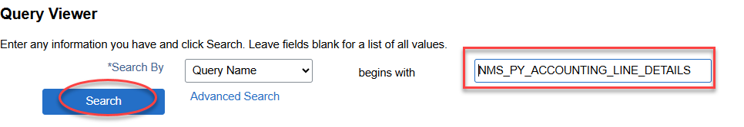
Key Enter the query name: [NMS_PY_ACCOUNTING_LINE_DETAILS]
Click on [Search]
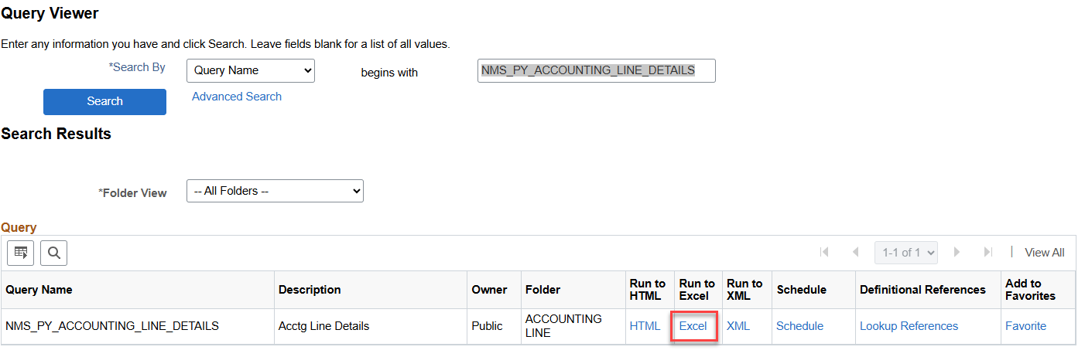
Click on [Excel]

NOTE: In this example we will be reconciling payroll for business unit 34100.

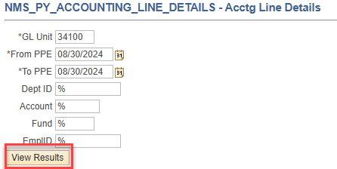
GL Unit: Agency Business Unit Number
From PPE: Pay period end date of the pay period you are reconciling
To PPE: Pay period end date of the pay period you are reconciling (these are typically the same date)
Dept ID: Leave the “%” sign
Account: Leave the “%” sign
Fund: Leave the “%” sign
EmplID: Leave the “%” sign
Click on: [View Results]

Query Results:
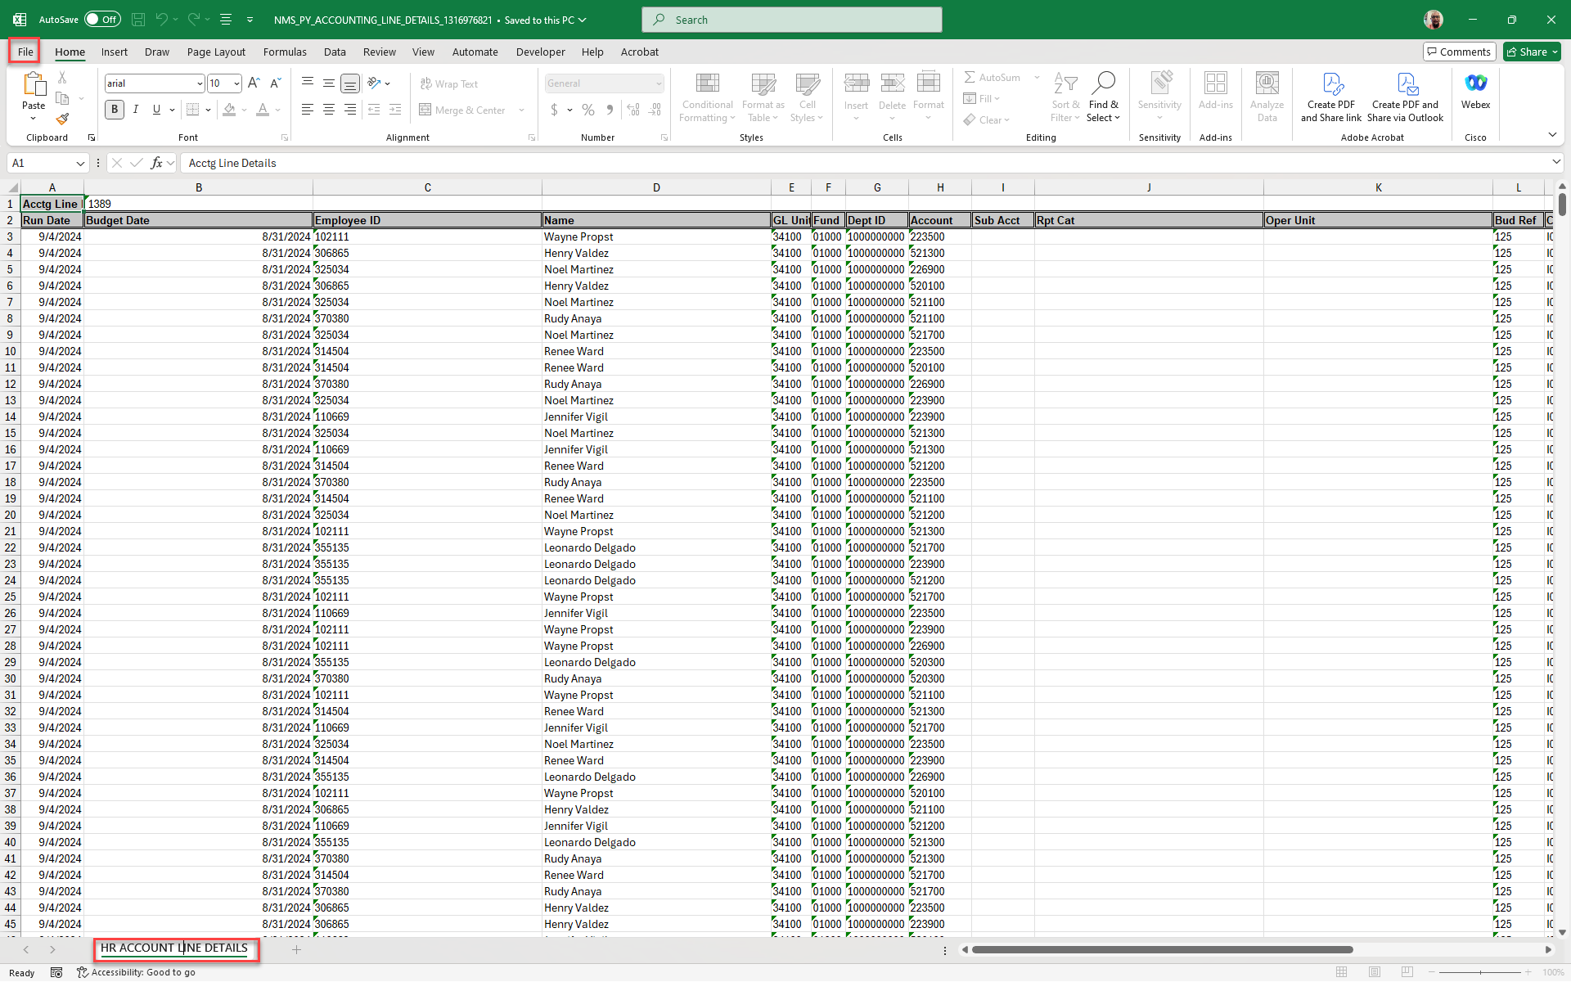
This will be the start of the workbook that finishes with the final reconciliation.

Click on [File]
- Save as: PAYROLL RECONCILIATION PPE MMDDYYYY
- Save as type “Excel Workbook”
- Rename Sheet (tab) as: HR ACCOUNT LINE DETAILS

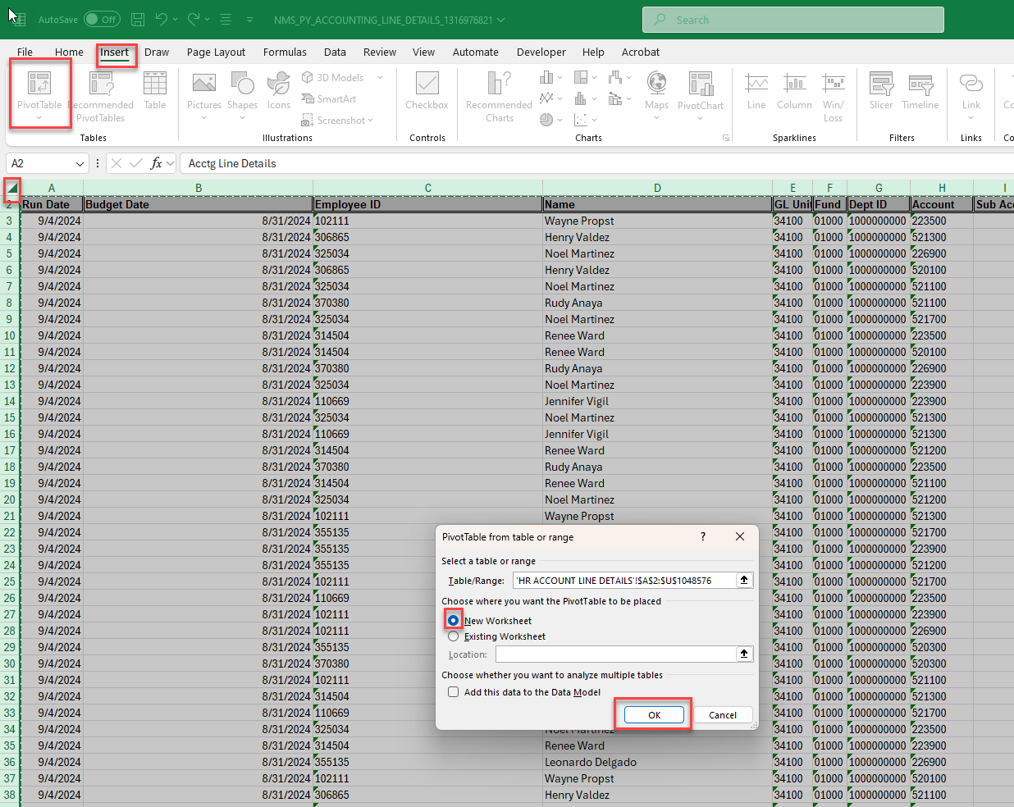
CREATE A PIVOT TABLE

- Position Cursor in corner of Column A and Row 1
- Click on [Insert] tab
- Click on [Pivot Table] Icon
- Select a table or range – default will be the whole query results
- Pivot table is to be placed in New Worksheet
- Click on the [OK] button

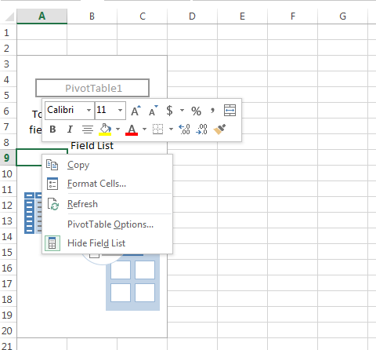

- Right Click within pivot table
- Click on [Pivot Table Options…]

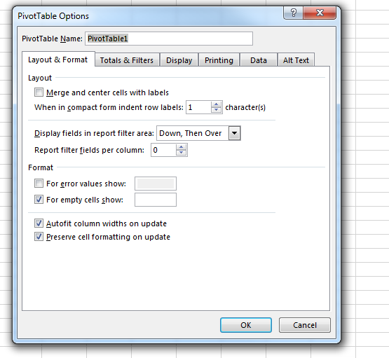

- Click on [Display Tab]

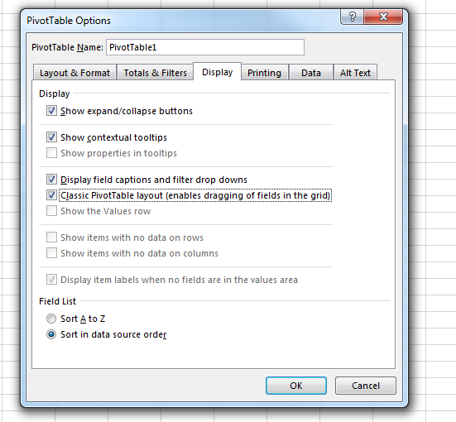

- Check [Classic Pivot Table layout (enables dragging of field in the grid)
- Click on [OK] button

NOTE: YOU WILL HAVE TO CHANGE PIVOT TABLES TO “CLASSIC” EVERYTIME A PIVOT TABLE IS CREATED

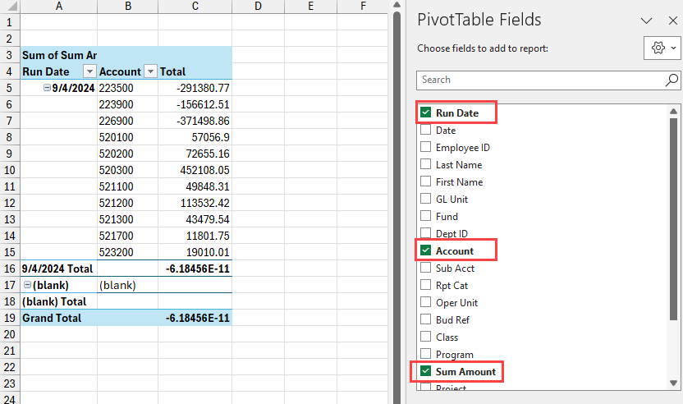

- Select
- Run Date
- Account
- Sum Amount
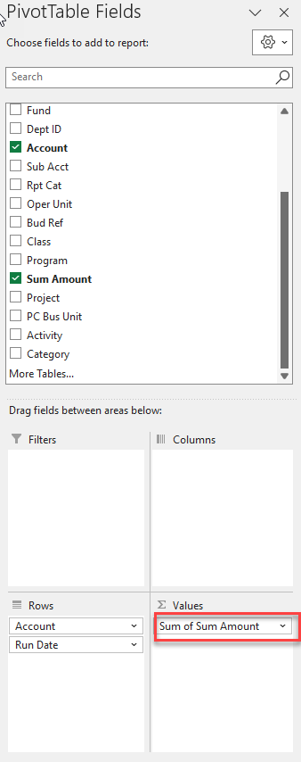

- You may need to drag [Sum of Sum Amount]to Values
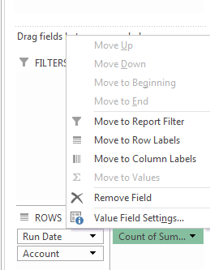
Sum of Sum… Amount

- Click on [Sum of Sum Amount]
- Click on [Value Field Settings]

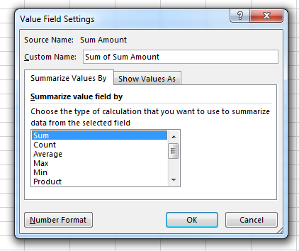

- Click on [Sum]
- Click on [Number Format]
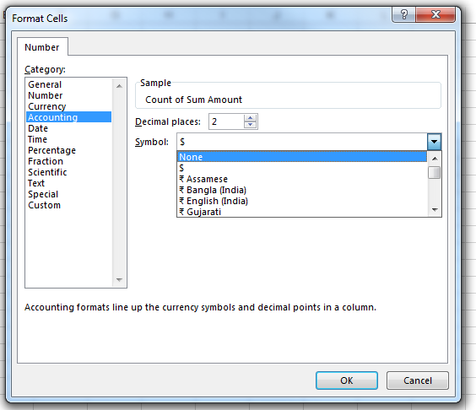

- Click on [Accounting]
- Click on [Decimal places: 2]
- Click on [Symbol: None]
- Click on [OK] button
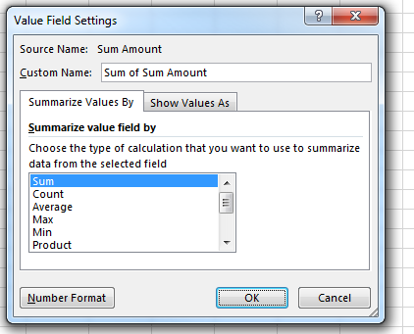

- Click on [OK]
- Rename Sheet (tab) as: HR PIVOT 1

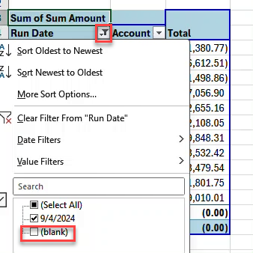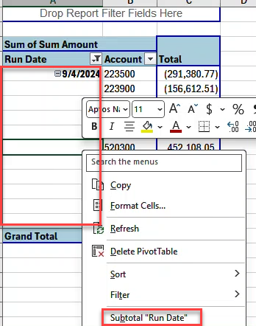

- Remove blanks by selecting the filter on Run Date and uncheck blank
- Remove Subtotals by placing curser in Run Date column, right click then select “Subtotal Run Date”

- On line one enter: HCM DETAIL
- On line two enter: PPE MMDDYYYY
- SAVE document

HR ACCT LINE DETAIL Pivot Table Results for HR PIVOT 1

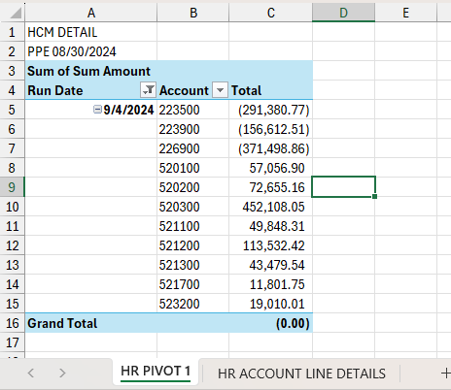

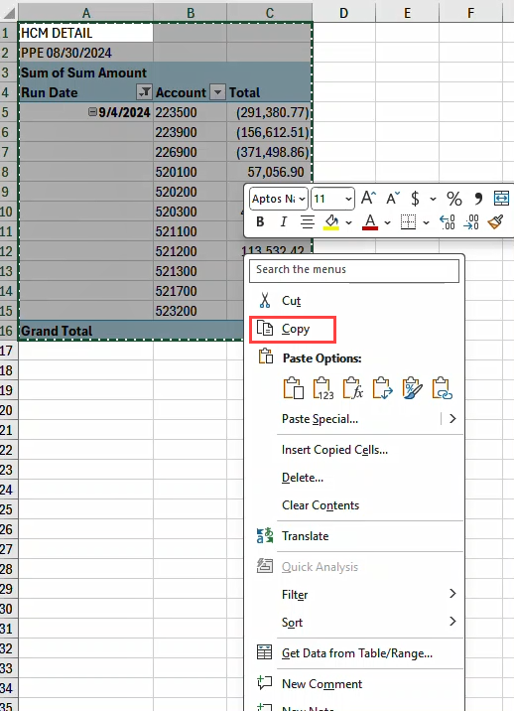

- Copy HR PIVOT 1

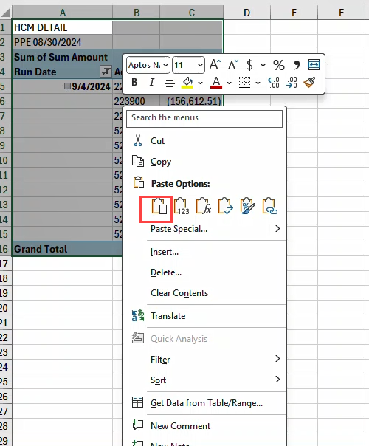

- Paste into new sheet (tab)

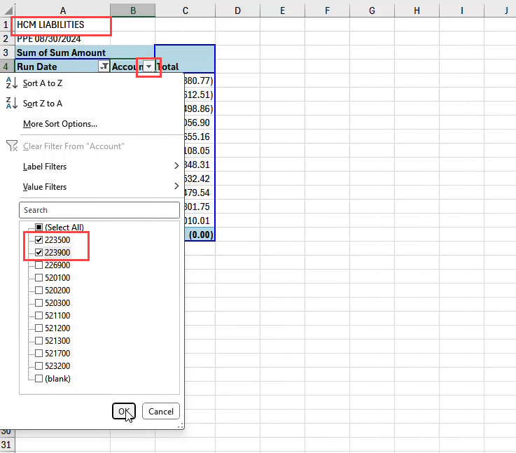

- On Account column, filter for 223500 and 223900
- 1st line enter HCM LIABILITIES
- Rename sheet (tab) HR PIVOT 2 LIABILITIES
- SAVE document

HR ACCT LINE DETAIL PIVOT TABLE RESULTS FOR HR PIVOT 2 LIABILITIES

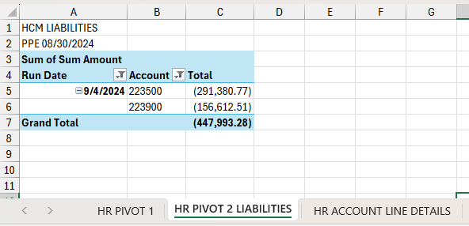

PR JOURNALS

FINANCIAL QUERY: REPORTING TOOLS > QUERY > QUERY VIEWER
{NMS_GL_JOURNAL_LINE}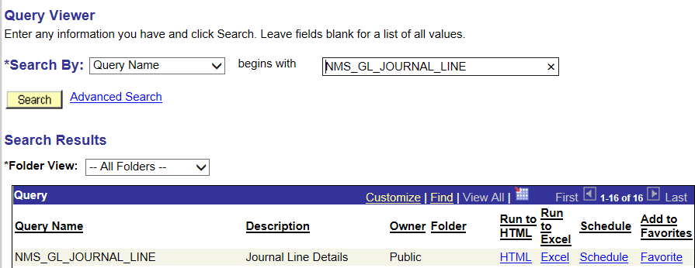
Click on [Excel]

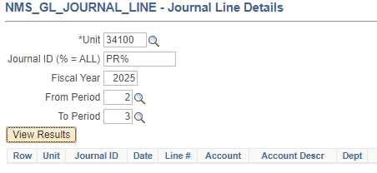

- Unit: Enter your Business Unit
- Journal ID (% = ALL): Enter PR%
- Fiscal Year: Enter the Fiscal Year
- From Period: Enter the period (Fiscal Month ex. July= 1, Aug=2, etc…)
- To Period: Enter the period (If PPE or Pay Date crosses into another month enter that month’s period number here)
- Click on [View Results] button

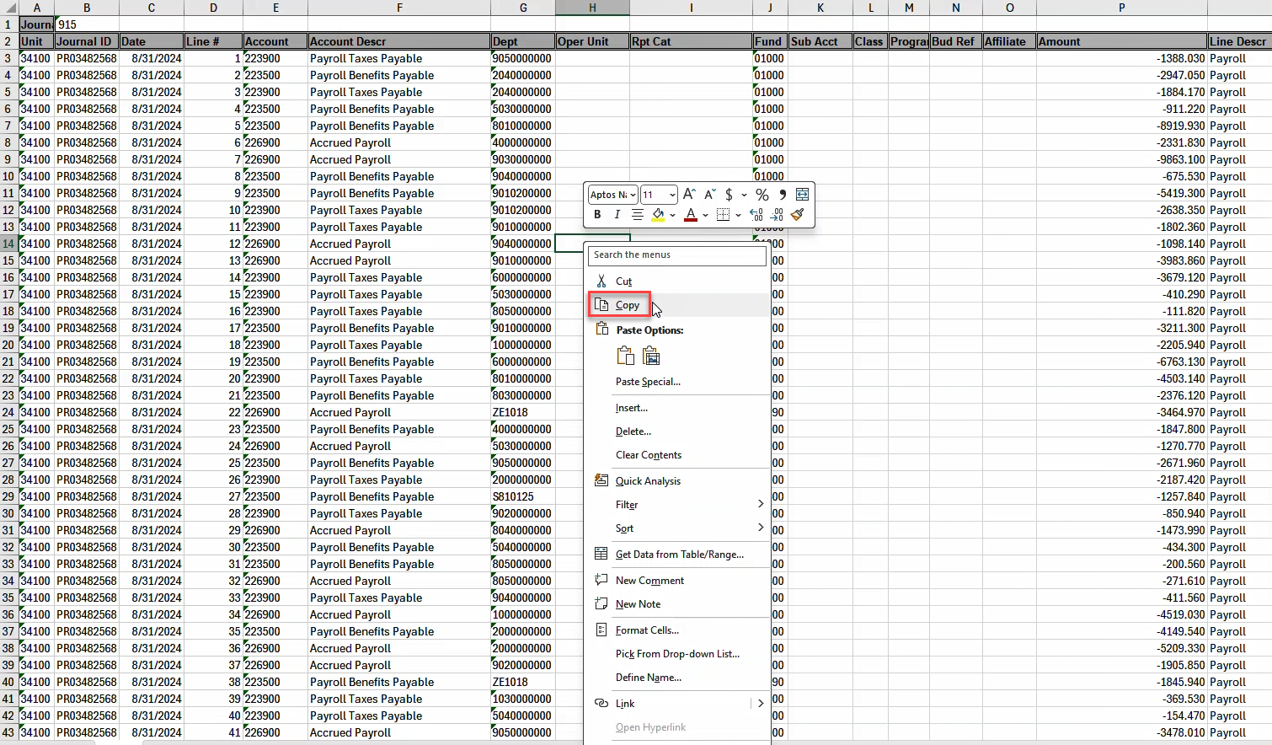

- Copy data

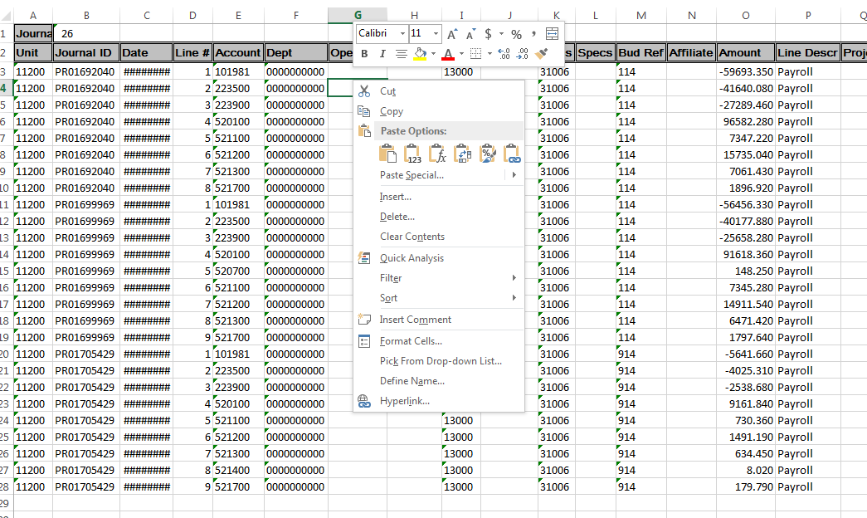

- Paste data in new sheet (tab) next to HR ACCOUNT LINE DETAIL sheet (tab)

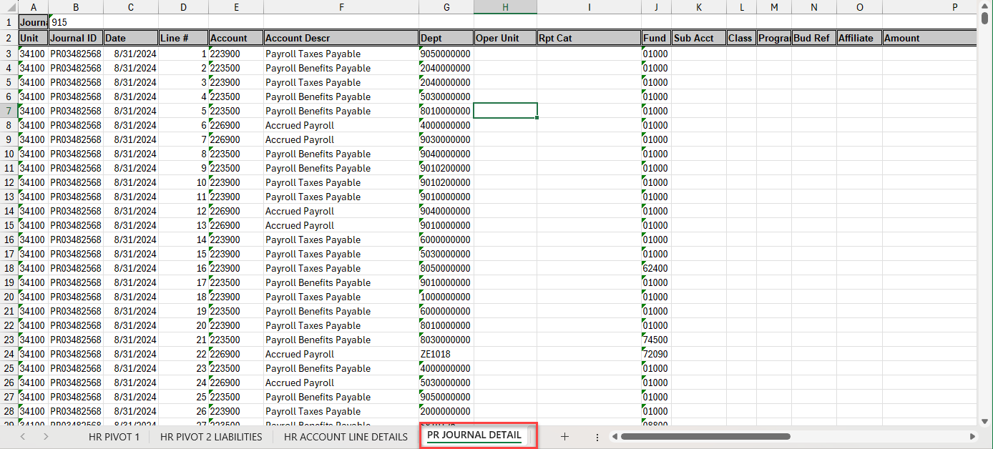

- Rename sheet (tab) PR JOURNAL DETAIL
- Close/don’t save NMS_GL_JOURNAL query. (No longer needed since data was copied to spreadsheet)

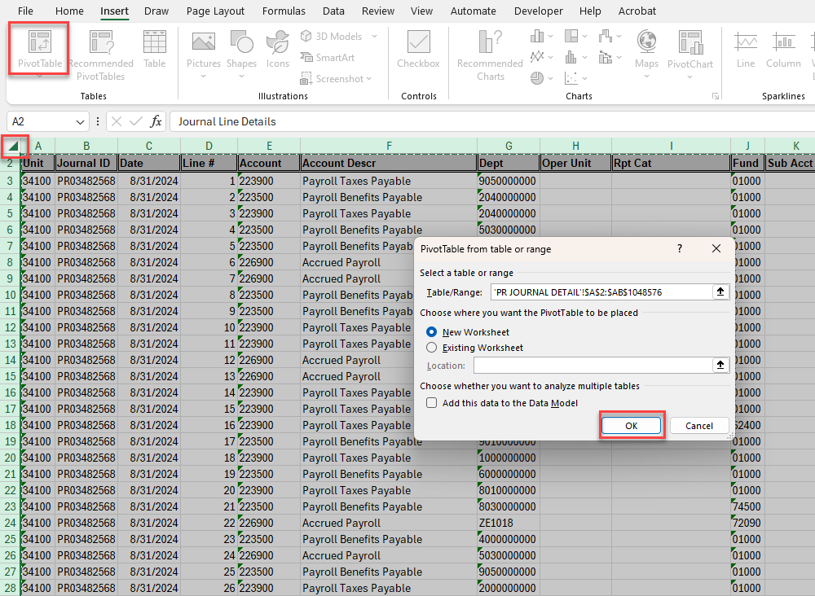

- Create a pivot table
- Position cursor in corner of column A and row 1
- Click on the [Insert] tab
- Click on the Pivot Table Icon
- Select a table or range – default will be the whole query results
- Click on the [OK] button

- Change pivot table to Classic
- Right Click within the pivot table
- Click on [Pivot Table Options…]

- Click on [Display Tab]

- Check Classic Pivot Table Layout (enables dragging of filed in the grid)]
- Click on the [OK] button

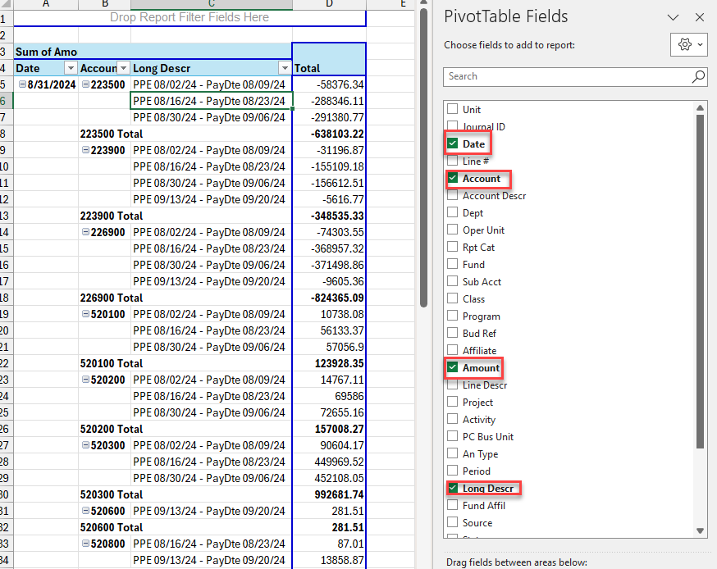

- Select
- Date
- Account
- Long Description
- Amount
(Make sure there aren’t any other fields selected)
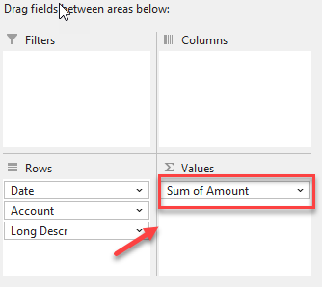

- You may need to drag [Sum of Amount] to Values

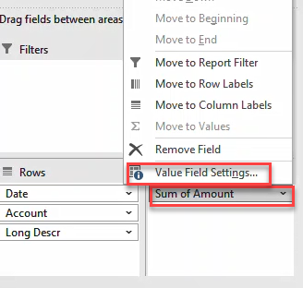

- Click on [Sum of Amount]
- Click on [Value Field Settings]

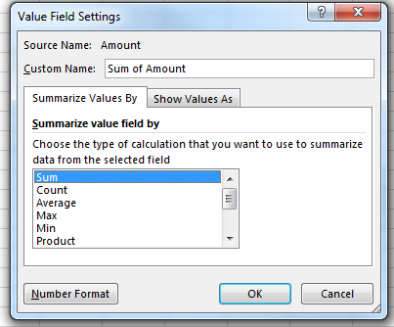

- Click on [Sum]
- Click on [Number Format]

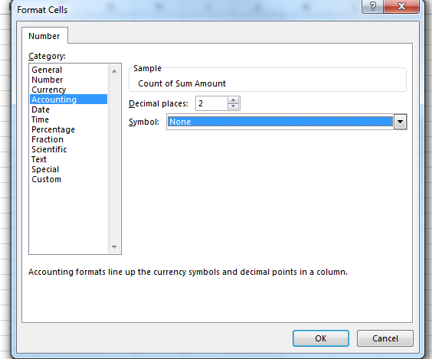

- Click on [Accounting]
- Click on [Decimal places: 2]
- Click on [Symbol: None]
- Click on [OK] button

- Click on [OK]
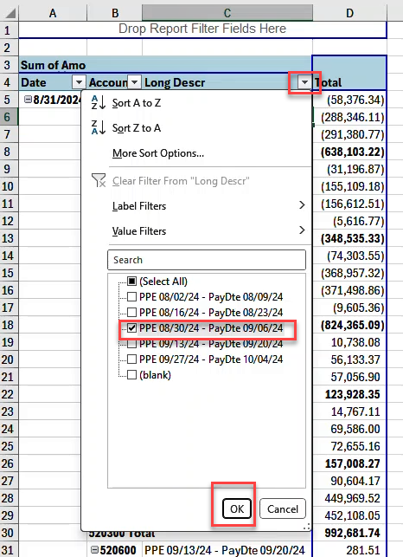

- Click on [Long Descr drop down] and filter for the PPE you are working on
- Click on [OK]

Results

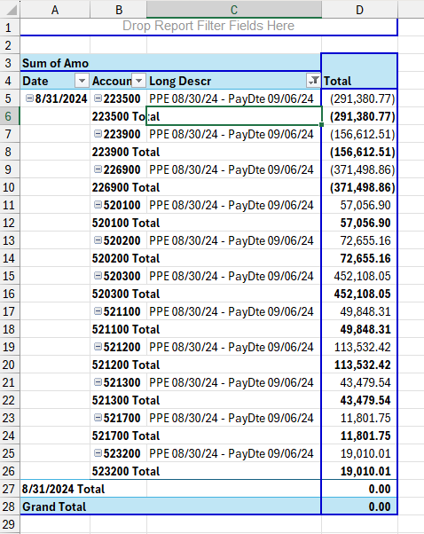

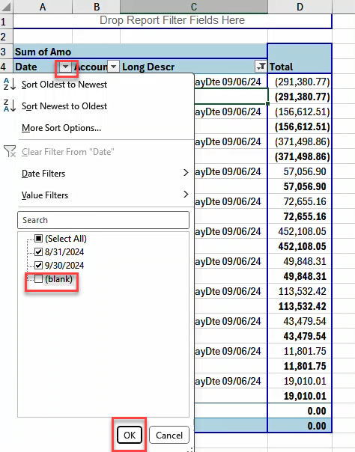

- Remove blanks by
  - Selecting the filter on Date column and uncheck Blank.
  - Click on the OK Button
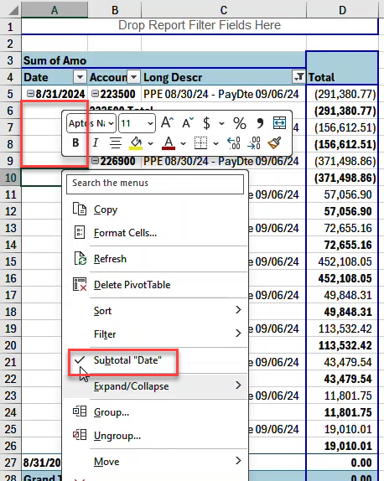

- Remove Date Subtotals by:
  - Placing cursor within date total column,
  - Right click,
  - Select Subtotal Date

- Remove Account Subtotals by
  - Place cursor within Account total column
  - Right click
  - Select Subtotal Account

- On line one enter PR JOURNALS
- On line two enter PPE MMDDYYYY
- Rename sheet (tab) as: PR PIVOT 1

PR Journals Pivot Table Results for PR PIVOT 1

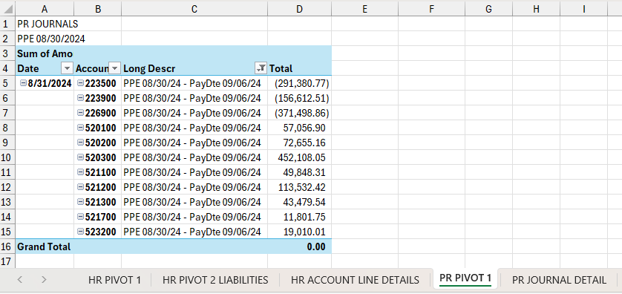

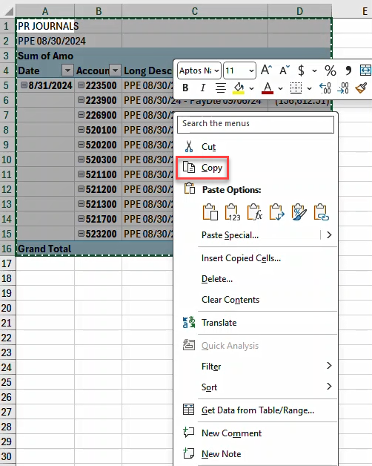

- Copy PR PIVOT 1

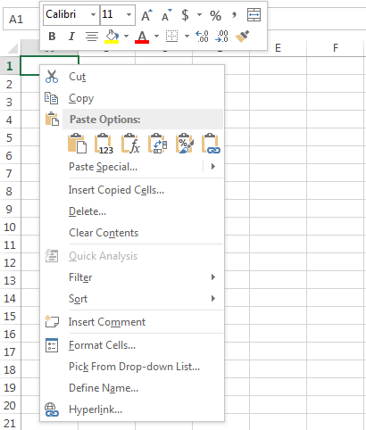

- Paste into new sheet (tab) next to PR PIVOT 1

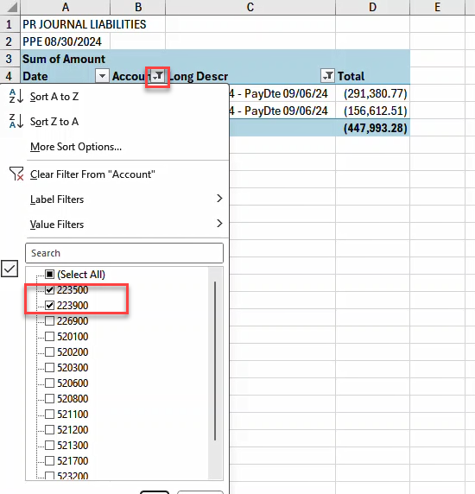

- On Account column filter for 223500 and 223900
- 1st line enter PR JOURNAL LIABILITIES
- Rename sheet (tab) as: PR PIVOT 2 LIABILITIES
- SAVE document

PR Journals Pivot Table Results for PR PIVOT 2 LIABILITIES

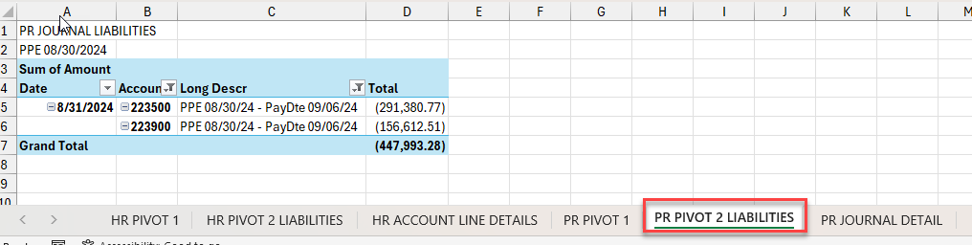

RECONCILE HR ACCOUNT DETAIL TO THE PR JOURNAL DETAIL

- Create new sheet (tab) next to the PR JOURNAL DETAIL sheet (tab)
- Name sheet (tab) as: COMPARE HR DETAIL – PR JOURNAL

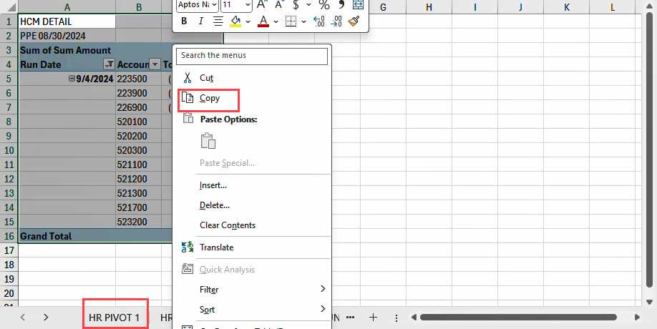

- Copy HR PIVOT 1

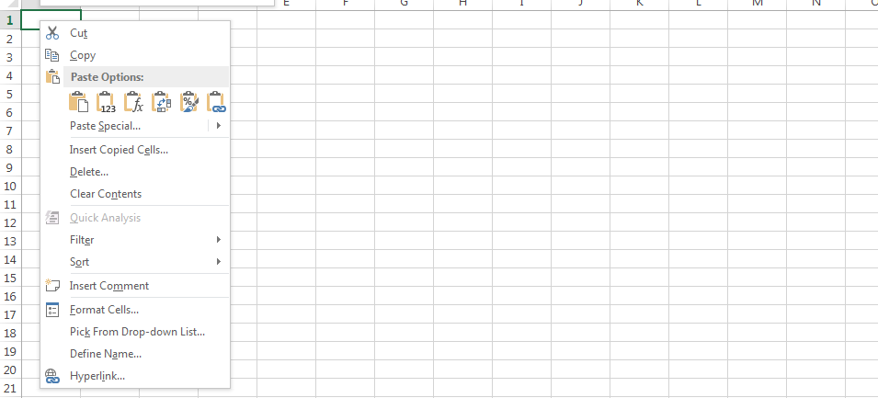

- Paste into COMPARE HR DETAIL – PR JOURNAL sheet (tab)

RESULTS

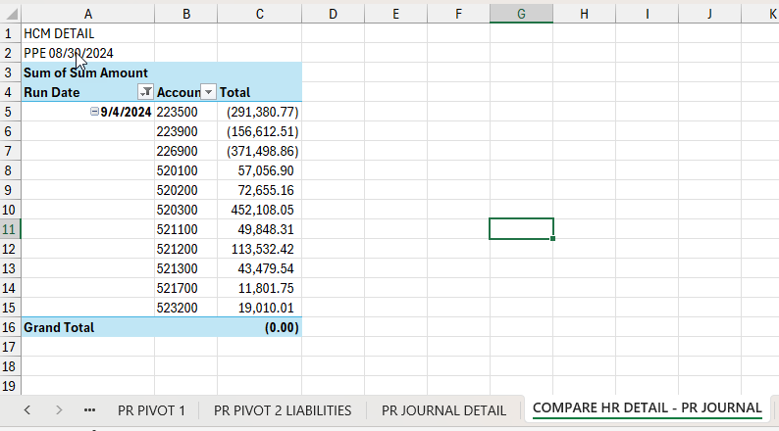

- Navigate to Tab PR PIVOT 1

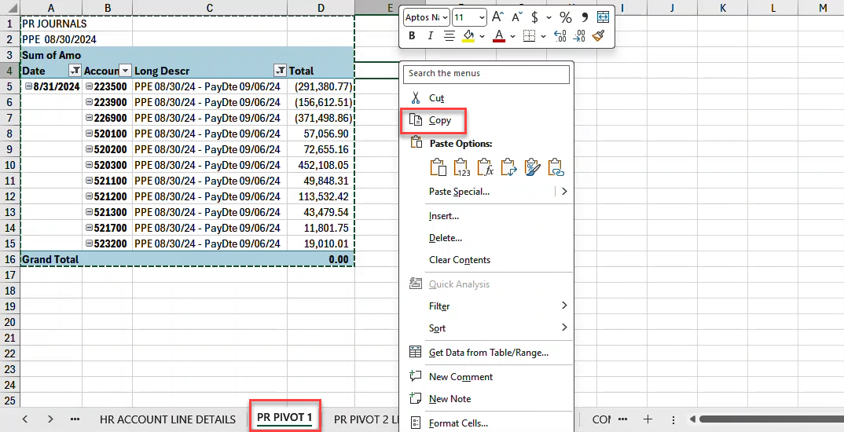

- Copy PR PIVOT 1

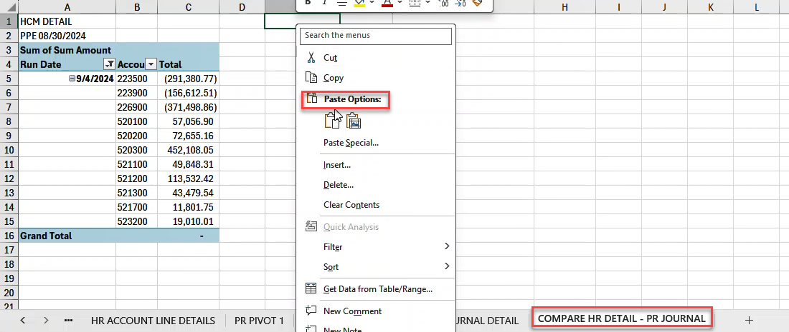

- Paste to Compare spreadsheet next to HCM DETAIL

RESULTS FOR COMPARE HR DETAIL – PR JOURNAL

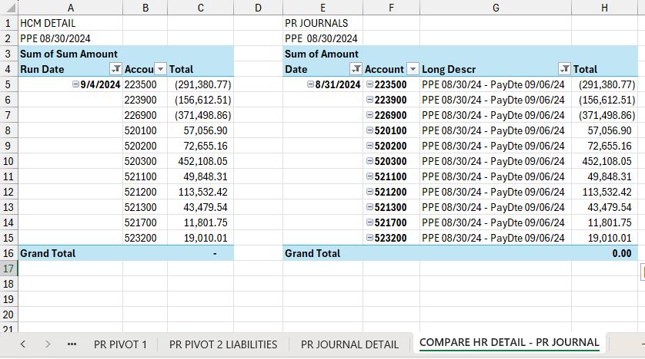

- Compare the amounts. They should equal each other. HCM DETAIL and PR JOURNALS are reconciled.
- Save document

AP JOURNALS

FINANCIAL QUERY: REPORTING TOOLS > QUERY > QUERY VIEWER
NMS_GL_JOURNAL_LINE

- Click on Excel

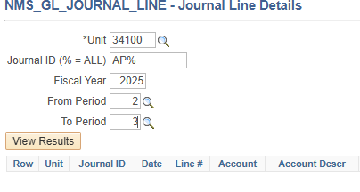

- Unit: Enter your Business Unit
- Journal ID (% = ALL): Enter AP%
- Fiscal Year: Enter the Fiscal year
- From Period: Enter Period working on
- To Period: Enter Period working on
- Click on [View Results] button

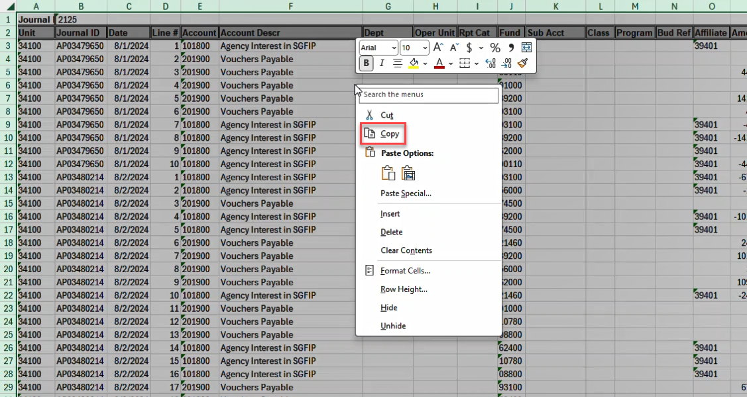

- Copy data

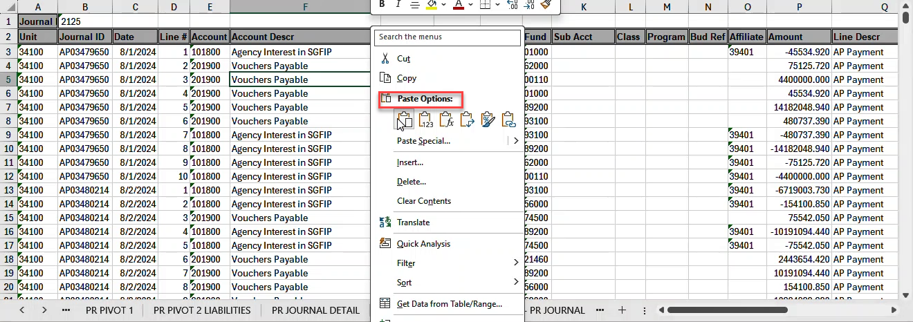

- Paste in new sheet (tab) next to PR JOURNAL DETAIL

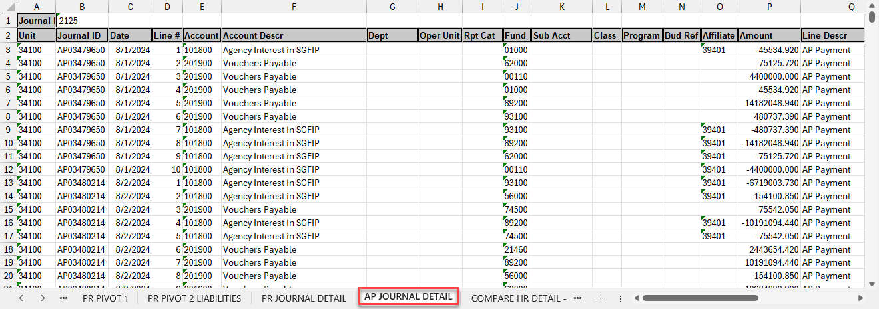

- Rename sheet (tab) AP JOURNAL DETAIL
- Close/don’t save NMS_GL_JOURNAL query. (No longer needed since data was copied to spreadsheet)

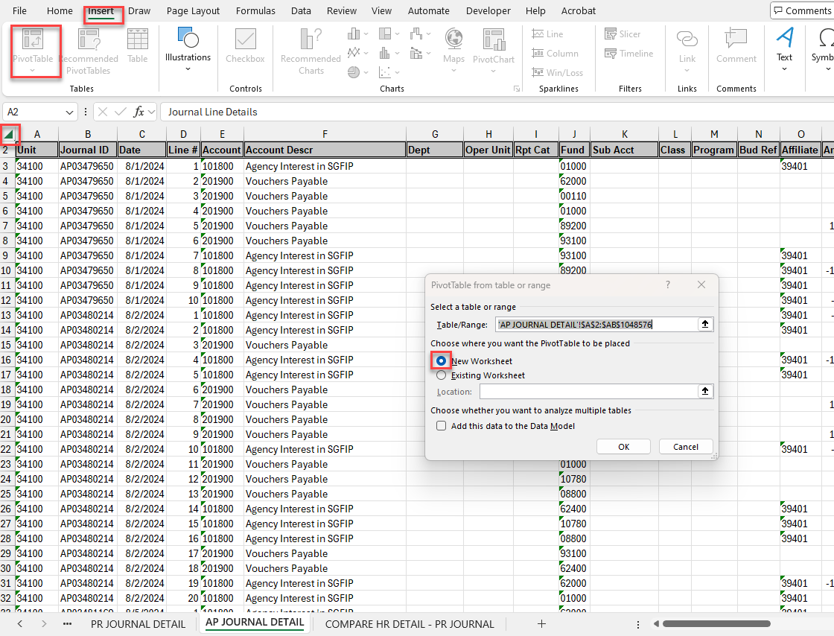

CREATE PIVOT TABLE
- Position cursor in corner of Column A and Row 1
- Click on the [Insert] tab
- Click on the [Pivot Table]
- Select a table or range – defaults will be whole query results
- Pivot table is to be placed in New Worksheet which is the default
- Click on the [OK] button

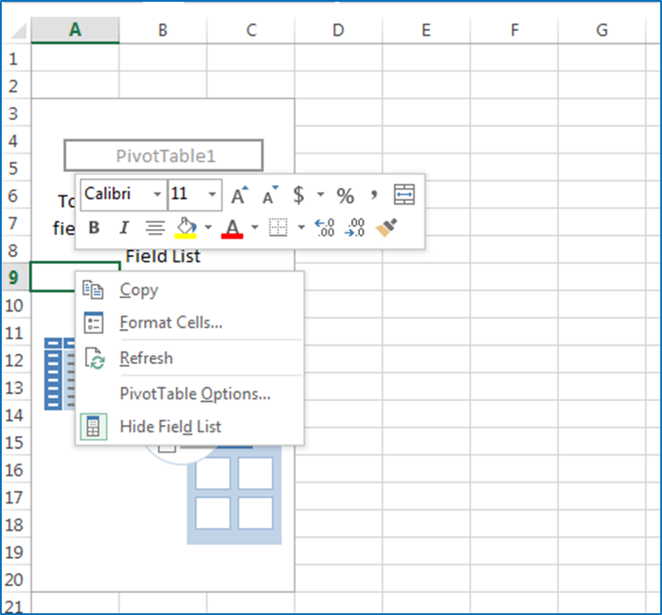

- Change pivot table to Classic
- Right Click within pivot table
- Click on [Pivot Table Options…]

- Click on [Display Tab]

- Check the [Classic Pivot Table layout (enables dragging of field in the grid)]
- Click on the [OK] button

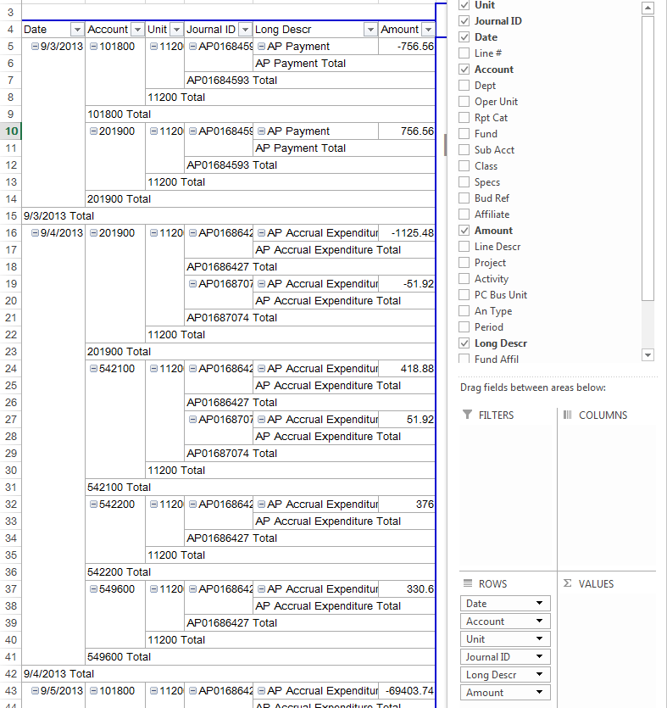

- Select
- Date
- Account
- Unit
- Journal ID
- Long Description
- Amount
- Unselect Years, Days, Months (Excel may have selected these automatically)

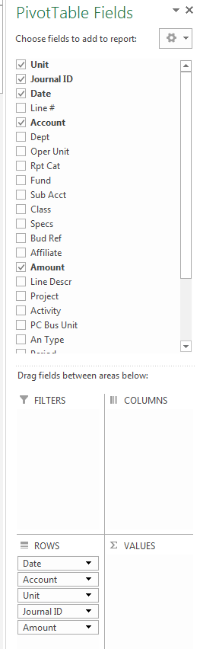
- Drag Amount to Values
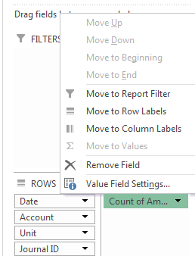
- Click on [Count of Am]
- Click on [Value Field Settings]

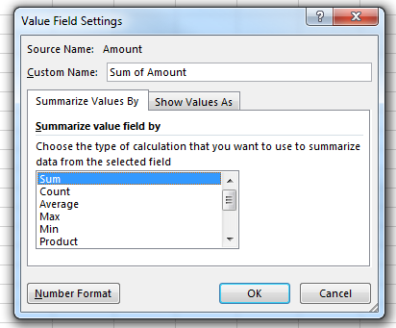

- Click on [Sum]
- Click on [Number Format]

- Click on [Accounting]
- Click on Decimal Places 2]
- Click on [Symbol: None]
- Click on the [OK] button

- Click on [OK]

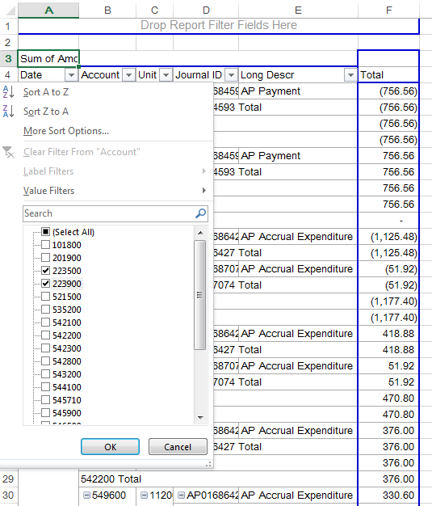

- Click Account drop down
- Filter for
- 223500 [Payroll Benefits Payable]
- 223900 [Payroll Taxes Payable]
- Click on [OK] button

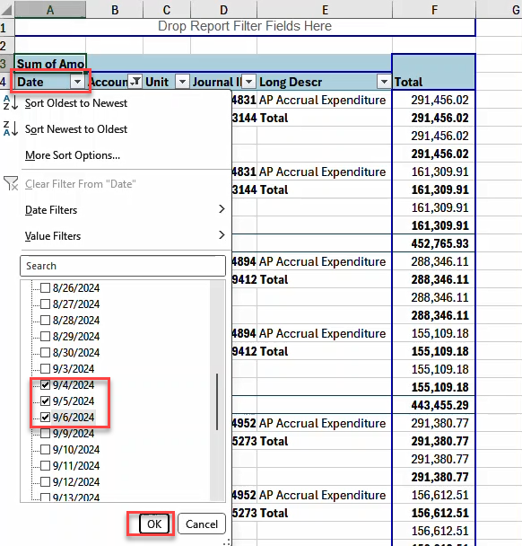

- Click on the Date drop down
- Filter for
  - Wednesday, Thursday and Friday of Pay Date week
- Click on the [OK] button

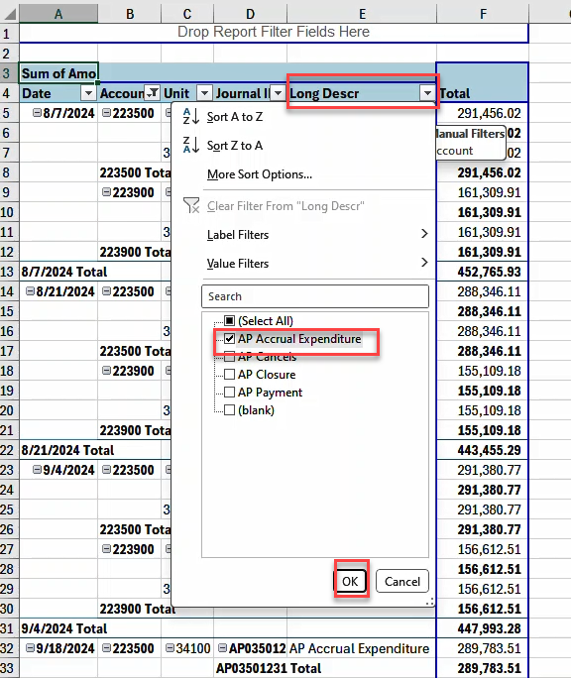

- Click on drop down for Long Descr
- Filter for
  - AP Accrual Expenditure
  - Child Support EFT File not applied to AP. PPE MMDDYY, Check Date MMDDY
Not applicable to all agencies. Will apply only if there are Child Support EFT payments. In this case there were not any child support EFT payments so only AP Accrual Expenditure was selected.
- Click on the [OK] button

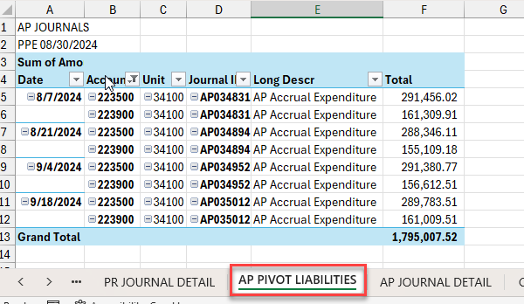

- Remove Sub Totals.
  - Right click within Date column, click on Subtotal Date.
  - Do the same for Account, Unit, Journal ID and Long Descr Columns.
- On line 1 enter AP JOURNALS
- On line 2 enter PPE MMDDYY
- Rename sheet (tab) to AP PIVOT LIABILITIES

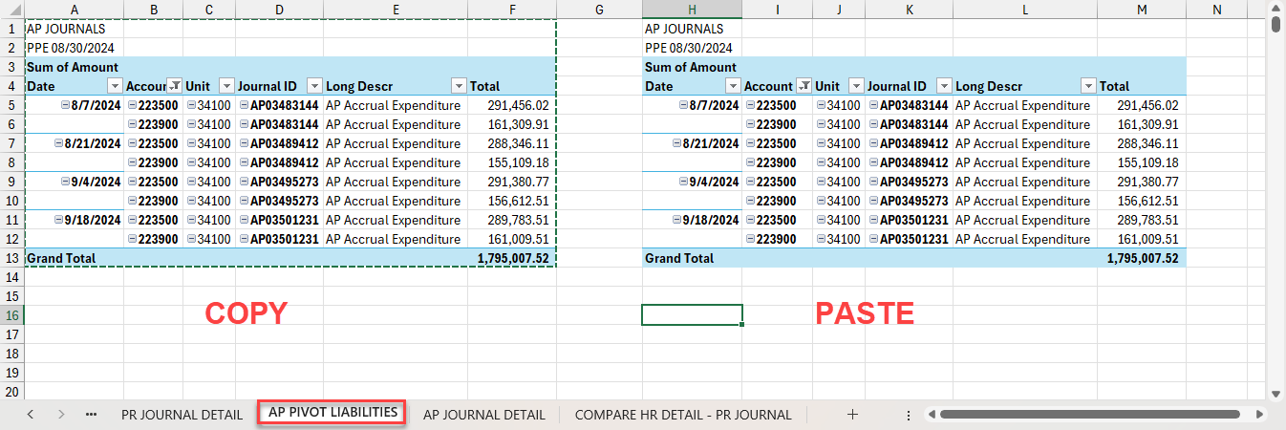

- Copy AP PIVOT LIABILITIES and paste next to itself

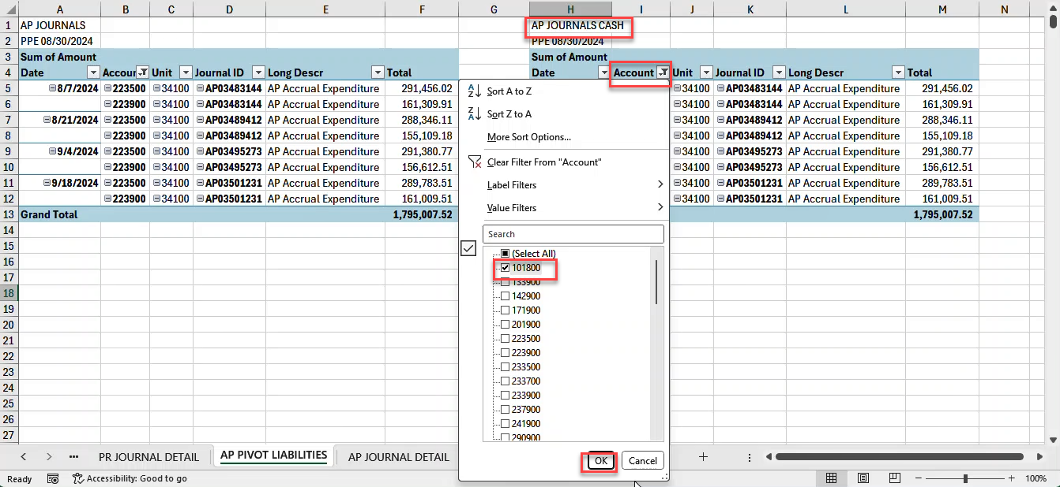

- On line one enter AP JOURNALS CASH
- Click on filter for Account
- Filter for 101800 & 101981 if applicable
- Click on [OK] button

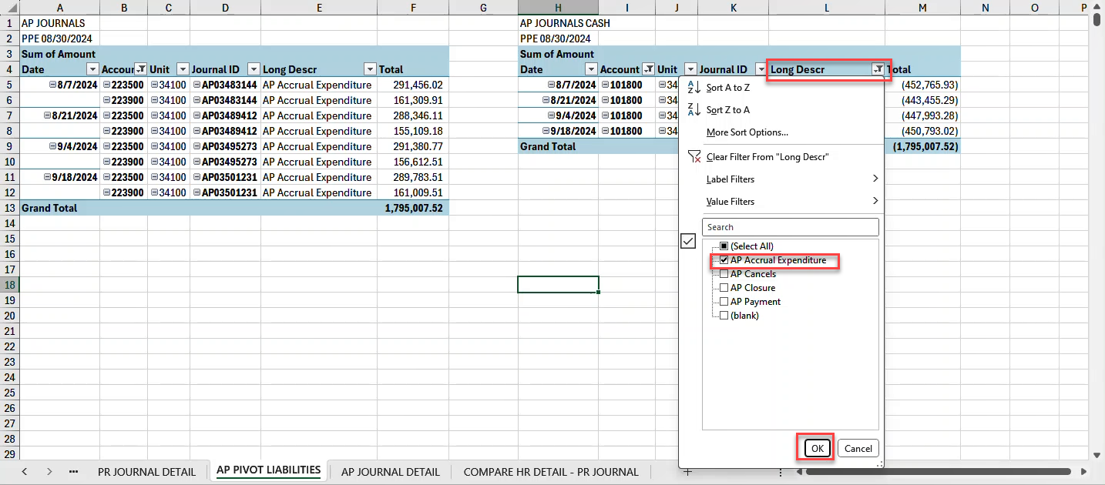

- Click on filter for Long Descr
- Filter for AP Accrual Expenditure and Child Support EFT (if applicable)
- Click on the [OK] button
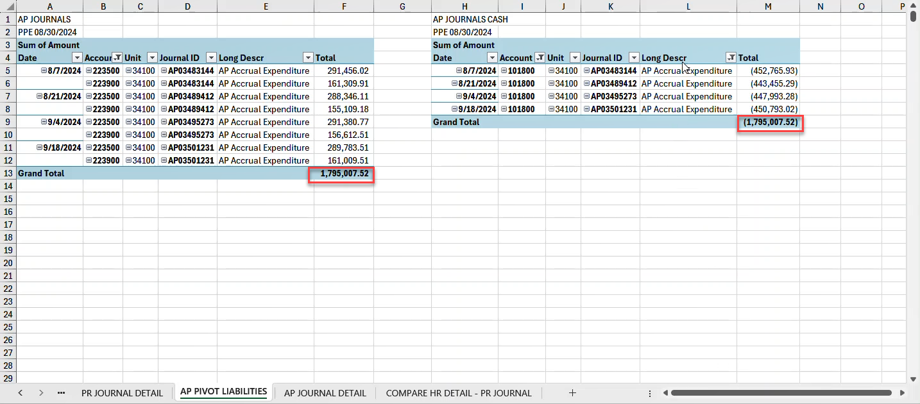

- AP Liability Account 223500 and 223900 should have the same total as AP Cash Account 101800 & 101981 if applicable
- SAVE document

RECONCILE PR JOURNAL CASH & LIABILITIES TO AP JOURNAL CASH AND LIABILITIES

- Create new sheet (tab) next to COMPARE HR DETAIL – PR JOURNAL sheet (tab)
- Name new sheet as: FINAL RECONCILIATION

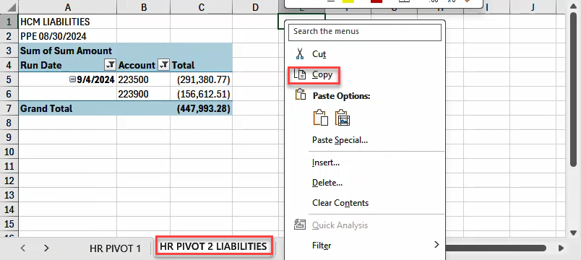

- Copy HR PIVOT 2 LIABILITIES sheet (tab)

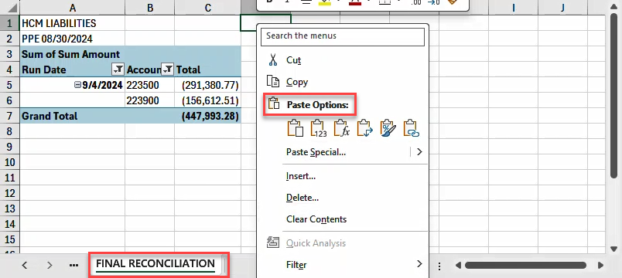

- Paste into Final Reconciliation sheet (tab)

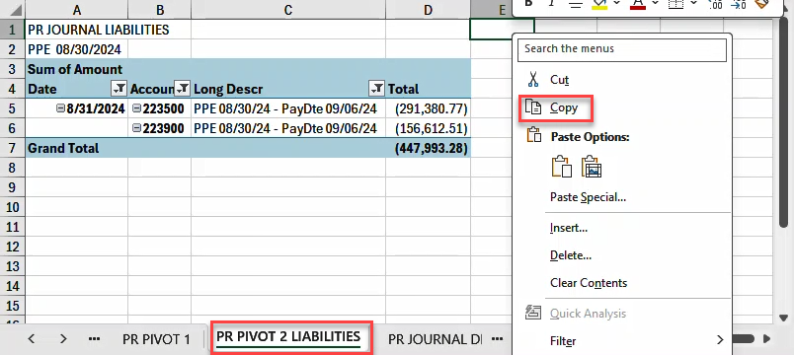

- Copy PR PIVOT 2 LIABILITIES sheet (tab)

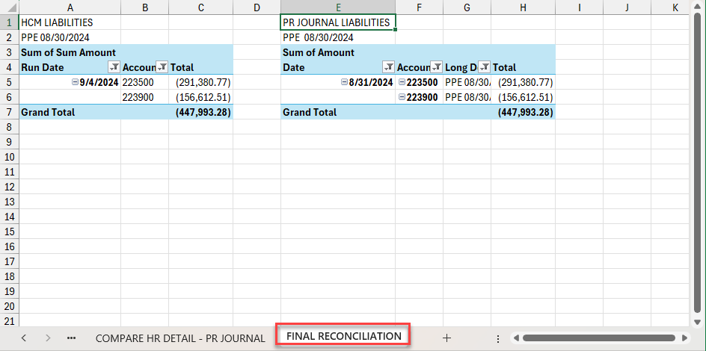

- Paste into FINAL RECONCILIATION sheet (tab) next to HCM LIABILITIES

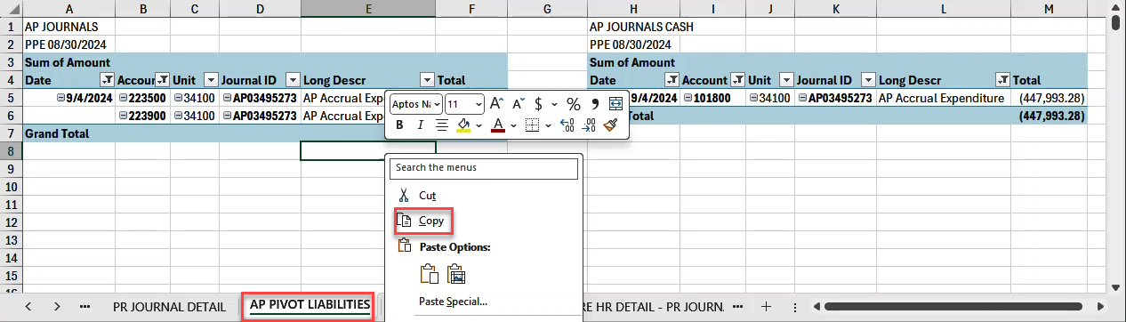

- Copy AP PIVOT LIABILITIES data

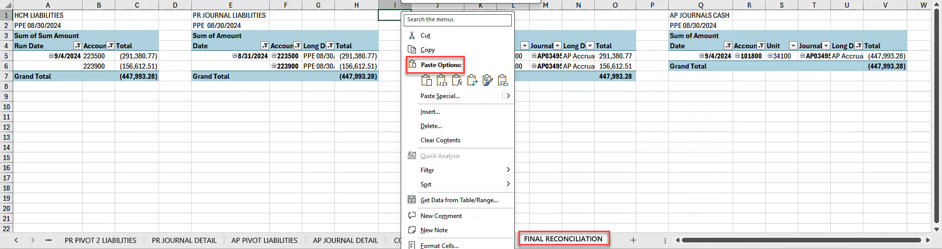

- Paste into FINAL RECONCILIATION Sheet (tab) next to PR JOURNAL LIABILITIES

RESULTS FOR FINAL RECONCILIATION

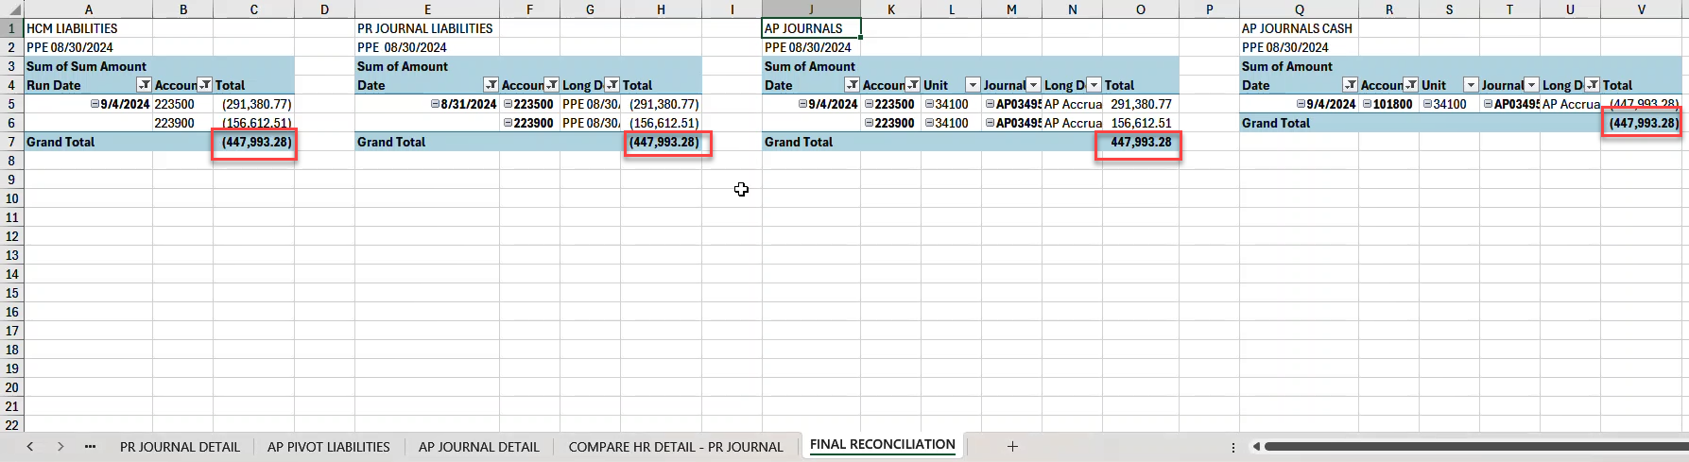

- Compare HCM Liability / PR Journal Liability and AP Journal Liability / Cash
They should all equal each other.

SAVE document

Note: If there are differences, see the tips on the following pages on how to resolve them.

DIFFERENCES

The cause of differences in the SHARE system are due to employee transfers and garnishments.

Pending Order to Pay Garnishments
- Garnishments – Since garnishments cannot be paid out until the Central Payroll Bureau receives an order to pay, the garnishment payment is held until the order to pay is received by the Central Payroll Bureau.

This HCM query was created for agencies to help in identifying differences due to garnishments held. NMS_PY_GARNS_NOT_SENT_TO_AP

If the query returns results you will have keep a running tally / spreadsheet of each employee with amounts withheld. Once the Order to Pay is received by central payroll an AP voucher is prepared with a lump sum amount which is applicable to all of the employee payroll deductions for each pay period of when the deduction for the garnishment began to when Central Payroll received the Order to Pay.

Child Support EFT (Electronic File Transfer) garnishments
- These payroll transactions do not get sent to AP. We prepare a Child Support Journal Entry and upload it into Share Financials so that it can be posted to the G/L. The Child Support Journal Entry will be: APMCSPXXX
XXX = Sequential number

Employee Agency Transfers
- Employee Transfers - The AP batch processes run in HCM picks up the business unit from the job record. So, when an employee transfers from one business unit to the other and the previous agency is paying the employee for any type of earnings, then the AP process picks up the receiving agencies business unit, which results in the AP payroll liabilities to be understated for the previous agency and overstated for the receiving agency.

In order to find out what employee transferred from one business unit to other you compare the HCM_DETAIL liabilities to the liabilities in the NMS_AP_EXTRACT query which reside in HCM.

In order to identify these employees who transferred from one BU to another BU, run
the HCM query: NMS_AP_EXTRACT

Compare the HCM_DETAIL to the NMS_AP_EXTRACT - You will be missing an employee from one of the files. See Example.

IDENTIFYING EMPLOYEE TRANSFERS

HCM QUERY: REPORTING TOOLS > QUERY > QUERY VIEWER
NMS_PY_ACCOUNTING_LINE_DETAILS

- Run to Excel

GL Unit: Agency Business Unit Number
From PPE: Pay period end date of the pay period you are reconciling
To PPE: Pay period end date of the pay period you are reconciling (these are typically the same date)
Dept ID: Leave the “%” sign
Account: Leave the “%” sign
Fund: Leave the “%” sign
EmplID: Leave the “%” sign
Click on: [View Results]

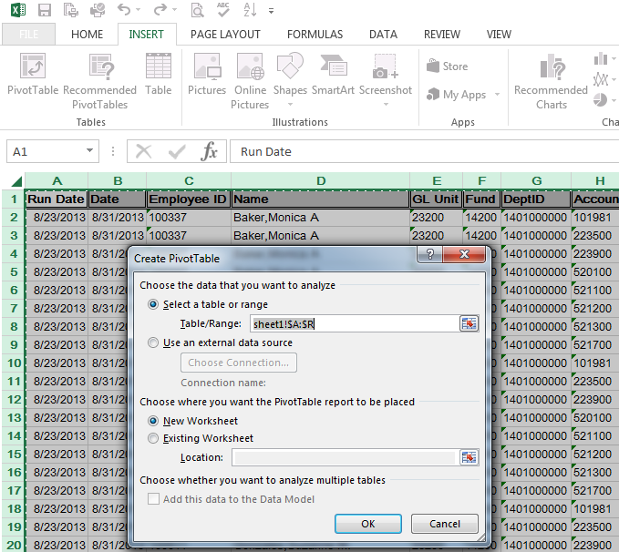

CREATE PIVOT TABLE
- Position cursor in corner of Column A and Row 1
- Click on the [Insert] tab
- Click on the [Pivot Table]
- Select a table or range – defaults will be whole query results
- Pivot table is to be placed in New Worksheet which is the default
- Click on the [OK] button
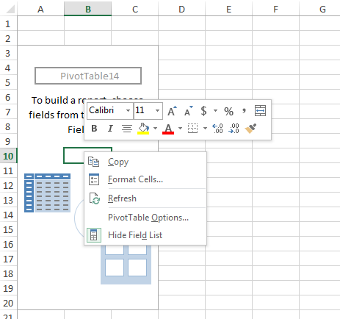

- Change pivot table to Classic
- Right click within pivot table
- Click on [Pivot Table Options…]
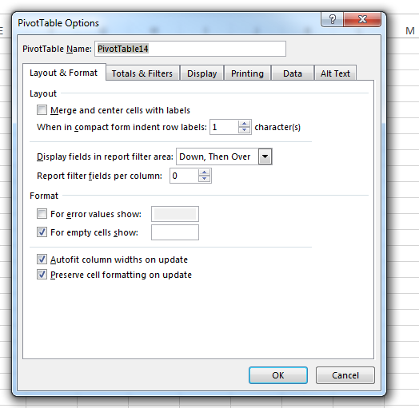

- Click on [Display tab]
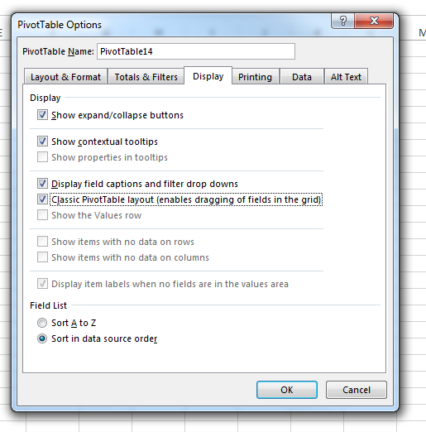

- Check the [Classic Pivot Table layout (enables dragging of filed in the grid)
- Click on the [OK] button
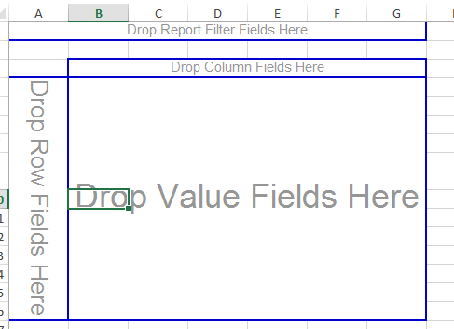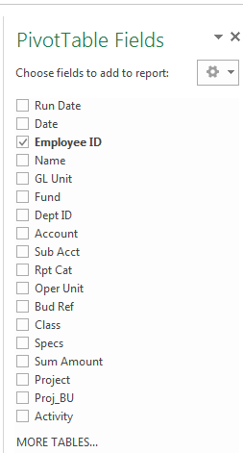

- Select Employee ID

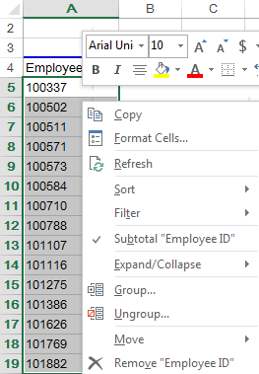

- Copy and paste data into new sheet
- Name new sheet Compare

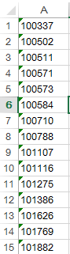

HCM QUERY: REPORTING TOOLS > QUERY > QUERY VIEWER
NMS_AP_EXTRACT

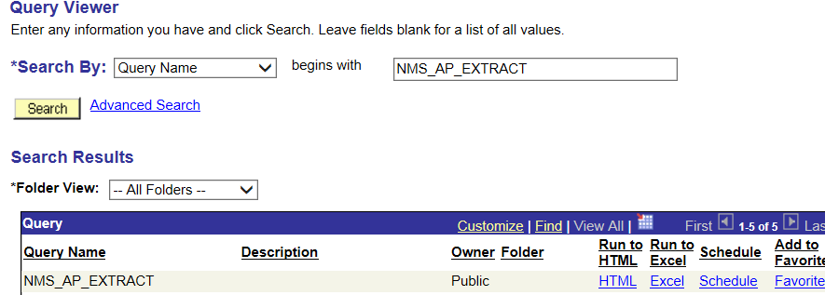

- Run to Excel

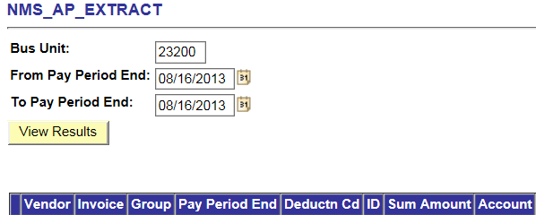

- Enter:
  - Bus Unit: Agency Business Unit
  - From Pay Period End: Pay period end date
  - To Pay period End: Pay period end date
- Click on View Results button

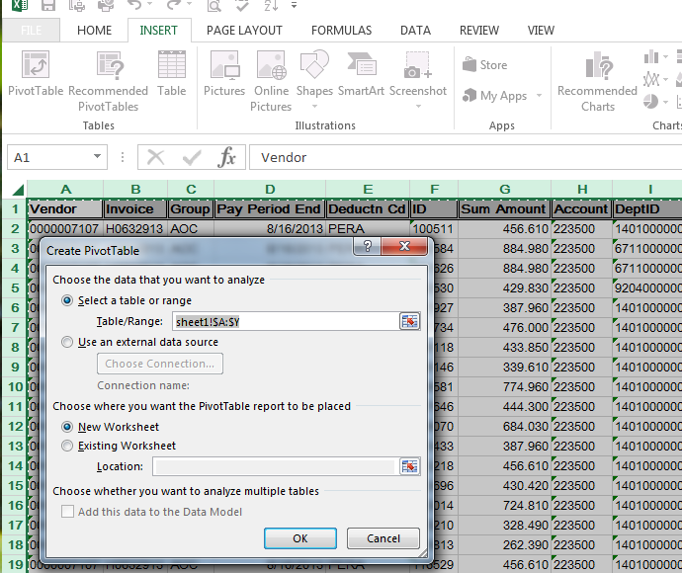

CREATE PIVOT TABLE
- Position cursor in corner of Column A and Row 1
- Click on the [Insert] tab
- Click on the [Pivot Table]
- Select a table or range – defaults will be whole query results
- Pivot table is to be placed in New Worksheet which is the default
- Click on the [OK] button

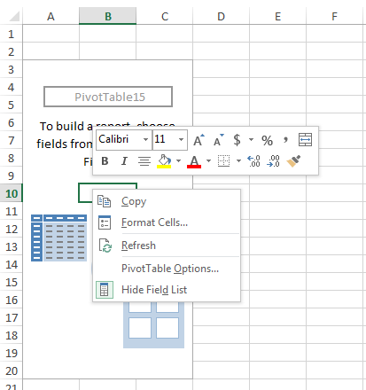

- Change pivot table to classic
- Right click within pivot table
- Click on the [Pivot Table Options…]

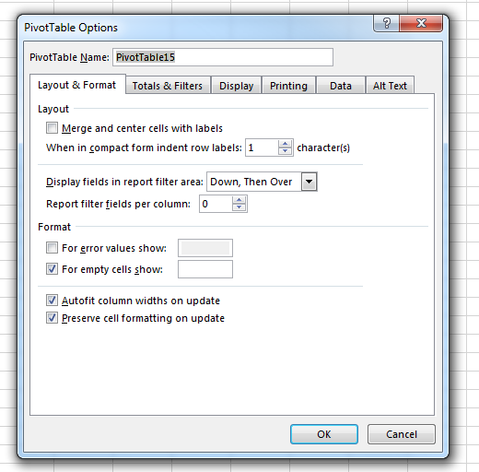

- Click on the [Display Tab]
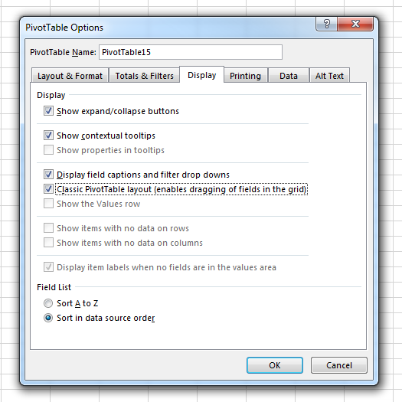

- Check the [Classic Pivot Table layout (enables dragging of field in the grid)]
- Click on the [OK] button
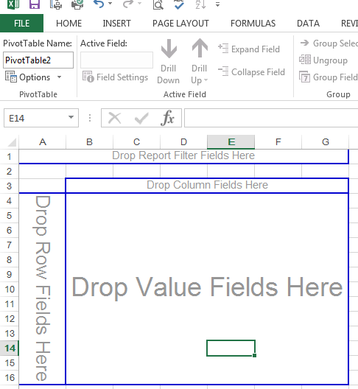

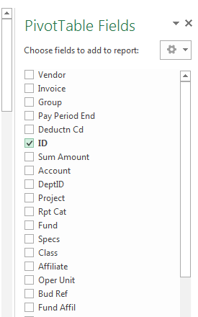

- Select ID

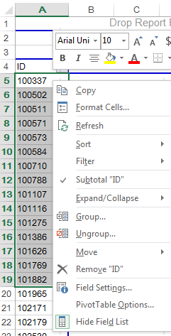

- Copy and paste data next to EMPLID’s in sheet named Compare

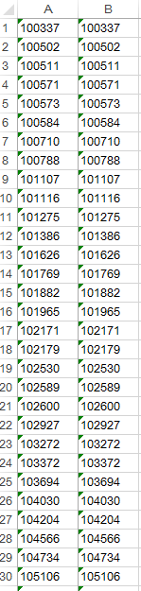

- Compare the data
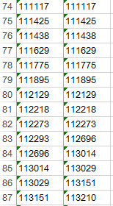

- In this case emplid 112xxx is missing from AP EXTRACT
- Once you have identified the employee open up an incident request through the FCD Helpdesk, giving them the employee id, pay period end date and amount difference. To get the amount difference, go back to the HCM details query and filter for the missing employee select Account and Sum Amount on the pivot table. Have them send the incident request to CPB (Central Payroll Bureau) attention to Third Party Integration. We will then prepare the supporting documentation to proceed with the OPR.

CHART of ACCOUNTS
Cash & Liability Accounts
101981 - Cash
223500 - Employee/Employer Deduction Liabilities
223900 - Employee/Employer Tax Liabilities

Expenditure Accounts
520100 – Exempt Perm Positions P/T & F/T
520200 – Term Position
520300 – Classified Perm Position F/T
520400 – Classified Perm Position P/T
520500 – Temporary Positions F/T & P/T
520600 – Paid Unused Sick Leave
520700 – Overtime and Other Premium Pay
520800 – Annual Leave Paid at Separation
520900 – Differential Pay
521100 – Employer Group Insurance Premium
521200 – Employer Retirement Contributions
521300 – Employer FICA/MEDICARE
521400 – Employer Workers Comp Assessment Fee
521700 – Employer Retiree Health Care
521900 – Other Employee Benefits
542200 – PDT/TPA(Taxable Per Diem Adjustment)

AP JOURNAL Cash & Liability Accounts
101800 - Cash
223500 – Employee/Employer Deduction Liabilities
223900 – Employee/Employer Tax Liabilities

Document Control
Date | Author | Description | Version
11/21/2013 | Theresa Gallegos | Draft | 0.1
07/22/2014 | Theresa Gallegos | Inserted two pages missing for PR journals
08/11/2014 | Theresa Gallegos | Updated example for HCM detail – AP extract compare
09/12/2014 | Theresa Gallegos | Updated to add shareftp site and change from PR Journal line to GL Journal Line query
11/19/2014 | Cathy Meyer | Added more information for differences
04/23/2014 | Theresa Gallegos | Updated instructions for pivot table accounting selection to include number format. Updated where to obtain run dates.
04/29/2015 | Cathy Meyer | Adding correct DFA Link to obtain the Payroll Run Dates. Adding example of running the HCM HR_ACCTG_LINE_DETAIL query vs extracting data from the SHAREFTP site. Added table of contents. Changed numbering for each topic.
07/28/2015 | Theresa Gallegos | Corrected page 48 #33 to Click on drop down for Long Descr
08/17/2015 | Theresa Gallegos | Draft | 0.2
04/28/2025 | Alejandro Guzman | Updated all screenshots, changed query from HCM HR_ACCTG_LINE_DETAIL to NMS_PY_ACCOUNTING_LINE_DETAILS | 0.3

