DFA Local Government Division
Budget & Finance Bureau
Budgeting Guidelines for Special Districts
Local Government Budget Management System (LGBMS)
Pursuant to Section 6-6-2. K. NMSA 1978, DFA/LGD requires that interim budgets for special districts be submitted on LGBMS. Additionally, budget supporting schedules in the prescribed Excel format must also be submitted electronically as attached files via LGBMS.
Special Districts must update submission of a NEW Security Access Form (SAF) in LGBMS for everyone within your local government who requires access to the system for the fiscal year. To safeguard the data submitted on LGBMS, be sure to deactivate the account in LGBMS of anyone that no longer needs access to the system or has left your organization.
LGBMS Budget Submission Simplification
If your special district is currently using LGBMS, please follow these steps to simplify your budget submission:
- Navigate to the LGBMS Reporting Module and open the most current completed quarter for the current fiscal year (for example you can go into period “FY2025 Q2”).
- Click on the “My Budget” button at the top of the screen. 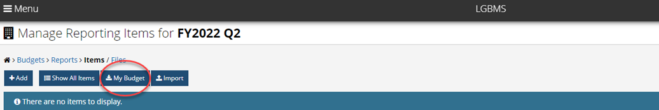
- A “CSV” (comma separated values) file with your entity’s current year’s budget line items will appear on the screen so that you can save it on your computer for creating next year’s budget upload file.
- Revise the “amount” column as needed and then use the “Save As” option in Excel, save the file with a new file name denoting it as the next year’s budget (for example FY2026-2027 budget and select “CSV” as the file type.)

- Navigate to the LGBMS MENU, select and open the Knowledgebase file and follow the instructions beginning on page 22 of the LGBMS Entity User Guide to upload the CSV file.
- All Special Districts receiving State Legislative Appropriations are required to submit their budget and submit all quarterly reports in LGBMS.
- If your Special District is not reporting in LGBMS and is interested in reporting in LGBMS, please contact your assigned budget analyst.
Fiscal Guidance/Tips
The following recommendations are offered in preparing a balanced budget, especially if your local government is facing financial challenges:
- Adopting and applying a formal policy that strictly disallows recurring expenditures from cash balances and non-recurring revenues.
- Re-evaluating all revenues while being cognizant of any legal, statutory, or governmental accounting standards regarding restrictions of use.
Optional Budget Forms, Supporting Schedules and Quarterly Report Forms
Excel Budget Forms | Special Districts not reporting on LGBMS may submit using either the fiscal year or calendar year standard Excel budget form only after consulting with their assigned budget analyst.
Excel Quarterly Report Forms | Special Districts that have been allowed by their assigned budget analyst to submit their budget outside of LGBMS are required to submit their quarterly reports on either the fiscal year or calendar year standard Excel quarterly report form.
Property Tax Calculation Worksheet | Calculates projected property tax revenue, if applicable to your special district.
Debt Schedule | Lists all outstanding debt (loans, revenue & general obligation bonds), if applicable to your special district. Electronically in LGBMS, make sure it ties to your Amortization Schedules.
S-5 (DETAIL OF NON-BUDGETED RESERVE REQUIREMENTS form) | Lists locally imposed reserves that must tie to amounts reported in LGBMS under Object Code 10105 Locally Imposed Reserve, if applicable to your special district. [There are no state required reserves for special districts.]
Balance Sheet and Bank Statements | A June 30th balance sheet or profit and loss statement along with bank statements as of June 30th are required to be submitted with the 4th Quarter report.

LGBMS Generated Budget Recapitulation (Recap)
- Beginning cash on recap page must tie to the prior year’s 4th quarter report ending cash (before reserves)
- Investments must be reported in the “investments” column
- Total Transfers must always be equal to zero (LGBMS will flag as an error)
- Adjusted Ending Cash balances of any Fund cannot be negative, including Funds that are awaiting grant reimbursements (LGBMS will flag as an error)
Salary Increases
One- time temporary salary increases (known as bonuses) are not allowed (see "July 2, 2008 Memo Performance Bonuses, Retroactive Pay Increases and Bonuses In Lieu of Pay Increases" memo.)

