DFA GUIDELINE FOR TLV PAY OUT ON A TRANSFER
Version 2.0 2.28.2019

When an employee transfers (or there is a break in service) from one Pay Group to another and the receiving agency is not willing to accept (full or partial) balances of the annual leave (Example: Classified to Judicial, Classified to DA’s, etc.) please follow the steps below.

- The receiving agency will be tasked with the responsibility of processing the TLV request to Central Payroll Bureau.

- The losing agency most provide the following funding sources to the receiving agency:

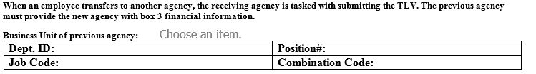

- The receiving agency will need to run the TLV Report and clean the employee record if need be.

- The receiving agency will need to submit the Terminal Leave Request Form along with the TLV Report to DFA- CPB by 5:00pm on Thursday Pay Period End to:

DFA-CentralPayrollForms@state.nm.us

- The person requesting must follow all best business practices outlined for TLV requests.

If you need any further assistance contact CPB Time & Labor

