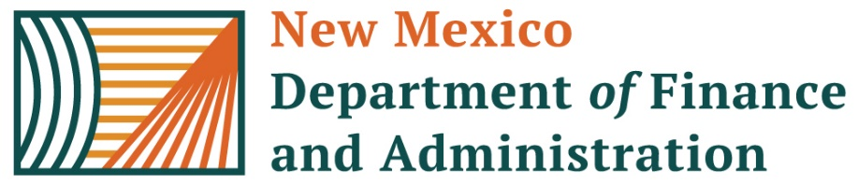 | State of New Mexico – Department of Finance and Administration  HOURS ADJUSTMENT REQUEST FORM
Version 12 Rev 04.30.2025
Today’s Date: | Requested By: |  | Telephone Number: |  |  | Pay Group:
Click here to enter a date. | Click here to enter text. |  | Click here to enter text. |  |  | Choose an item.
Current Pay Period Ending: | Employee Name |  | EMPLID#: |  |  | Business Unit:
Click here to enter a date. | Click here to enter text. |  | Click here to enter text. |  |  | Choose an item.
EARNING CODE: |  | #of Hours |  | Adjustment Type |  | EARNING CODE: | #of Hours | Adjustment Type
Choose an item. |  | Click here to enter text. |  | Choose an item. |  | Choose an item. | Click here to enter text. | Choose an item.
Choose an item. |  | Click here to enter text. |  | Choose an item. |  | Choose an item. | Click here to enter text. | Choose an item.

Explanation for the hours adjustment: |  | (Required)
Click here to enter text.
HR Manager Signature: (Required) |  | DATE: Click here to enter a date.
Print Name: | Click or tap here to enter text. | Phone Number:Click or tap here to enter text.

If the request includes prior FYs, please include agency CFO signature: ___________________________

Final Instructions:
The person requesting, reviewing and approving this form cannot be recipients of the request. Requester and approver may not be the same person. Forms and supporting documentation must be submitted by 5:00 PM on Tuesday Pay Period End via Central Payroll Bureau’s Form Submission System (FSS) at the following website: https://platform.dfa.nm.gov .

