Instructions for Requesting BAR Authority and Section 4 Language in BFM
- Provide information requested on the 2600 form if you require language for Section 4 (operating budget) or additional BAR authority for FY22 or agency specific FY23 BAR authority. If you do not have any of these special language requests, you do not need to submit this form.
- Navigate to the 2600 form and click Add New. Create a new form for each request.
- Select stage 2601 from the Stage dropdown, enter your BU and give the request a name. Click on Save.
- All info is entered on the Header tab. Click on Save when done. Supplemental documents can be added via the Attachments tab but are not required.
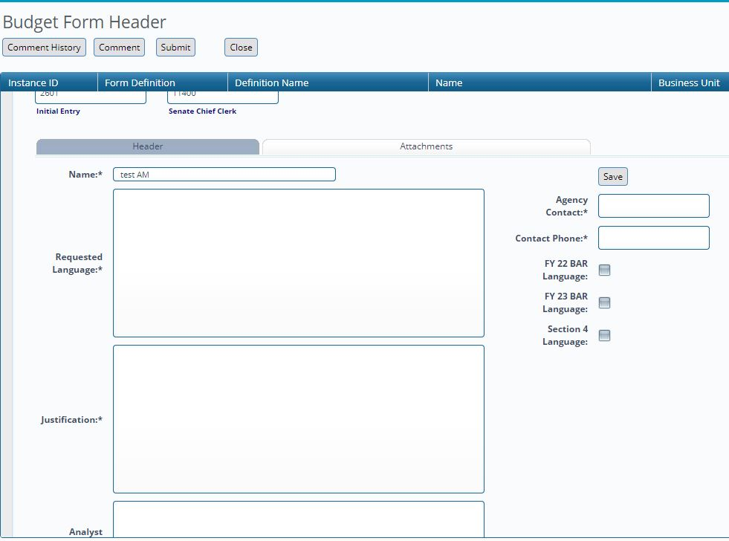

- Please include a brief justification for each request stating why such language is needed for the agency to carry out its mission. Enter agency contact and phone number at the right.
- Click the appropriate checkbox for the type of request at the right.
- Enter the requested language. Follow the capitalization and formatting conventions outlined below:
- Most words are not capitalized except at the beginning of a sentence; however, you should capitalize the following: place names (e.g. New Mexico, United States, Santa Fe county – note “county” is not capitalized, Ute reservoir, Vaughn pipeline, etc.); proper names (Vigil-Giron, Gutierrez, and Kupfer cases); legislative acts (Title IV-E funds, Section 12 of Chapter 114 of Laws 2004, Indian Education Act, etc.); months of the year (May, June, etc.), and the words “Indian” and “Native American.”
- Do not capitalize the names of agencies, departments, divisions, programs or funds.
- Do not capitalize the beginning word of clauses that contain agency-specific BAR adjustment language (See BAR examples below).
- Follow standard format/legislative conventions for structuring sentences such as the following:

Section 4: The (category of fund) appropriation to the (name of program) of the (name of department) include (dollars expressed in words) (dollars in numerals) for (the source and/or purpose of funds).

        - The other stare funds appropriation to the university of New Mexico health sciences center include two million nine hundred sixty-two dollars ($2,962,100) from the tobacco settlement program fund.
        - The general fund appropriation to the administrative program of the department of health in the contractual services category include two hundred thousand dollars ($200,000) for evaluation and services for victims of sexual assault.
BAR Language: the (name of program) of the (name of agency) may request budget increases up to (dollars expressed in words) (dollars in numerals) from (source or type of funding) for (purpose or use of funds);
        - the New Mexico medical board may request budget increases up to one hundred thousand dollars ($100,000) from other state funds for the administrative hearing and litigation process;
        - the interstate stream compact compliance and water development program of the state engineer may request budget increases up to three hundred thousand dollars for Pecos water settlement compliance;
- Do not enter anything in the Analyst comments box.
- When the request is complete, click on Submit to send the request through your agency review. When finalized, submit to stage 2604 which will simultaneously submit to DFA and LFC. Requests must be submitted by Friday, October 29, 2021.
- In BFM Reporting you can print a report that will list all of your language requests. However this is informational only and is not required to submit to DFA and LFC.

