Instructions for Special, Supplemental, and Deficiency Requests in BFM
- Navigate to the 3500 Form and click on Add New. Create a new form for each request.
- Select stage 3501 from the Stage dropdown, enter your BU and give the request a name. Click on Save.
- Header Tab:
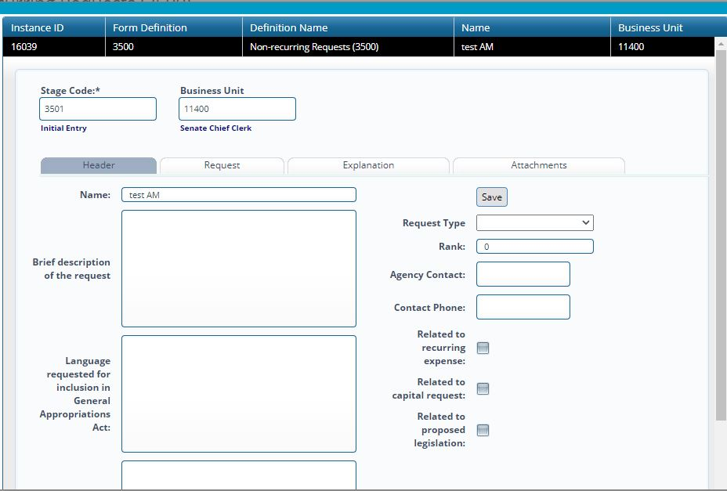
  - Provide a brief description of the request.
  - Identify the type of request on the right side dropdown menu: Deficiency (Expenditures exceeded revenues in FY21 or prior year); Supplemental (Additional funds needed in FY22 – must be spent by June 30, 2022); Special (Funds available for use upon bill signing through 6/30/2023), IT Request (entering Section 7 information technology requests), or Special (Language Only). Language Only requests included on this form often relate to extensions of prior appropriations in Sections 5, 6 and 7 of the GAA. Do NOT request BAR or Section 4 language on this form; request these on the 2600 form (see separate instructions).
  - Rank the requests within each type that your agency submits (if your agency submits 3 special appropriation requests and 2 supplemental appropriation requests, rank the specials 1-3 and the supplementals 1-2).
  - Provide agency contact and phone number.
  - Provide language that would need to appear in the bill describing the purpose of the appropriation. (Reference examples from previous General Appropriation Acts; capitalization and format instructions provided below). If you need assistance in crafting language please consult your SBD analyst.
  - Provide brief justification; further related questions are asked on the Explanation Tab.
  - If a Special Appropriation, provide quantitative data regarding the results that you hope to achieve with the appropriation. Please be specific (e.g. to purchase ten vehicles for senior centers; to provide mediation training to 100 agency employees, etc.). Attach supporting documentation as needed on the Attachments tab.
  - Check any appropriate boxes on the right side of the tab.
- Request Tab:

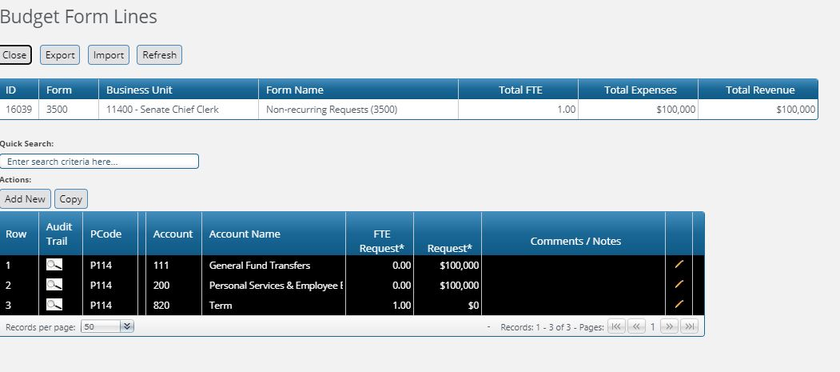
  - Each line of revenue and expenditures is entered here but only at the category level. Click on Add New to enter a new line.
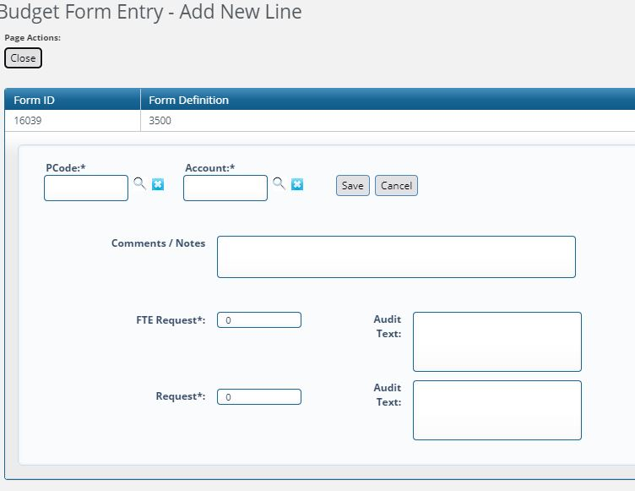
  - Enter the Pcode most properly associated with where/how the money will be spent (keep in mind these are usually appropriated by Zcodes)
  - Use the Account box to add either a revenue category, expenditure category, or type of FTE. Enter any notes in the comments field if desired (enter the specific fund if applicable here).
  - Note: IT appropriation requests for Section 7 coming from the Computer Systems Enhancement Fund should be requested as Transfers. Please identify the CSEF as the funding source in the Comments field in these cases. Correspondingly, there should be no Section 7 requests made from General Fund.
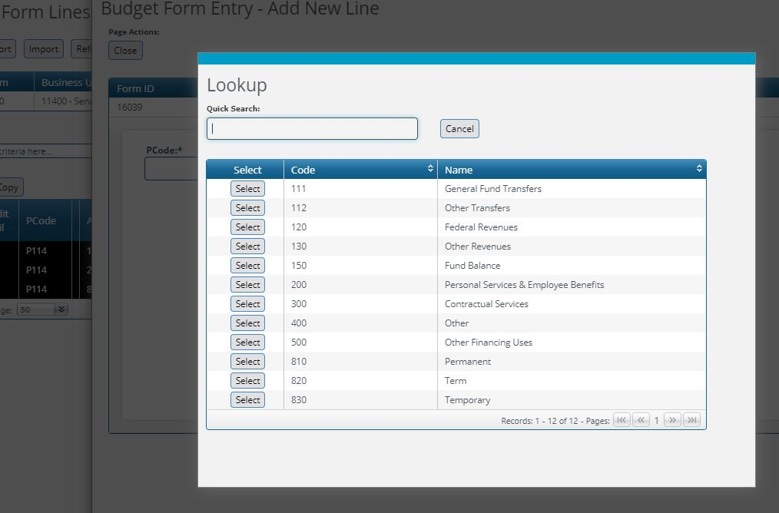
  - Enter any FTE requested in the FTE Request* box.
  - Enter dollars requested in the Request* box, in whole dollars.
  - Remember to add both revenues and expenditures such that they balance at the top of the form. Click Close when done.
- Explanation Tab: Complete narrative question as fully as possible to help justify your request. Click Save when done.
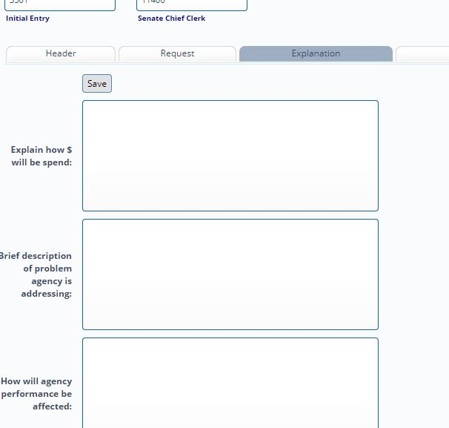
- Click on Submit when the request is complete. Submit through your agency review process and finally to stage 3504, which will simultaneously submit to DFA and LFC. Requests must be submitted by Friday, October 29, 2021.
- In BFM Reporting you can print a report listing all of your nonrecurring requests. However, this is informational only and it is not required to submit this report to DFA and LFC.
When crafting appropriation language, follow the capitalization and formatting conventions outline below:
- Most words are not capitalized except at the beginning of a sentence; however, you should capitalize the following: place names (e.g. New Mexico, United States, Santa Fe county – note “county” is not capitalized, Ute reservoir, Vaughn pipeline, etc.); proper names (Vigil-Giron, Gutierrez, and Kupfer cases); legislative acts (Title IV-E funds, Section 12 of Chapter 114 of Laws 2004, Indian Education Act, etc.); months of the year (May, June, etc.), and the words “Indian” and “Native American.”
- Do not capitalize the names of agencies, departments, divisions, programs or funds.
- Clearly and concisely state the purpose of the non-recurring appropriation. See examples below
To provide funding to compensate victims of crime.
To provide oversight to regional housing authorities to include travel, audit and
other expenses related to overnight functions.

For arbitration expenses related to tribal gaming.
- General format for appropriation reauthorization language:
The period of time for expending the (dollars expressed in words) (dollars in numerals) appropriated from (fund) in Subsection XX of Section X of Chapter XX of Laws XX for (state purpose of appropriation) is extended through fiscal year (identify fiscal year).

