
Legislating for Results:
Budget Development Tool

Agency Expansion Request Justification
New Mexico agencies making significant requests to expand agency budgets, other than workload changes, or for large special appropriations that appear to expand an agency’s recurring budget are being asked to assess the proposals and report on their purpose, potential for success, and plans for implementation and accountability in accordance with the Budget Guidelines of the New Mexico Legislative Finance Committee (LFC) and LFC's Legislating for Results Framework.
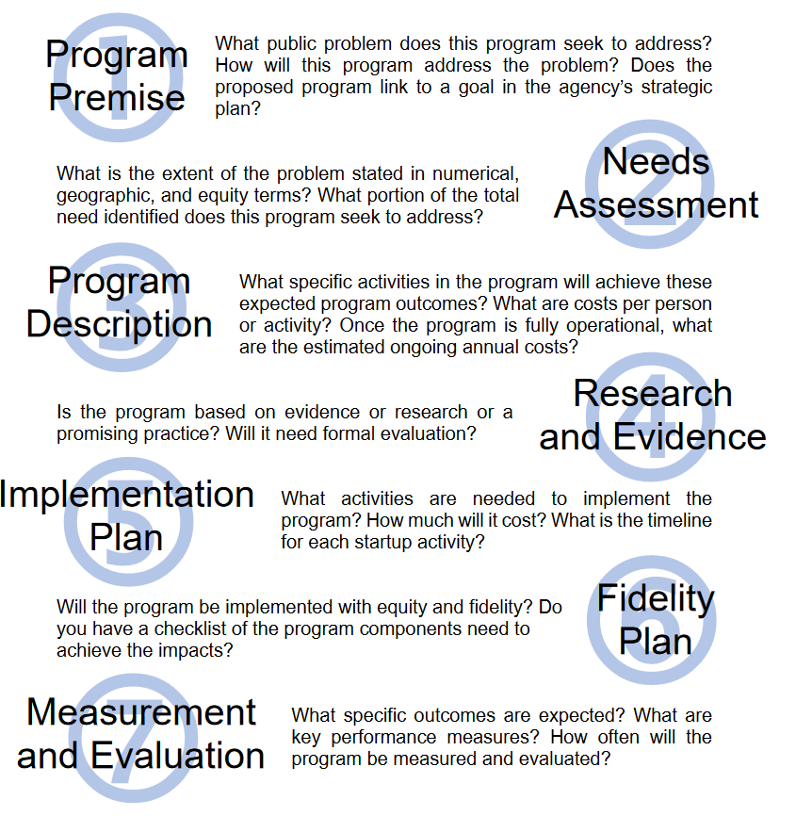
Agency and Expansion Request Information
Agency: Click or tap here to enter text.
Short Title of Request:Click or tap here to enter text.
Point of contact for follow-up information:
Name: Click or tap here to enter text.
Title:Click or tap here to enter text.
Phone:Click or tap here to enter text.
E-Mail:Click or tap here to enter text.
Is the requested expansion solely the result of a workload change? Choose an item.
If yes, no further information is needed. If no, please provide narrative responses addressing item below.

- Program Premise
In this section, provide information describing the problem this funding is proposed to address.
  - Why is this expansion needed and what problem or need it is attempting to address?
Click or tap here to enter text.
  - How does this request differ from existing programming?
Click or tap here to enter text.
  - How does the requested program fit into the agency’s strategic plan?
Click or tap here to enter text.
  - Has the agency developed a logic model describing the agency’s theory of change?
Choose an item.
  - If yes, please provide a copy of the logic model as a picture below or as an additional attachment with the form as part of the agency’s submission in BFM. If no, please contact your LFC or DFA analyst for assistance in developing a logic model.


- Needs Assessment
In this section, provide specifics on the extent of the problem this proposal proposes to solve.
  - What is the extent of the problem to be addressed?
Click or tap here to enter text.
  - What is the total statewide need in numerical or geographic terms? If applicable, this may include a description and analysis of historically unserved or underserved populations.
Click or tap here to enter text.
  - What percentage of the previously identified total statewide need does this request seek to address?
Click or tap here to enter text.

- Program Description
In this section, provide information detailing activities, costs, and benefits of the proposal.
  - How much is the agency’s request for FY26 and from what source is the agency requesting additional funding?
Click or tap here to enter text.
  - Provide a list of specific activities that will be carried out if this request is granted.
Click or tap here to enter text.
  - Provide a cost per unit for the funding (such as the cost per individual or cost per activity).
Click or tap here to enter text.
  - If available and applicable, provide a benefit-to-cost ratio for this program (the total monetized benefits divided by total costs).
Click or tap here to enter text.
  - Does the agency anticipate additional increases above the FY26 request will be needed in future years to continue to operate the program? If so, please describe these additional expenses and projections of future financial needs.
Click or tap here to enter text.

- Research and Evidence Categorization
In this section, provide information regarding the evidence and research supporting your request.
  - As defined in New Mexico's Accountability in Government Act, specify whether your program is evidence-based, research-based, a promising program or practice, or none of the above.
Choose an item.
  - Please provide any references or links to relevant research supporting your categorization. For example, sources may include published research or categorization provided by clearinghouse databases.
Click or tap here to enter text.
  - How will you evaluate the program to confirm your categorization?

Click or tap here to enter text.
- Implementation Plan

In this section, describe all activities related to implementation of your proposal (What, when, where, who, and how) by addressing the following items:
  - What are the training and startup requirements for the proposed program?
Click or tap here to enter text.
  - Provide an estimated timeline for implementation of activities. Include planned benchmarks, milestones, and a target date for full implementation. If the request includes new FTE, provide your current vacancy rate and plan for recruitment.
Click or tap here to enter text.

- Fidelity Plan
In this section, provide information regarding how you will ensure your proposal is delivered as intended.
  - Describe key components critical to the success of your program.
Click or tap here to enter text.
  - Provide a checklist or specific process metrics you will use to ensure component parts are implemented, including equity if applicable.

Click or tap here to enter text.

- Measurement and Evaluation Plan
In this section, provide information about measuring outcomes and the impact of your proposal.
  - What measurable outcome is the agency trying to achieve with the requested expansion?
Click or tap here to enter text.
  - Will the requested program affect any existing performance measures?
Choose an item.
    - If yes, which performance measures will be affected?
Click or tap here to enter text.
  - What program outputs will the agency measure?
Click or tap here to enter text.
  - What efficiency metrics will the agency monitor?
Click or tap here to enter text.
  - Does the agency have baseline data for the proposed measures?
Choose an item.
    - If yes, please provide baseline data.
Click or tap here to enter text.
    - If no, when and how does the agency anticipate collecting baseline data?
Click or tap here to enter text.
  - How often will the agency collect and report on these performance metrics?
Click or tap here to enter text.
  - How do you plan to share the results of your program with the public and the Legislature?
Click or tap here to enter text.

