PR Journal Errors – Job Aid

Business Purpose

Each payroll cycle, the Central Payroll Bureau (CPB) creates and posts payroll journals for all state agencies. If the agency’s payroll journal(s) does not post automatically due to budget and journal errors, these journals must be corrected. It is essential that agencies provide CPB the appropriate accounting information to correct all journal entries within 24 hours of receiving notification from CPB. Additionally, agencies must correct the error in HCM prior to the next payroll cycle.
Payroll journals are essential to the state’s financial accounting system accurately reflecting payroll activity, therefore if an agency has the same errors for two pay periods, all agency stakeholders will be required to meet with DFA Financial Control Division and Central Payroll prior to the journal corrections being made the second time.
Most of the errors are caused by project costing associated with combo codes and task profiles. Agencies should provide Central Payroll with contact information for financial staff that are responsible for maintaining this information.

Business Procedure

- After Central Payroll Bureau completes the payroll processes, the third-party process begins. These processes include the PAYGL02 transaction.
- The PAYGL02 process collects all necessary information from Human Capital Management (HCM) and posts entries to the financial general ledger accounts. This creates Payroll (PR) Journals using the liabilities and expenses related to payroll.
- Central Payroll then runs a process to post the PR Journals and performs an edit. This editing process reviews all line items and expenses to ensure that there aren’t errors such as budget errors, validity of funds, departments, budget references, and classes.
- The edit process is run for each payroll entry, which can contain multiple lines and expenses for each employee, resulting in a substantial number of lines.

Identifying Errored Journals

The query [NMS_JRNLS_NOT_POSTED_PR_SYS] can be used to identify all journal entries that do not pass the edit process. This query is run in FIN and not in HCM.

Query Path
[FIN] Menu Reporting Tools Query Viewer NMS_JRNLS_NOT_POSTED_PR_SYS

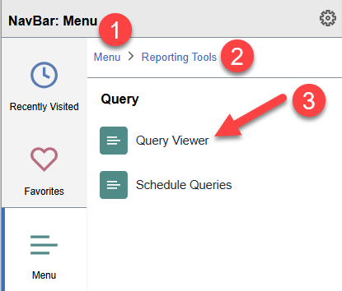

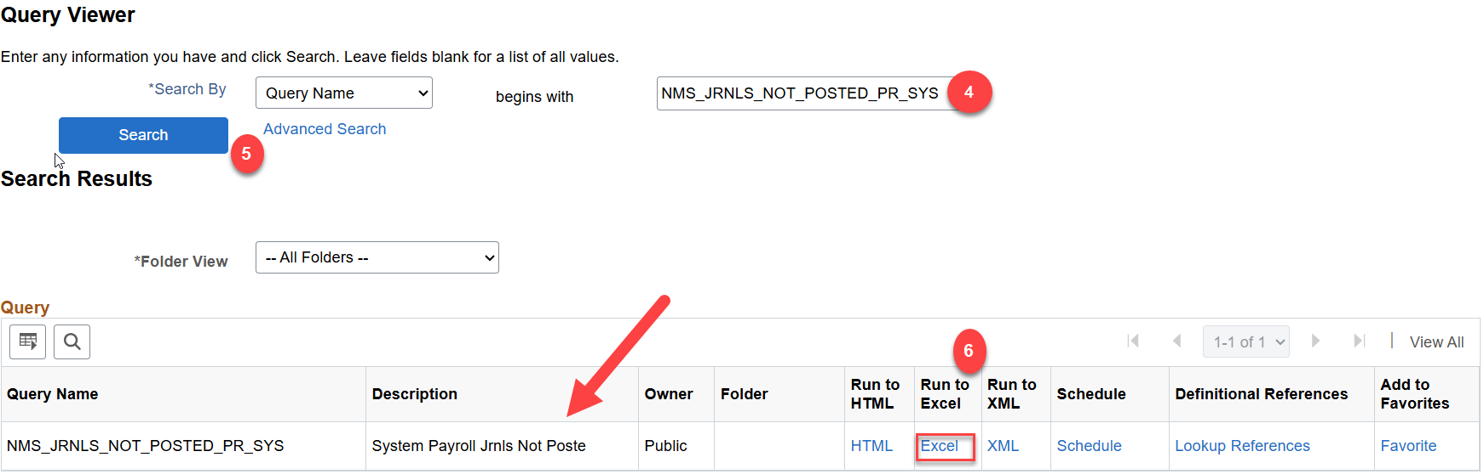

Query Results

This query shows the information needed to research the journal errors in the General Ledger module in FIN.
V=Valid
E=Error
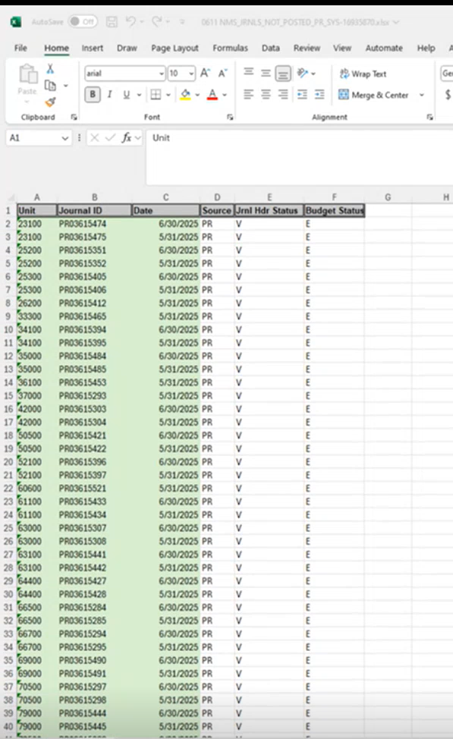

Identifying The Error Type
[FIN] Menu General Ledger Journals Journal Entry Create/Update Journal Entries

- Click on Find an Existing Value

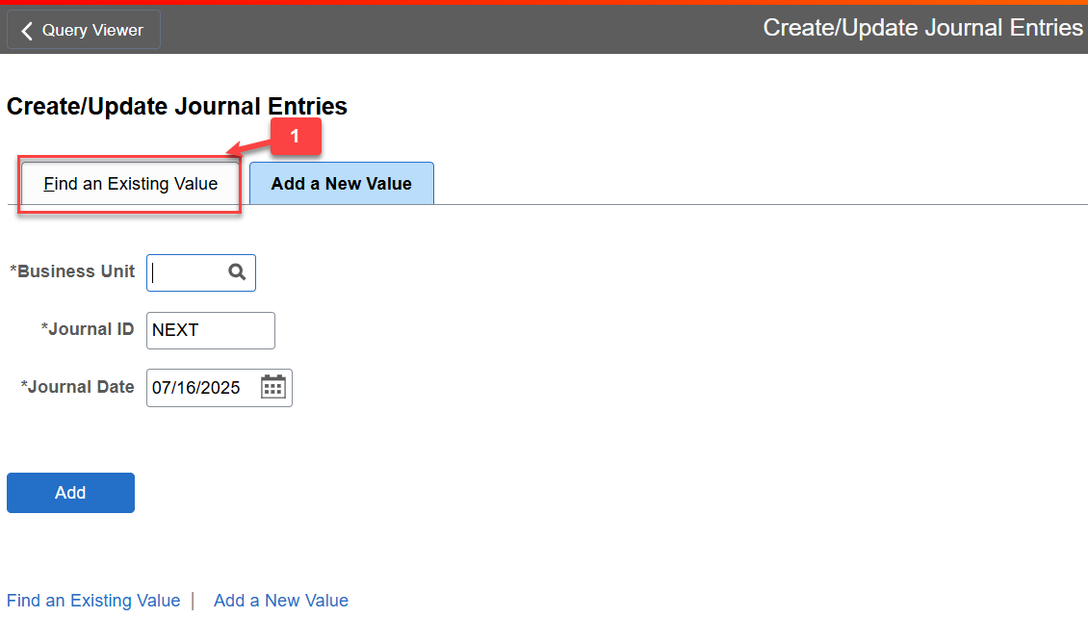

- Click the Clear button to remove any existing information pre-populated in the fields.
- Enter your Business Unit number
- Enter the Journal ID that is found in the query results or from the notification email sent by CPB.
- Click Search
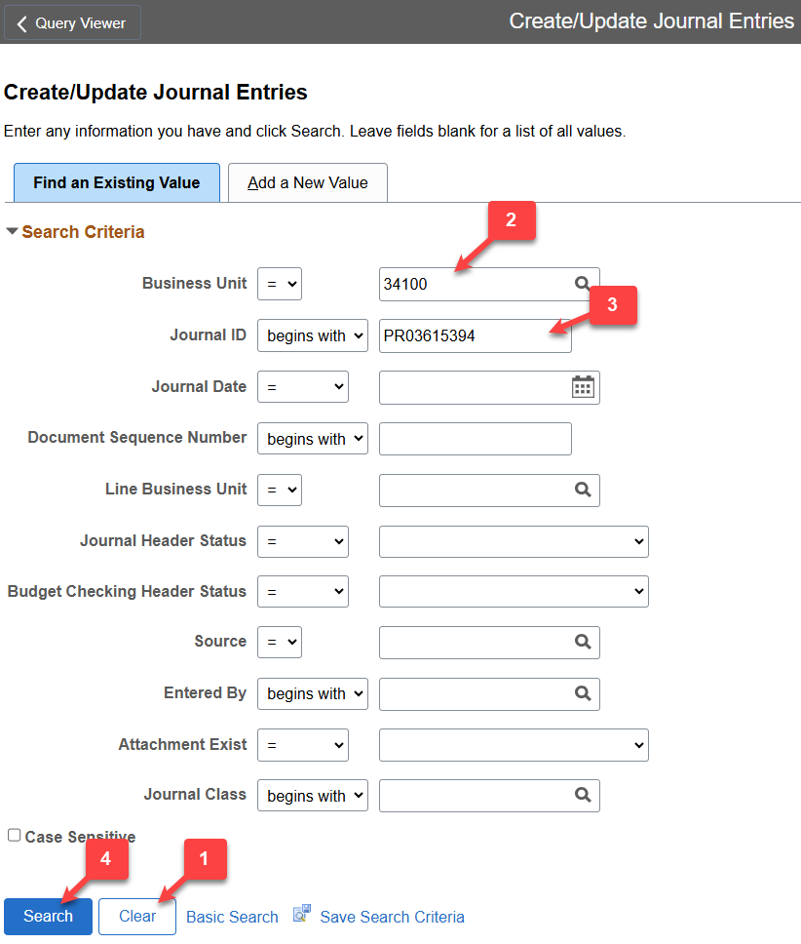

- Click on the Lines tab
- Click on the E in Budget Status
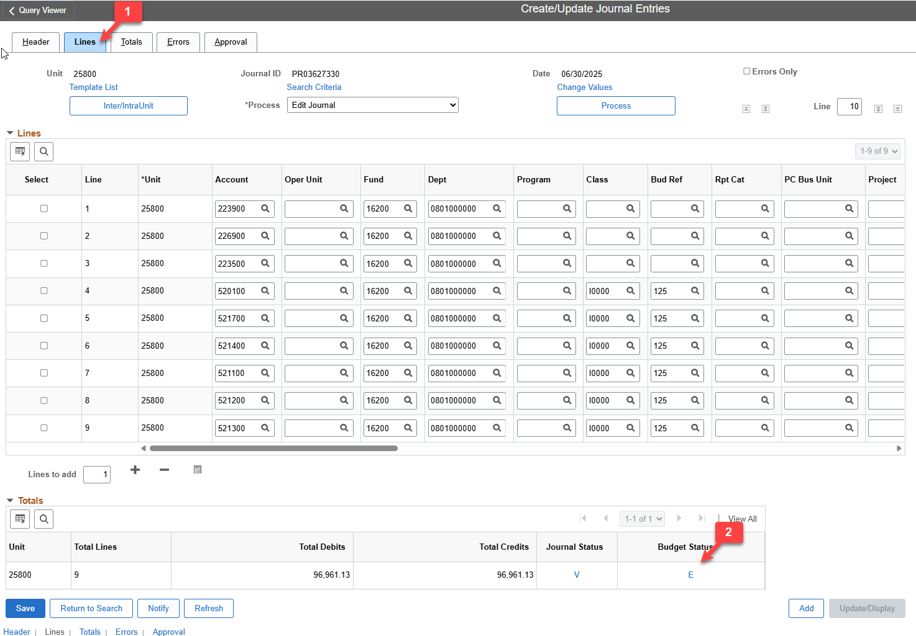

- Enter 9999 in the Maximum Rows field to ensure you view all lines
- Click Search
- Click expand Arrow
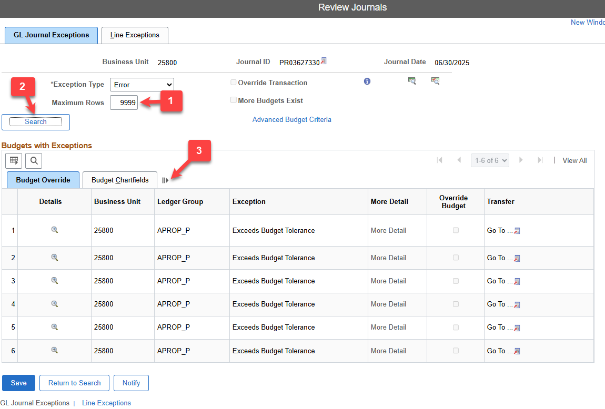

Results:
This now shows the description of the Exception causing the error.
The agency’s finance/budget team will need to provide the information needed to correct the error.
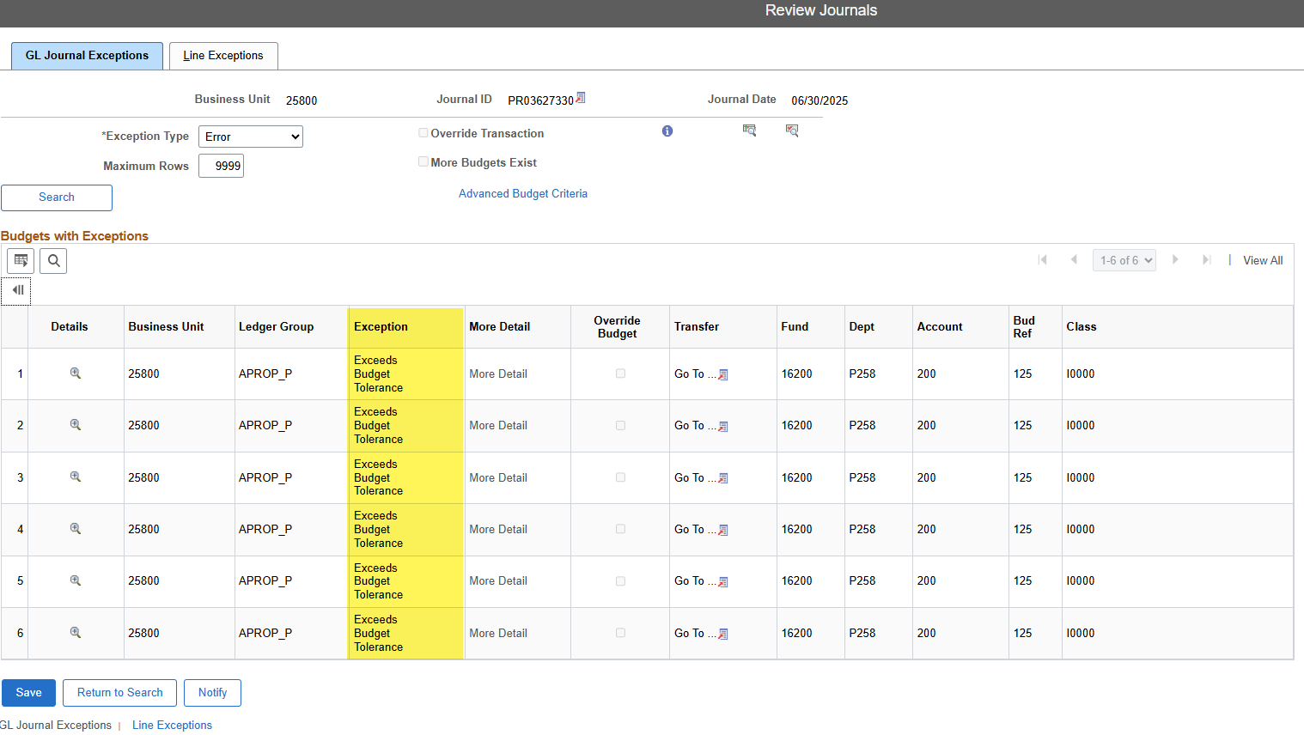

Journal Error Examples
[FIN] Menu General Ledger Journals Journal Entry Create/Update Journal Entries
1st Example: Budget Date out of Bounds
Journal is in error – click on the “E” to obtain detail of the error or on the Errors
Tab.
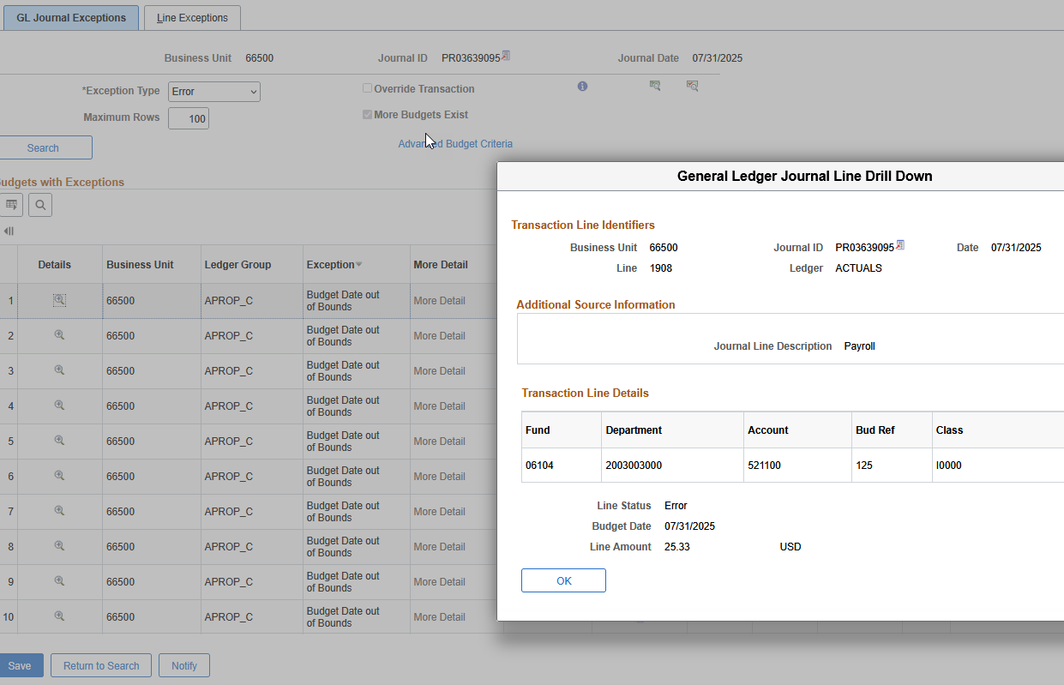

2nd Example: Budget Errors (No Budget Exists)
No Budget Exists – refers to budget not established for
Fund/Department/Account/Bud Ref/Class accounting string.
Select errors only – Department budget does not reflect correct bud reference

Select to open and view roll up chart fields
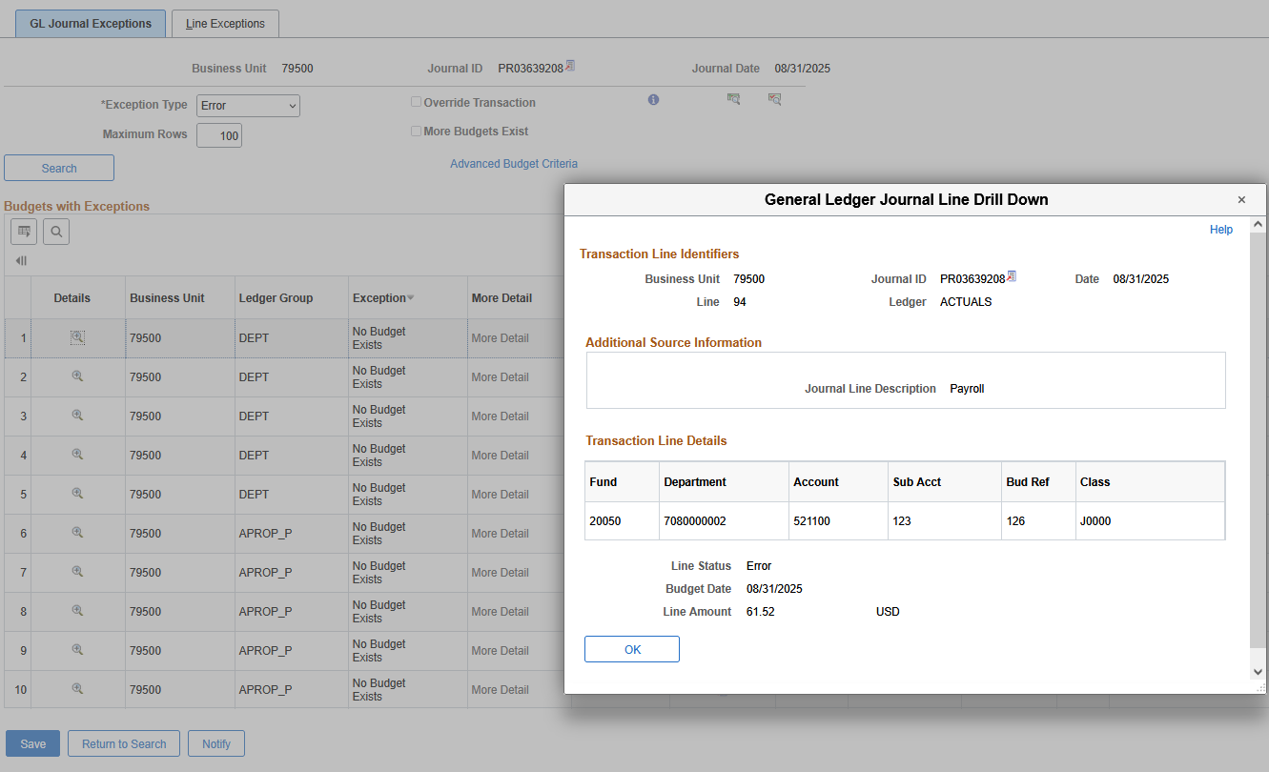
Error message shows that no budget exists for the accounting lines entered the
journal entry.

3rd Example: Budget Errors (Exceeds Budget Tolerance)
Exceeds Budget Tolerance – refers to the Fund/Department/Account/Bud
Ref/Class accounting string exceeding available budget.
In the Lines Tab, click on box indicated “Errors Only” to display the line(s) containing
the budget error. Click on the “E” hyperlink located below the Budget Status to
view the description of the budget error. If agencies budget at a lower level, such
as the Department code, reporting category, project codes, than the P Code,
budget errors also will be displayed at those levels.
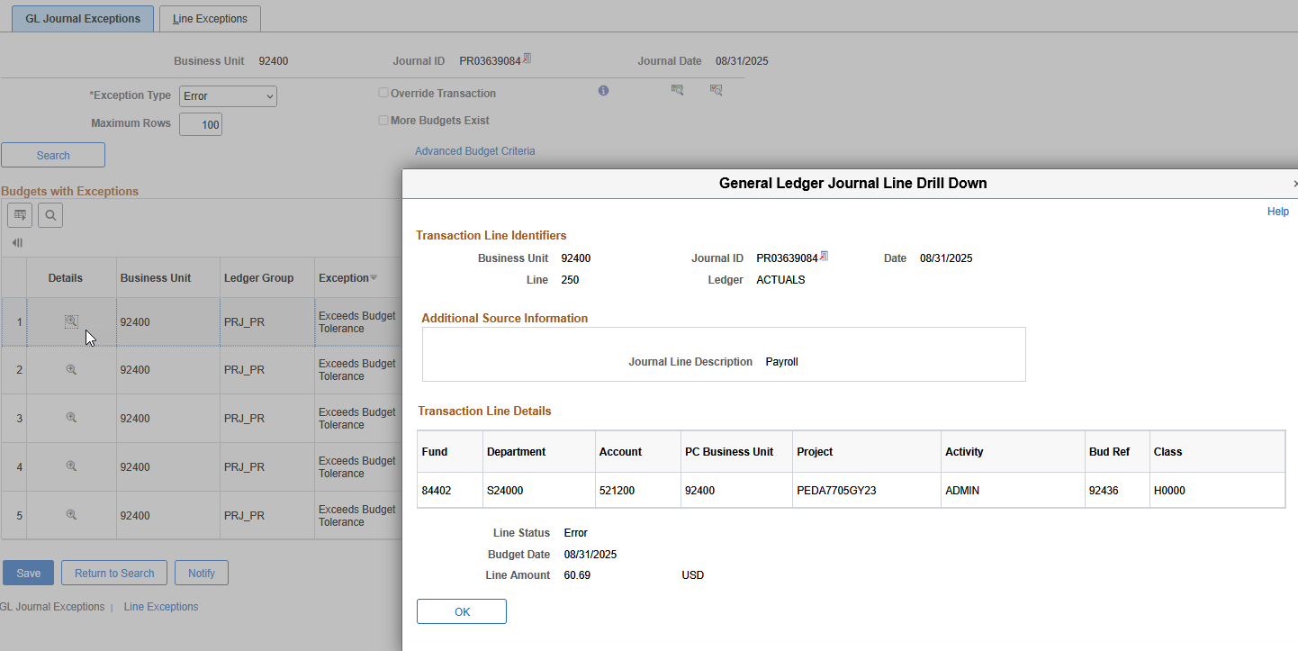
Budget error – Exceeds Budget Tolerance

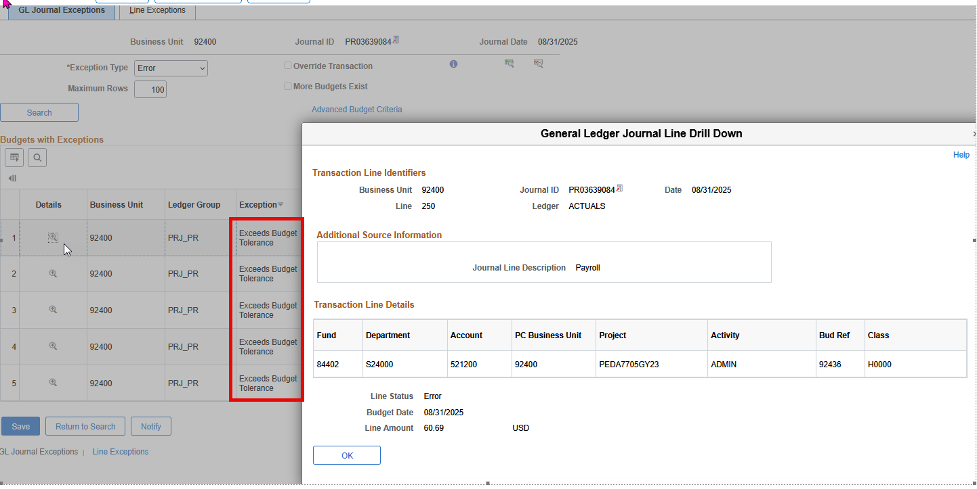
Click hyperlink to retrieve budget in commitment control and research to
determine what is required to clear budget error

Budget error – “Exceeds Budget Tolerance” need to review budget and adjust
journal amount.

