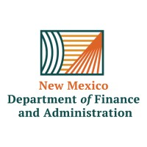
Payroll Training
Request Form

Name: Click or tap here to enter text. Today’s Date:Click or tap to enter a date.
E-mail Address: Click or tap here to enter text.
Business Unit: Click or tap here to enter text.
Format of Training: Video Conference ☐ Phone Call ☐ In-Person ☐
Number of attendees: Click or tap here to enter text.

Training Subject:
☐ Refunds & Deductions ☐ Terminal Leave Process ☐ Payroll Processes
☐ Payroll Reconciliation ☐ Additional Pays ☐ Other: (Explain Below)
Click or tap here to enter text.

List three dates you are available for the training:
Click or tap to enter a date.
Click or tap to enter a date.
Click or tap to enter a date.

Please e-mail completed form to CPBTrainers@dfa.nm.gov .

* This form is for training requests from the Central Payroll Bureau regarding subjects related to payroll and payroll processes. For requests for HR related training, please contact SPO (State Personnel Office) or DoIT for their provided training.

