Terminal Leave Request Form – Instructions

Business Purpose
- The Terminal Leave Request Form (TLV) is used to pay out annual leave when an employee terminates employment or transfers to another state salary plan. TLV requests are processed during the On-Cycle Pay Period one pay period following the termination date. This is to ensure that all final payroll processes and leave accruals are updated before the payout is requested.
- This is a fillable form. To complete the form, use your mouse to navigate between the fields. We recommend you complete this form electronically to avoid illegible entries.
- Forms should be submitted through the Central Payroll Bureau’s Forms Submission System https://platform.dfa.nm.gov by 5pm on the Tuesday of the Pay Period End date, which is subject to change due to observed holidays.
- A copy of the NMS Terminal Leave Report must be attached to the Terminal Leave request and must be generated in the current pay period that it is submitted. Instructions for generating the NMS Terminal Leave Report can be found on the DFA website.

Business Procedure
Please complete all fields in the top section of the form.

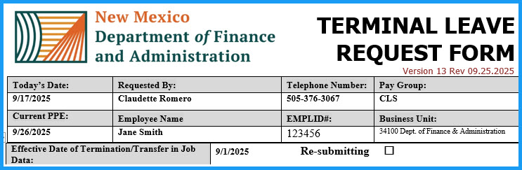

- Today’s Date - the date you are filling out the form
- Requested By - the name of the person completing the form
- Telephone Number - the telephone number of the person completing the form
- Pay Group - choose the correct value from the “drop down menu”
- Pay Period Ending - this is the current pay period ending date
- Employee Name - full name of the employee
- EMPLID# - always includes the employee’s state ID number
- Business Unit - choose the correct value from the “drop down menu”. If the request is for a transferred employee, the current agency’s information is listed at the top of the form. The prior agency’s information goes in Box 3.

Please complete all fields in the middle section of the form.

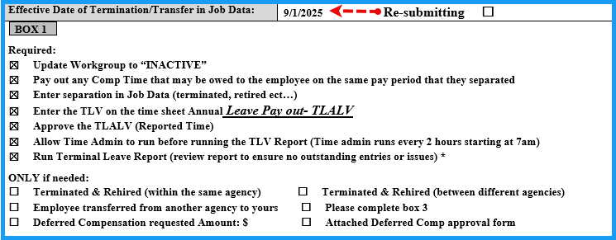
- Effective Date of Termination in Job Data - this date should match the date used in job data when inserting the termination row – effective date should be the day after the employee’s last day worked (i.e. if the employee worked Friday, the termination date is Saturday).
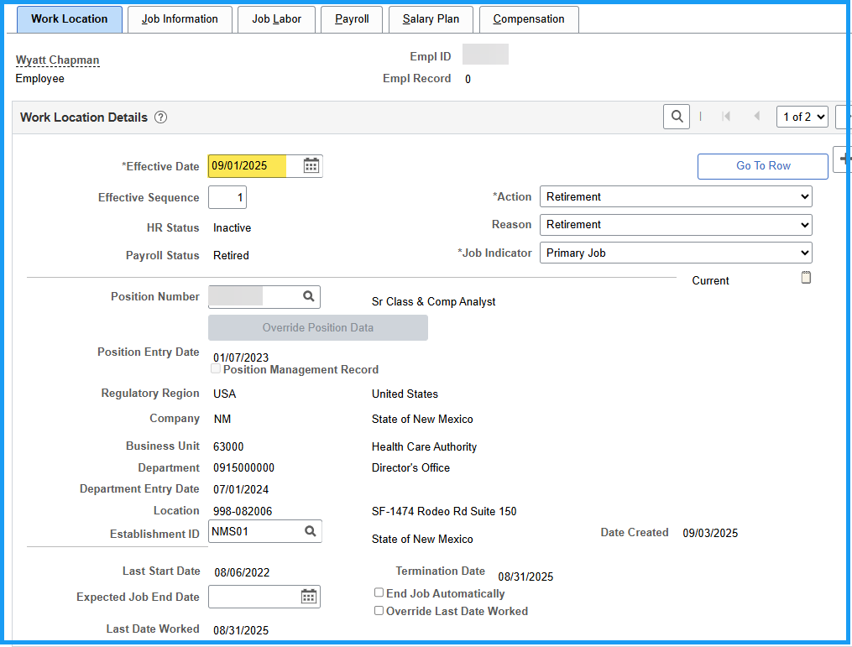
- Box 1 - If the employee has terminated, then it is required that all the procedures in Box 1 have been completed in HCM before submitting the form to Central Payroll. If any of the steps have not been completed, the form will not be processed. These steps include:
  - Process the termination or retirement event in Job Data. Ensure that the effective date is the day after the last day worked (i.e. employee worked Friday, Saturday is the termination date)
  - Update the workgroup in Maintain Time Reporter Data to “INACTIVE”. This stops further payable time from being created and prevents accidental approval of the time, which will result in overpayment to the employee.
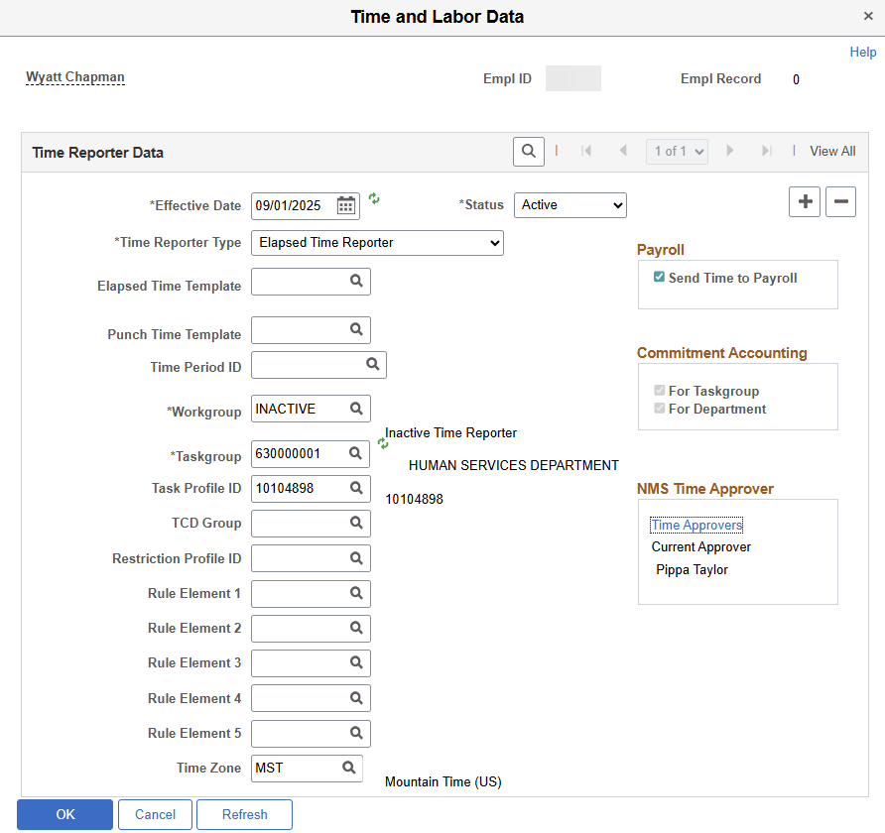

  - Verify that there is no payable time after the last day worked that has either been approved or is available for approval. Verify that all leave has been accrued and that the balances on the form are accurate and reflect the balances from the employee’s timesheet. If your agency does not use SHARE to track leave balances, a memo from the HR Manager is required to validate that the balances are true and accurate.
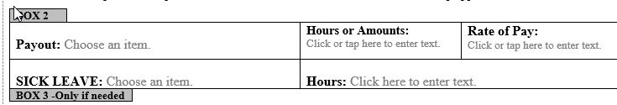
Box 2
- Payout – if the hours are entered on the timesheet select TLV Annual Leave Payout - Hours. If the agency does not use timesheets to payout annual leave, select NBN Terminal Payout – Amount only. Sick Leave - if the employee is separating from state government select sick leave lost. If the employee is retiring from state government and has over 600 hours of sick leave, select retirement sick payout (TLRSK) and sick lost.
- Hours or Amounts– refer to employee’s balance on timesheet. DO NOT round up when entering the number of hours and use only first two decimal places (i.e. if the employee has 86.365 hours, enter 86.36 NOT 86.37 as this will cause the employee to go into a negative balance situation)
- Rate of Pay– use rate of pay for all leave and comp time paid at termination.

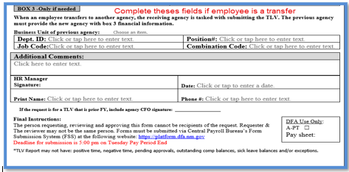

Please complete all fields in the bottom section of the form.

- Box 3 – Only complete fields in box 3 if the employee is now working at another agency, and the hours requested on the form are being charged to the employee’s previous agency. All boxes must be completed to appropriately charge the prior agency.
The bottom section of the form requires a signature from the Human Resource Manager or a Human Resource Supervisor indicating that they have reviewed the form. Note: the person reviewing and signing the form cannot be the same as the one requesting. A copy of the Terminal Leave Report must be attached for us to process your request.
Although you have until Tuesday of Pay Period End at 5:00 PM to submit the TLV form and TLV Report, we encourage you to submit them as soon as you have them completed. This allows Central Payroll time to address any questions and provides the agency with sufficient time to make corrections and resubmit the complete packet by the established deadline.

Document Control
Date | Author | Description | Version
08/08/2013 | Carol Ortiz | Draft | 0.1
09/17/2025 | Claudette Romero | Update | 0.2

