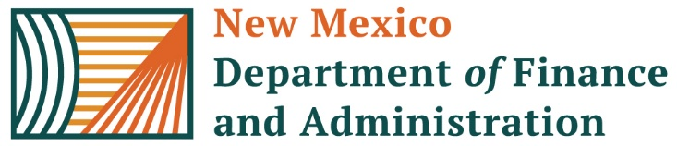 | Time Sheet Correction FORM
Version 12 Rev 05.01.2025
Today’s Date: |  | Requested By: |  | Telephone Number: | Pay Group:
Click here to enter a date. |  | Click here to enter text. |  | Click here to enter text. | Choose an item.
Current PPE: |  | Employee Name |  | EMPLID#: | Business Unit:
Click here to enter a date. |  | Click here to enter text. |  | Click here to enter text. | Choose an item.
Corrected PPE: | Workgroup:
Click here to enter a date. | Choose an item.
Sat: | Sun: | Mon: | Tue: | Wed: | Thu: | Fri: | TRC | Combo Code

Sat: | Sun: | Mon: | Tue: | Wed: | Thu: | Fri: | TRC | Combo Code

 | Additional Comments:
 | HR Manager Signature: |  |  | DATE: Click here to enter a date.
 | Print Name: | Click or tap here to enter text. |  | Phone Number: Click or tap here to enter text.
If the request includes prior FYs, please include agency CFO signature: ___________________________
Final Instructions: The person requesting, reviewing and approving this form cannot be recipients of the request. Requester & Reviewer may not be the same person. Forms must be submitted via Central Payroll Bureau’s Form Submission System (FSS) at the following website: https://platform.dfa.nm.gov Deadline for submission is 5:00 pm on Tuesday Pay Period End.

